1. 6-4-21,6/19
2. 7/1, 7/4,7/6,
3. 8/2🡪**8/15(milestone -1)**
4. **8/25 focus on Stack, String, array and linked list**
5. **11/16/21**
6. **12/31/21 done**
7. **1/10/22->**

* 1/12,1/15,1/28,2/7

1. 3/17/22->
2. 5/2, 8/22
3. **Python rex, bisect, bitmask, union find, trie, graph**

https://www.hackerearth.com/practice/algorithms/dynamic-programming/bit-masking/tutorial/

Focus on solving problems in category:

* **Stack**:

1. **Basic calculator**
2. **Scan twice, forward and backward**
3. **Range stack – scan once: always append current, and pop stack which is either smaller/equal or larger/equal.**

* String
* array
* Dictionay
* Dp/BFS/DFS
* bitmask

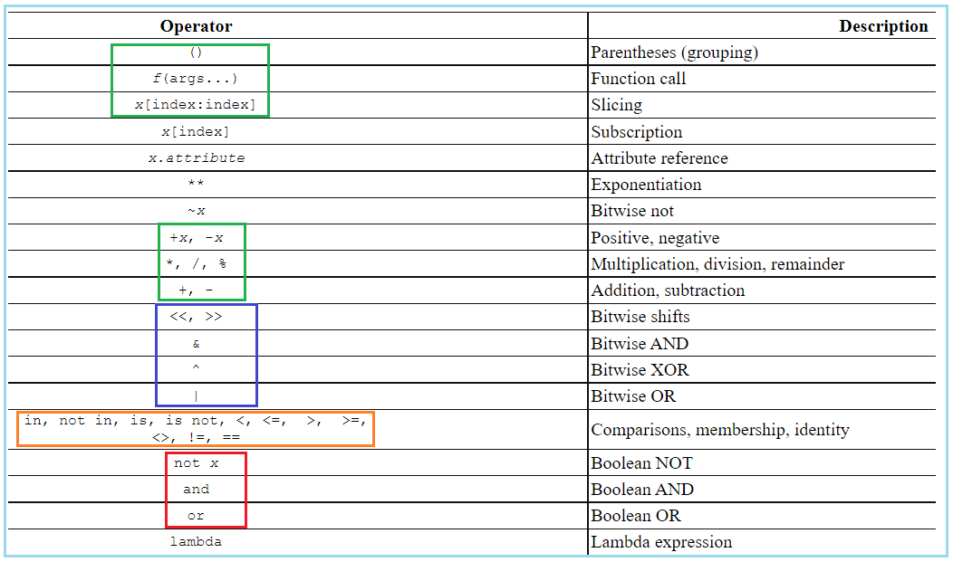

1. **Logic Very Challenging**
2. **1186. Maximum Subarray Sum with One Deletion**
3. **801. Minimum Swaps To Make Sequences Increasing**
4. **1524. Number of Sub-arrays With Odd Sum**
5. **82. Remove Duplicates from Sorted List II**
6. **1124. Longest Well-Performing Interval**
7. **1717. Maximum Score From Removing Substrings**
8. **Binary Search**
9. **Linked List**
10. **Priority Q**
11. **Linear scanning with dict()**

* **sorted(dic) returns an ordered list of keys of dict**

1. **Stack-mono**
2. **Parenthesis**
3. **Sliding Window**
4. **DP: longest increasing sub-sequence**
5. **DP: longest palindrome sub-string**
6. **DP: How many ways in total for doing something; recursive**
7. **DP: shortest/minimum steps to certain amount****`**
8. **DP: True or False**
9. **BFS\*\*\*\*\***
10. **DFS\*\*\*\*\***

* **sum of sub-arrays or sub-sequences:**
* **Check if elements are positive only or Non-negative only or any integers**

1. **Sum of subarrays == target value**
2. **Sum of subsequence of array**
3. **Find max sum of sub-array**
4. **Circular Array**
5. **Scheduling**
6. **Sorting\*\*\*\*\***
7. **Matrix-Opertation \*\*\*\*\***
8. **Range Check**
9. **Tricky problems**
10. **Collections.defaultdict(set)**
11. **Topological Sort**

**6/10/21, 6/11/2021**

1. **Binary number**
2. **Bit Mask**

* **Top mistakes**

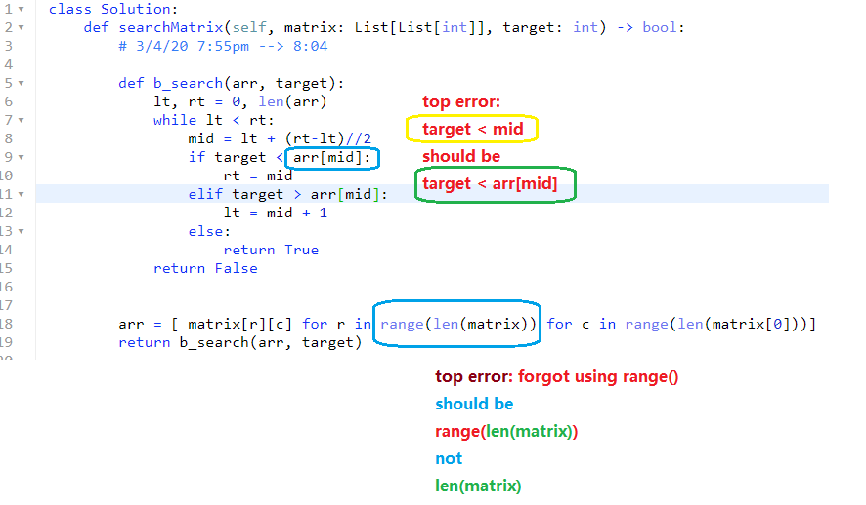

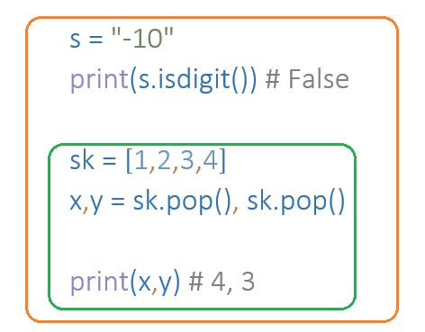

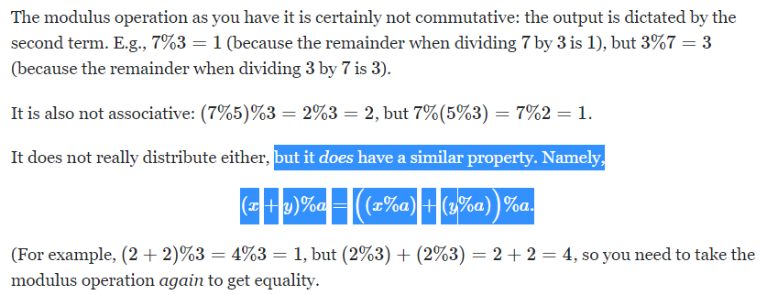

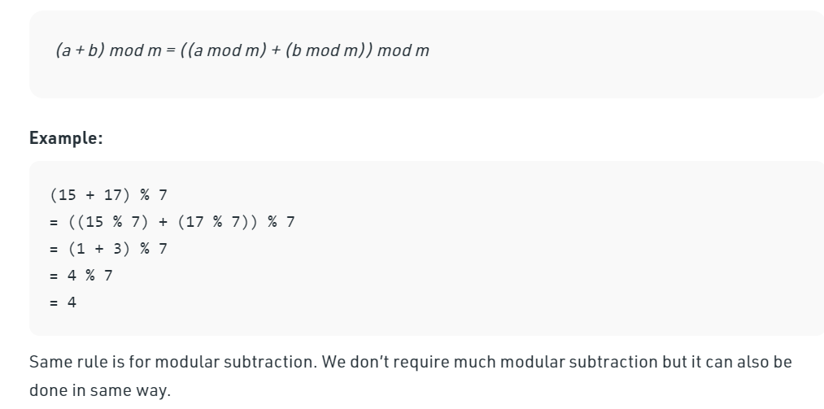

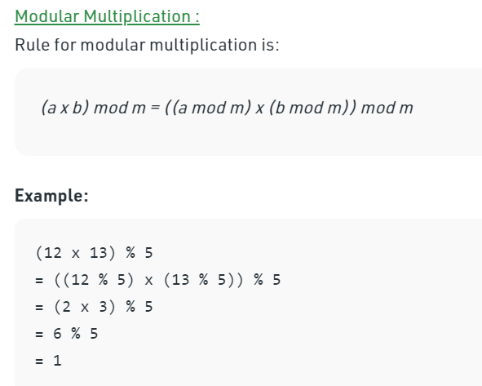

1. **Binary Search \*\*\*\*\***
2. **Basic Principles, 5/5,**

**Three possibilities that target is not found:**

1. **Target larger than [n-1]**
2. **Target smaller than [0]**
3. **[lt] < [mid] < [rt] while lt = rt-1**

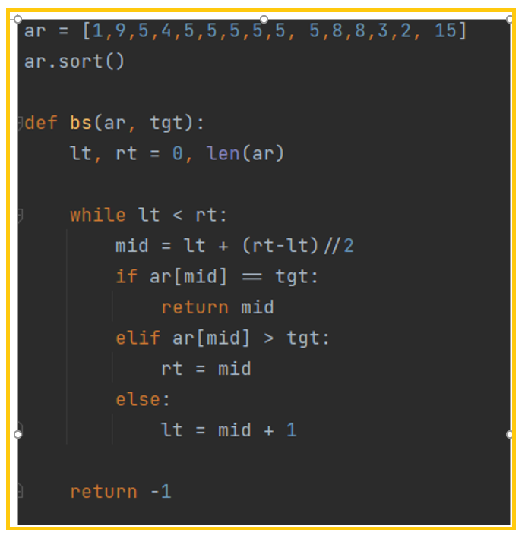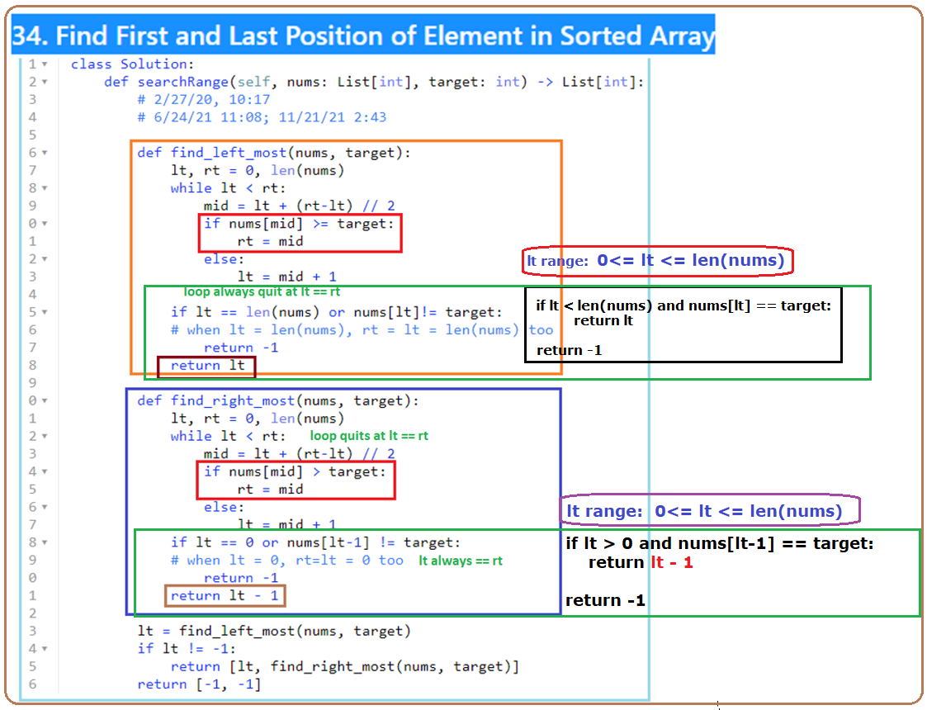

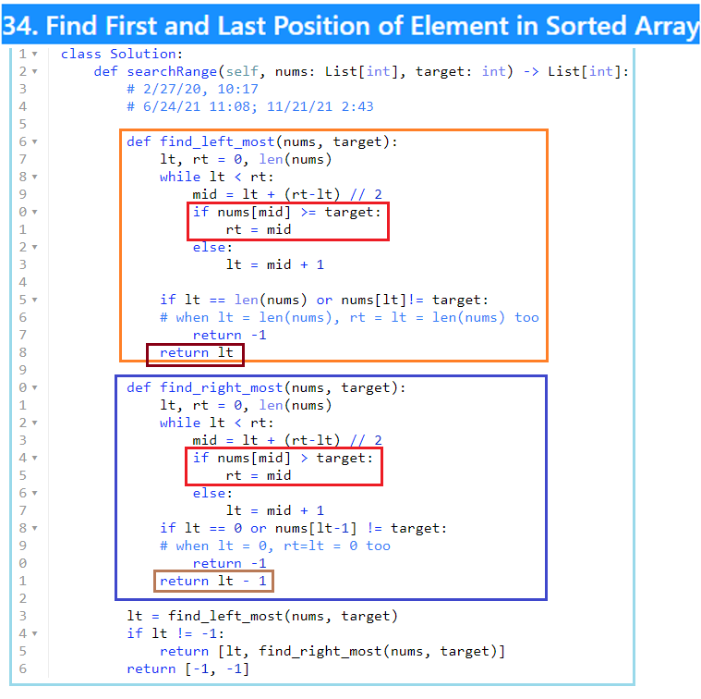

1. **1712. Ways to Split Array Into Three Subarrays**

5/9/22

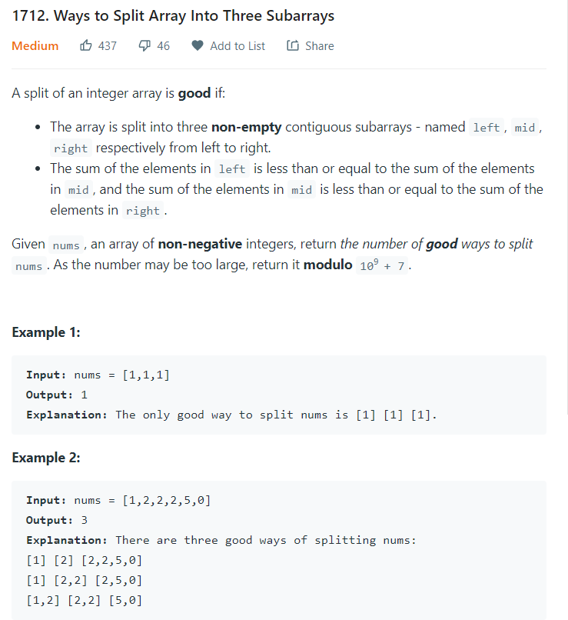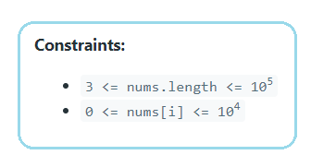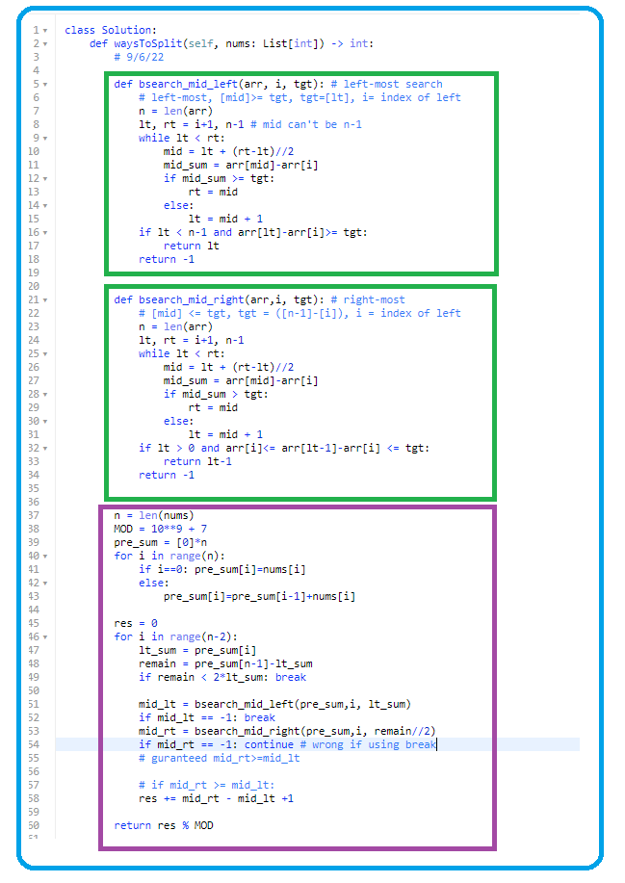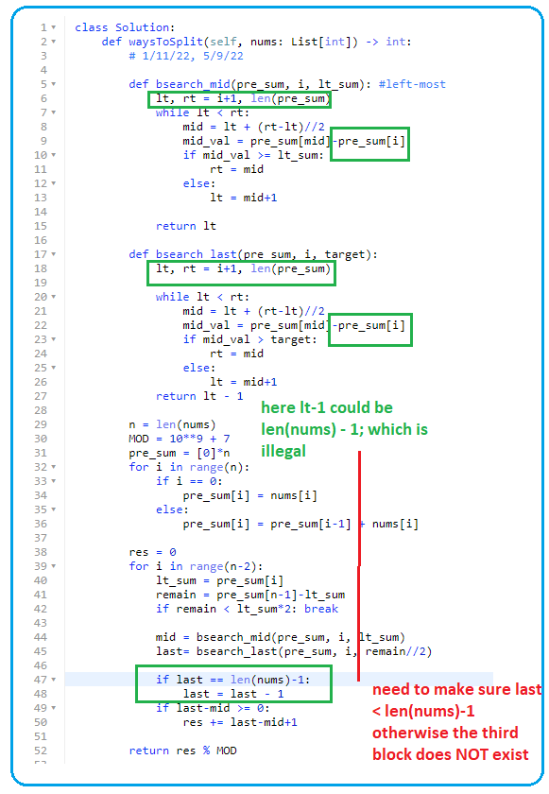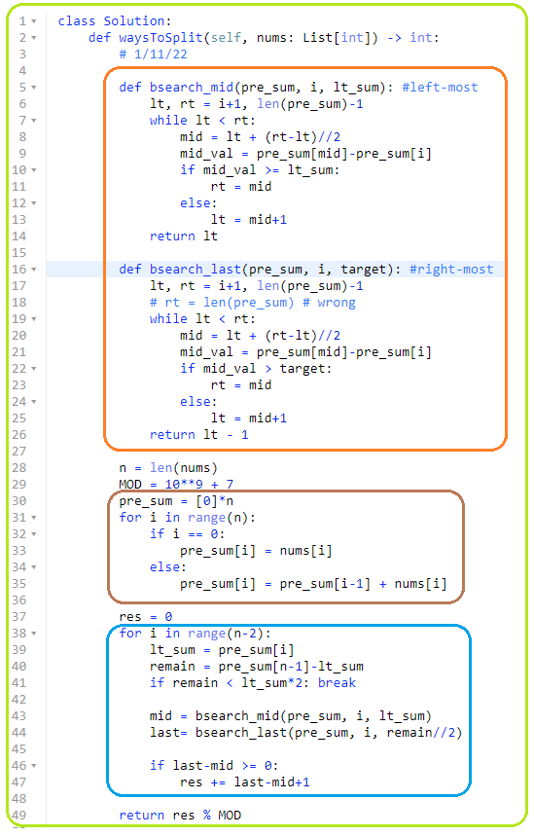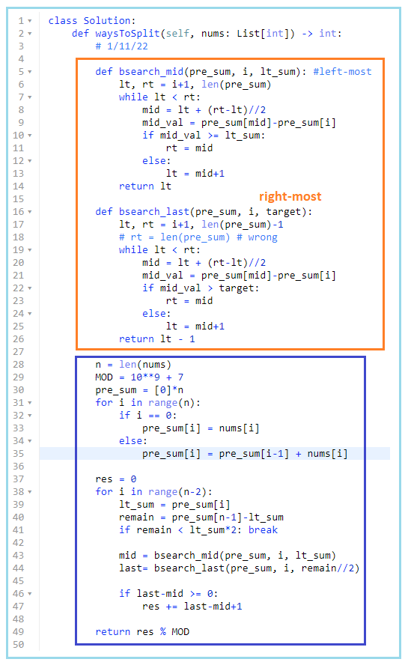

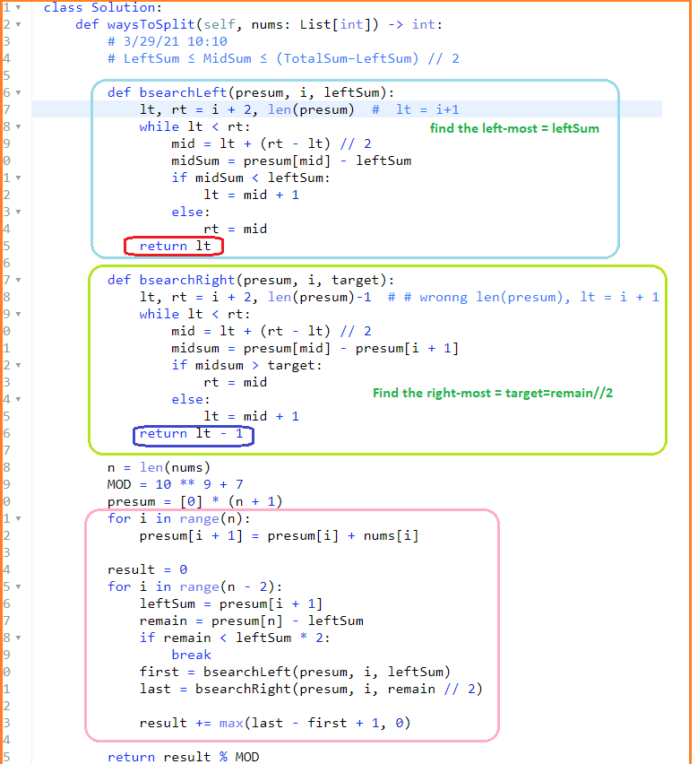

1. **33. Search in Rotated Sorted Array**

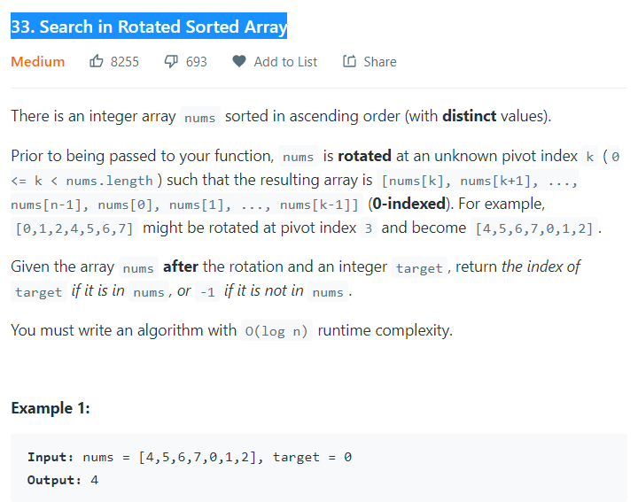

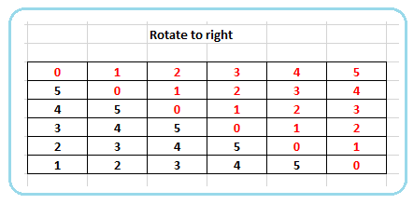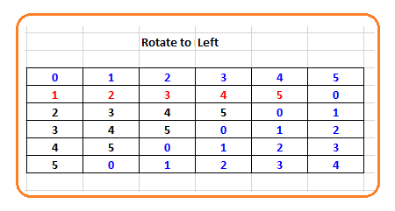

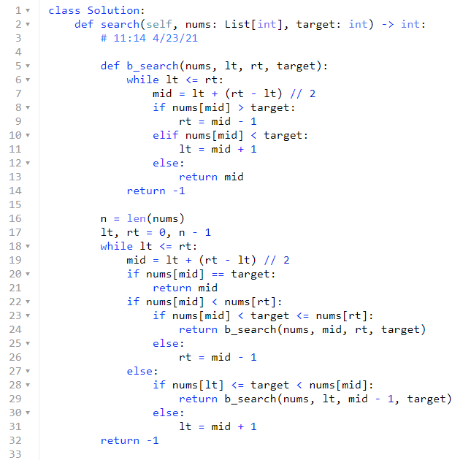

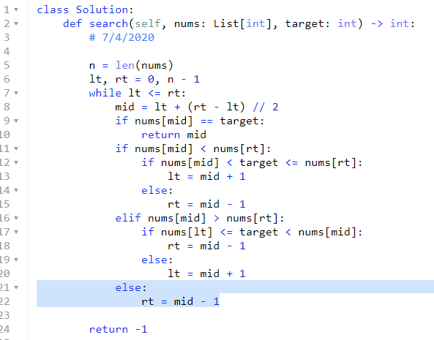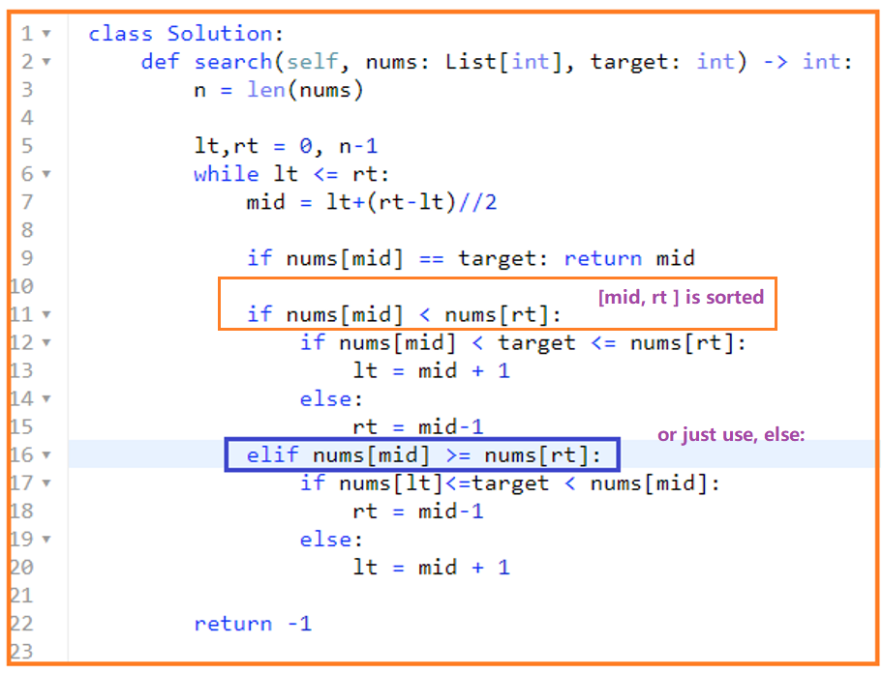

1. **34. Find First and Last Position of Element in Sorted Array**

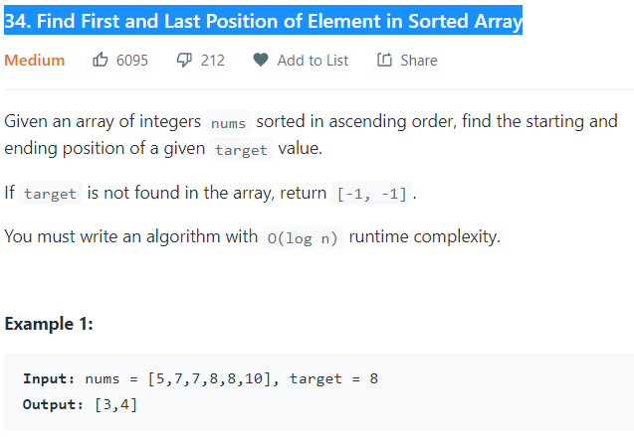

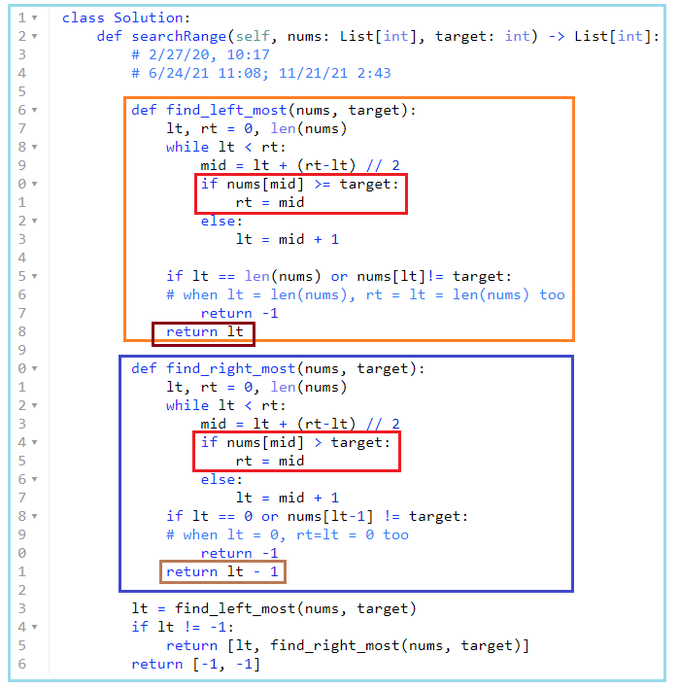

1. **74. Search a 2D Matrix**

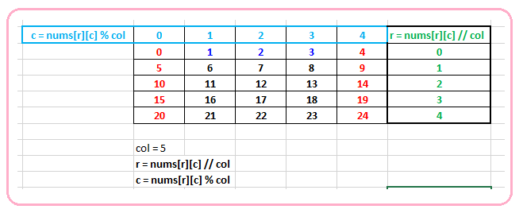

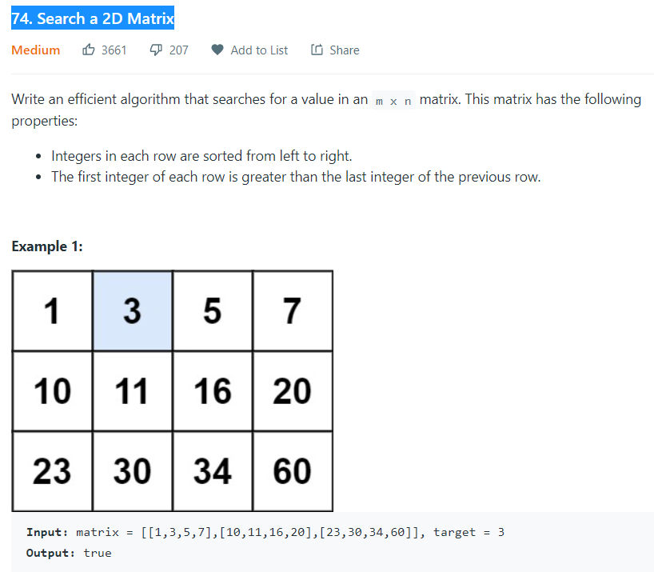

* #

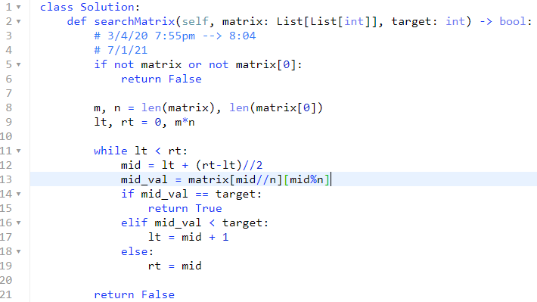

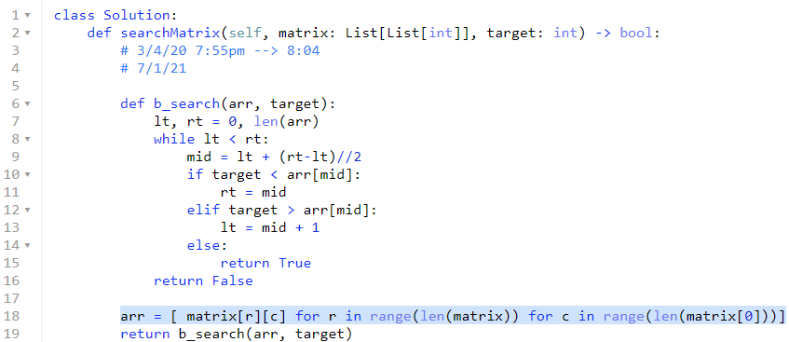

1. **Linked List**
2. **82. Remove Duplicates from Sorted List II**

**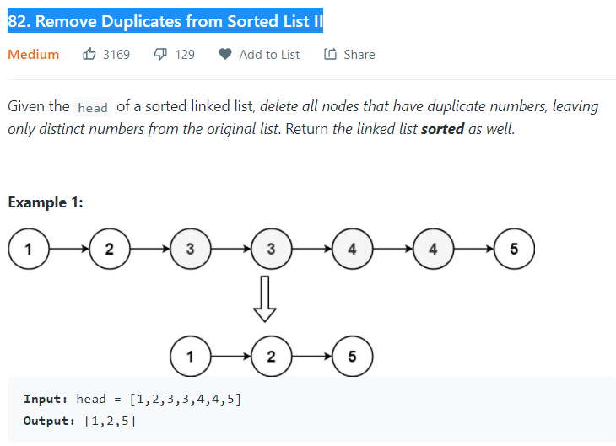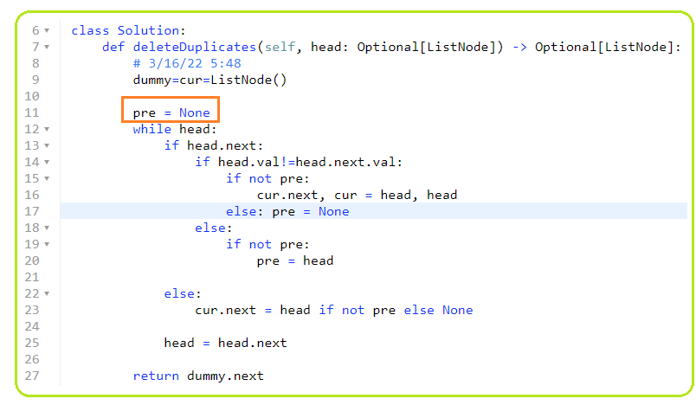  
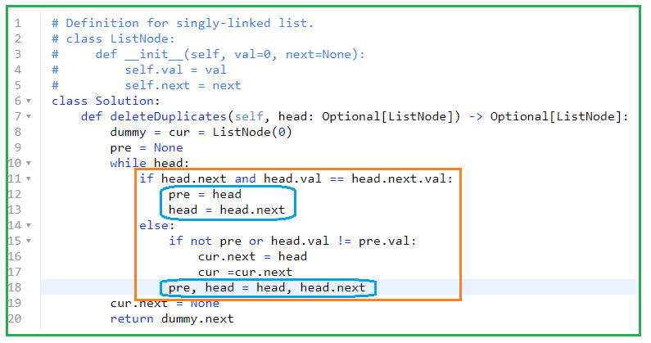**

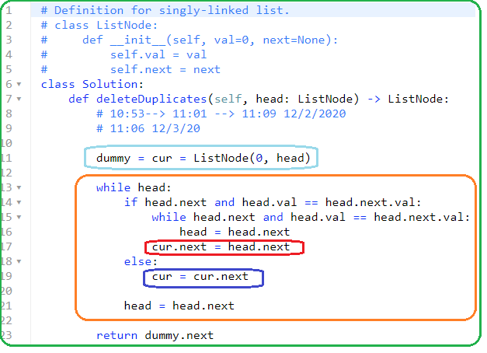

1. **92. Reverse Linked List II**

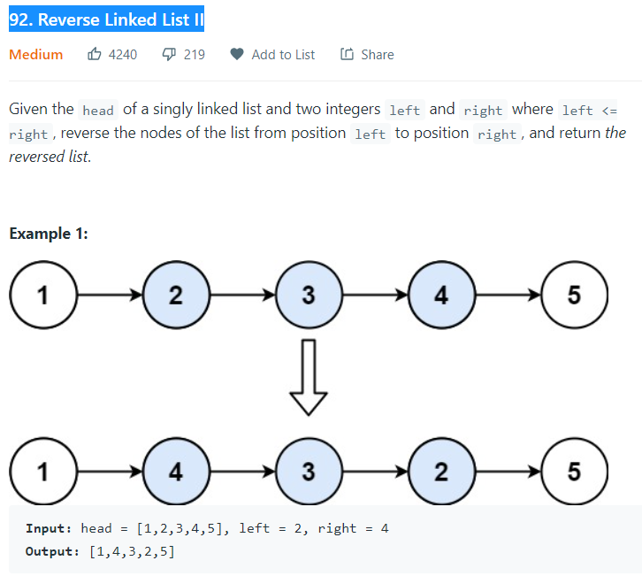

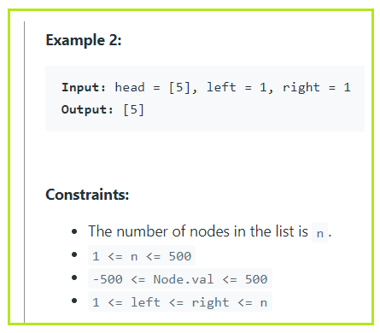

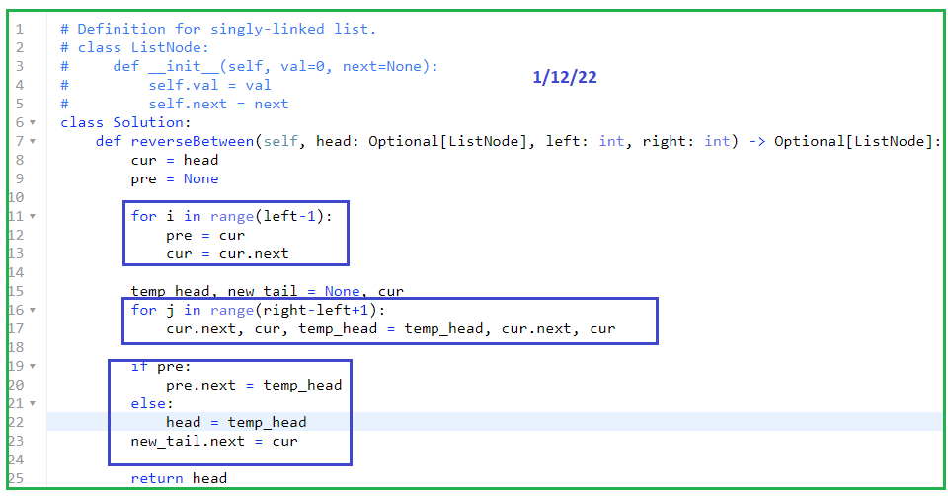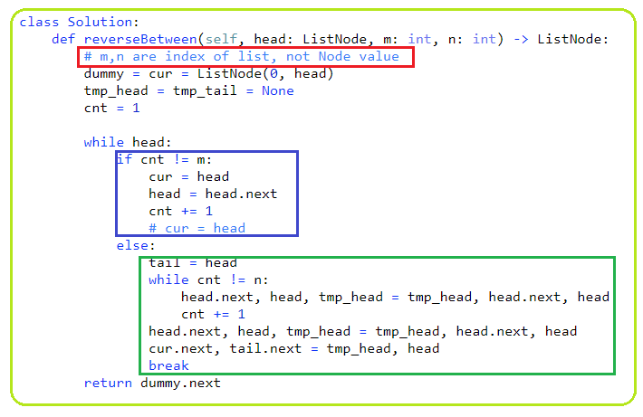

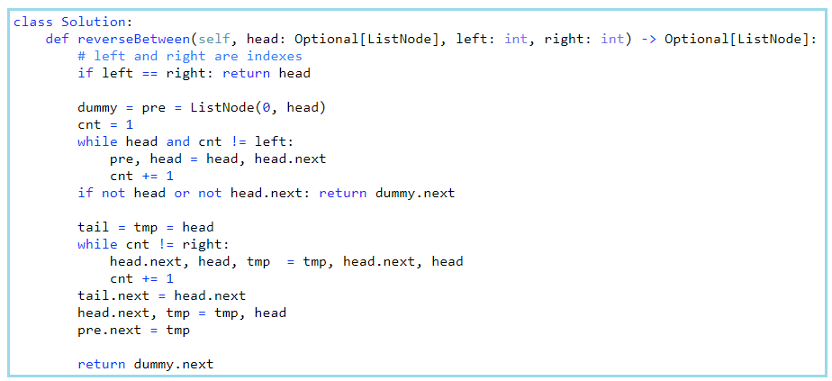

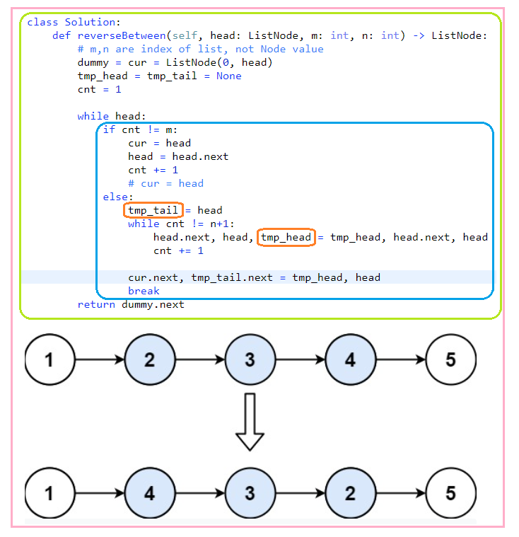

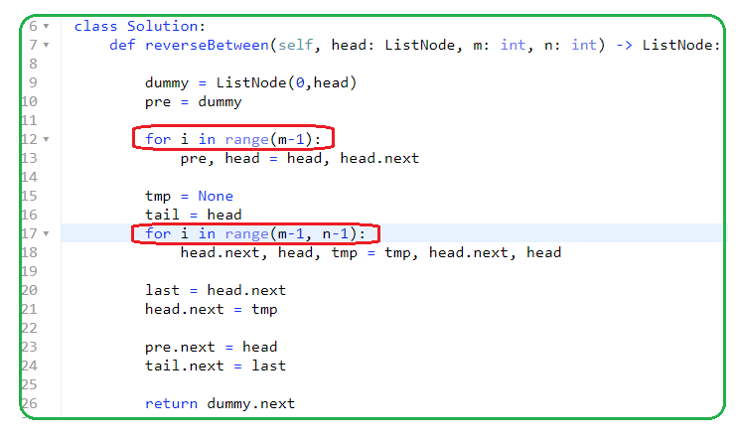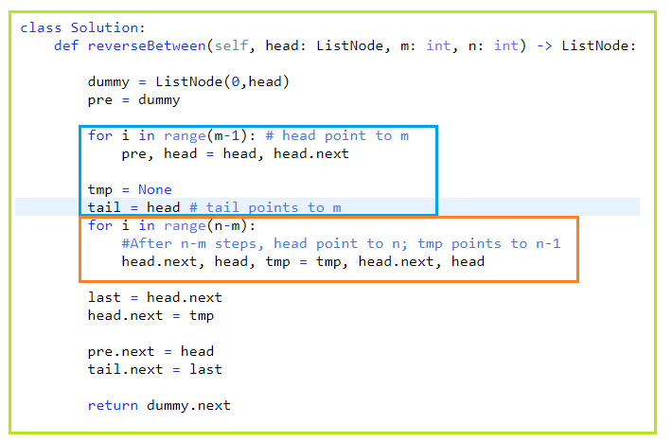

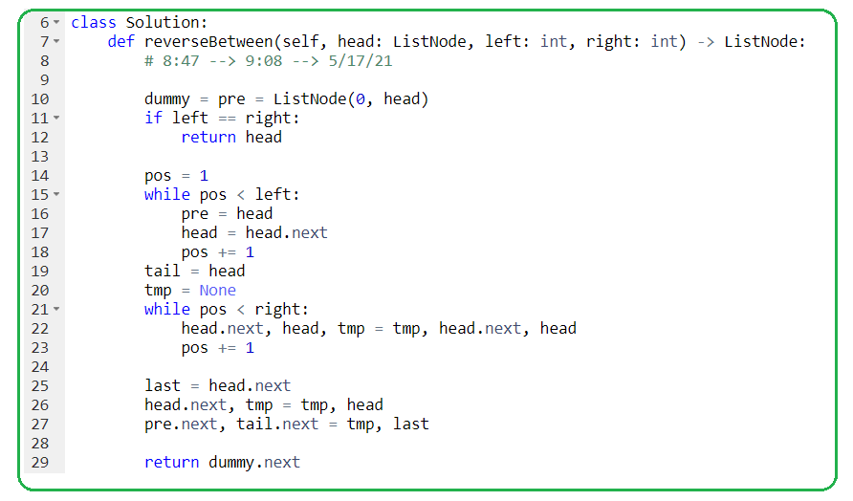

1. **1171. Remove Zero Sum Consecutive Nodes from Linked List**

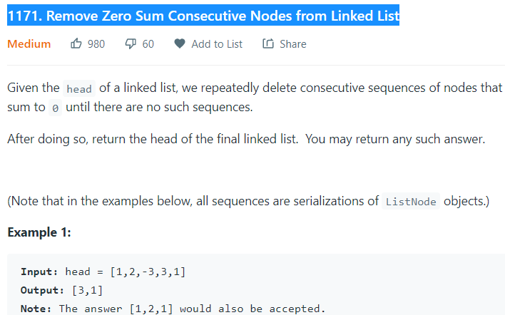

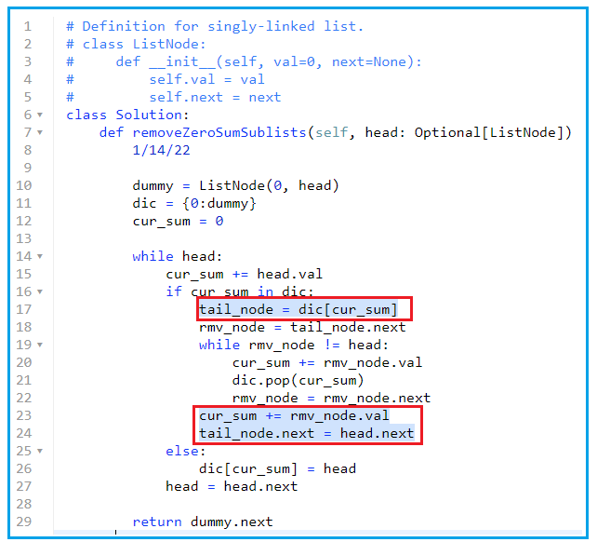

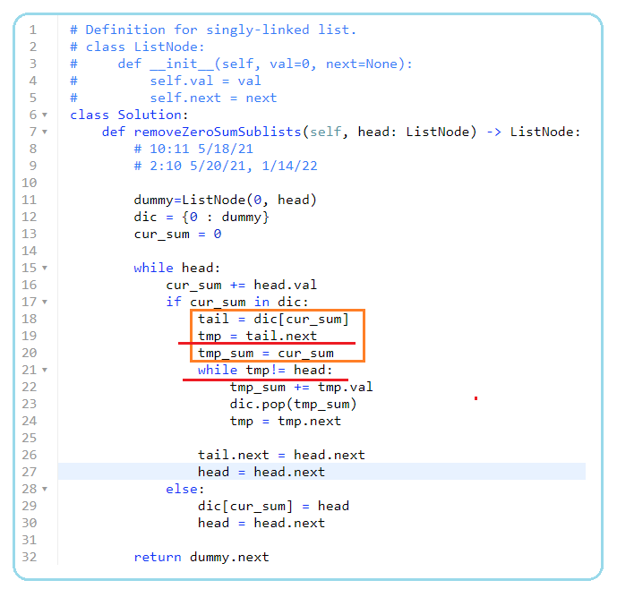

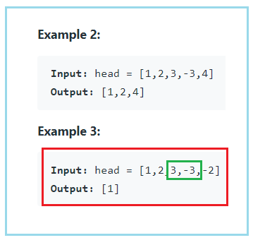

1. **143. Reorder List**

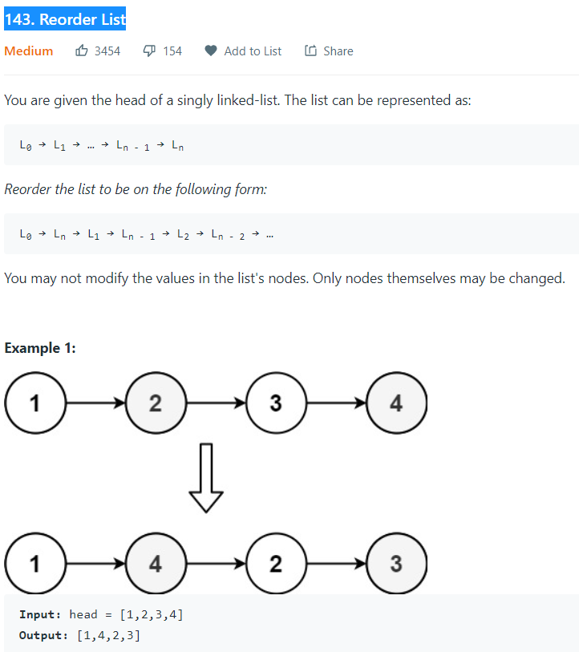

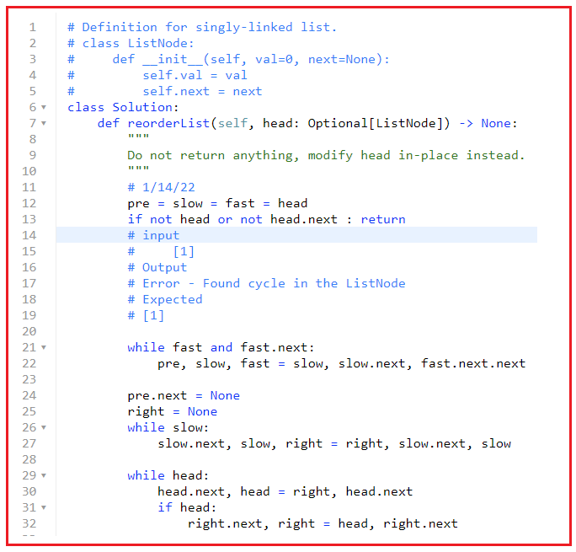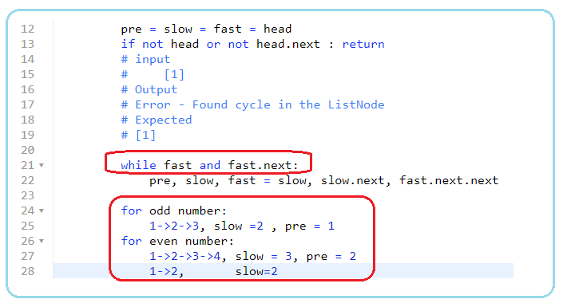

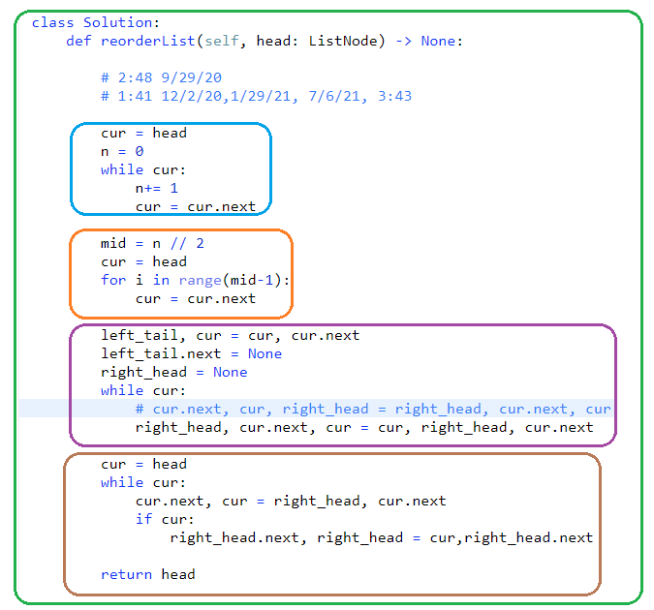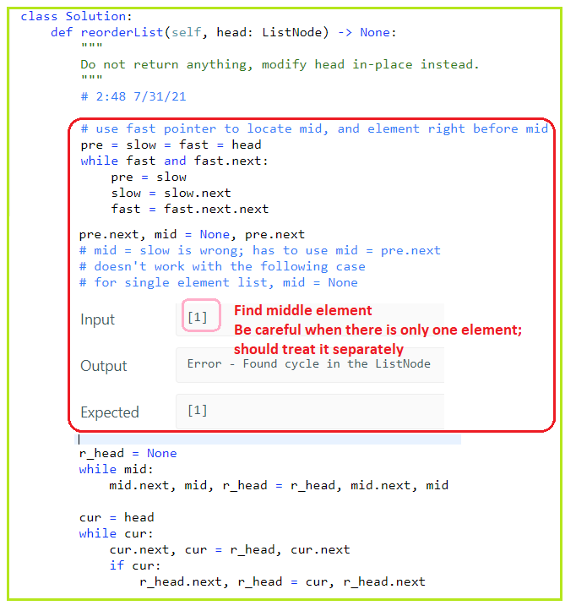-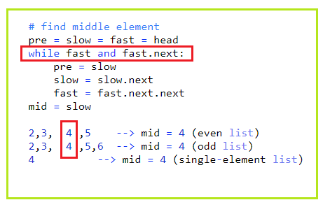

1. **445. Add Two Numbers II**

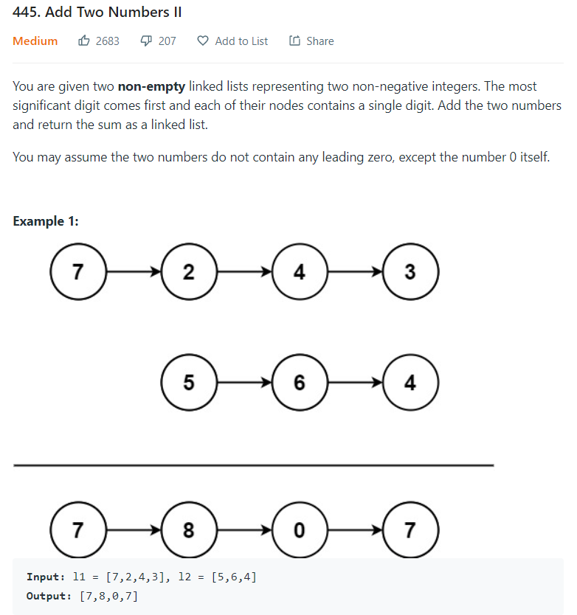

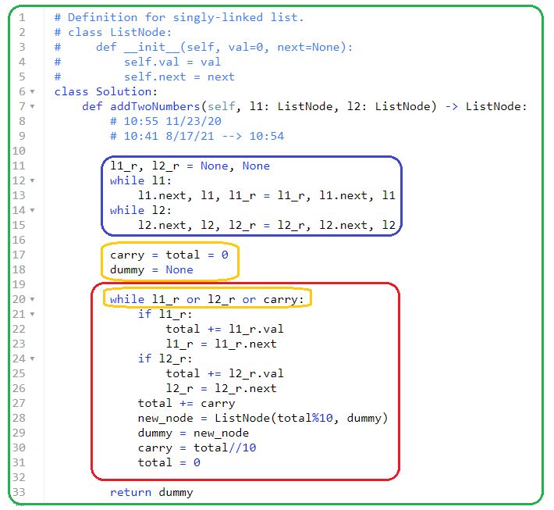

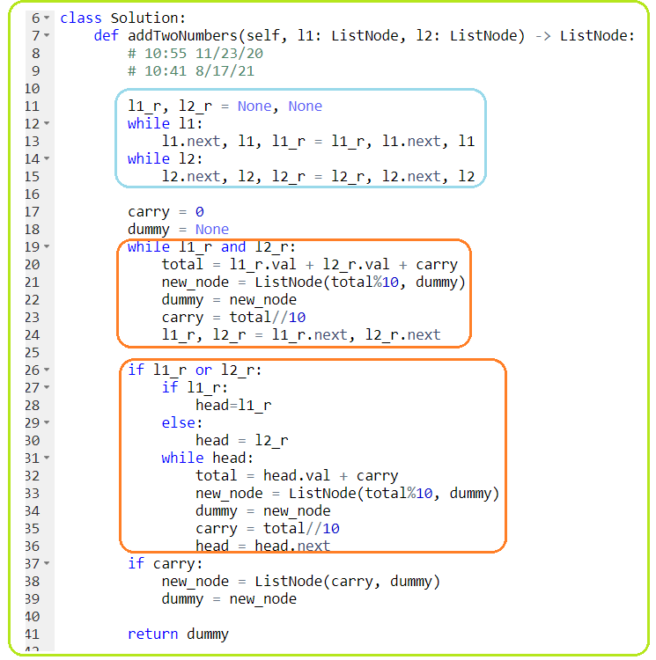

1. **Priority Q \*\*\*\*\***

**Heapq, heapq.heappush, heapq.heappop(),nsmallest, nlargest**

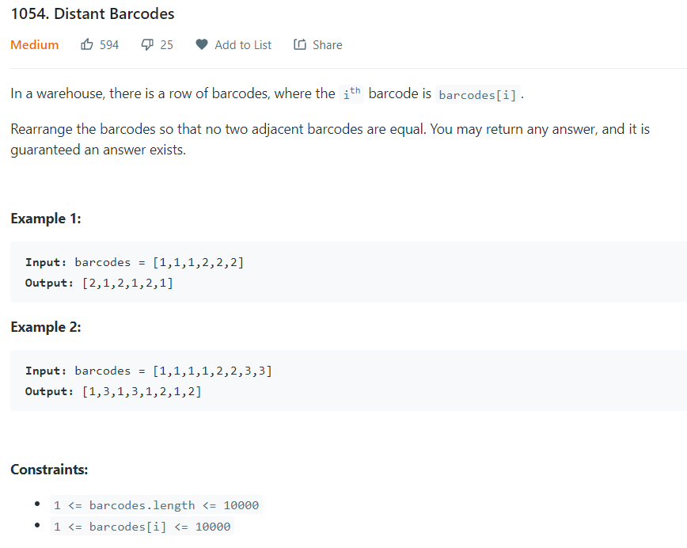

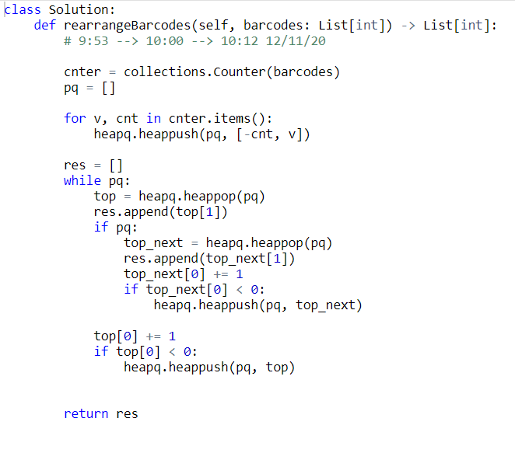

Element of heapq can be a tuple or list and **sorted based on first_element, then 2nd element and so on**.

Heapq is min priority queue, by default, the smallest is on the top of the queue

Heapq.heappush**(-cnt**) to sort decreasingly and is **max** queue. The logic is

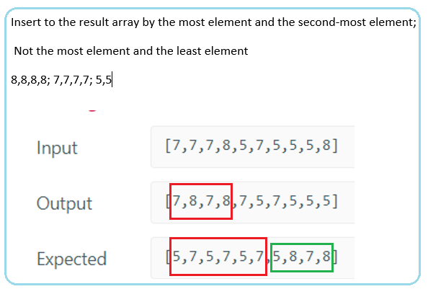

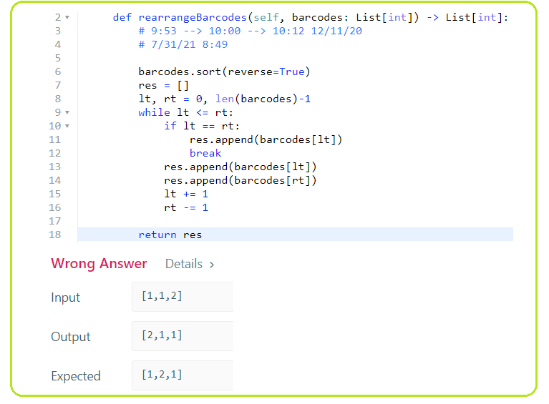

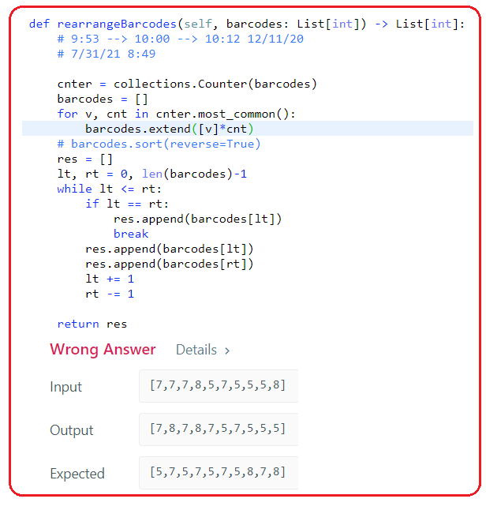

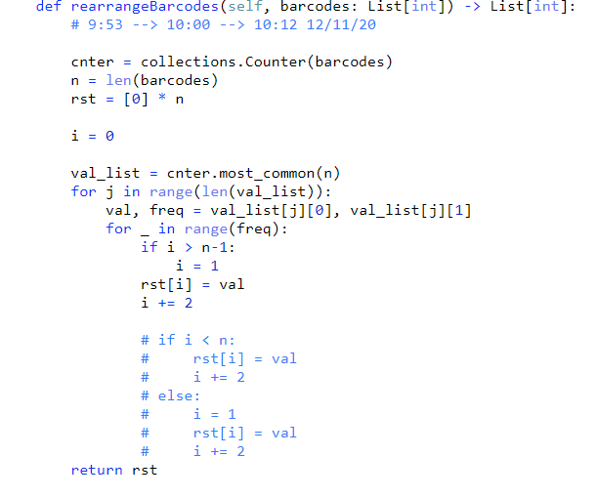

1. **Linear scanning with dict() \*\*\*\*\***
2. **299. Bulls and Cows**

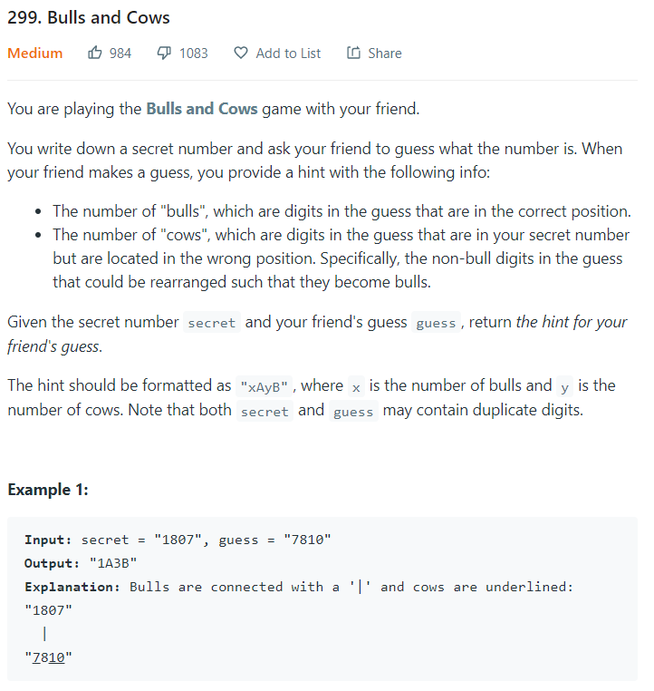

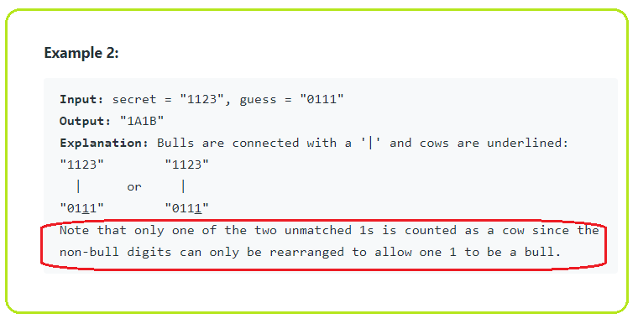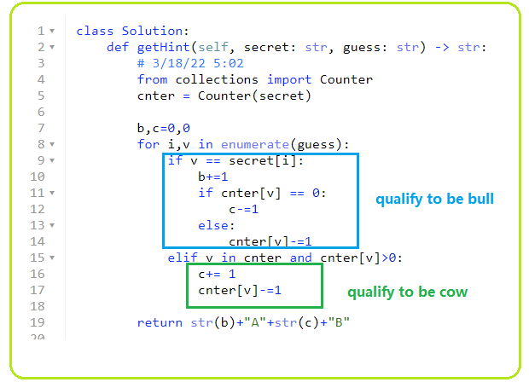

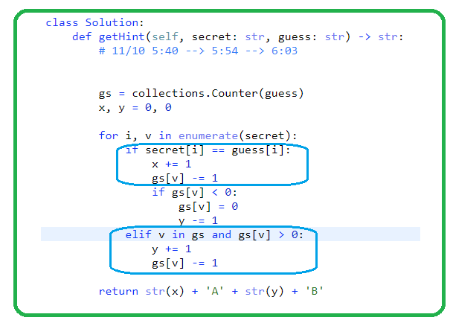

1. **1124. Longest Well-Performing Interval**

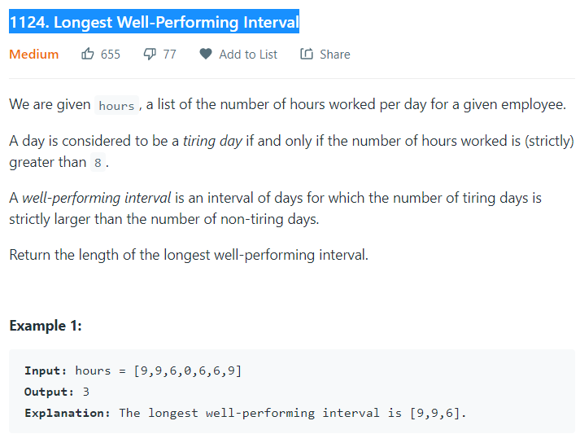

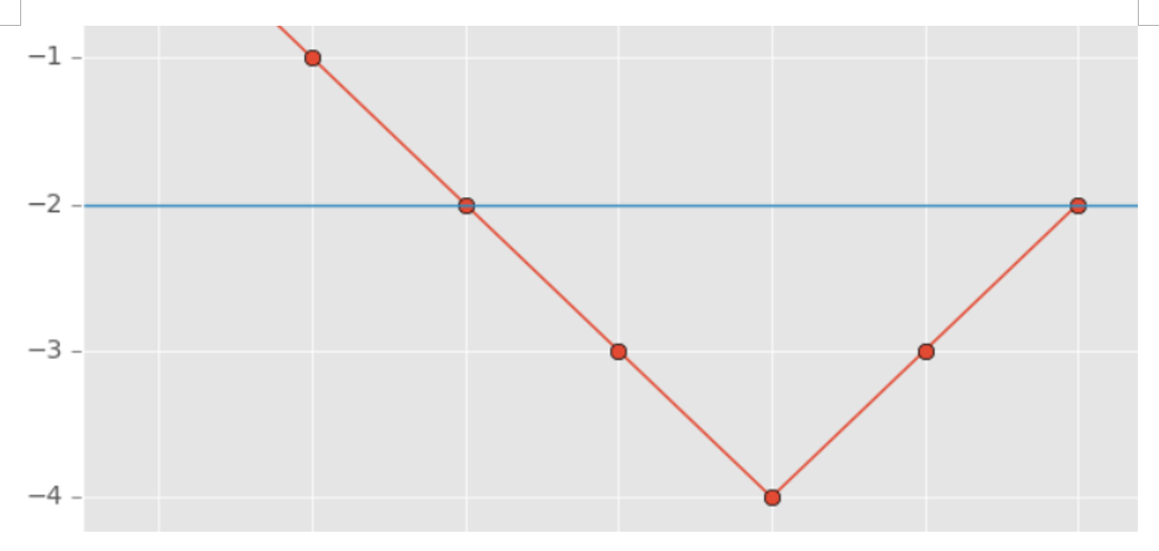

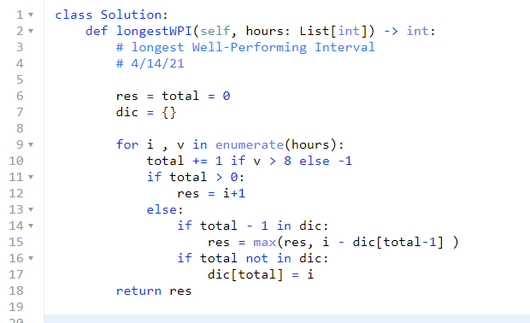

1. **1169. Invalid Transactions**

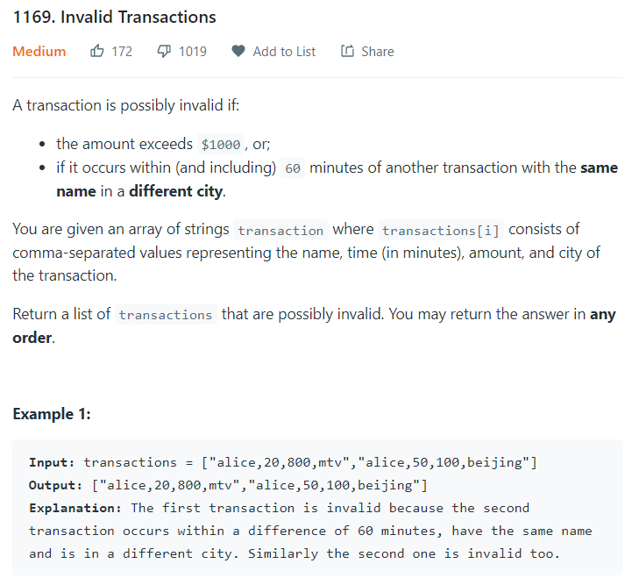

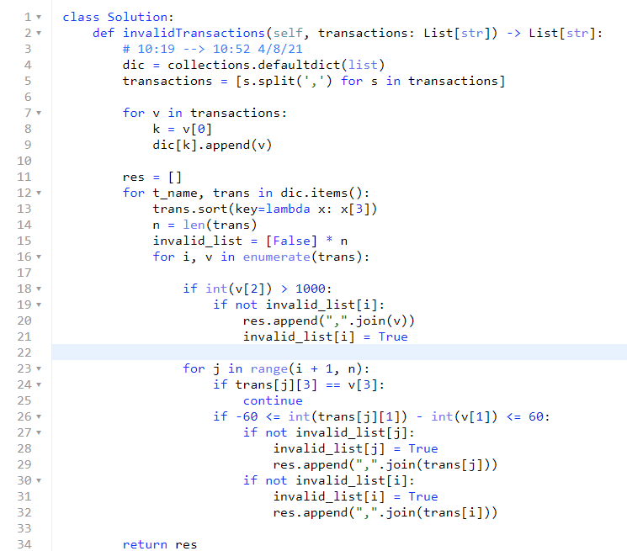

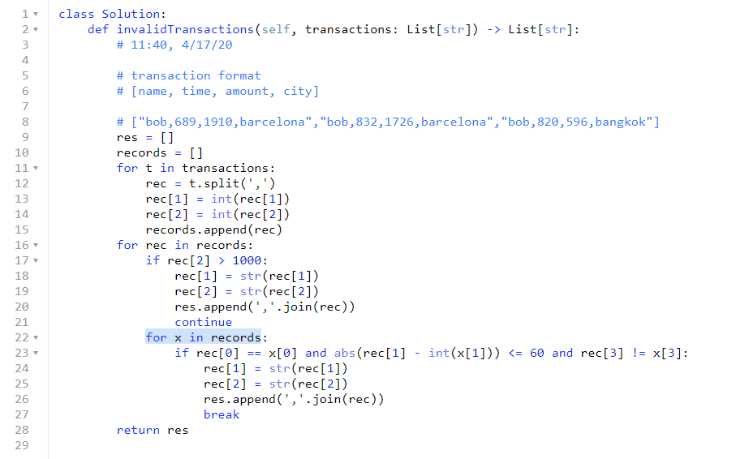

1. **954. Array of Doubled Pairs**

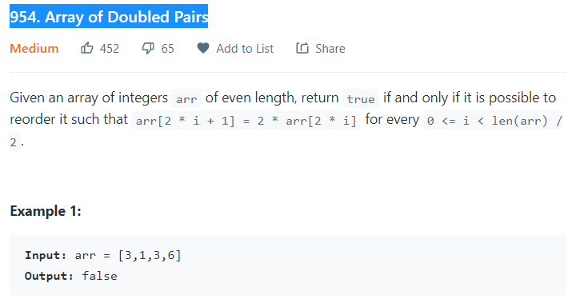

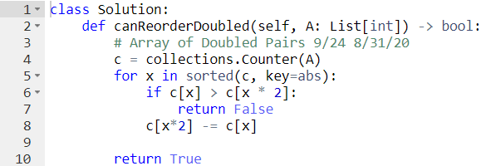

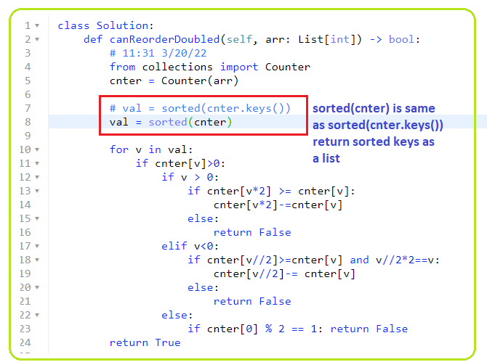

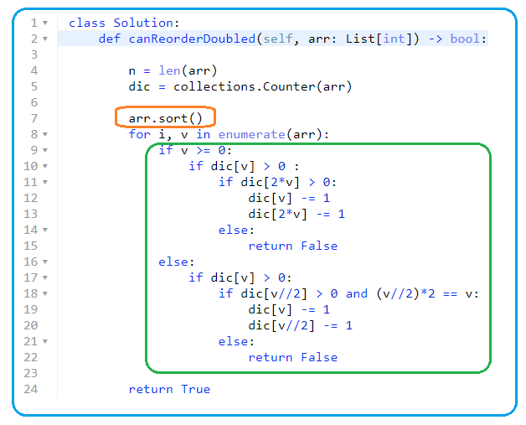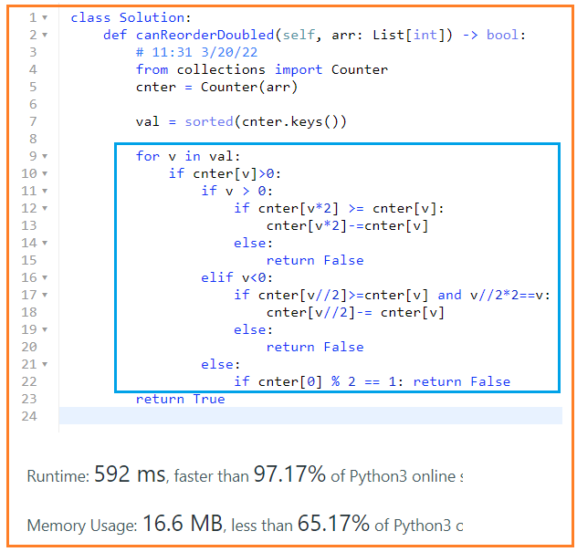

1. **1386. Cinema Seat Allocation**

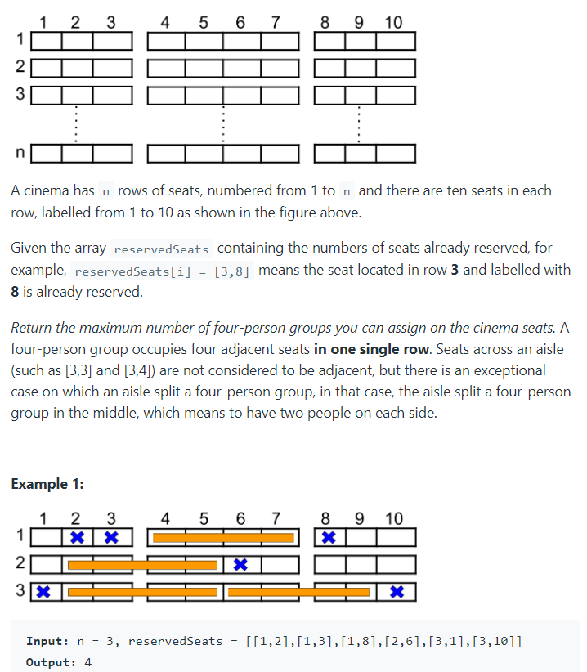

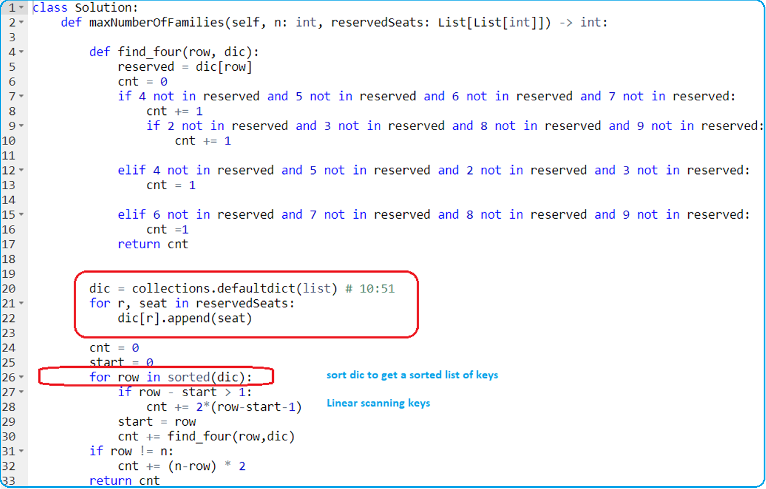

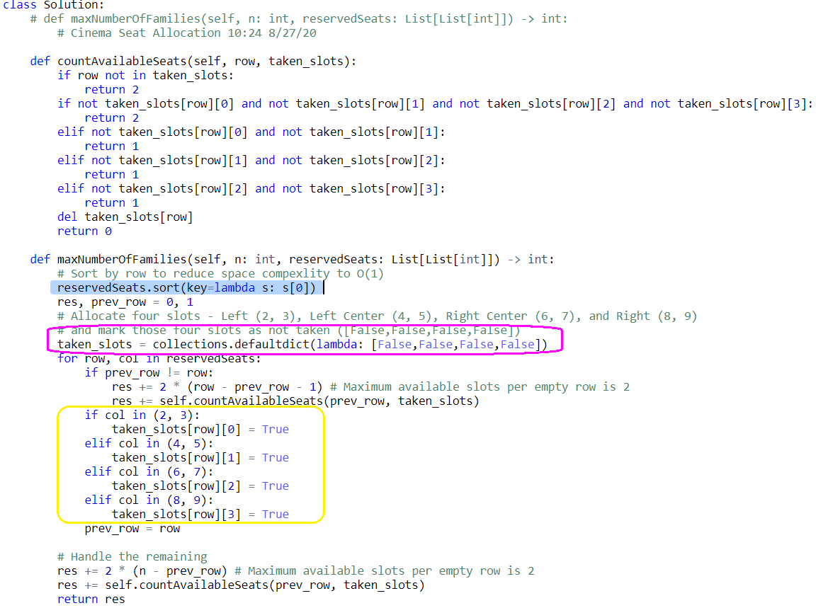

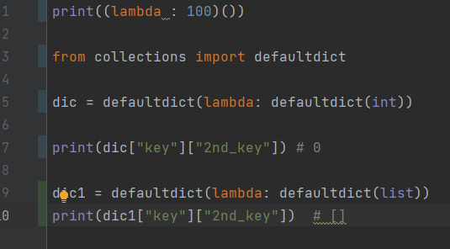

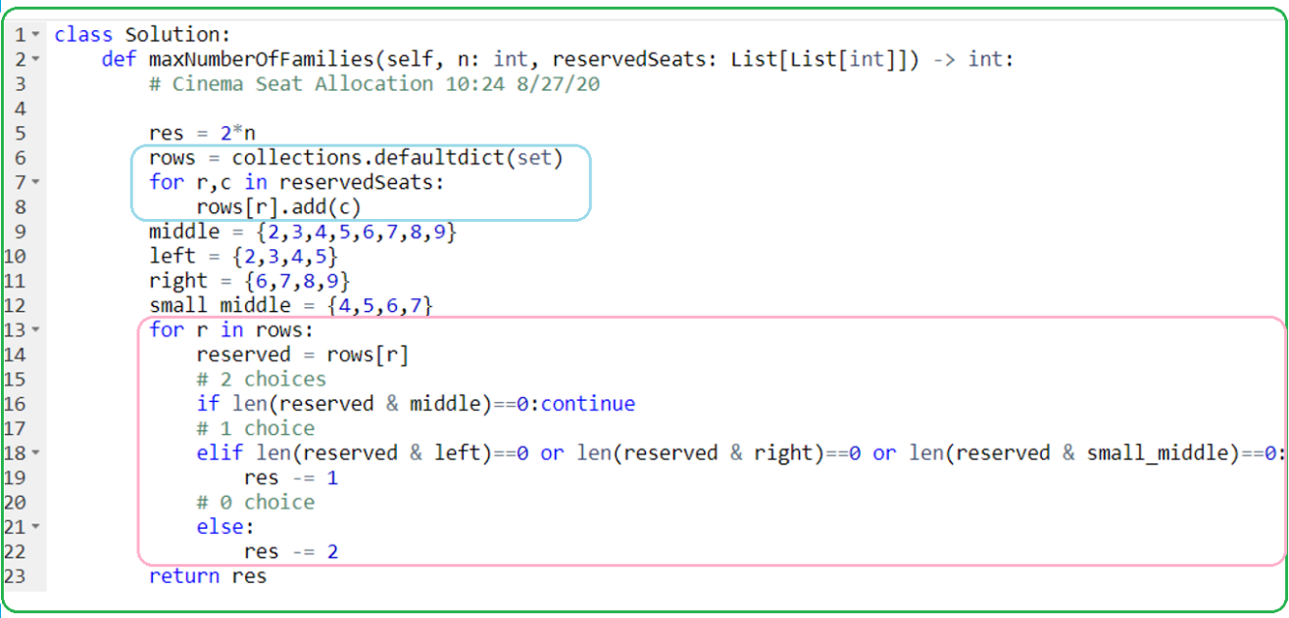

1. **1124. Longest Well-Performing Interval**

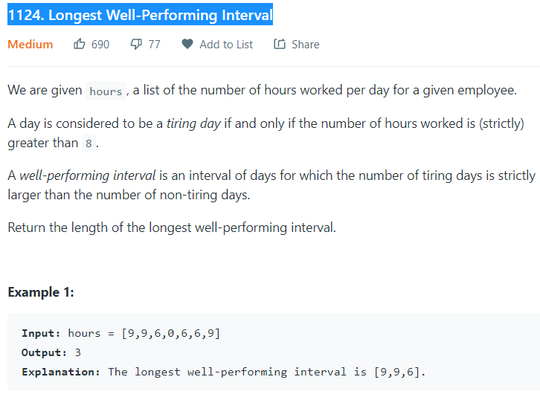

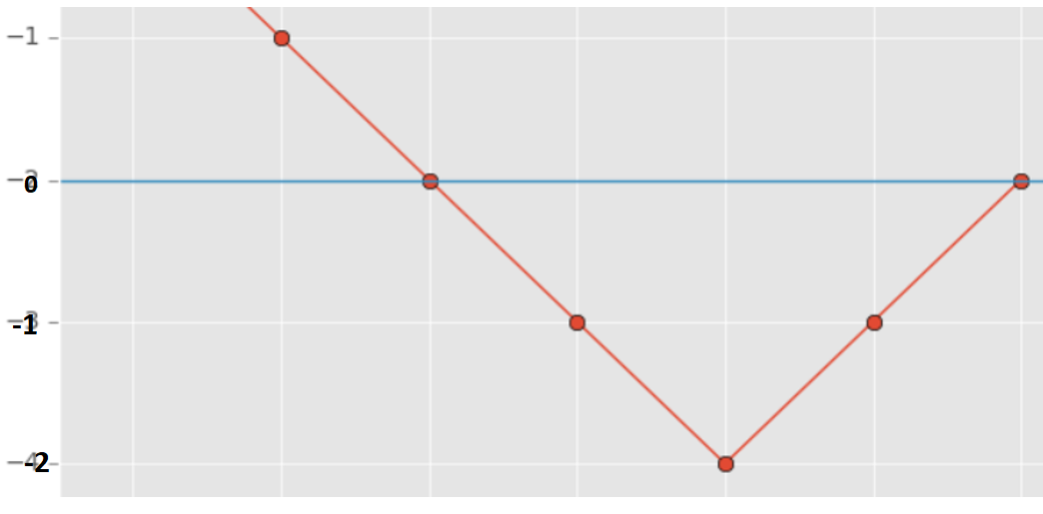

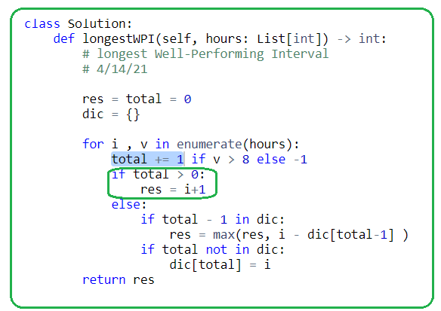

1. **Stack-mono \*\*\*\*\***

**Logic is very hard to come by.**

1. **880. Decoded String at Index**
2. **907. Sum of Subarray Minimums**

**394. Decode String**

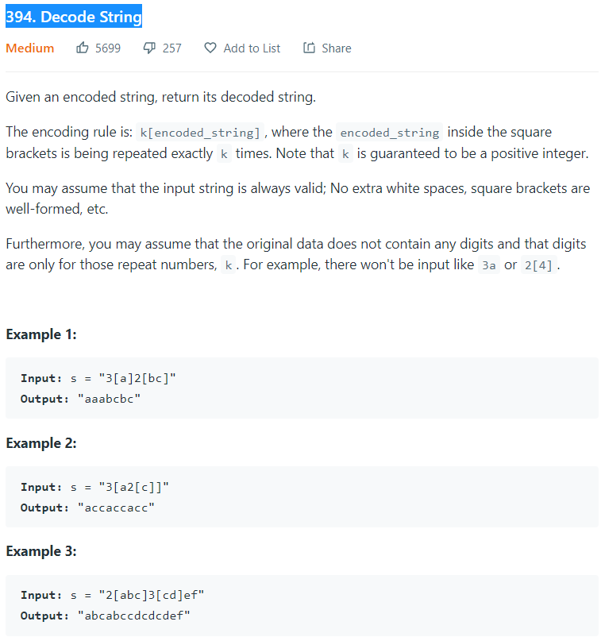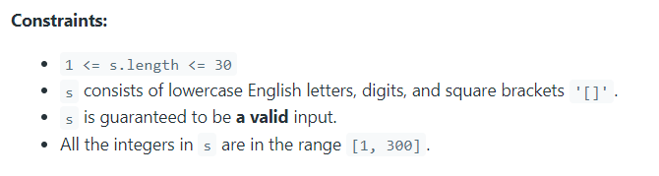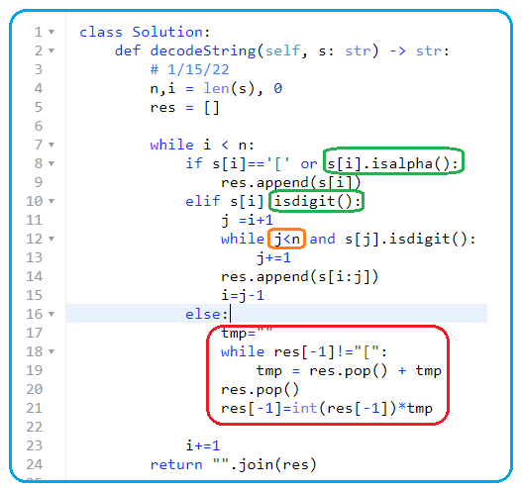

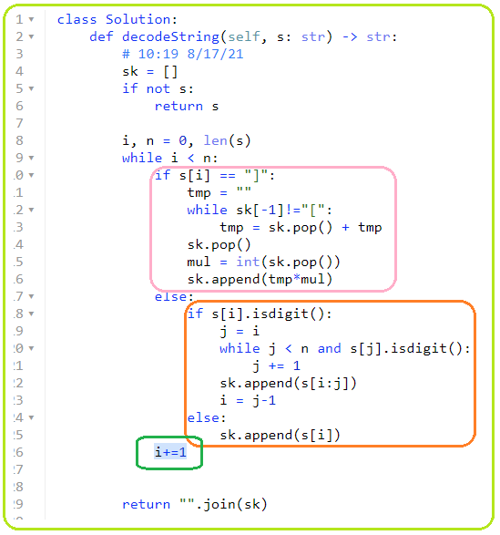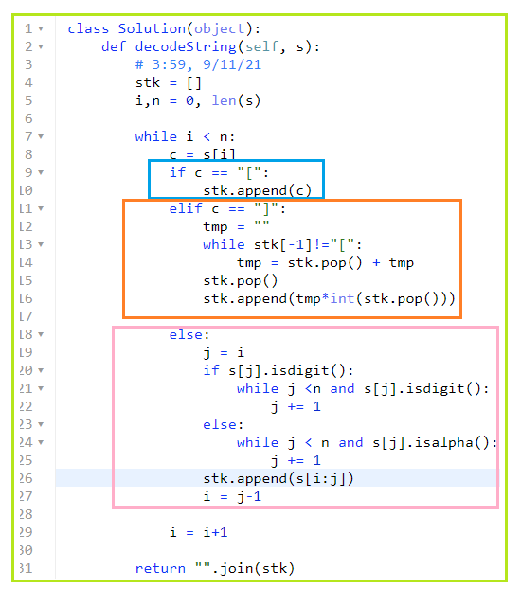

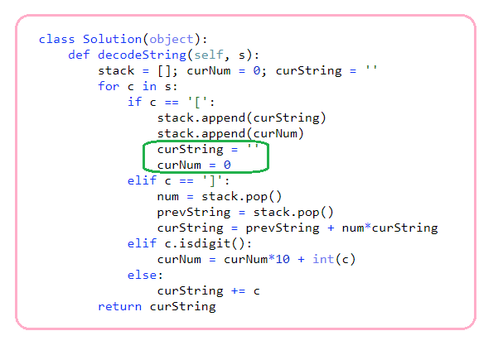

1. **456. 132 Pattern**

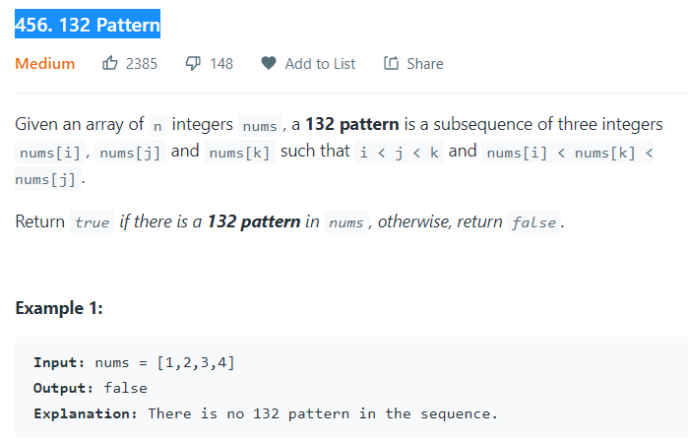

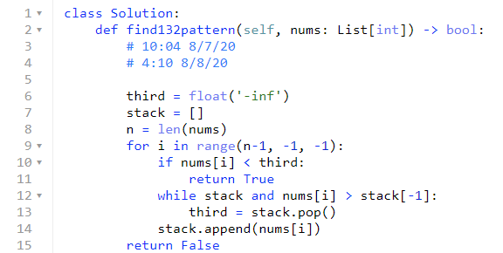

1. **845. Longest Mountain in Array**

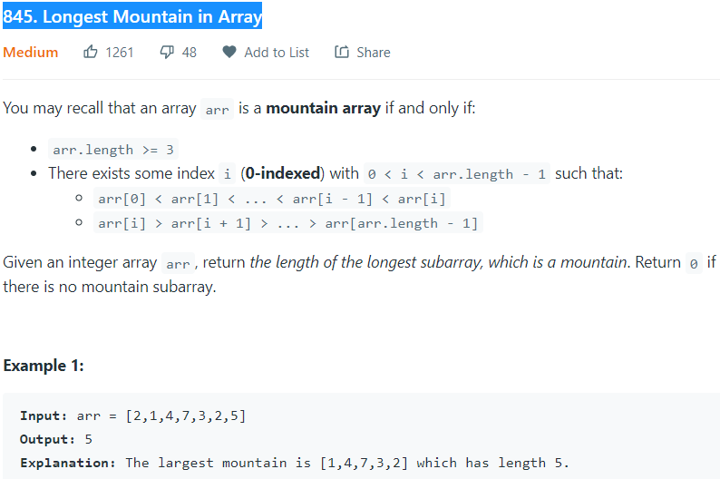

* **Using a stack**

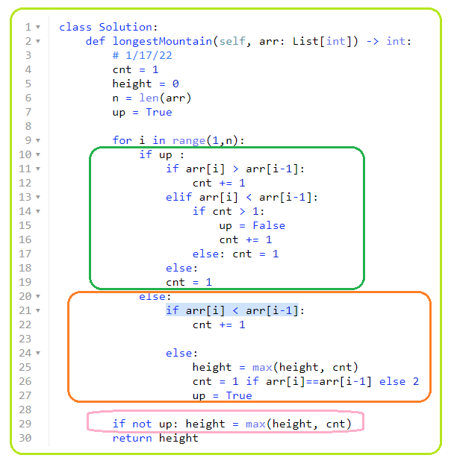**2**

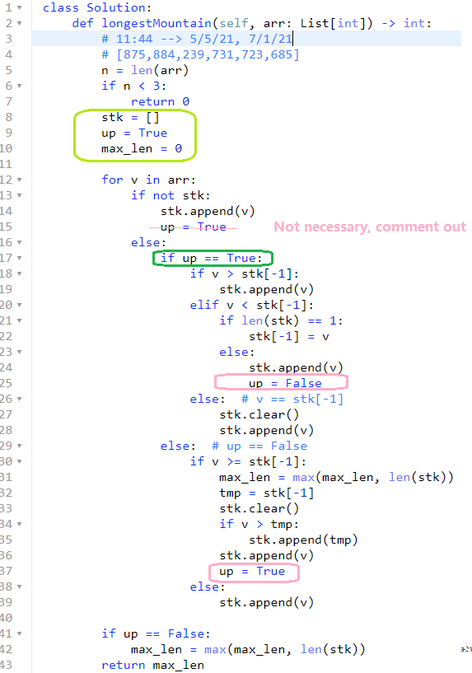

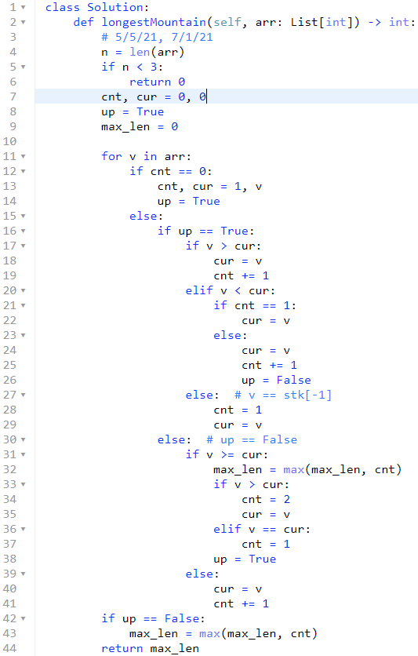

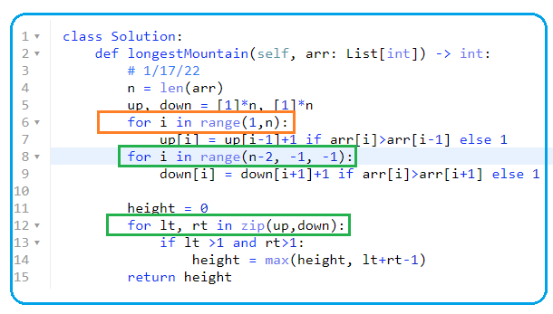

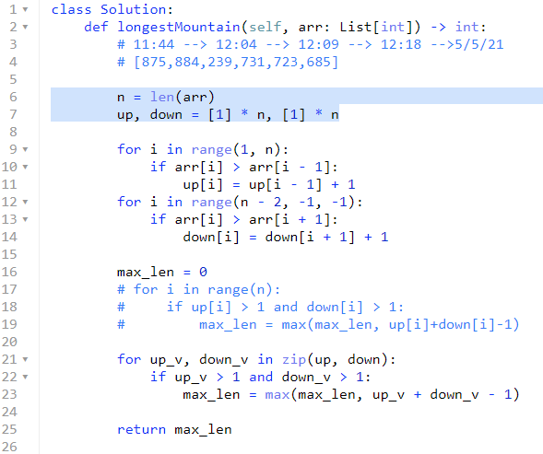

1. **316. Remove Duplicate Letters**

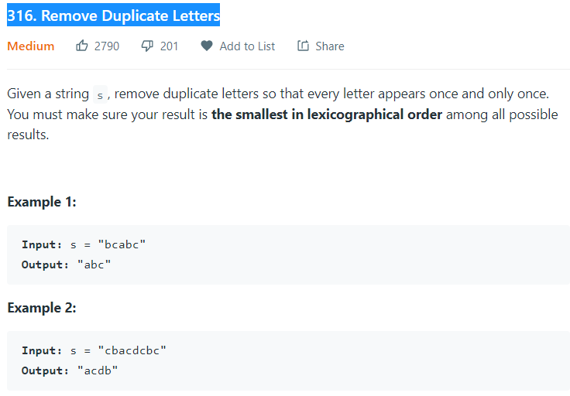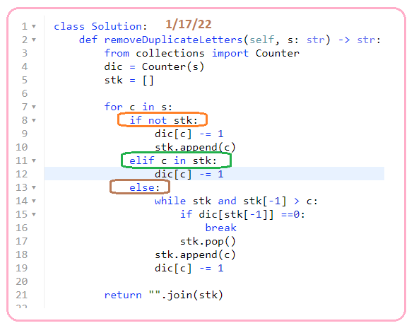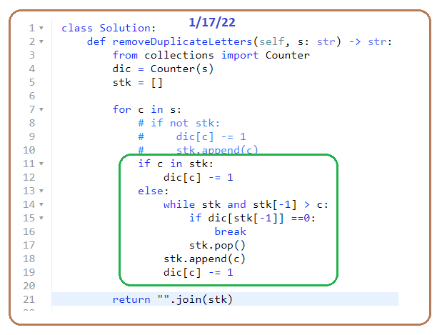

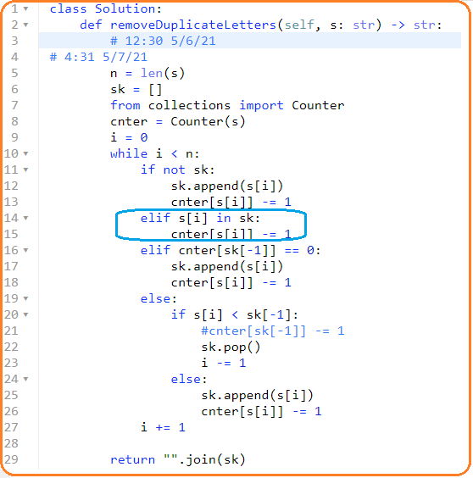

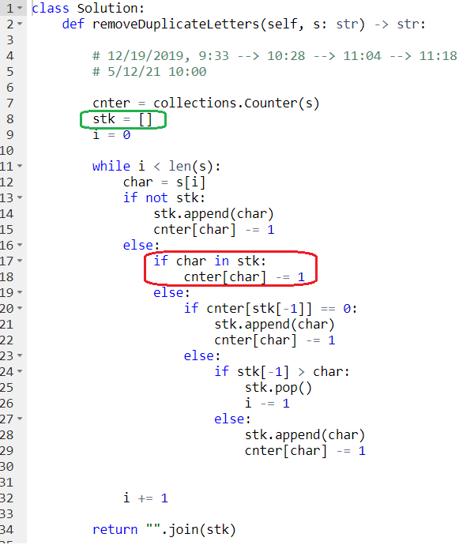

1. **402. Remove K Digits**

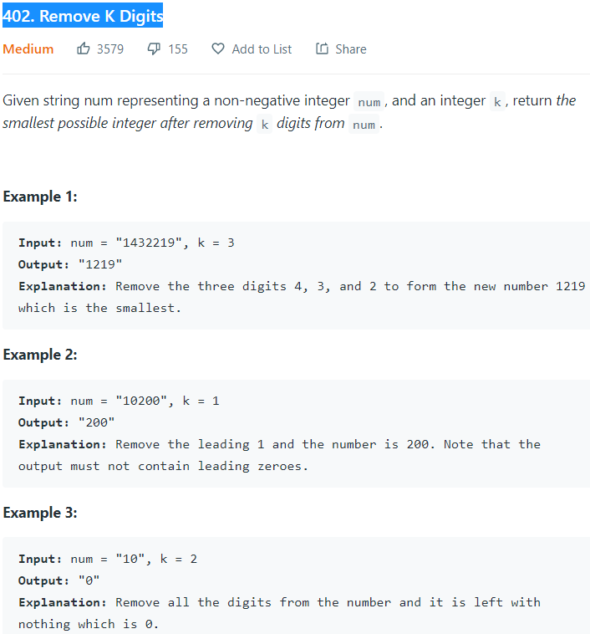

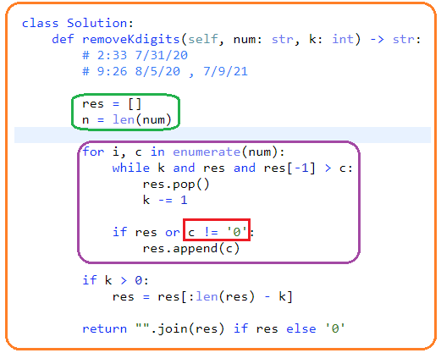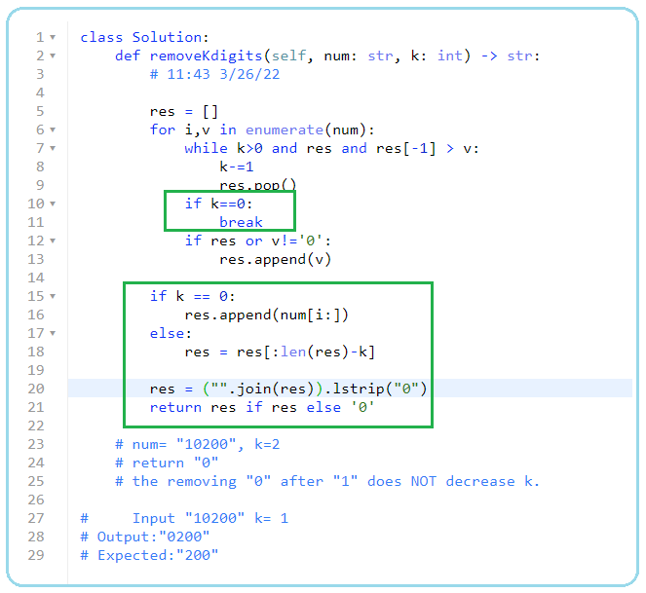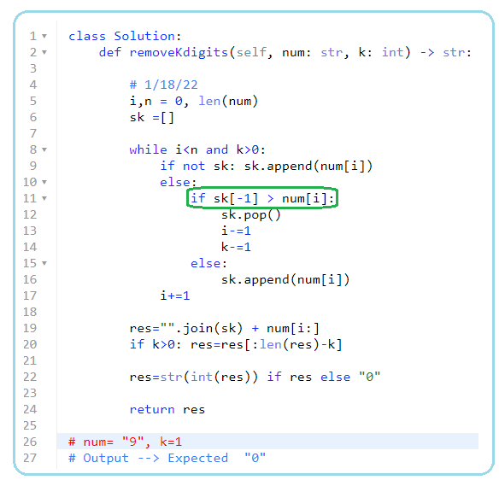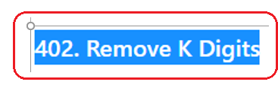

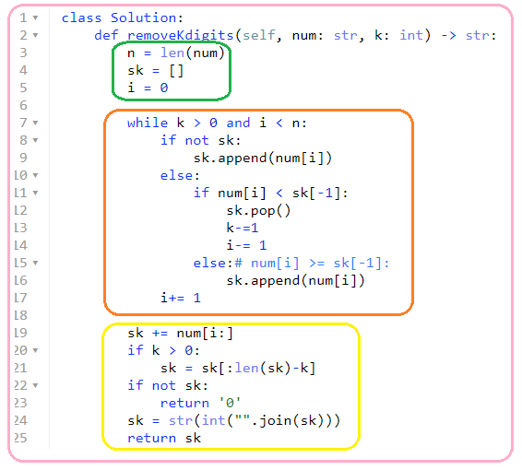

1. **581. Shortest Unsorted Continuous Subarray**

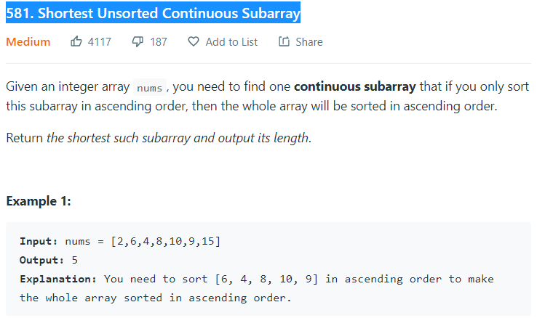

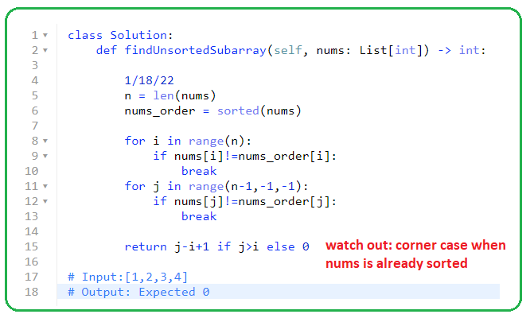

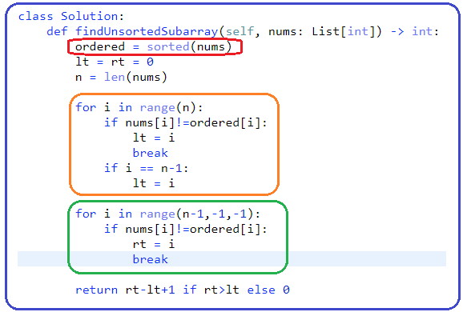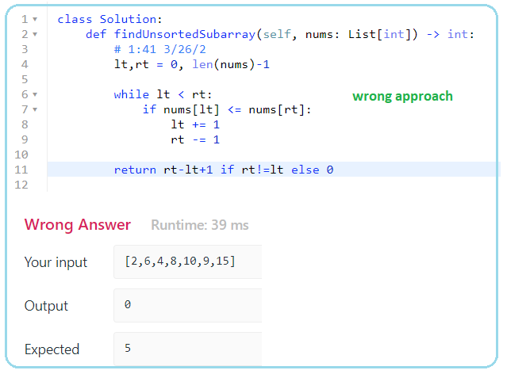

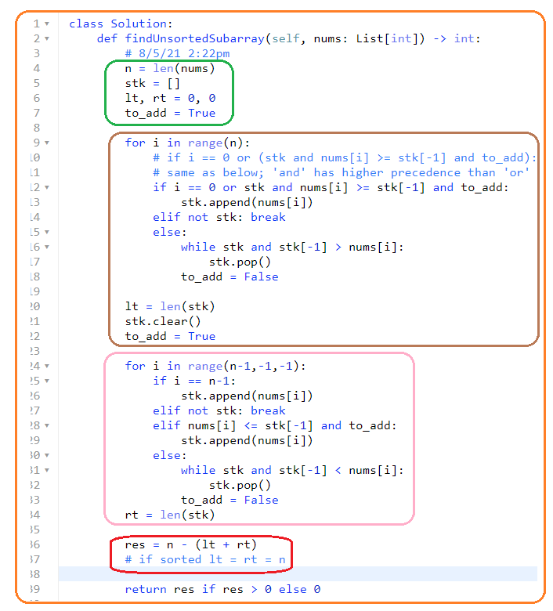

1. **1856. Maximum Subarray Min-Product**

**1/18/22 No Clues**

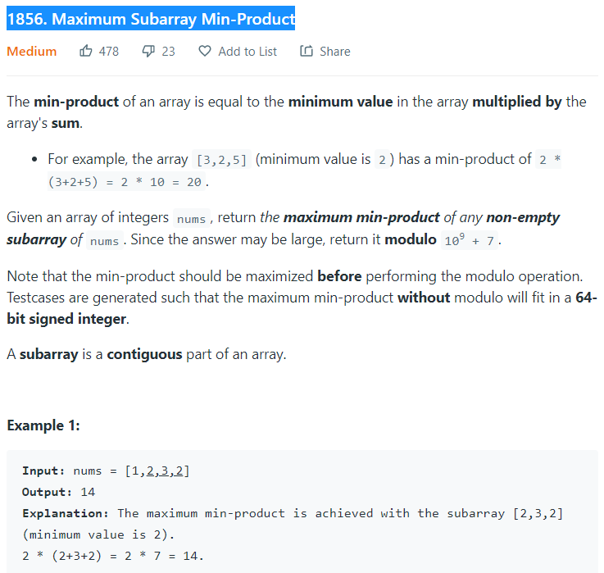

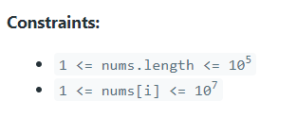

3/31/22

**Use stack to handle bound!**

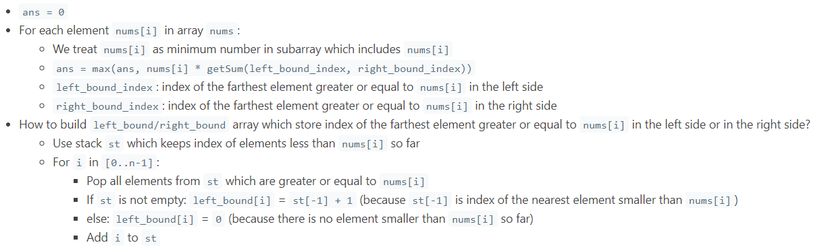 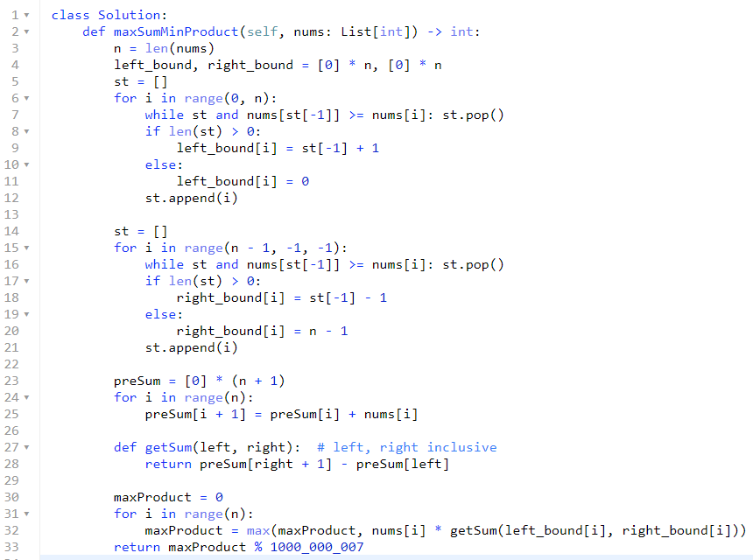

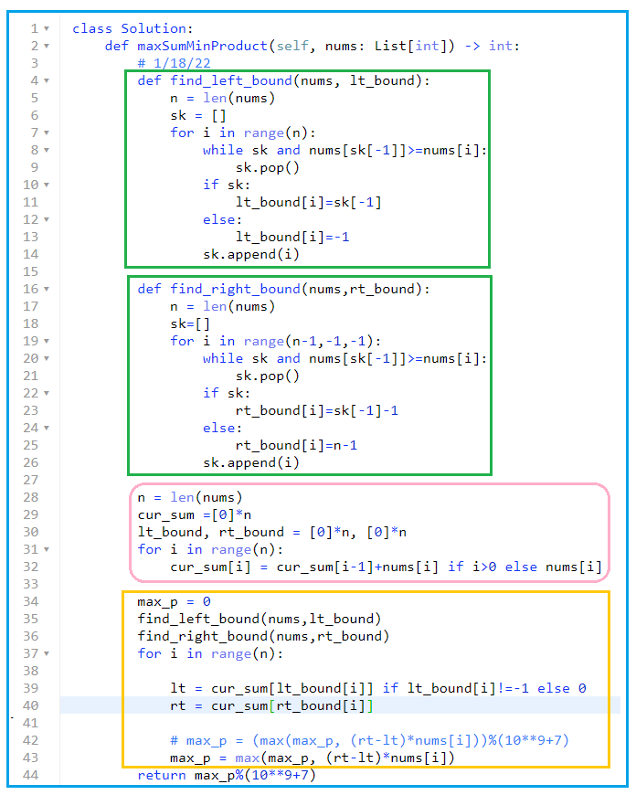

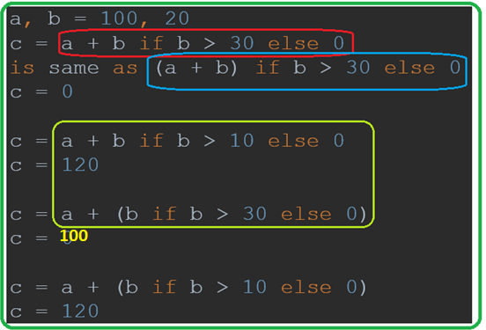

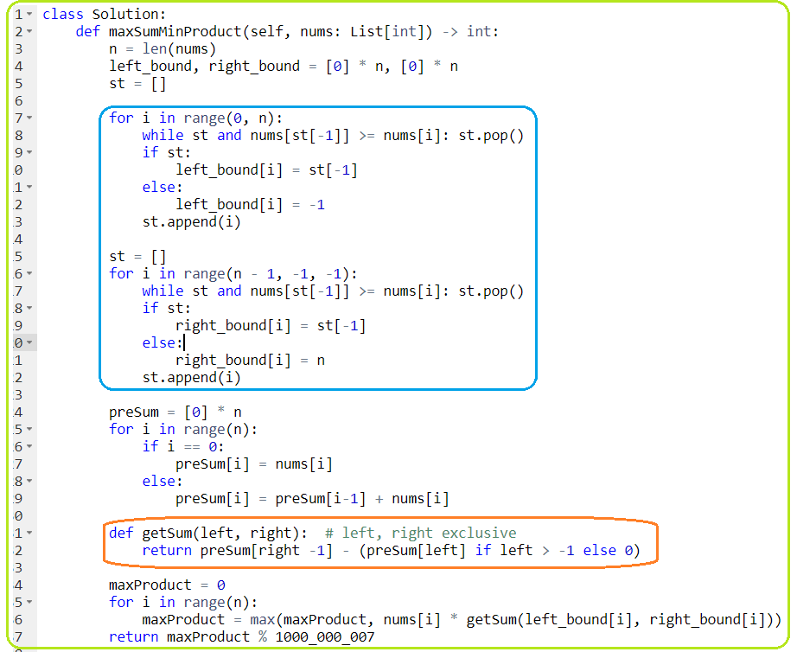

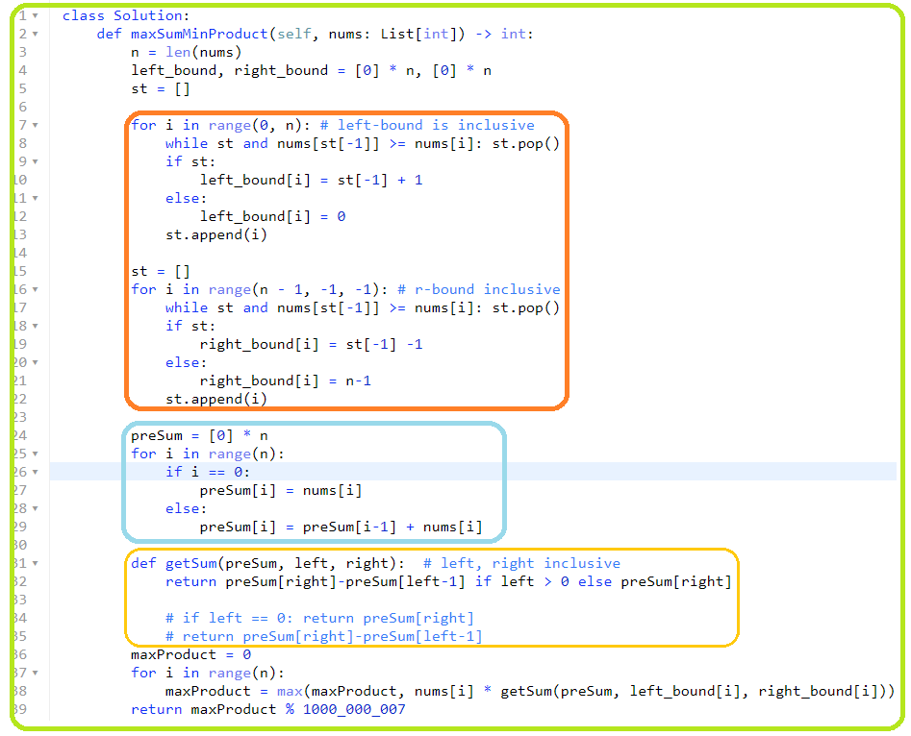

1. **1574. Shortest Subarray to be Removed to Make Array Sorted**

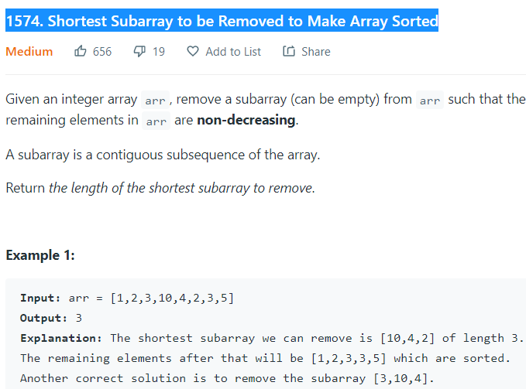

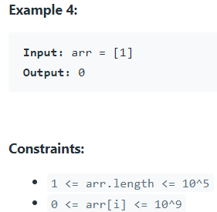

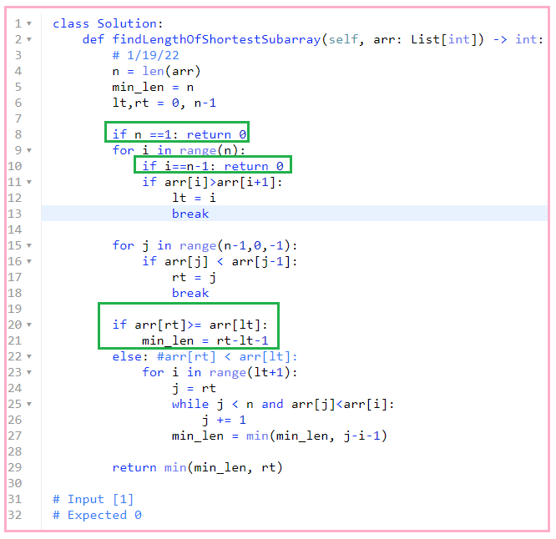

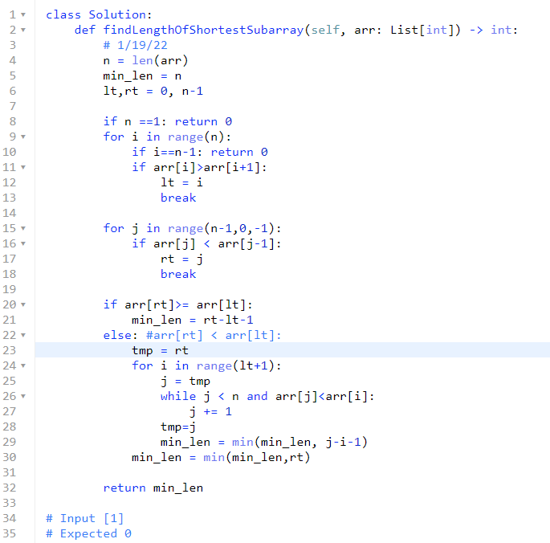

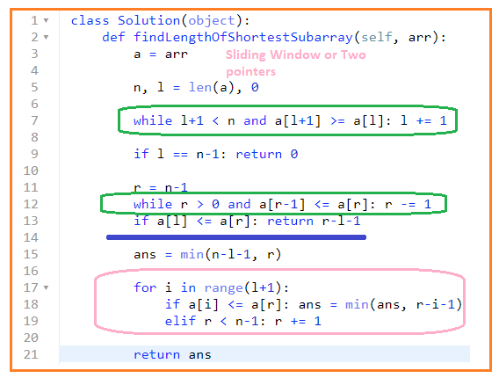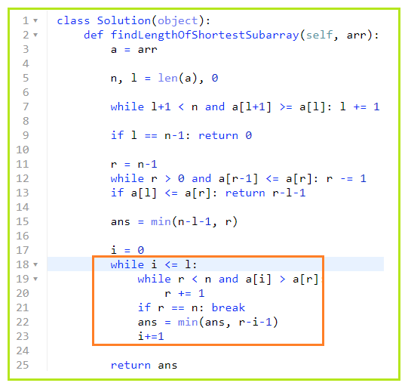

1. **71. Simplify Path**

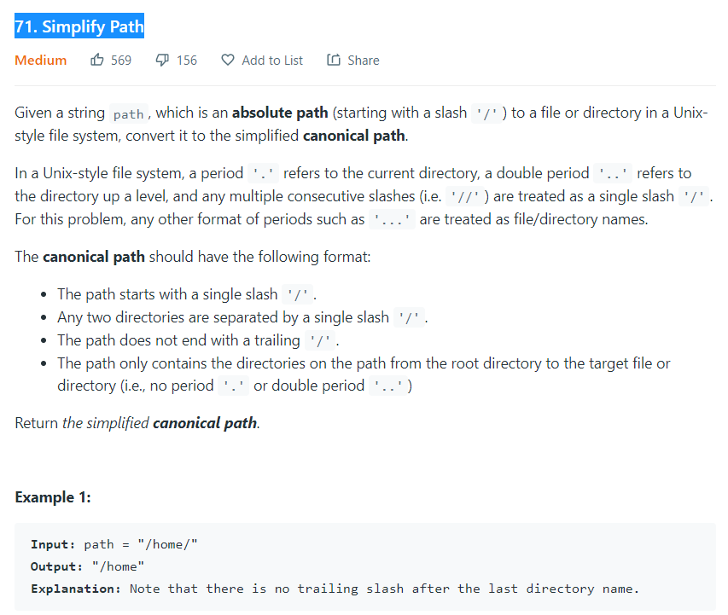

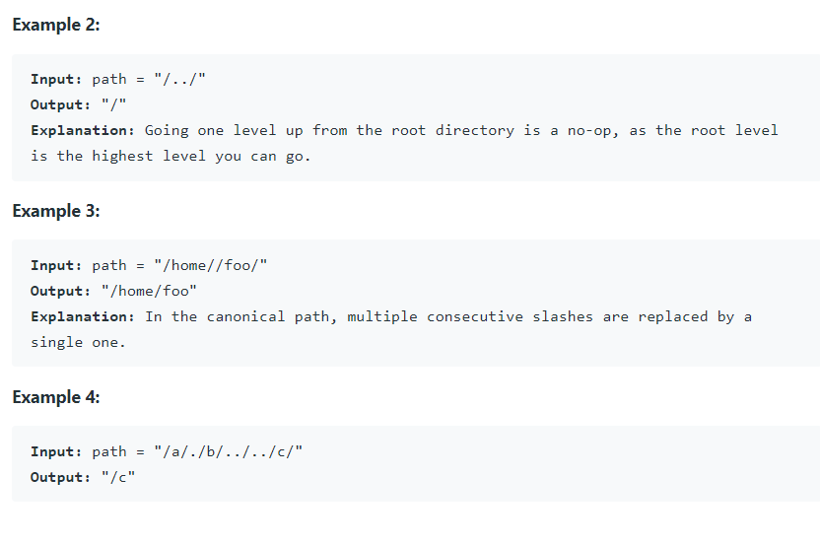

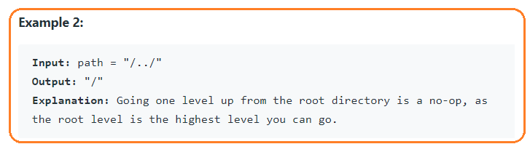

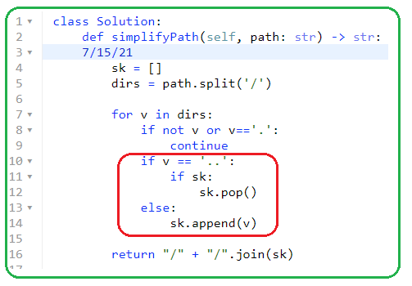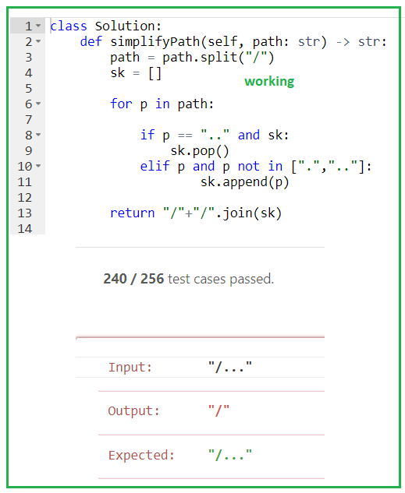

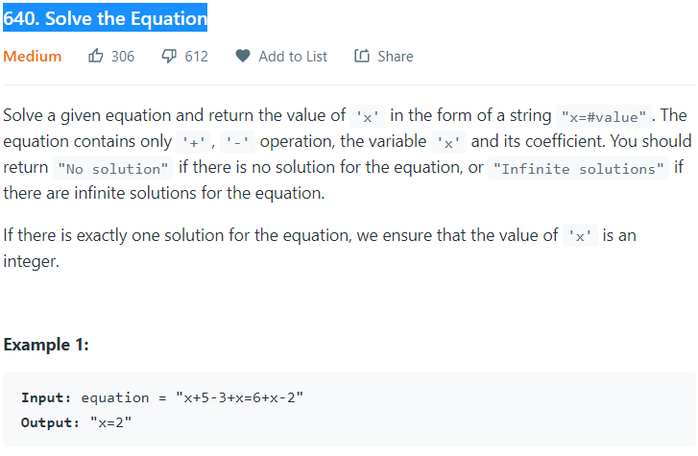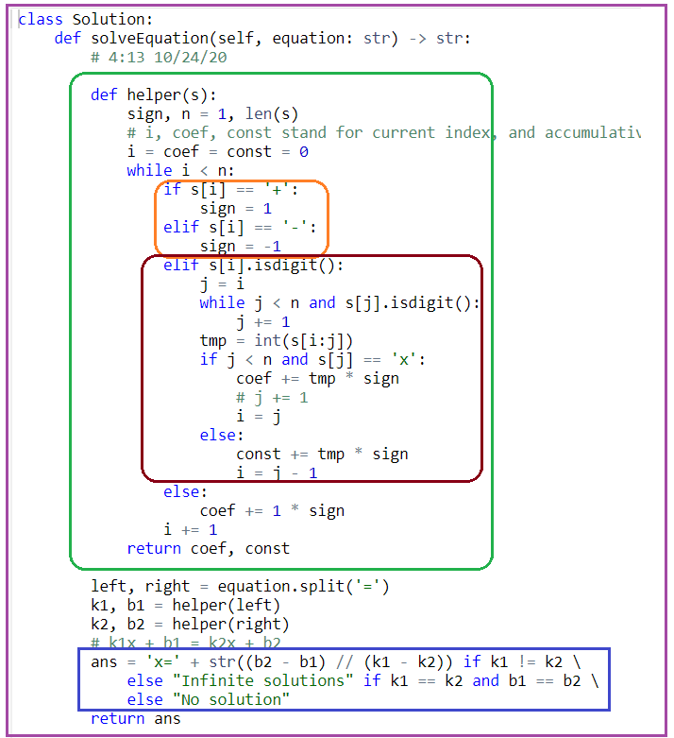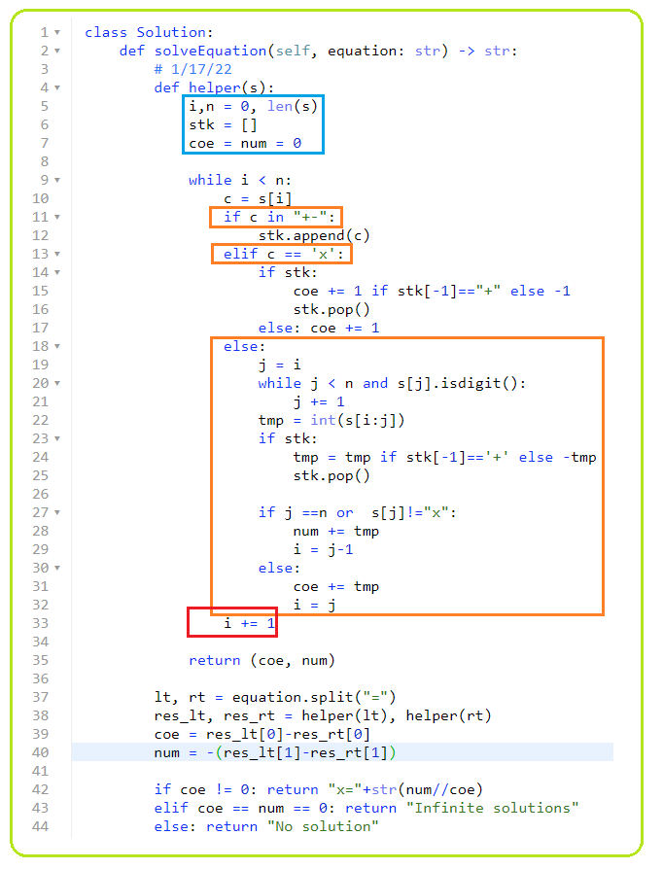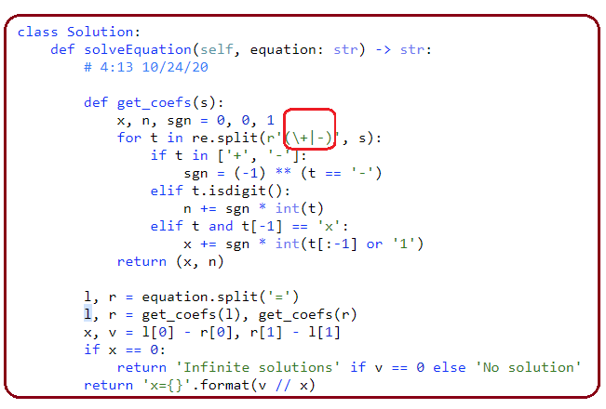

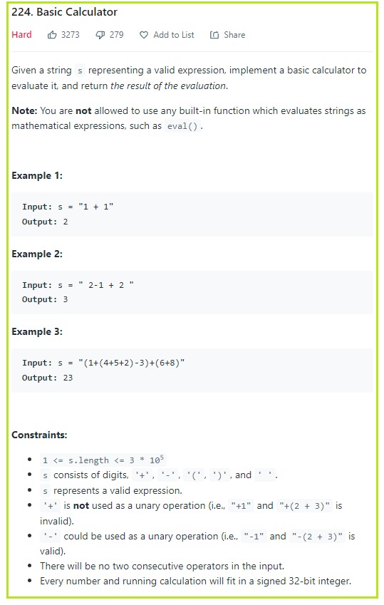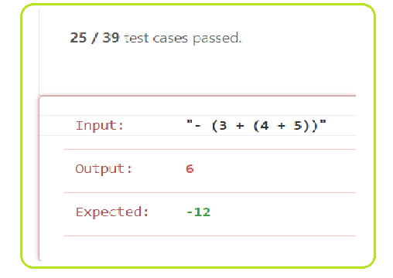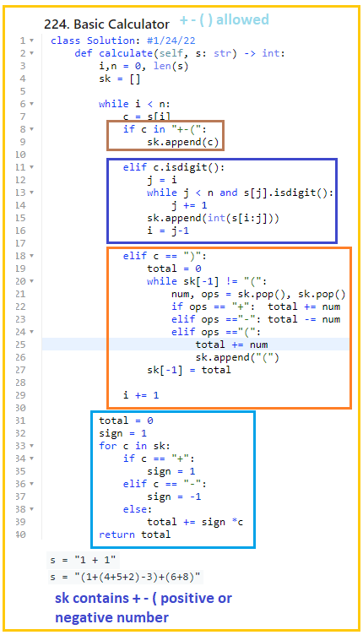

1. **227. Basic Calculator II**

4/5/22

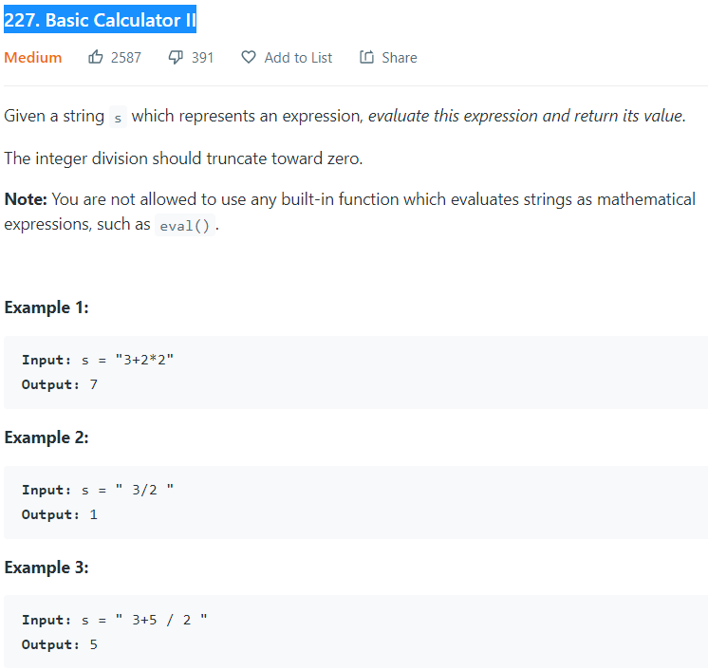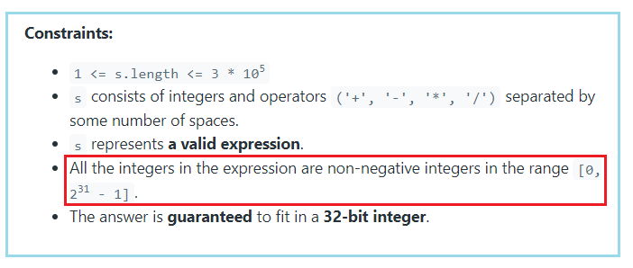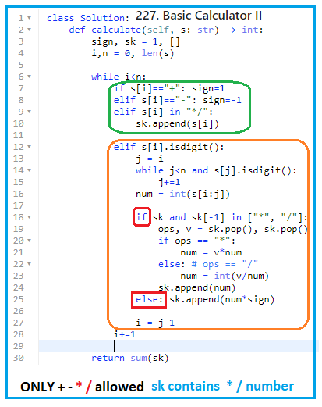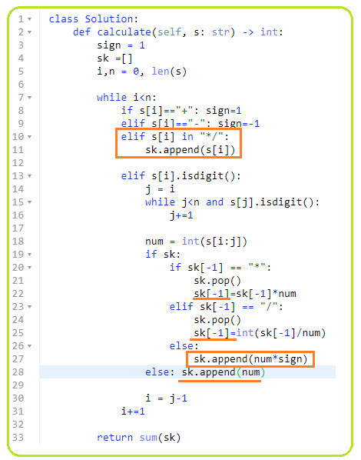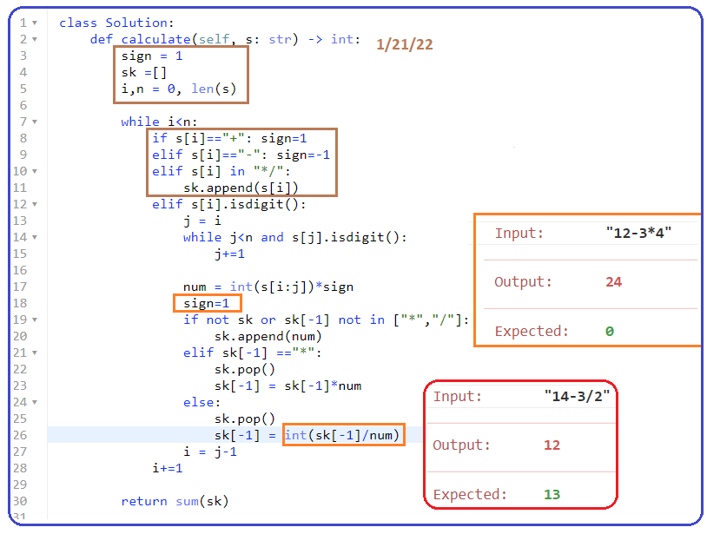

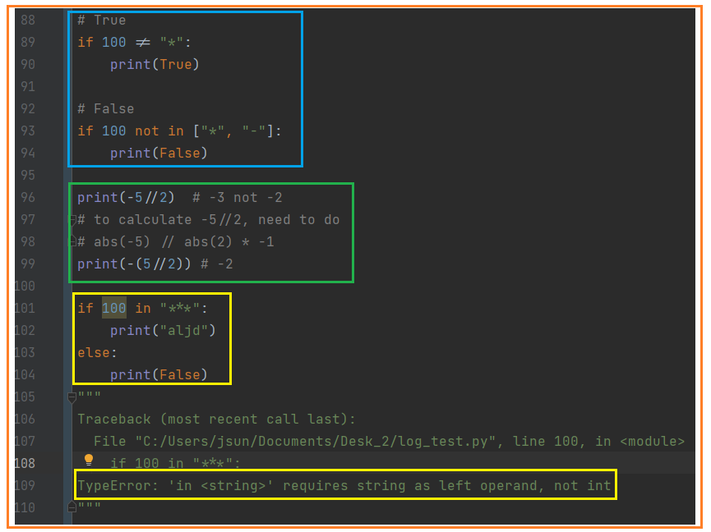

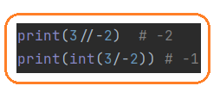

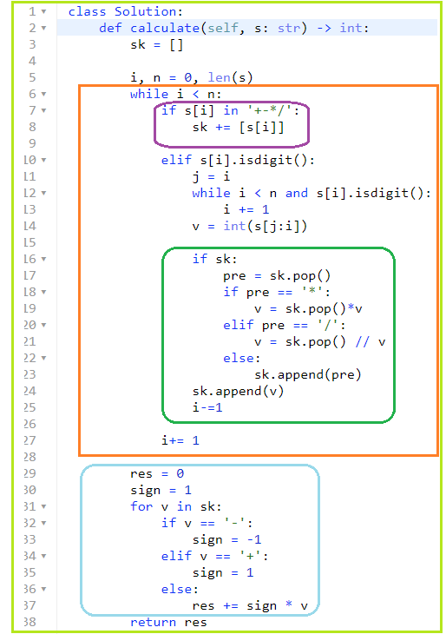

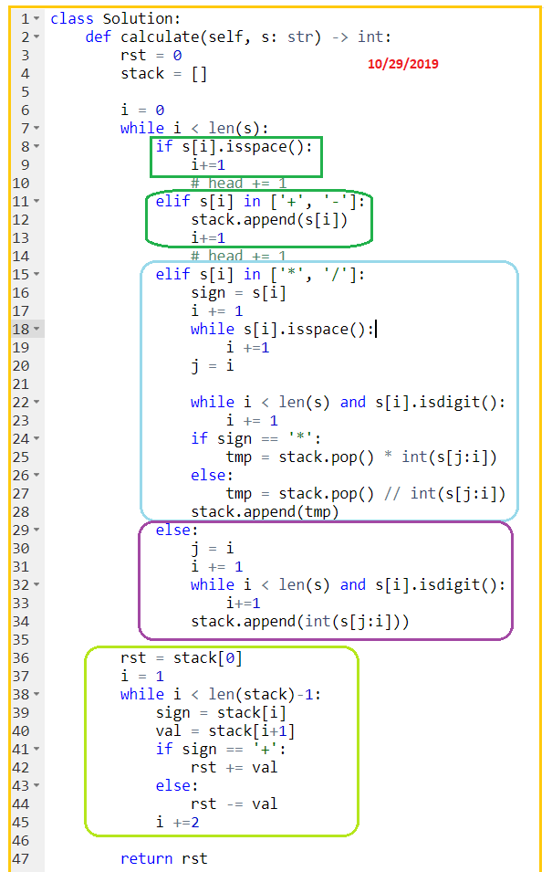

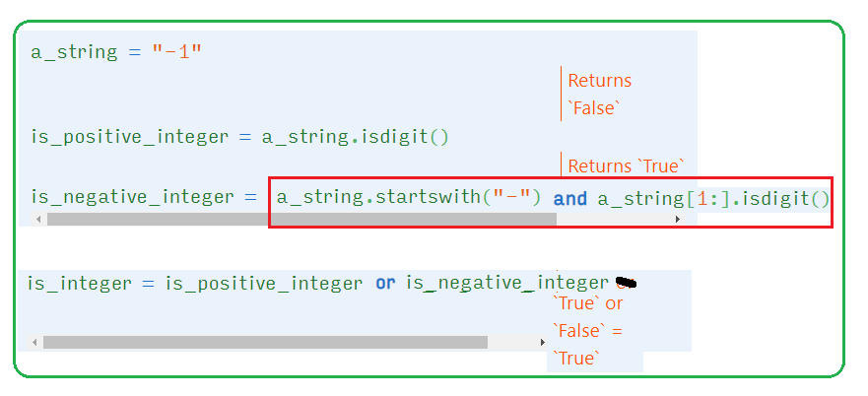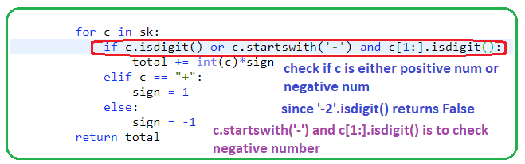

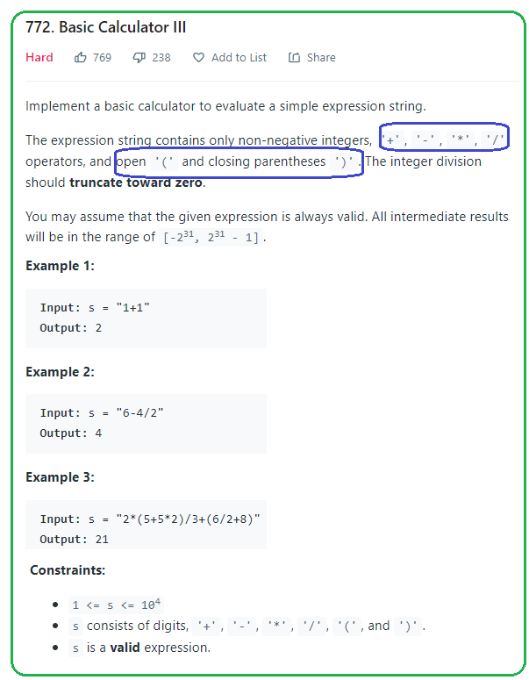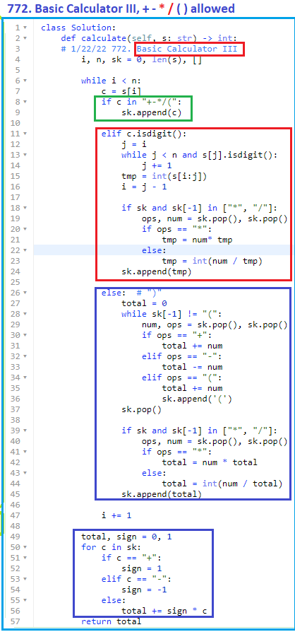

s="2*(5+5*2)/3+(6/2+8)" = 21

sk = ['10', '+', '11']

s="3**/**(2/1-4)" =-1  
sk = ['-1']

1. **150. Evaluate Reverse Polish Notation**

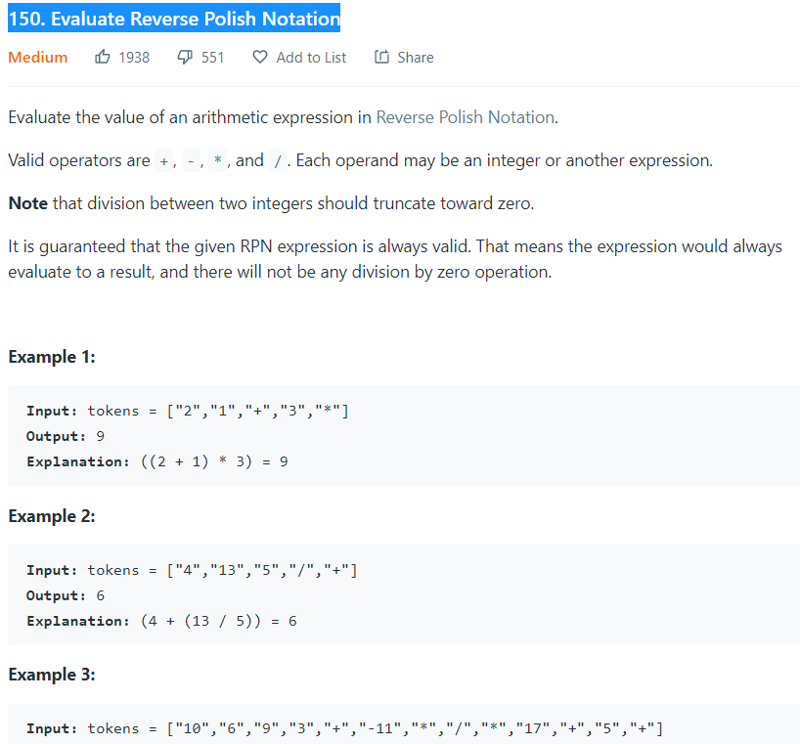

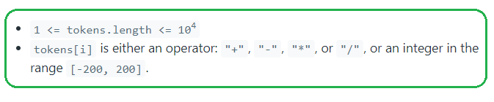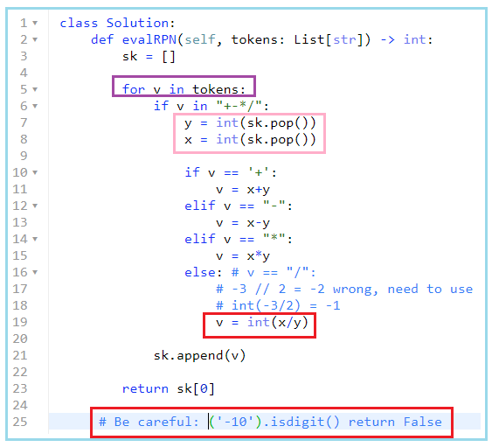

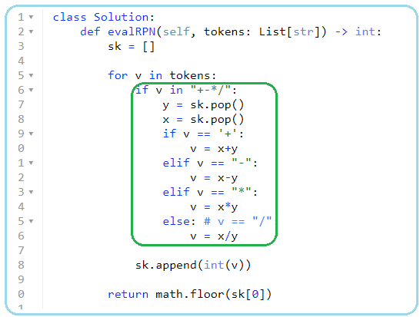

# 

1. **Parenthesis\*\*\*\*\***
2. **678. Valid Parenthesis String**

**1/25/22**

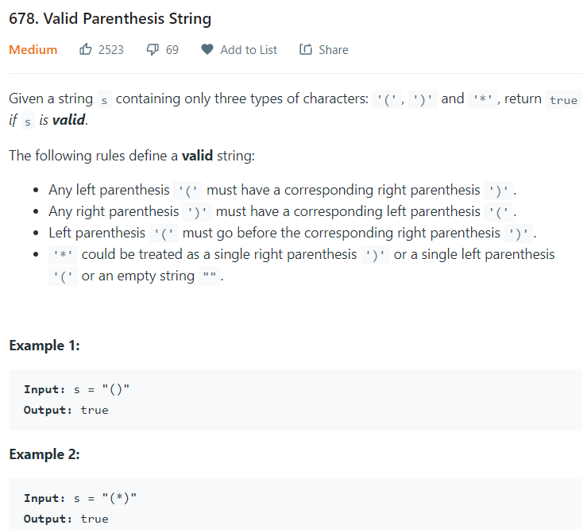**,**

**Takeaway:**

**Since “*” can be treated as “”,**

1. **the length of s doesn’t need to be even.**

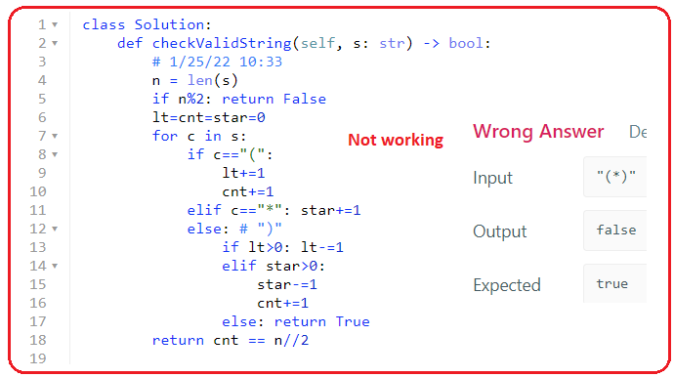

* **Two -stacks**

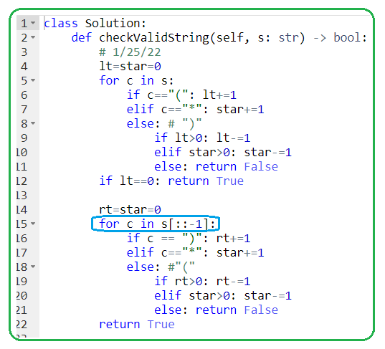

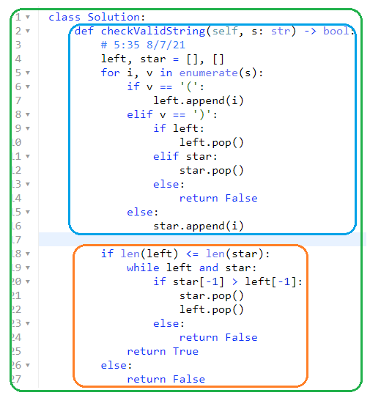

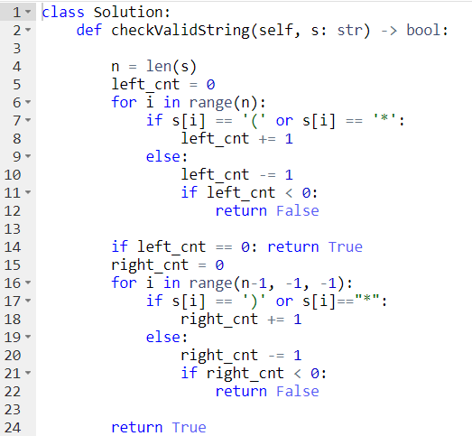

**#stack 8/22/2021; 9/15/21,1/25/22**

**2/19/22,4/5,**

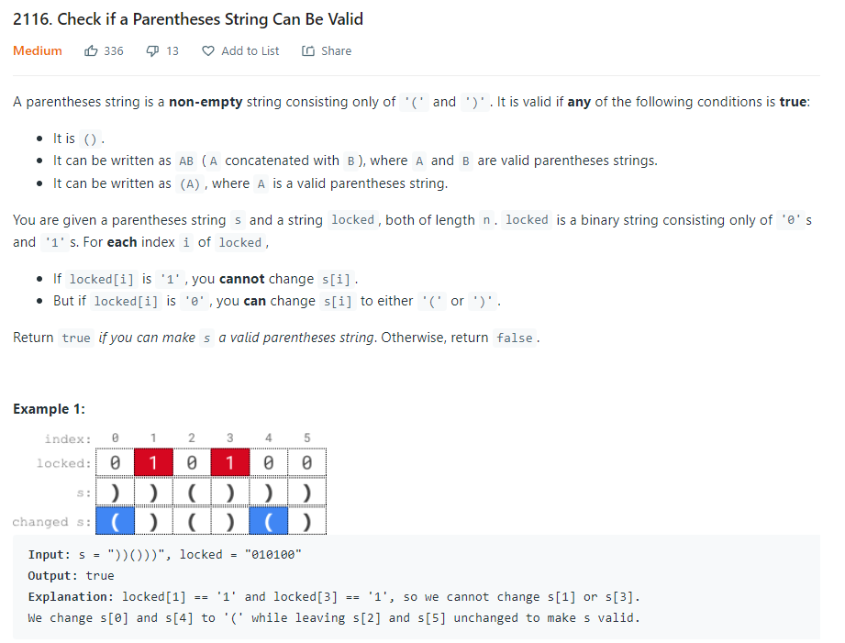

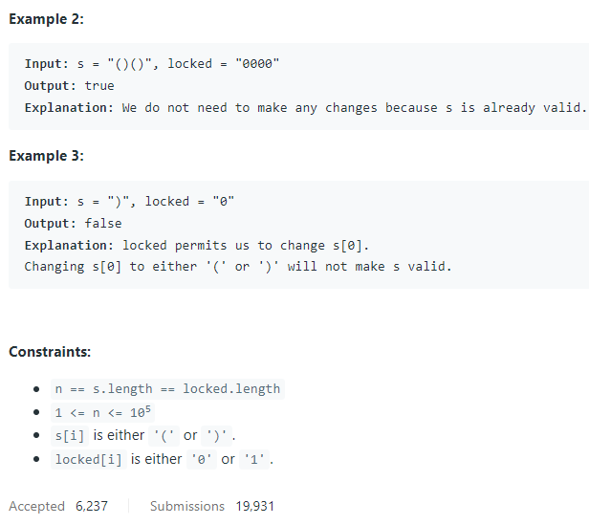

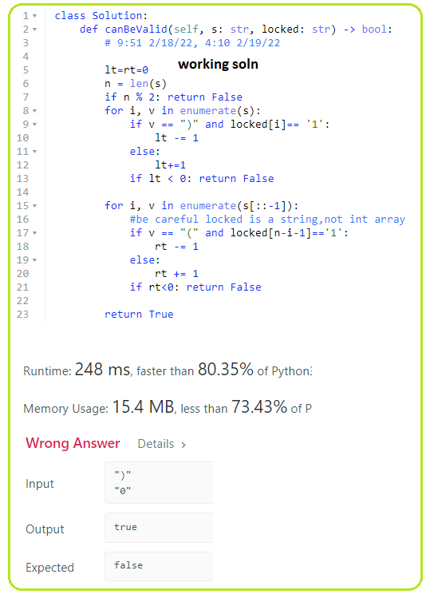

1. **901. Online Stock Span**

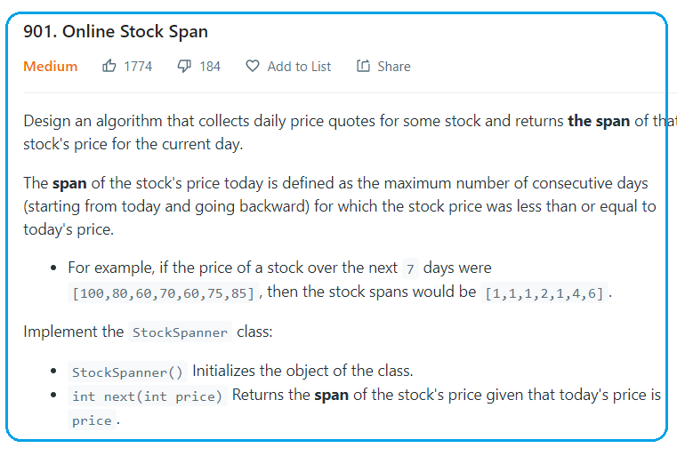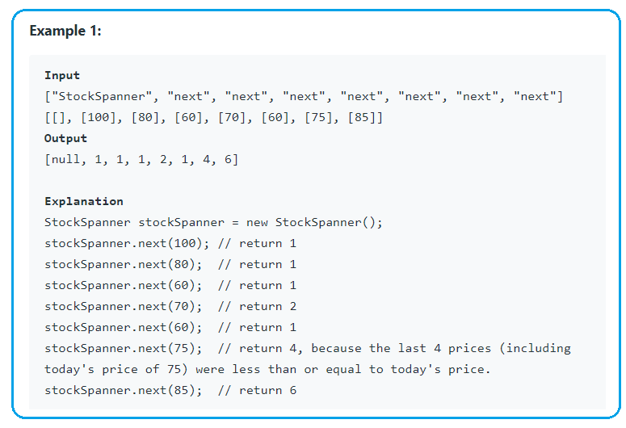

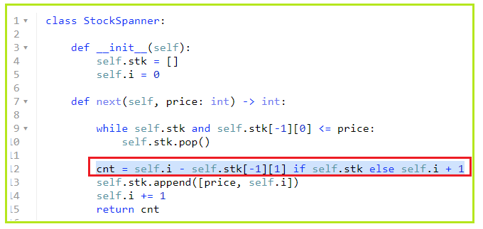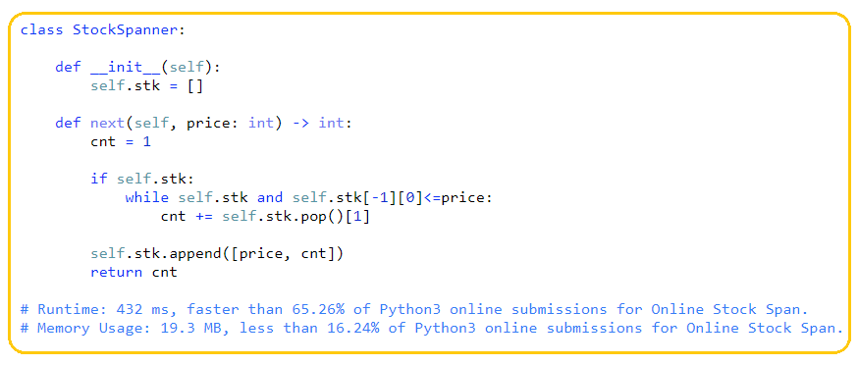

**1/25/22,4/5/22,**

1. **1963. Minimum Number of Swaps to Make the String Balanced**

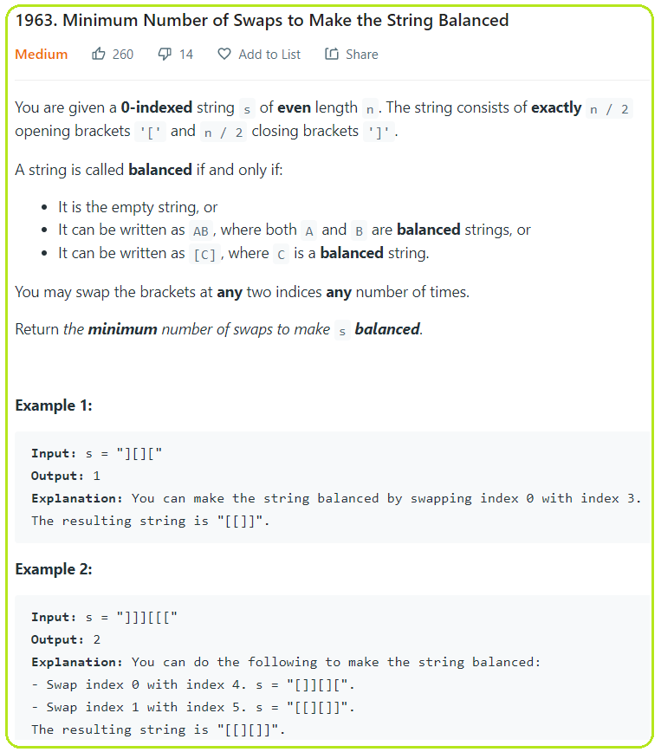

**1/25/22**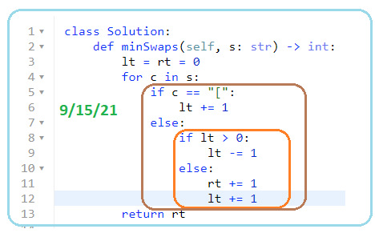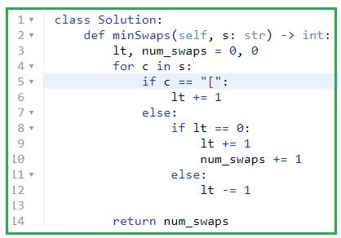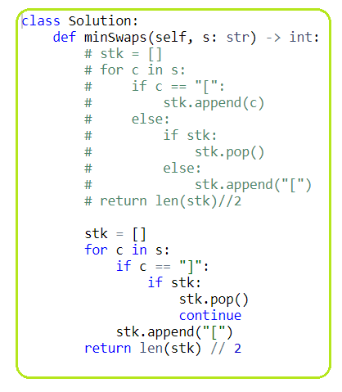

1. **946. Validate Stack Sequences**

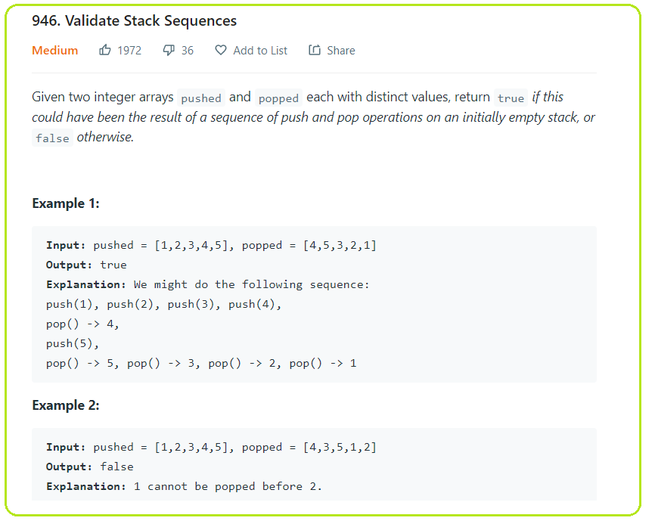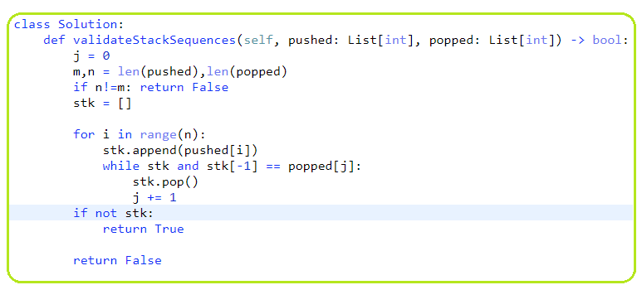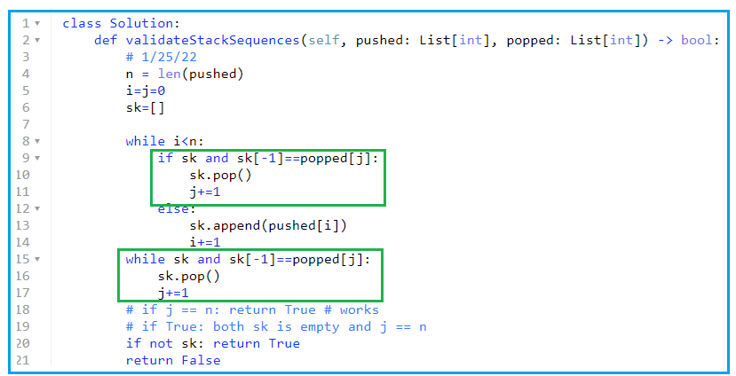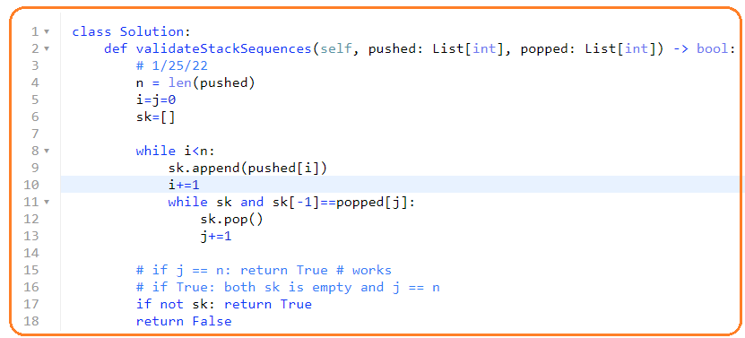

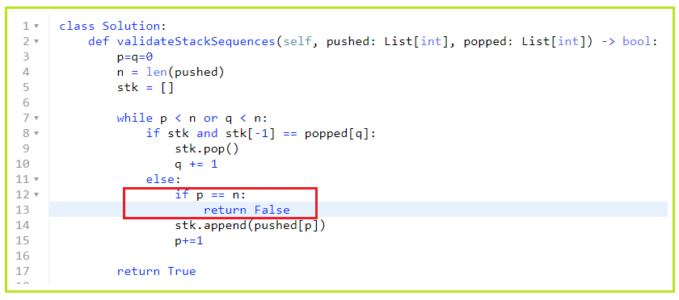

1. **1249. Minimum Remove to Make Valid Parentheses**

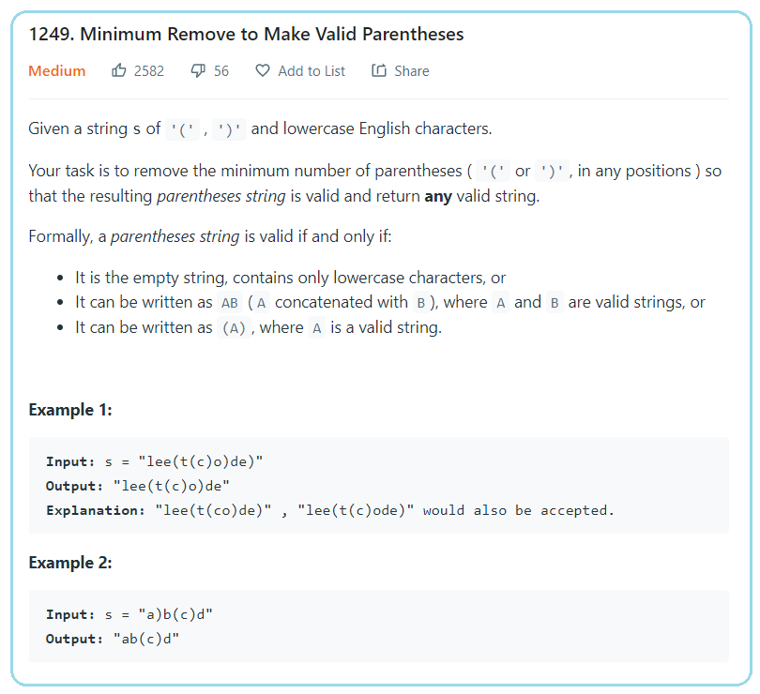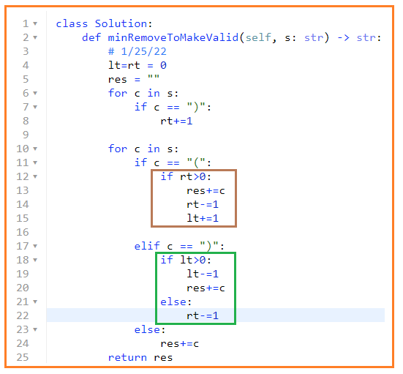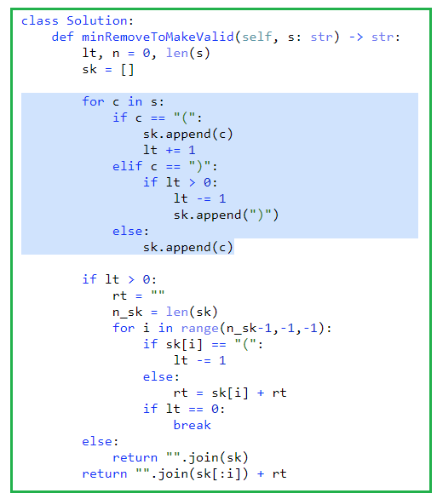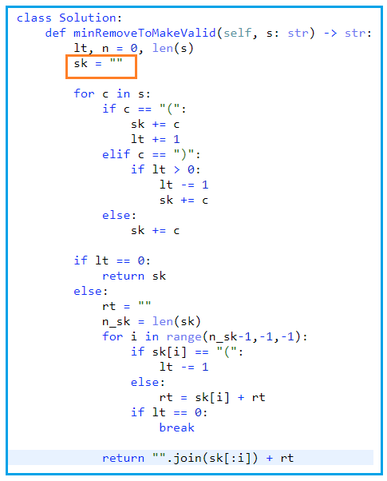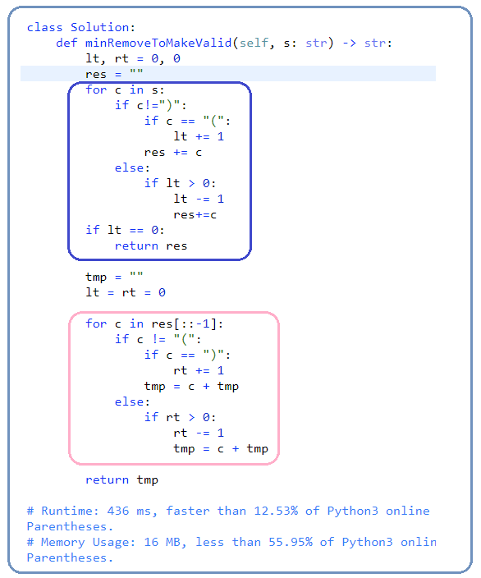

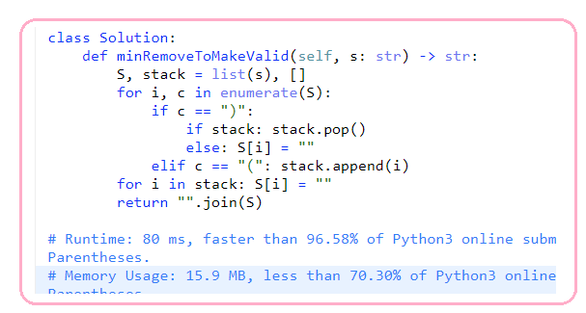

**8/23/21, 9/16/21,1/25/22**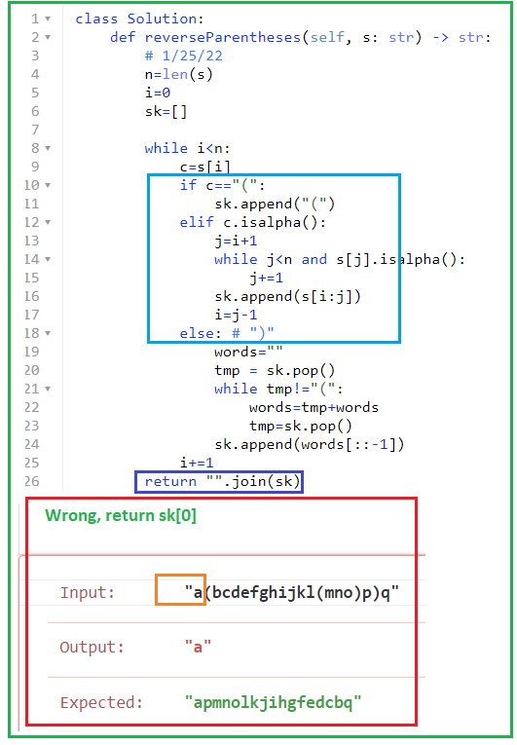

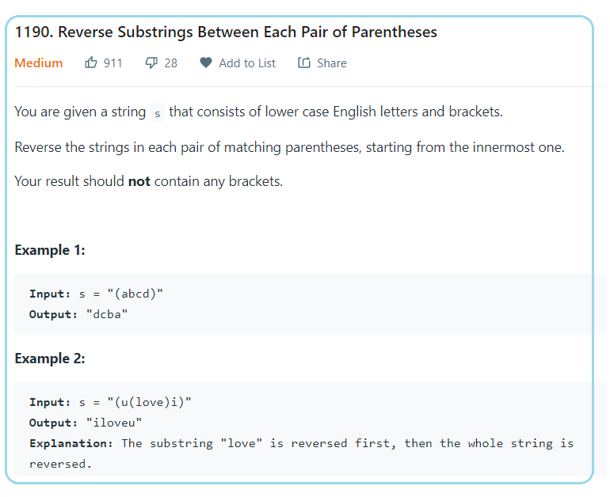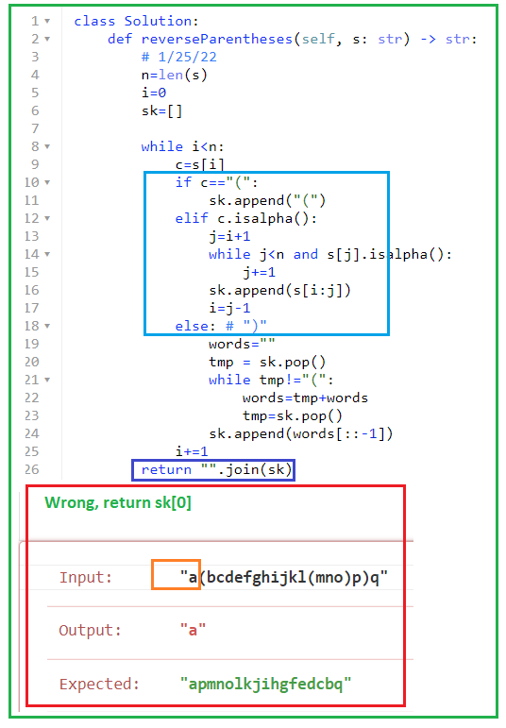

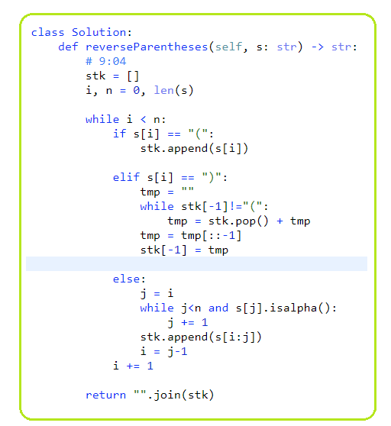

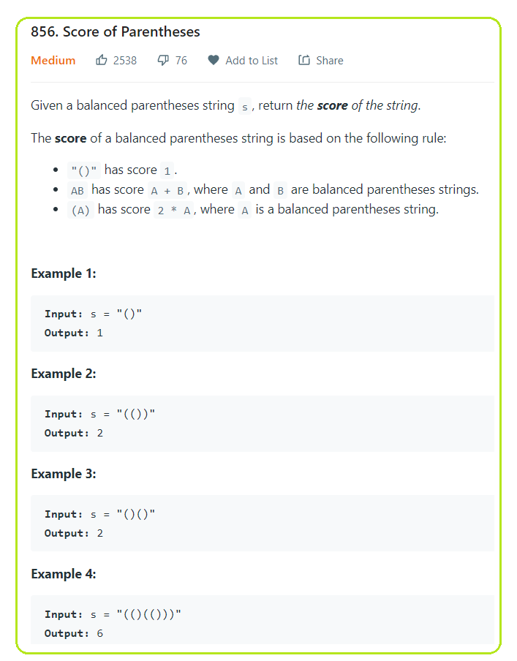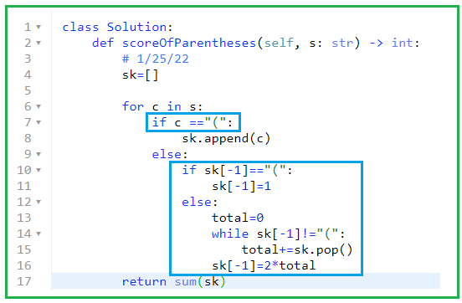

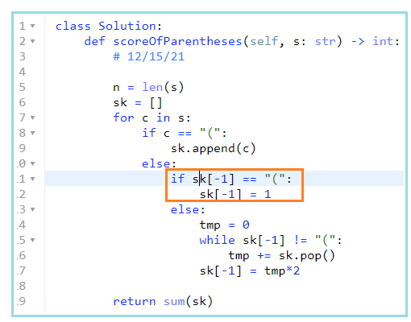

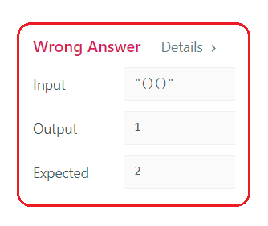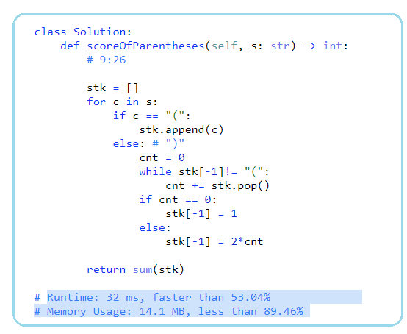

**8/25/21,9/16/21,1/25/22,4/6/22**

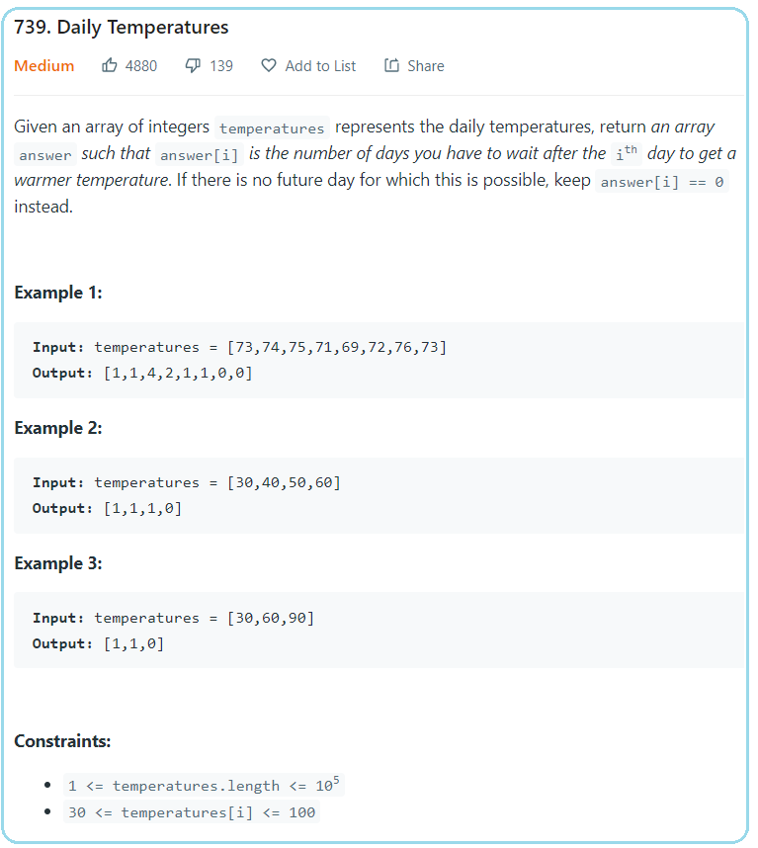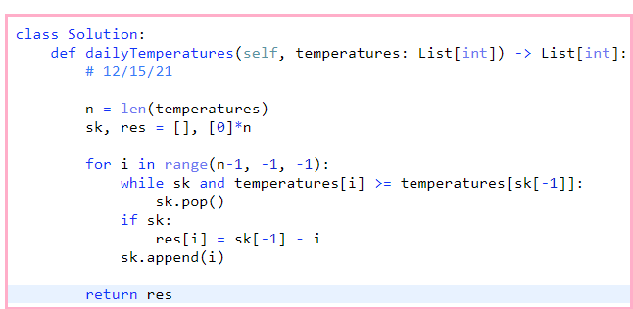

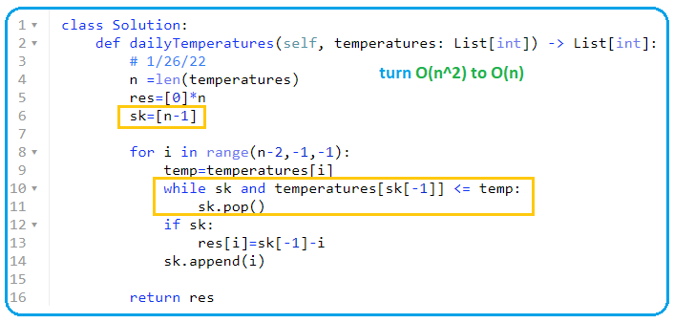

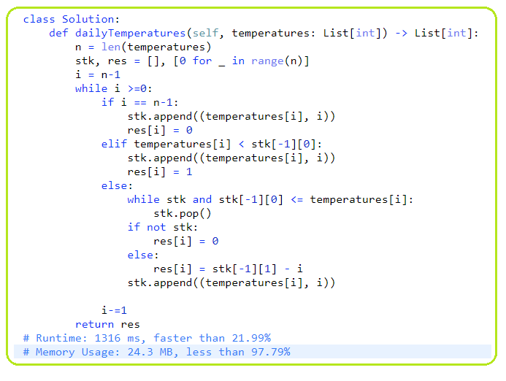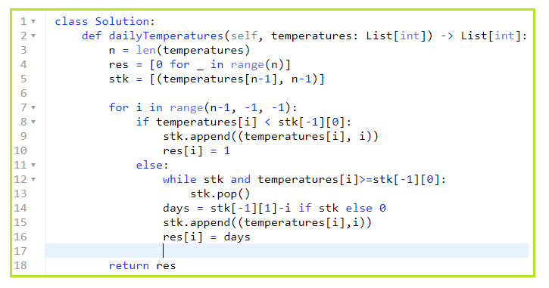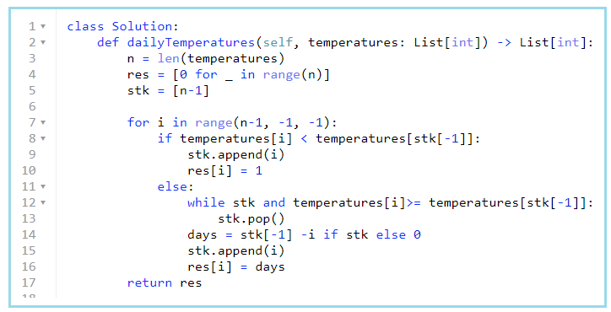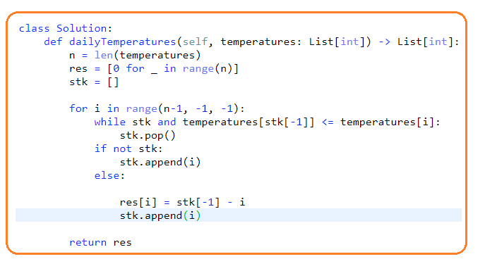

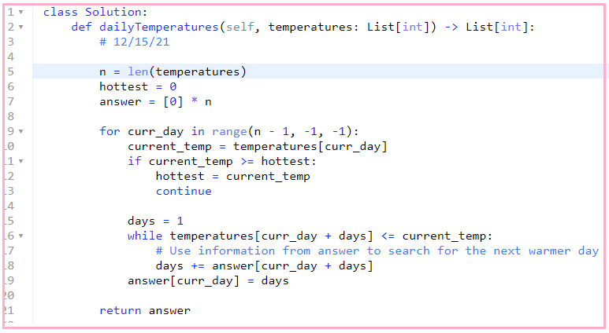

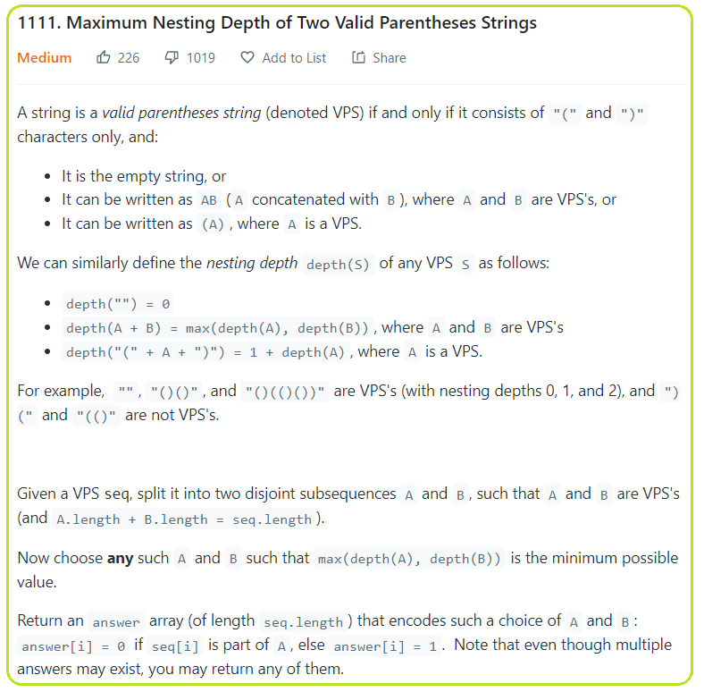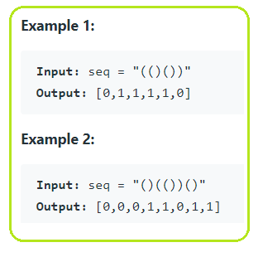

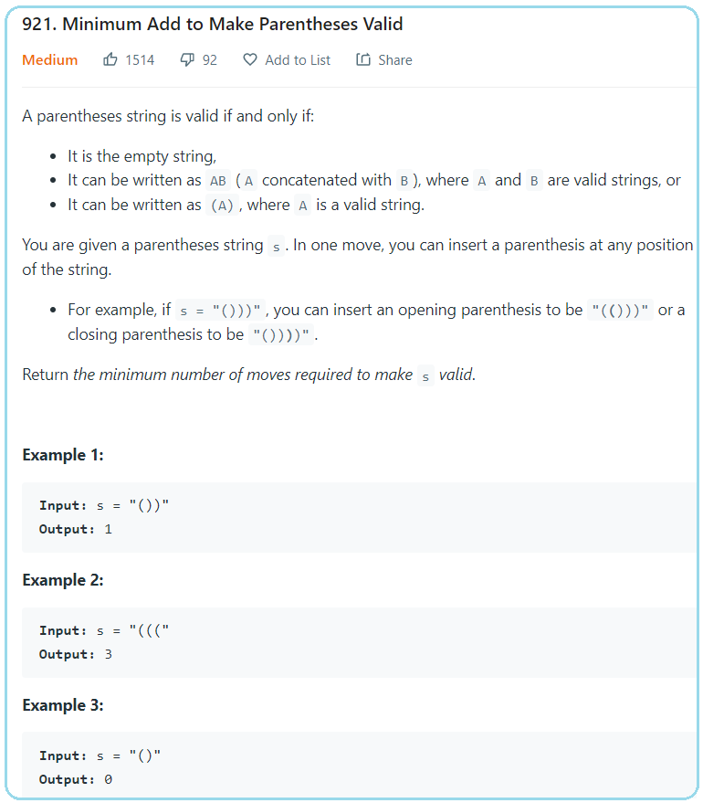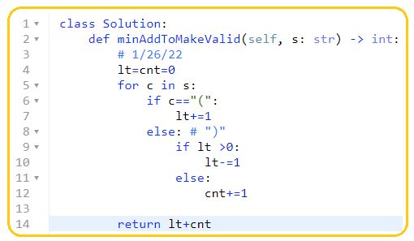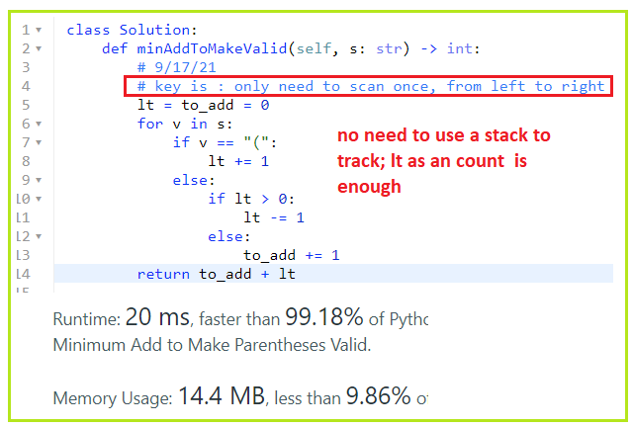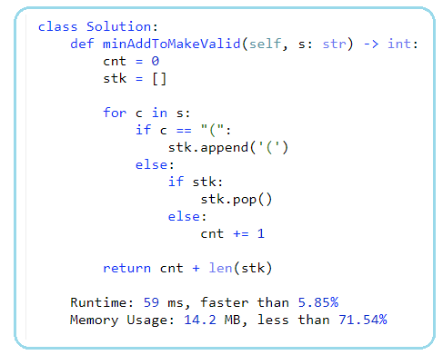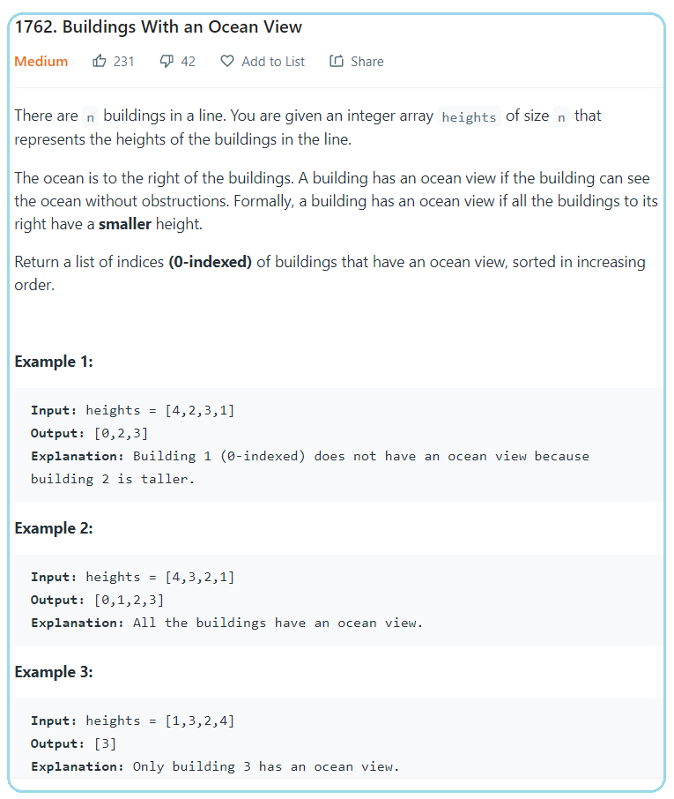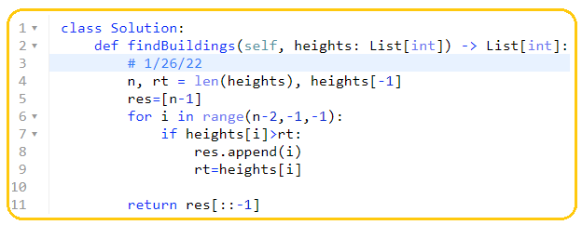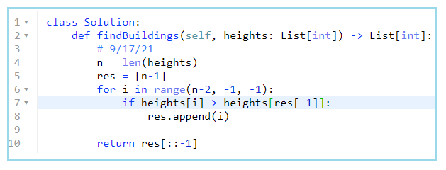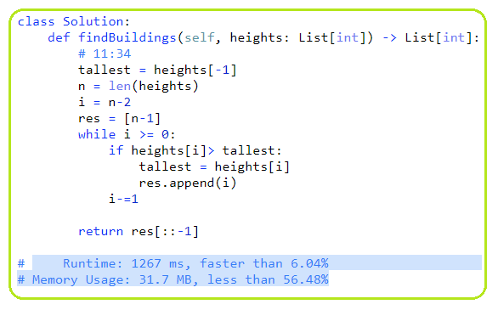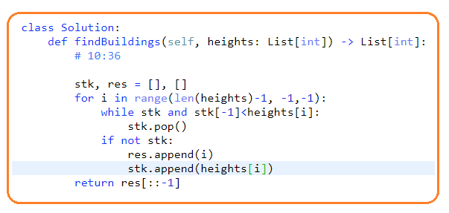

#### 32. [Longest Valid Parentheses](https://leetcode.com/problems/longest-valid-parentheses/)

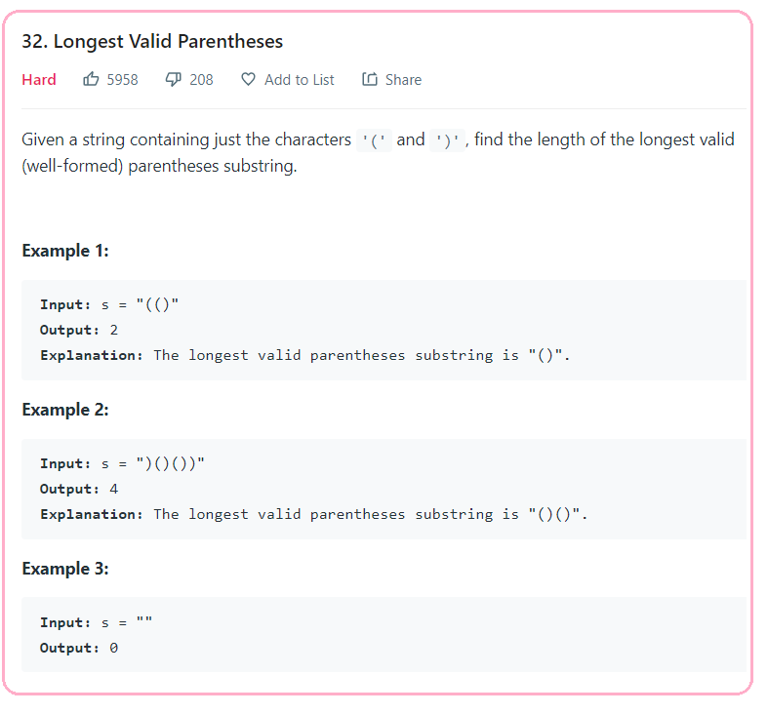

**1/26/22, 4/6/22**

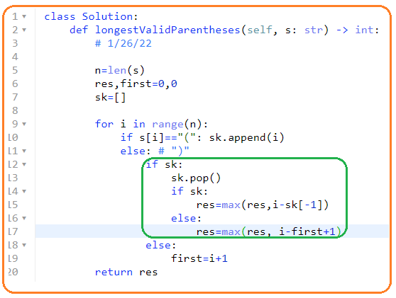

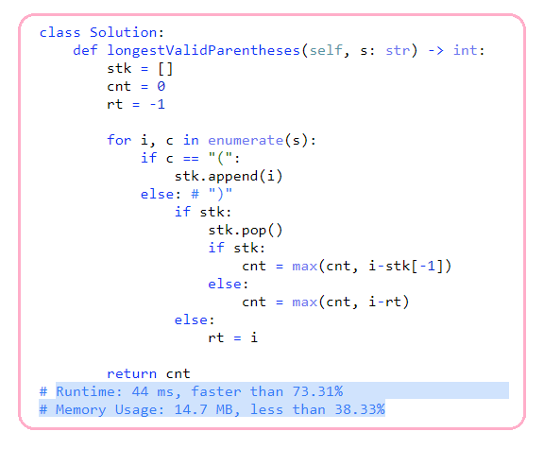**42 Trapping Rain Water**

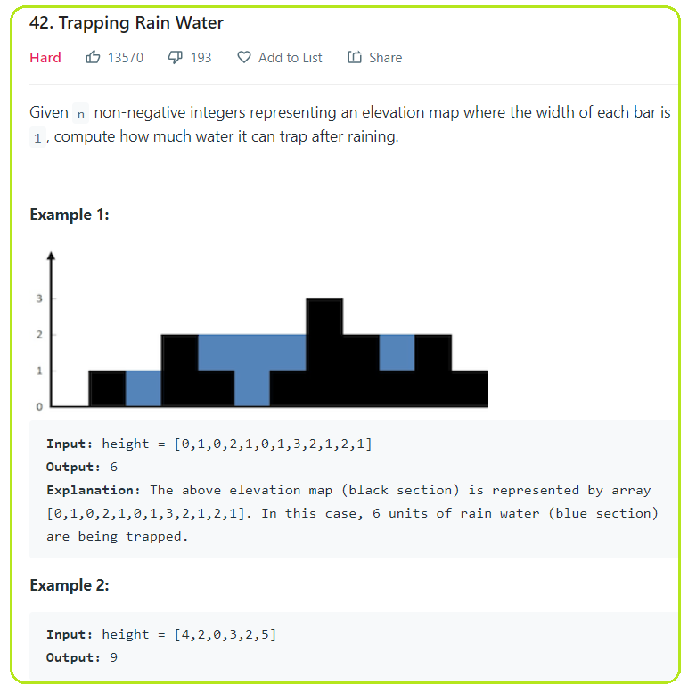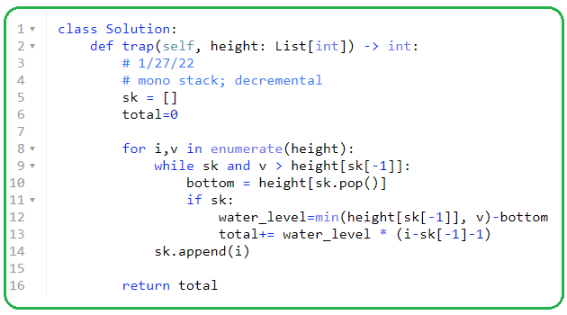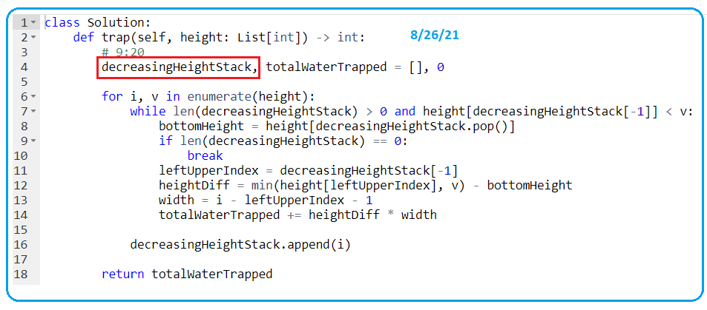

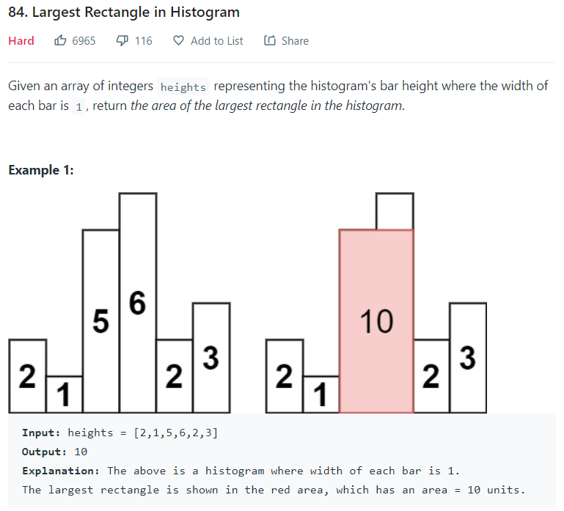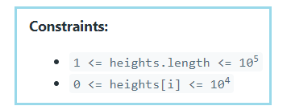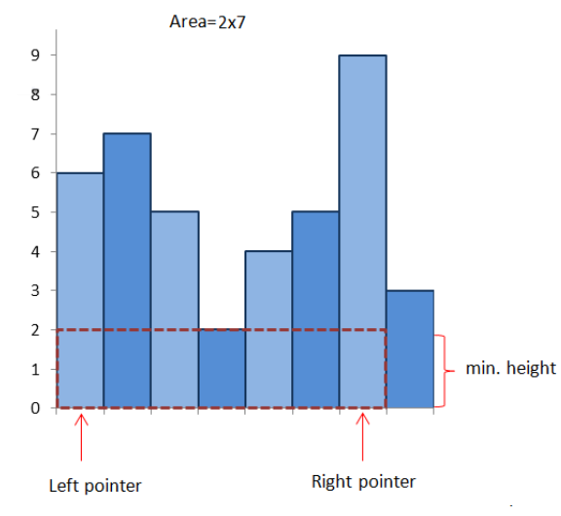

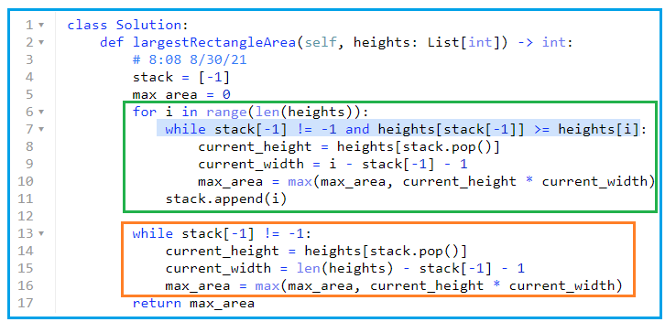

**9/17/21, 9/20/21, 1/28/22,**

1. **Sliding Window\*\*\*\*\***
2. **3. Longest Substring Without Repeating Characters**

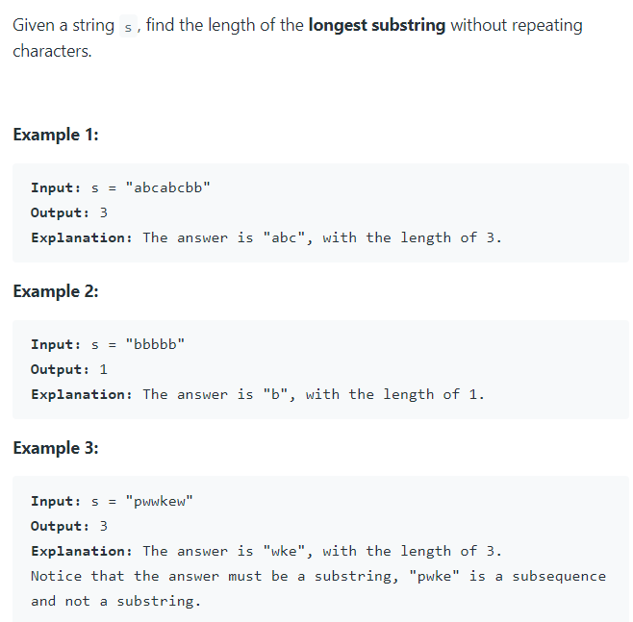 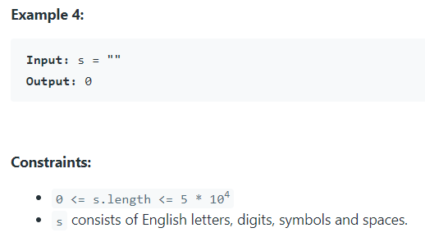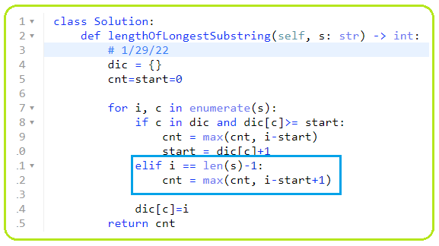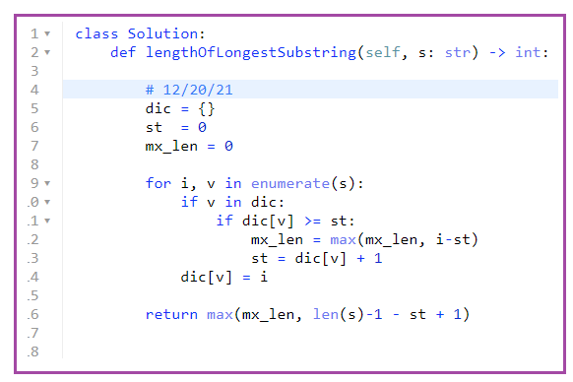

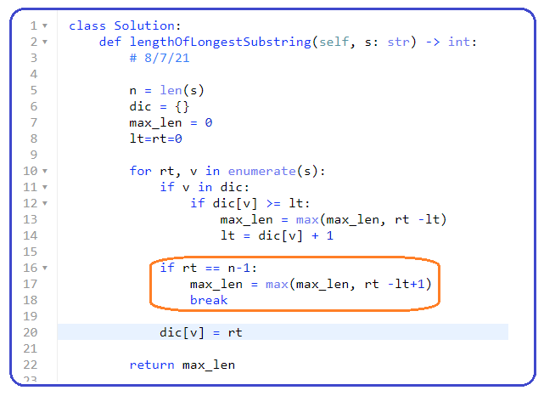 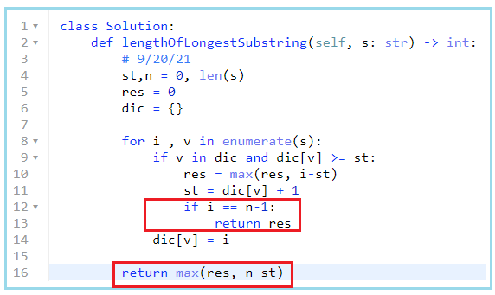

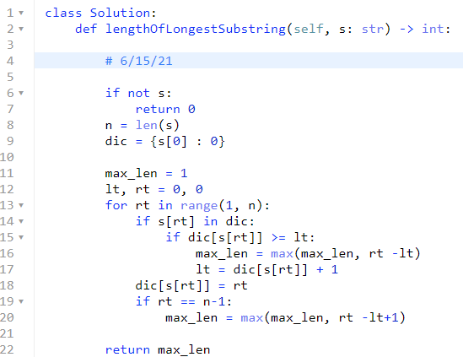

1. **DP: longest increasing sub-sequence \*\*\*\*\***
2. **300. Longest Increasing Subsequence**

4/11/22,

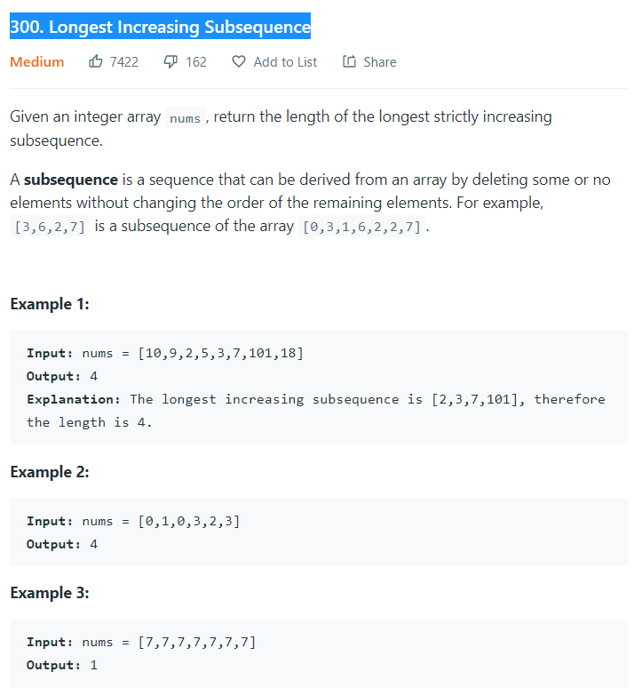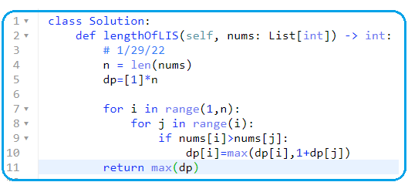

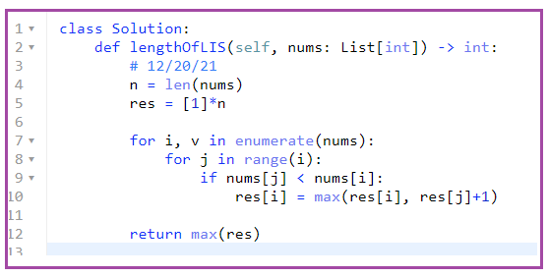

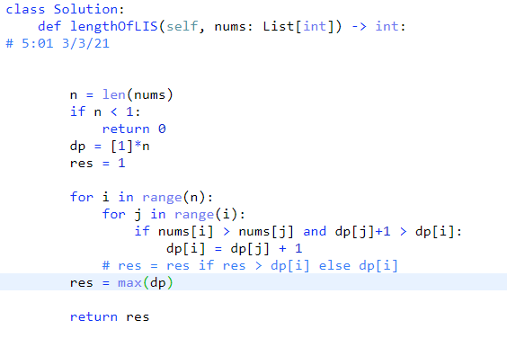

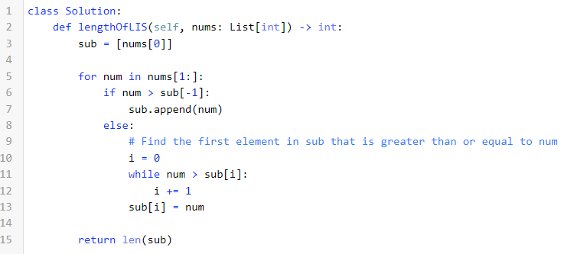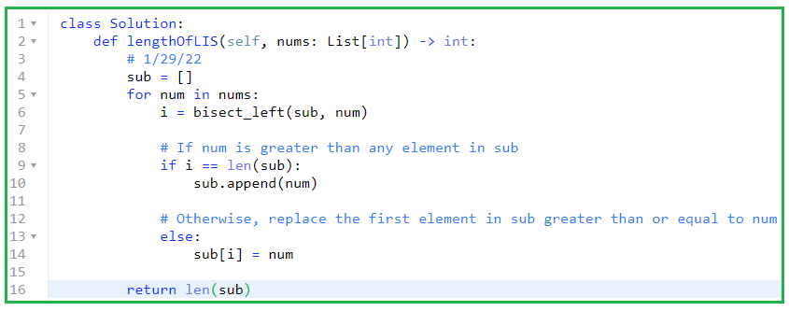

1. **673. Number of Longest Increasing Subsequence**

**4/22/22,**

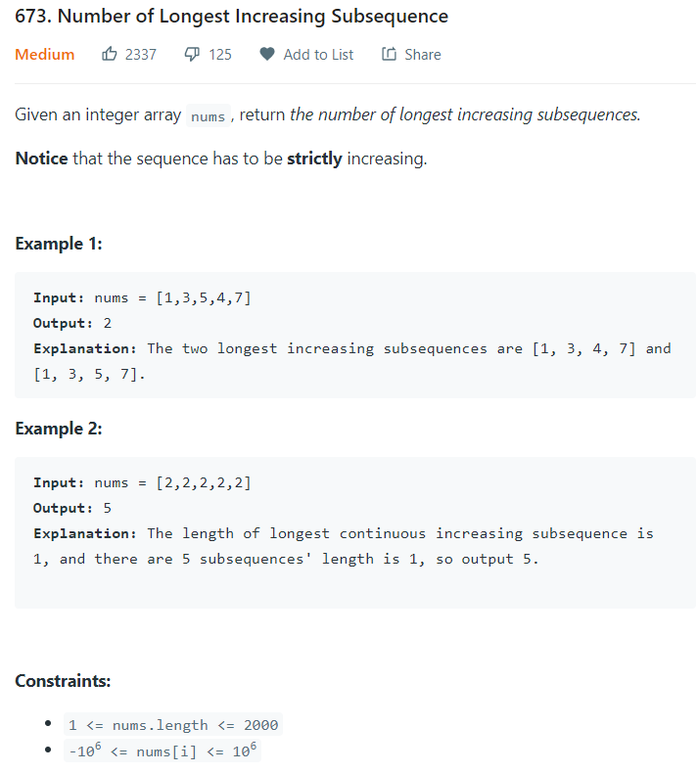

**# DP with trace back.**

**# each element is a pair of [length, cnt]**

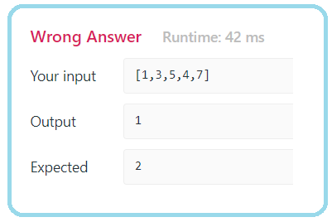

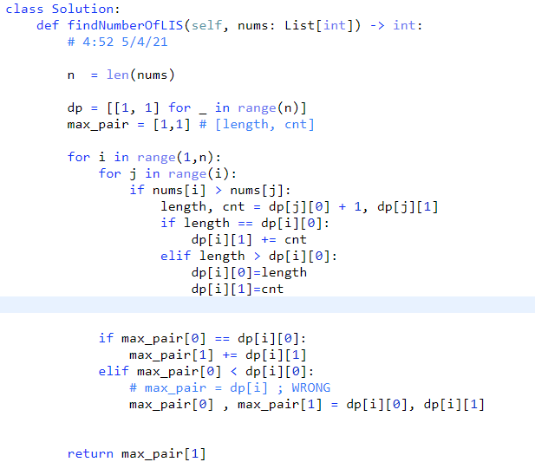

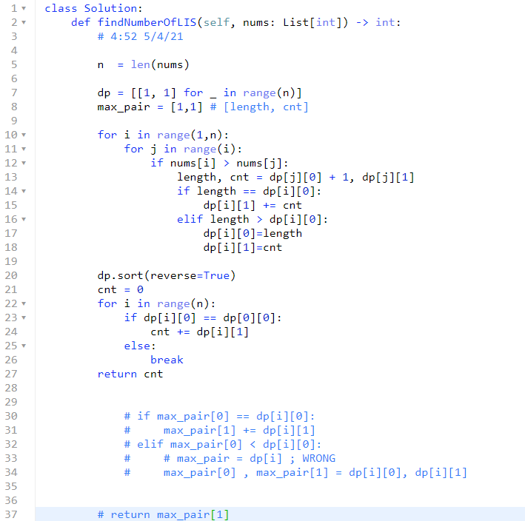

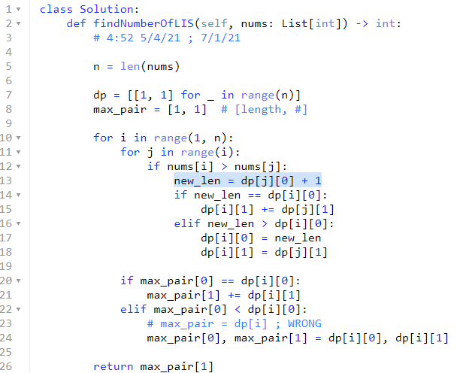

1. **152. Maximum Product Subarray**

**4/11 /22**

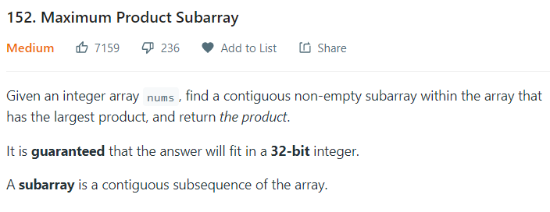

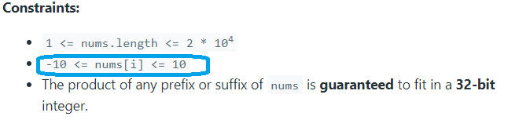

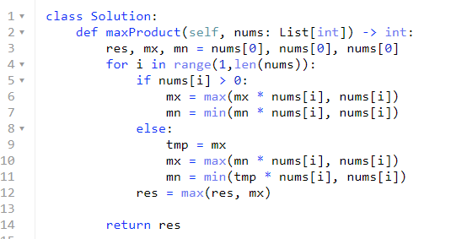

**9/21/21 , 2/1/22 , 4/11/22**

1. **DP: longest palindrome sub-string \*\*\*\*\***
2. **Longest Palindromic Substring (pair-wise)**

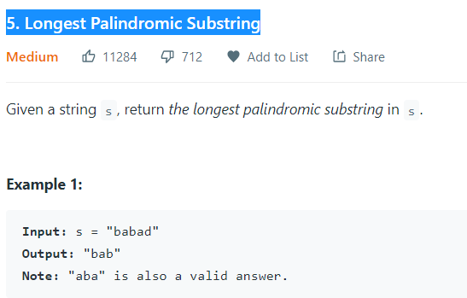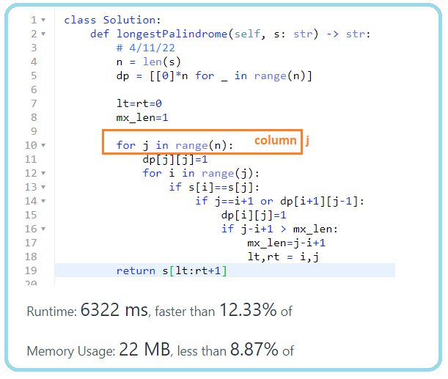

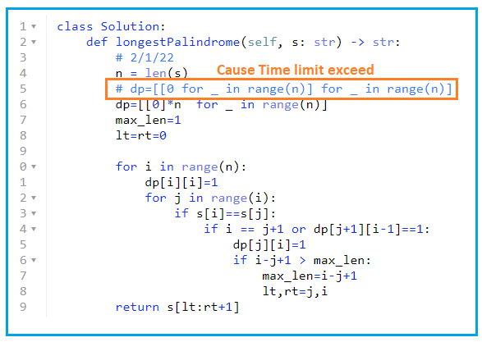

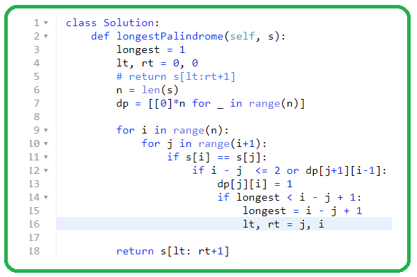

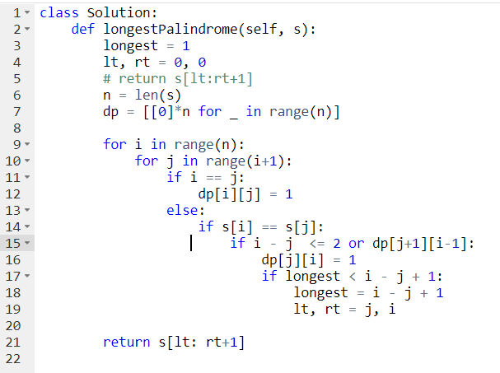

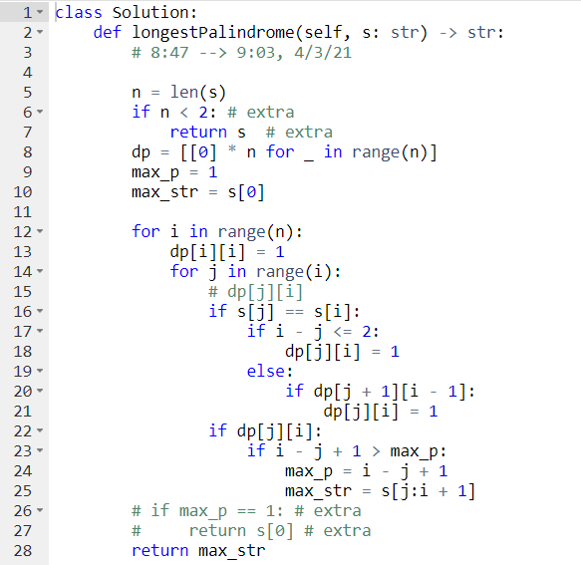

1. **DP: recursive, How many ways in total for doing something. \*\*\*\*\***

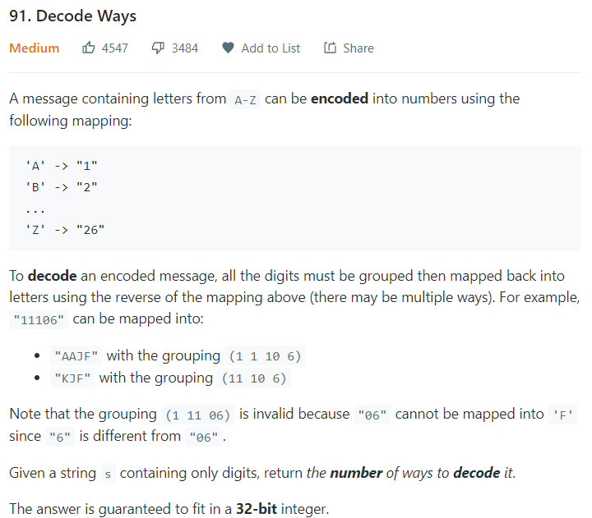

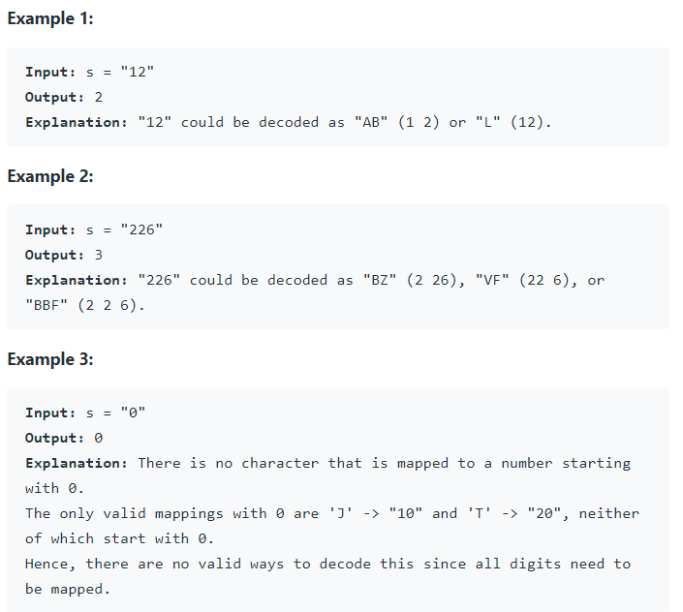

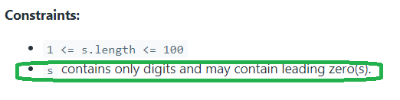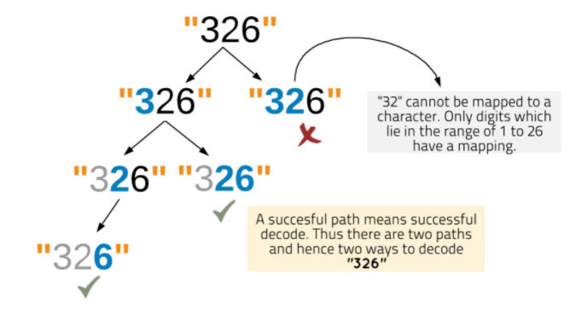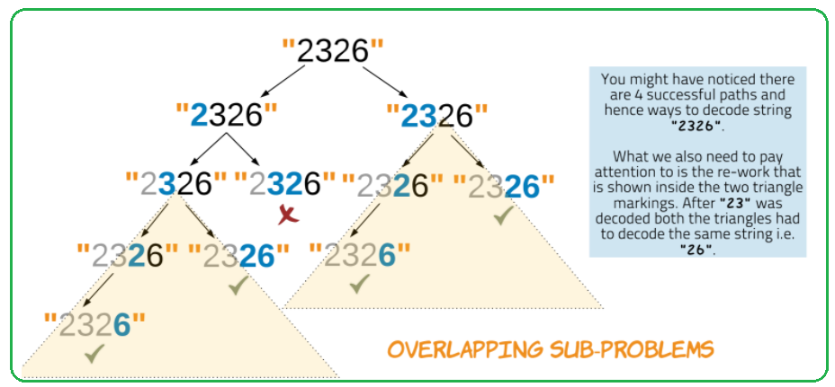

**# There are invalid s, that leads to zero way to decode!**

**# backtracking**

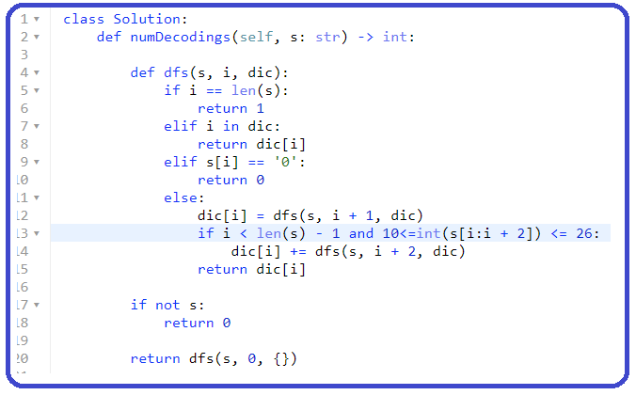

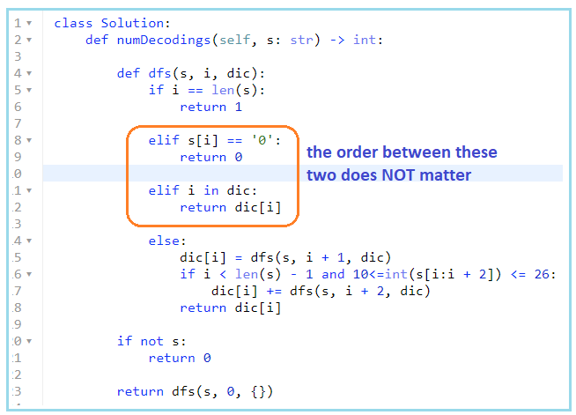

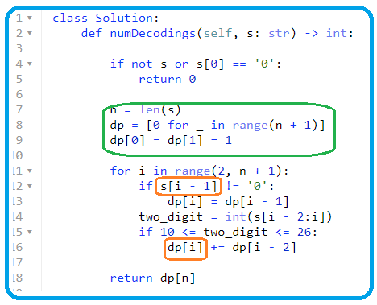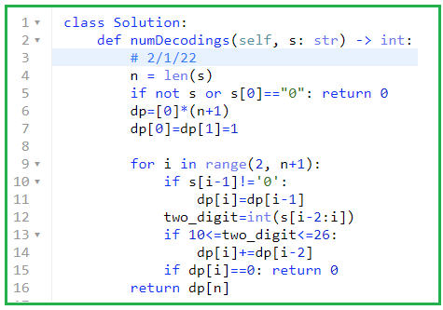

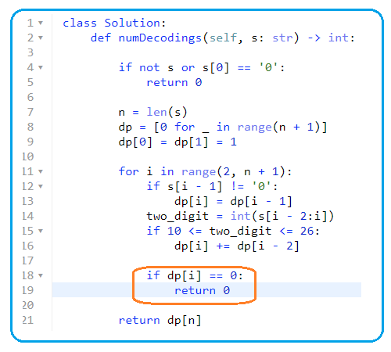

1. **1524. Number of Sub-arrays With Odd Sum**

**2/2/22,4/11/22**

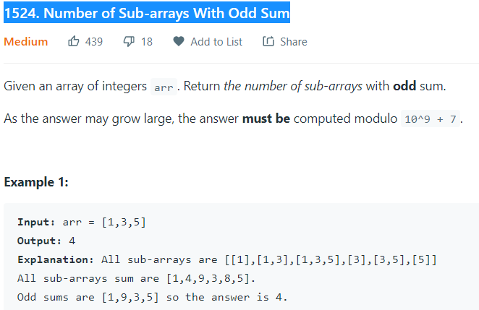

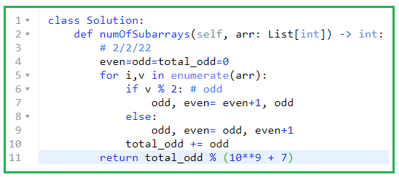

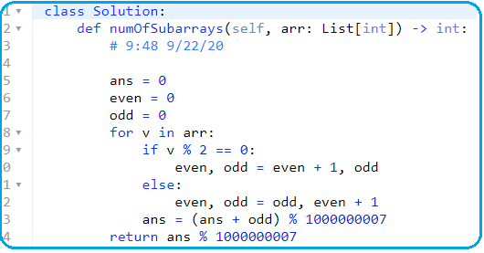

1. **DP: shortest/minimum steps to certain amount\*\*\*\***
2. **322. Coin Change (12/23/21, 2/2/22,4/11)**

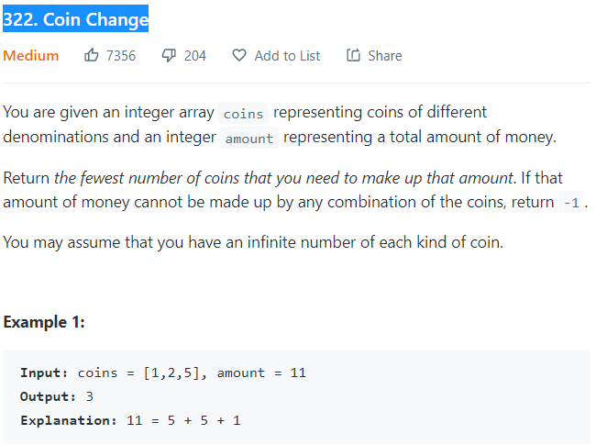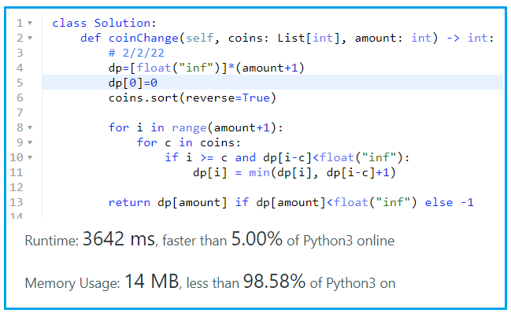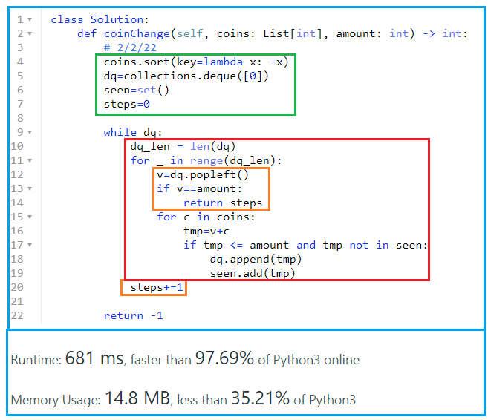

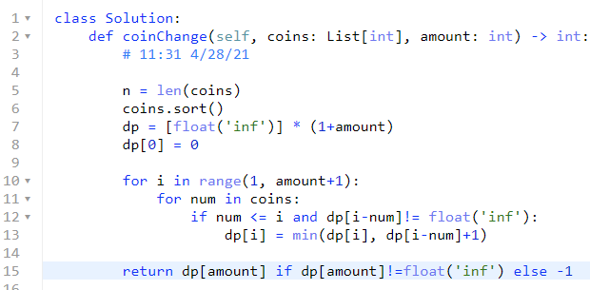

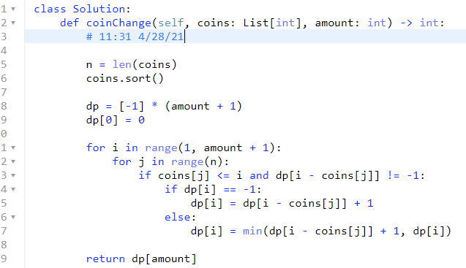

1. **DP: True or False**

**139. Word Break**

**9/22/21, 12/21/21, 2/3/22,4/11/22**

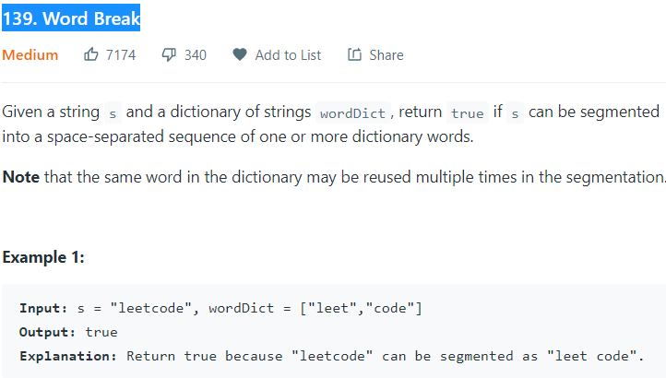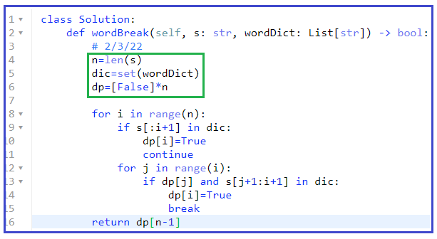

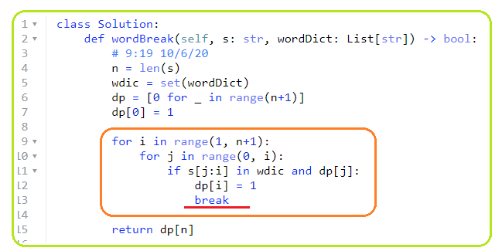

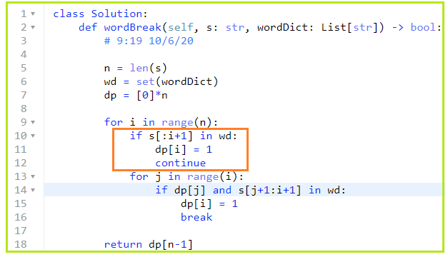

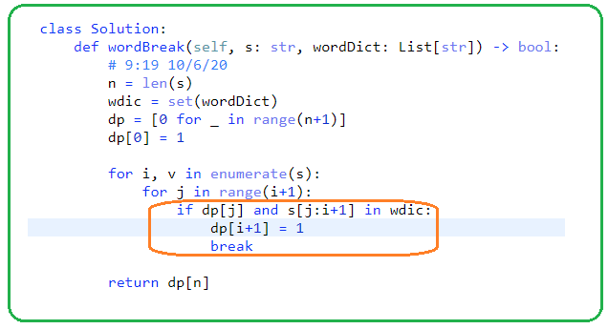

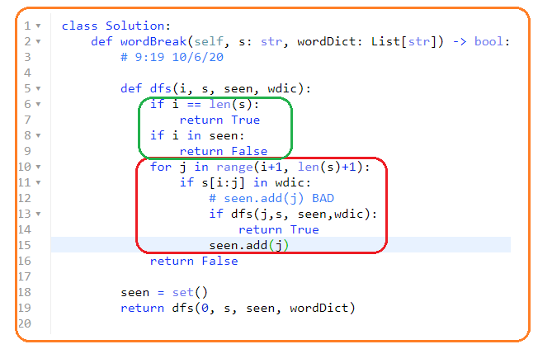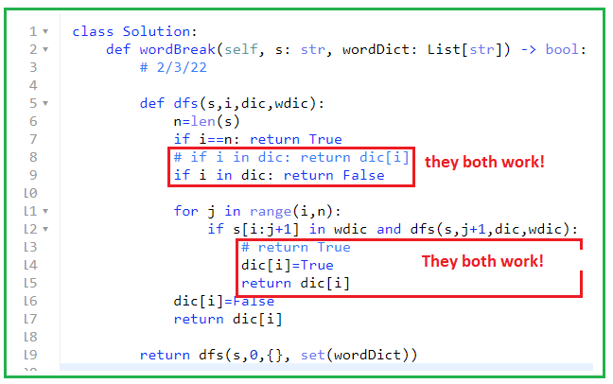

1. **BFS\*\*\*\*\***
2. **322. Coin Change, 4/8/22**

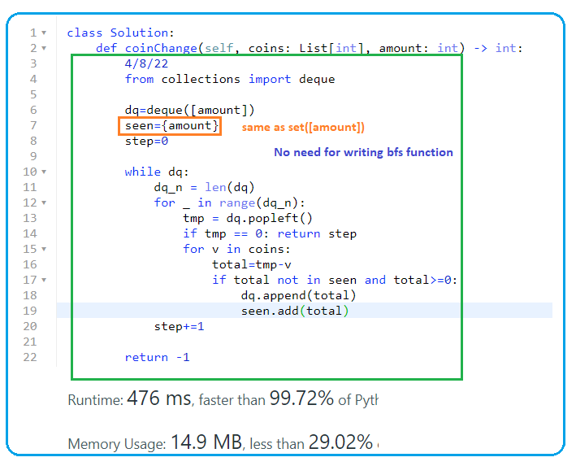

* **# 1.**

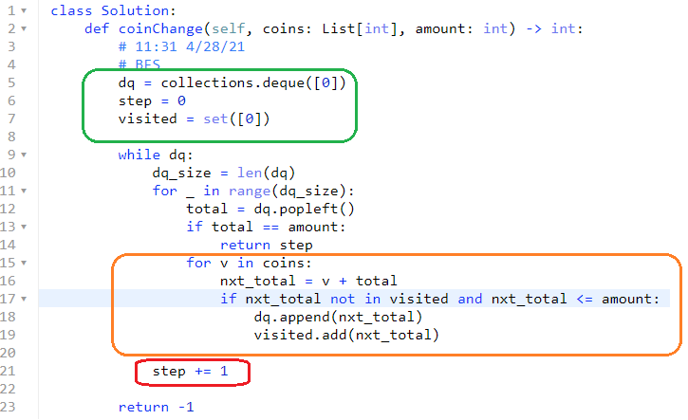

1. **649. Dota2 Senate**

**12/21/21, 2/3/22,4/8**

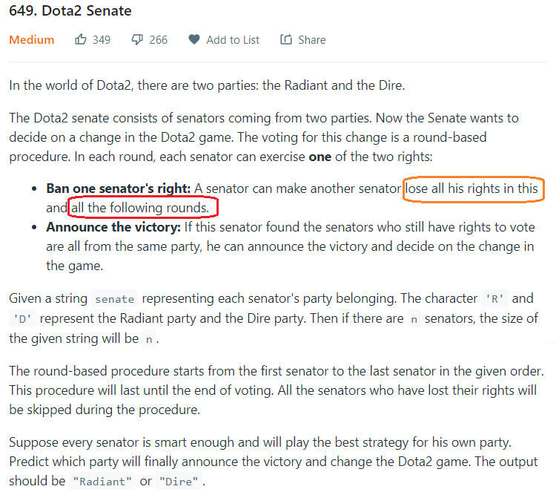

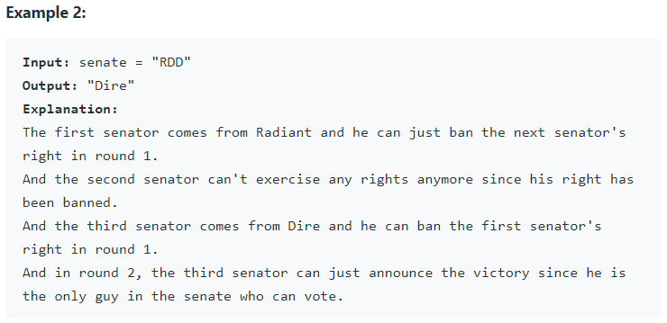

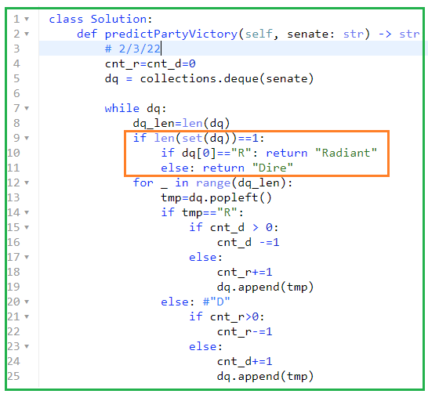

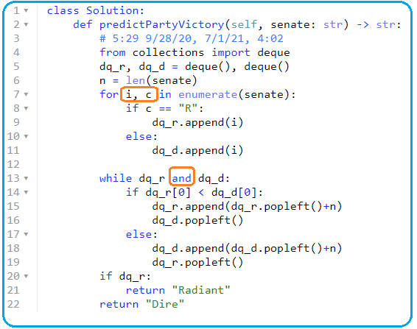

1. **909. Snakes and Ladders**

**12/23/21, 4/8/22**

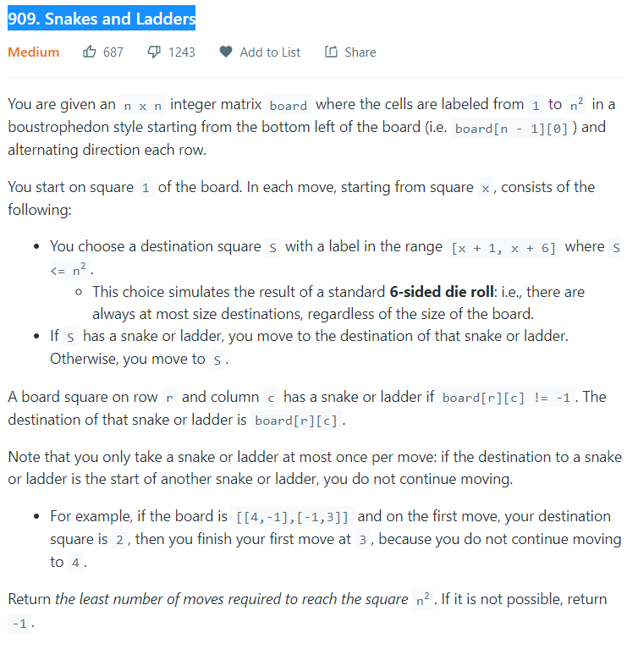

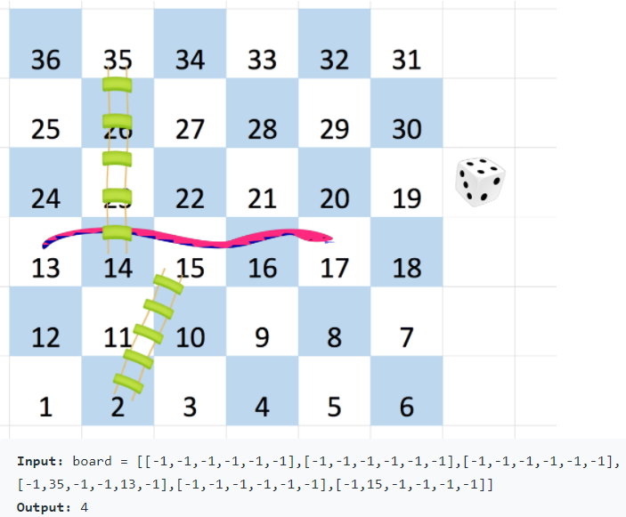

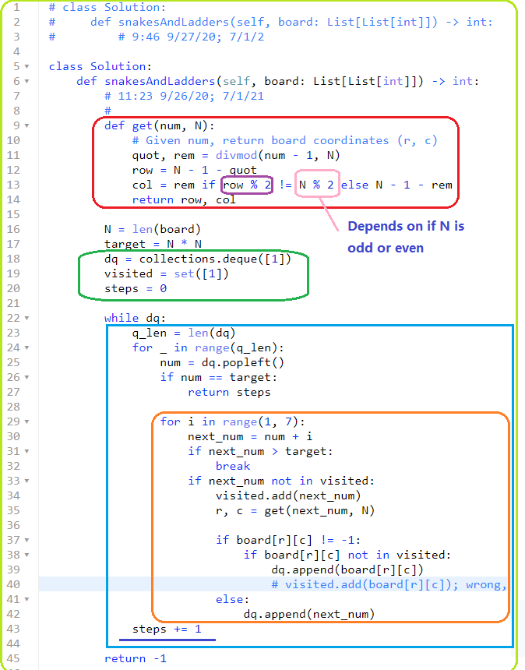

1. **1129. Shortest Path with Alternating Colors**

**9/22/21,12/24/21, 2/4/22,4/8**

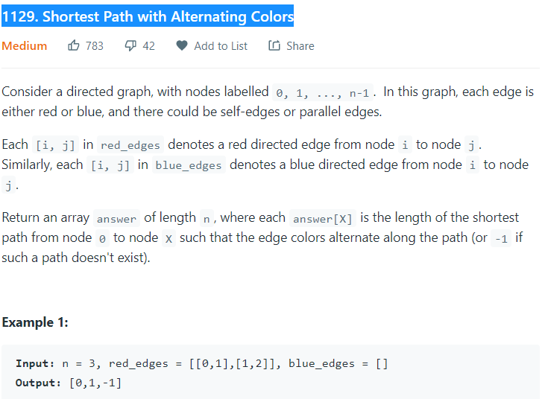

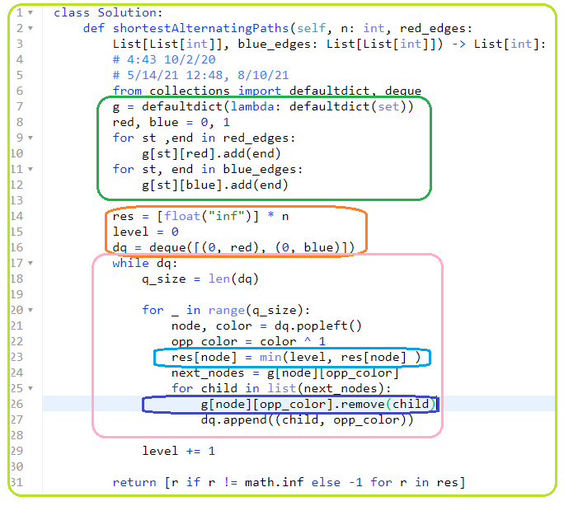

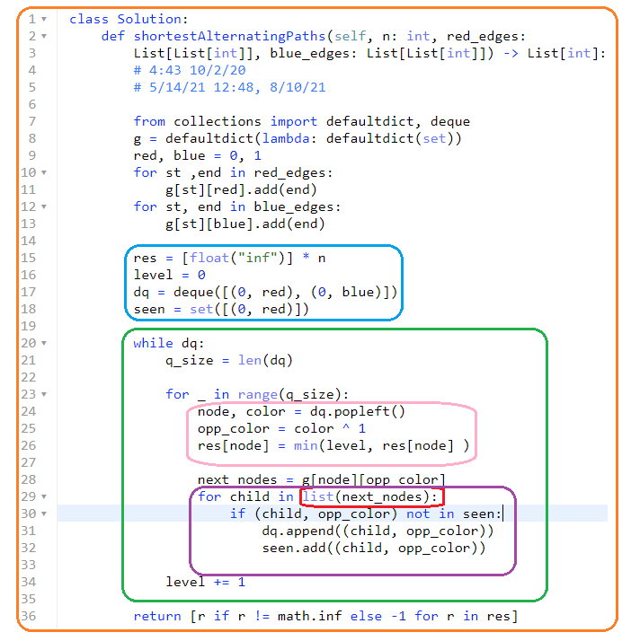

1. **1091. Shortest Path in Binary Matrix**

**12/24/21, 2/4/22,4/8/22**

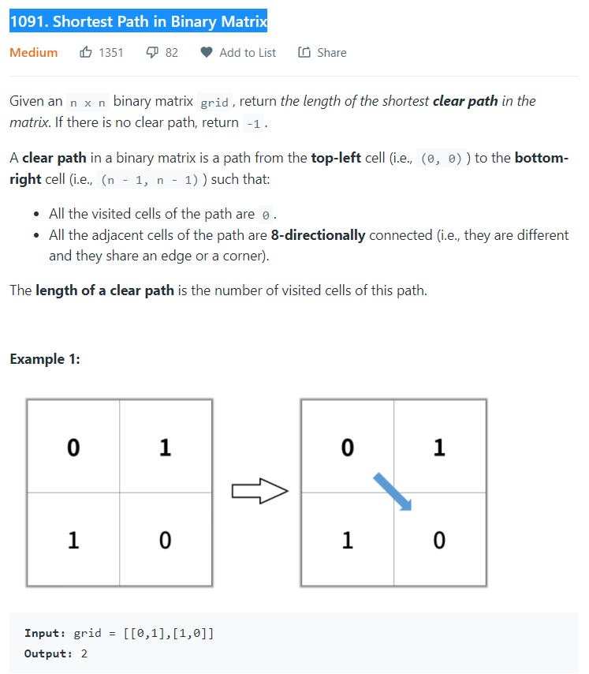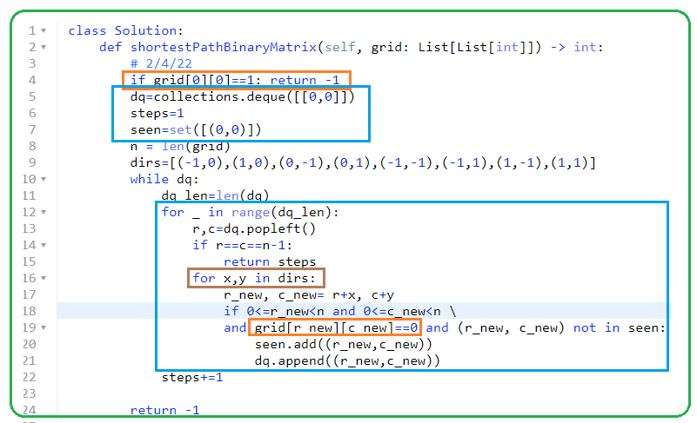

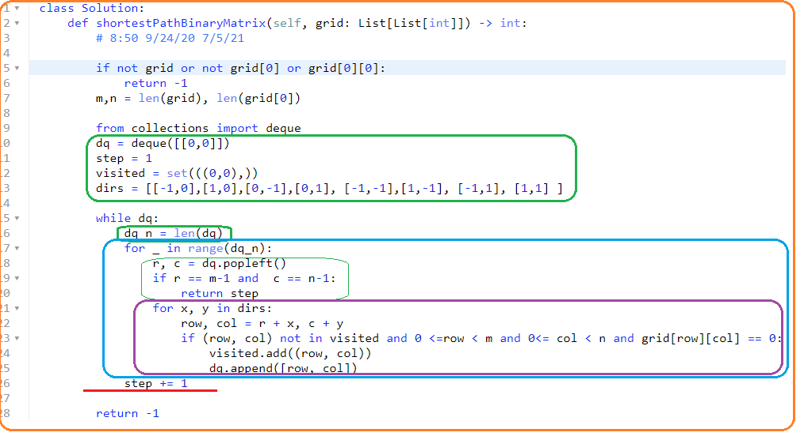

**1514. Path with Maximum Probability**

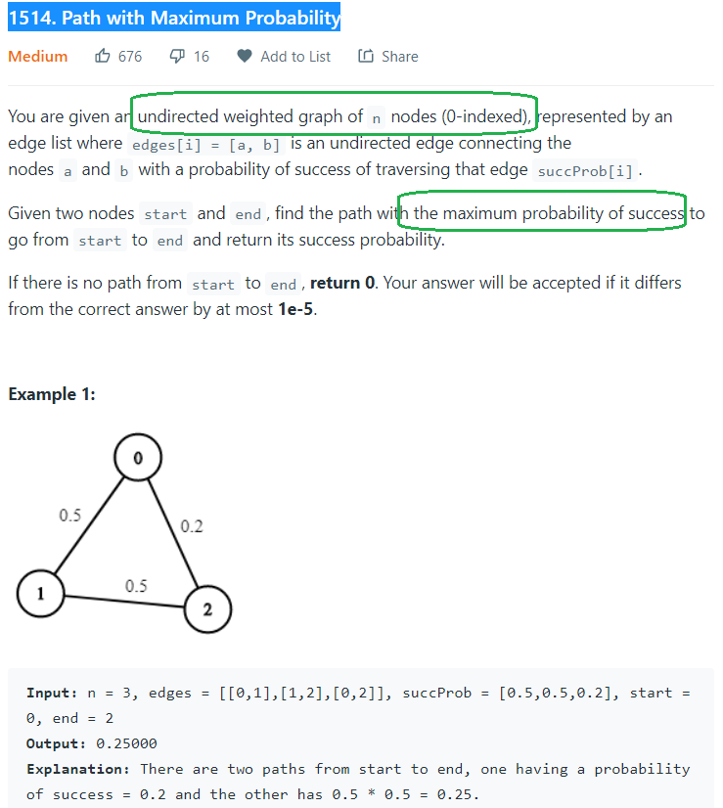

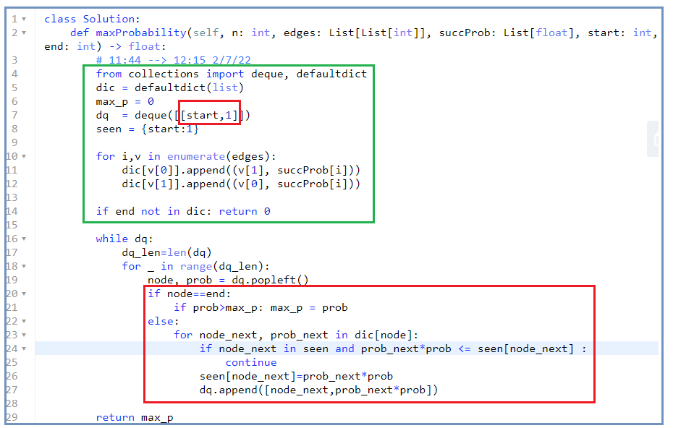 **,,,,,,,,,,,,,,,,,,,,,,,,,,,,,,,,,,,,,,,,,,,,,,,,,,,,,,,,,,,,,,,,,,,,,,,,,,,,,,,,,,,,,,,,,,,,,,,,,,,,,,,,,,,,,,,,,,,,,,,,,,,,,,,,,,,,,,,,,,,,,,,,,,,,** 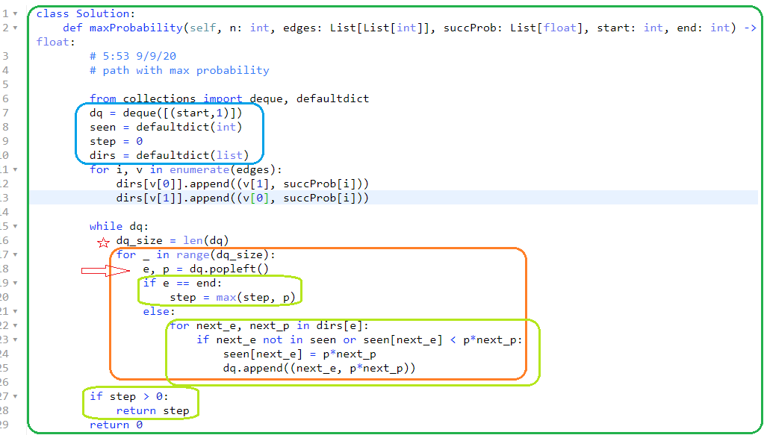

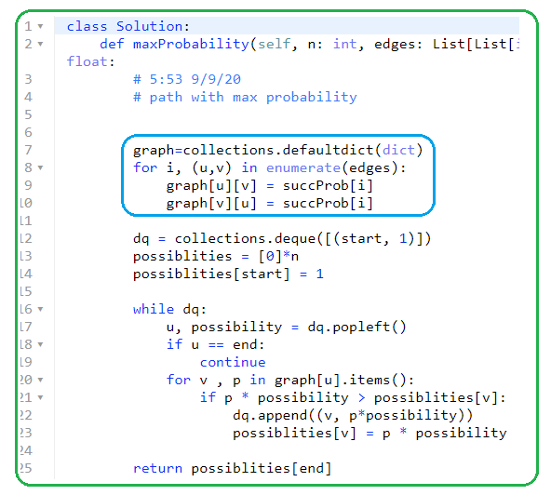

1. **DFS\*\*\*\*\***
2. **130. Surrounded Regions🡪backtracking**

**12/24/21, 2/7/22,4/7/22**

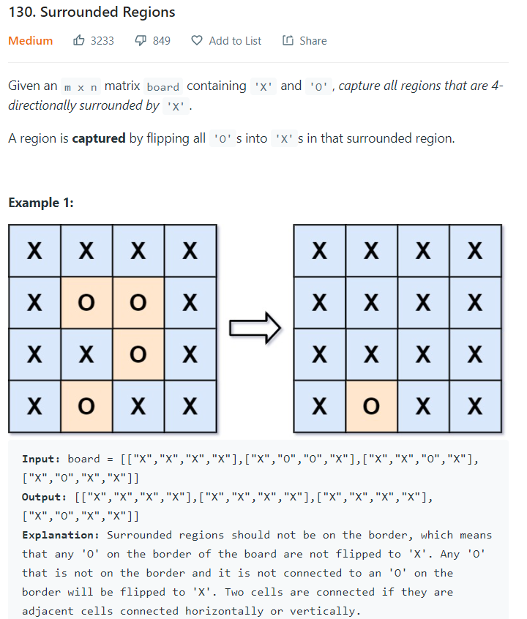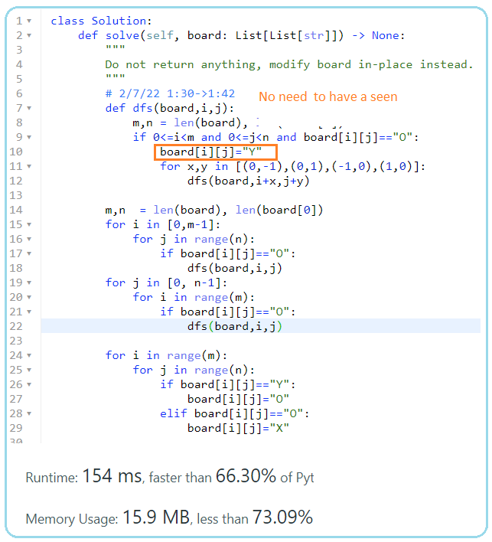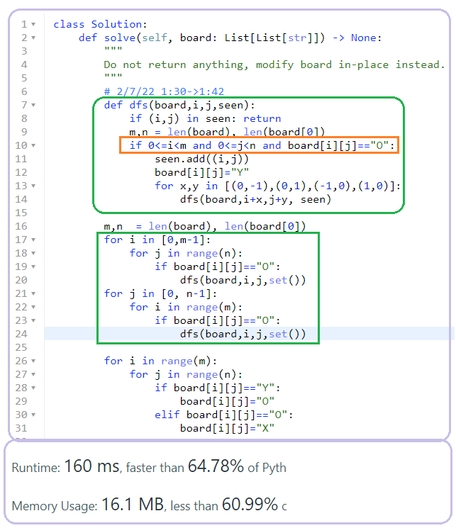

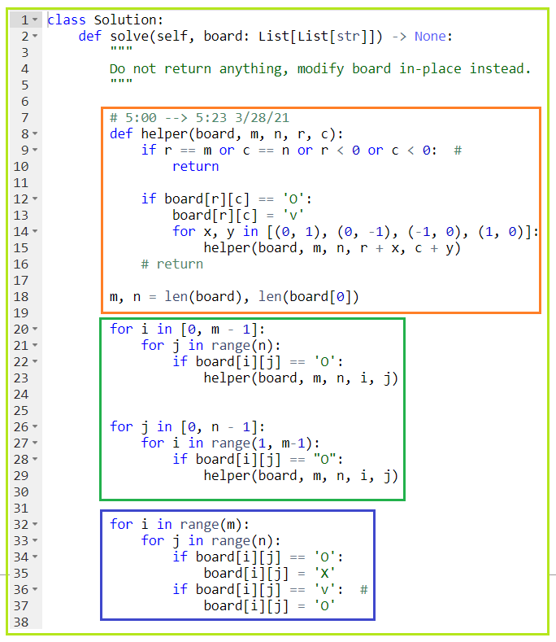

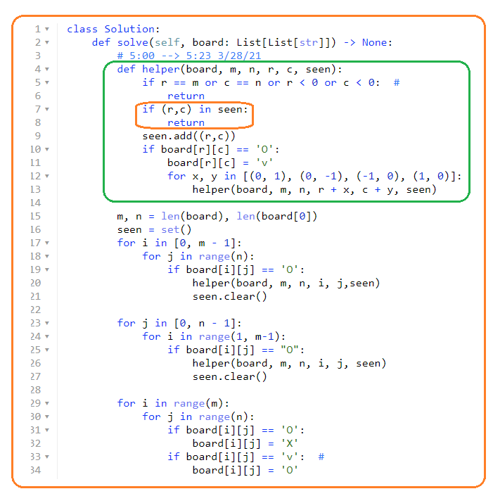

1. **464. Can I Win**

**Don’t understand**

**4/7/22,**

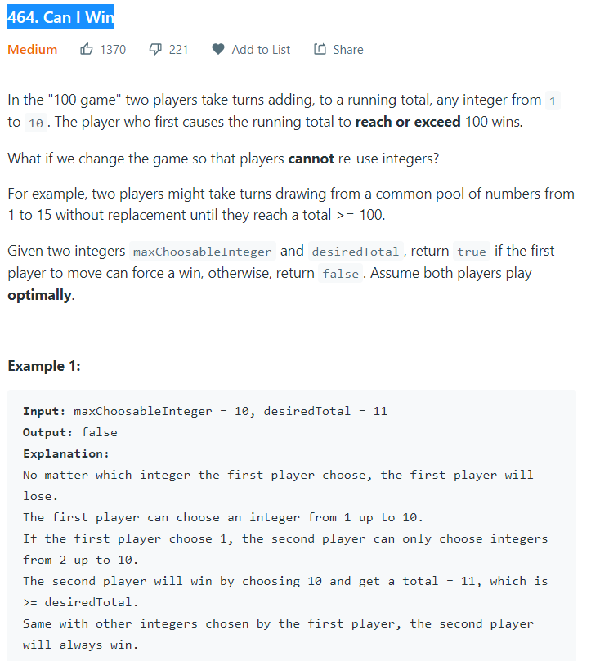

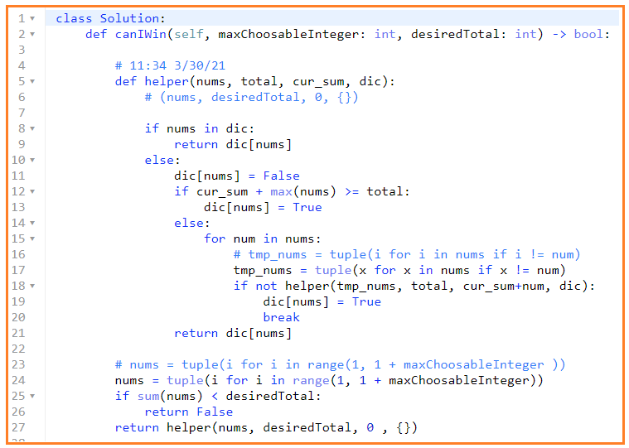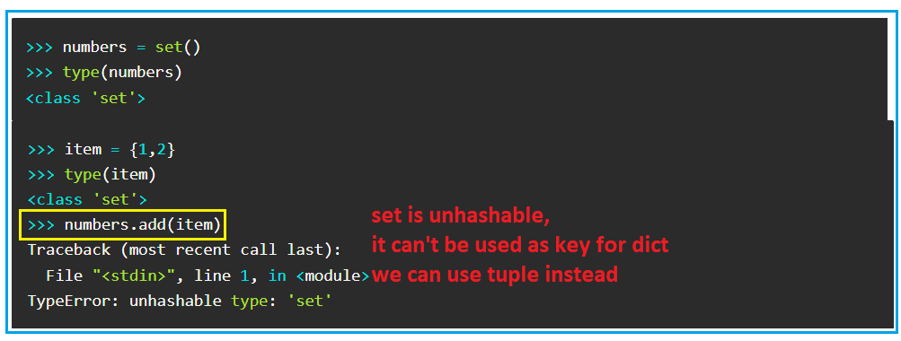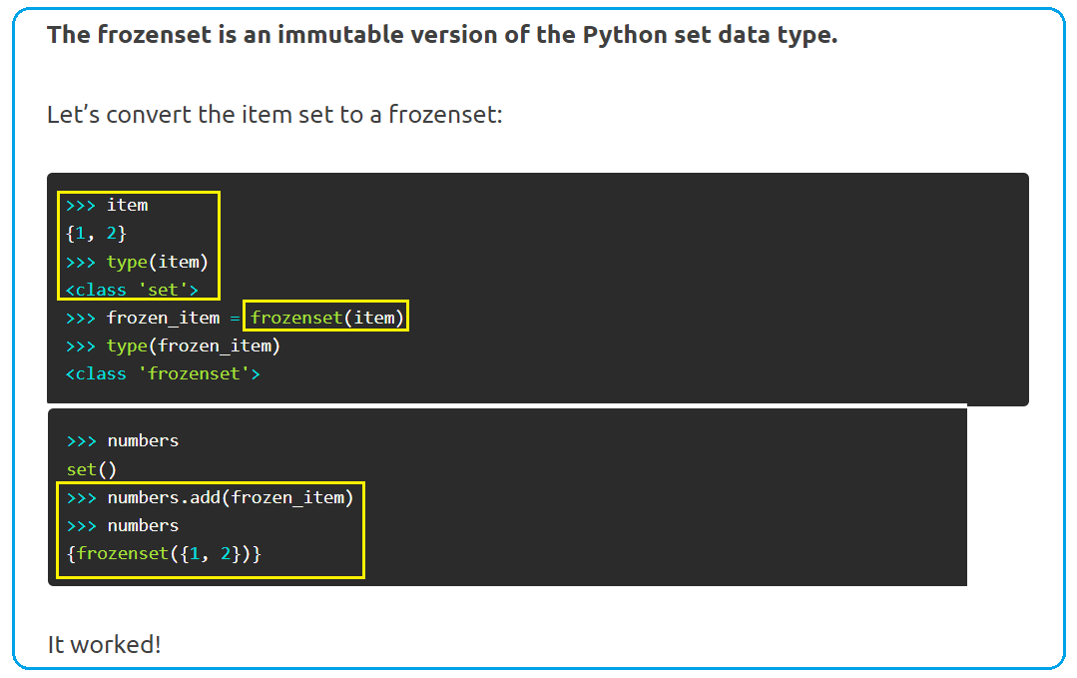

class Solution:  
 def canIWin(self, maxChoosableInteger: int, desiredTotal: int) -> bool:  
  
 # 11:34 3/30/21  
 def helper(nums, total, cur_sum, dic):  
 # (nums, desiredTotal, 0, {})  
  
 if nums in dic:  
 return dic[nums]  
 else:  
 dic[nums] = False  
 if cur_sum + max(nums) >= total:  
 dic[nums] = True  
 else:  
 for num in nums:  
 # tmp_nums = tuple(i for i in nums if i != num)  
 tmp_nums = tuple(x for x in nums if x != num)  
 if not helper(tmp_nums, total, cur_sum + num, dic):  
 dic[nums] = True  
 break  
 return dic[nums]  
  
 # nums = tuple(i for i in range(1, 1 + maxChoosableInteger ))  
 nums = tuple(i for i in range(1, 1 + maxChoosableInteger))  
 if sum(nums) < desiredTotal:  
 return False  
 return helper(nums, desiredTotal, 0, {})

1. **842. Split Array into Fibonacci Sequence**

**4/7/22, 5/3/**

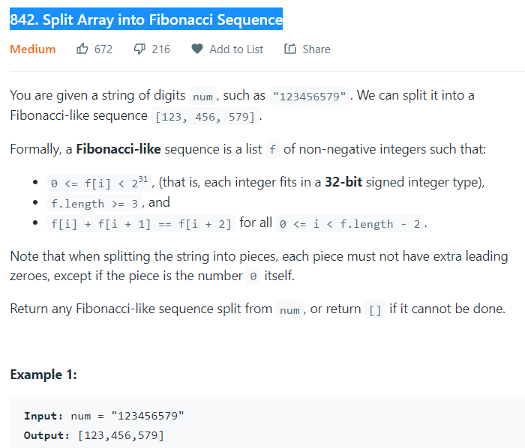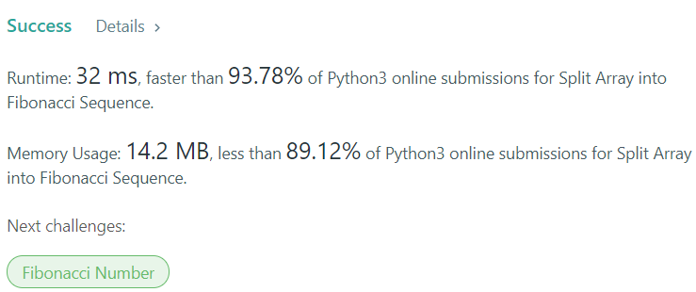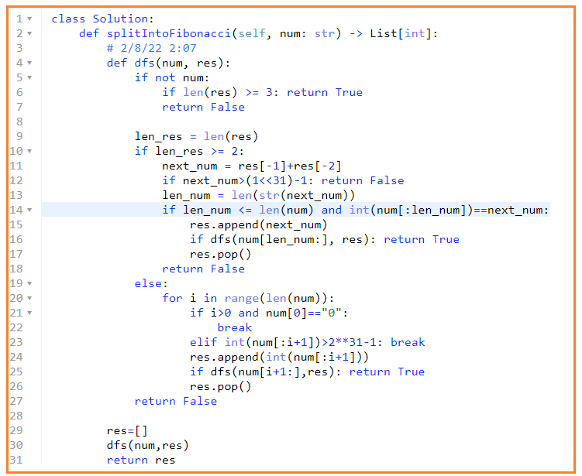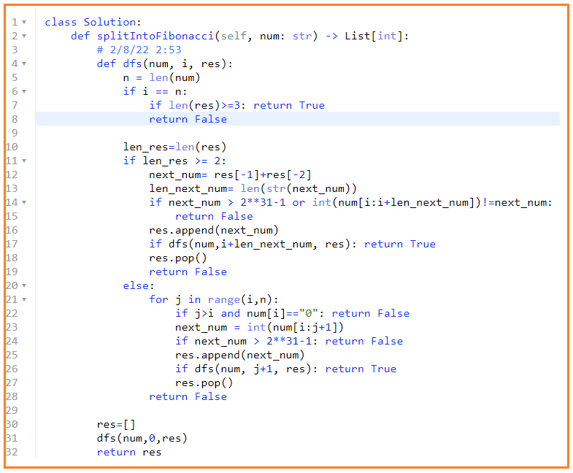

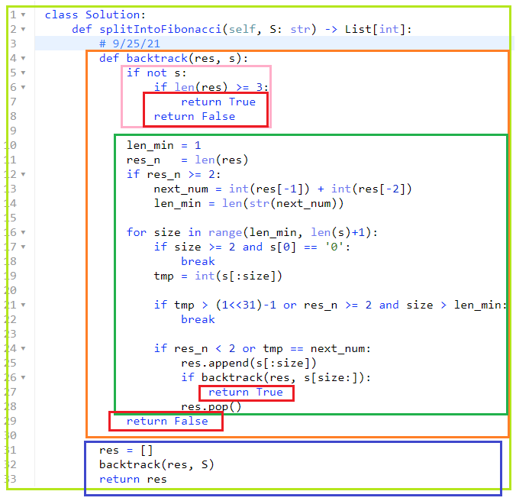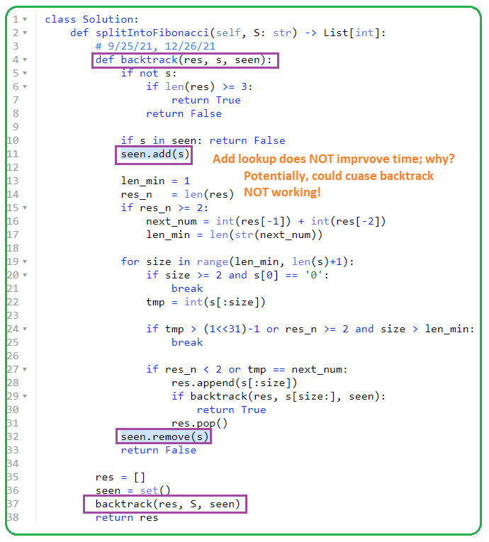

**# Save more space than above**

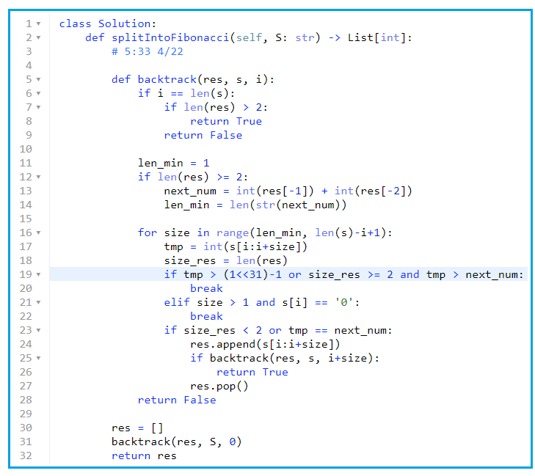

* **Not working**

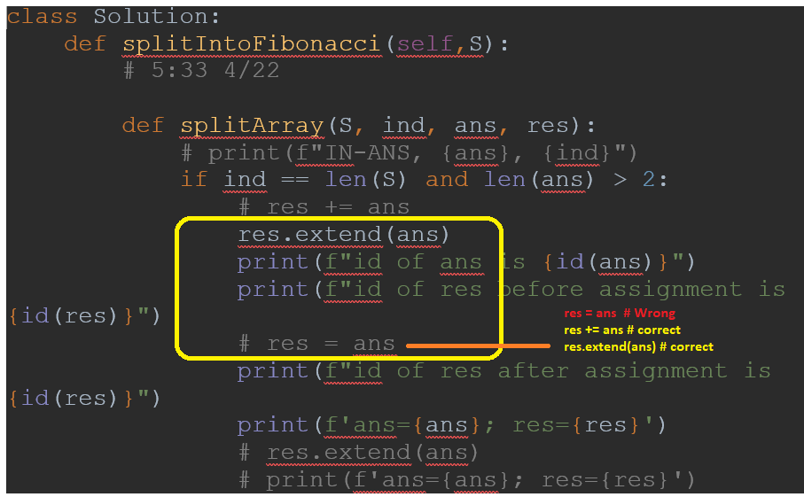

* **Working, but not good method since return statement is empty; better method is above that return True or False**

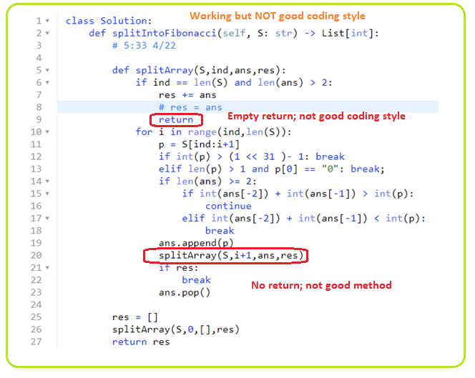

**9/27/21, 12/26/21**

1. **Work break 2/9/22, 4/7/22, 5/3**

****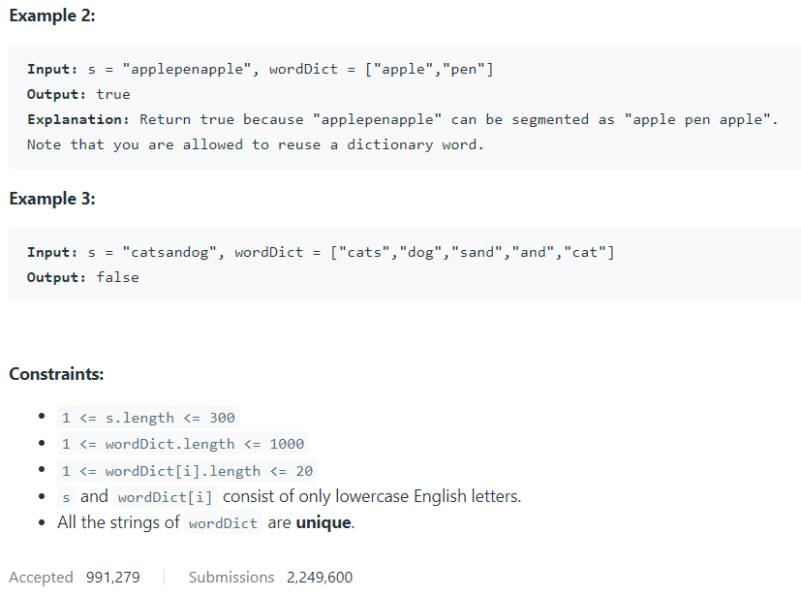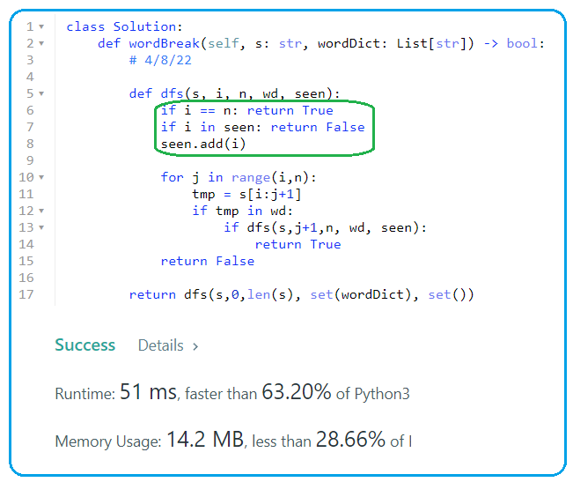

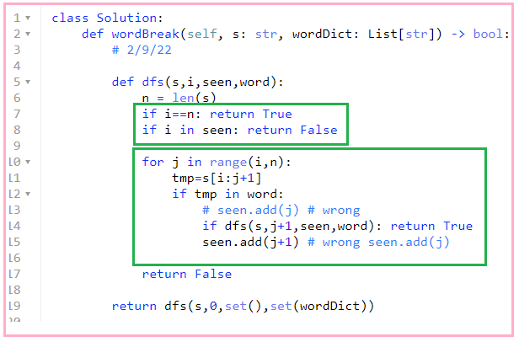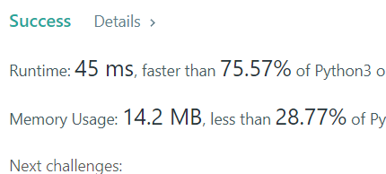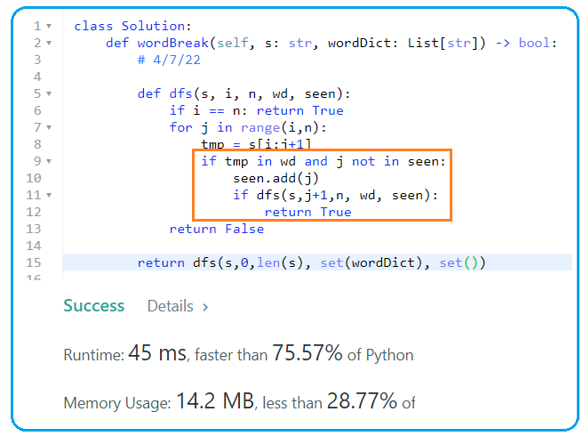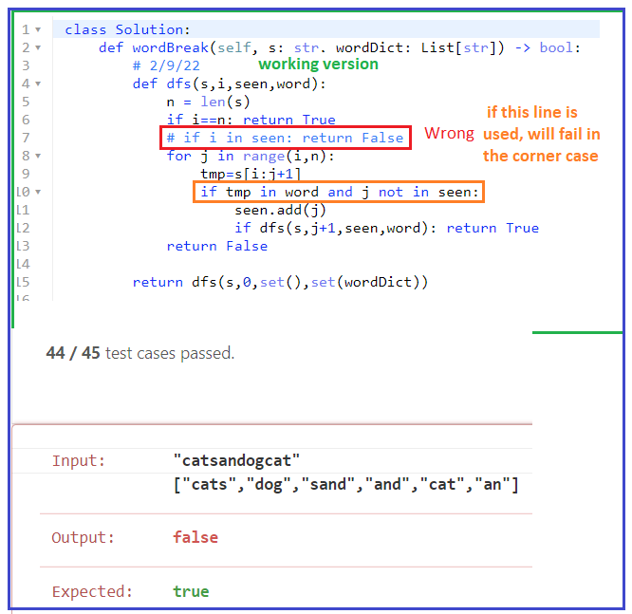



1. **91. Decode Ways, 2/10/22, 4/7/22, 5/3/22**



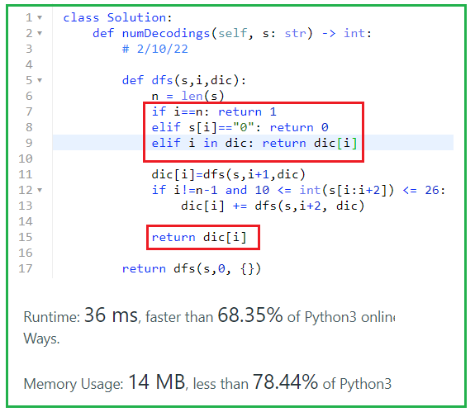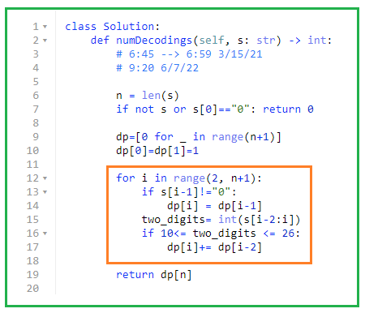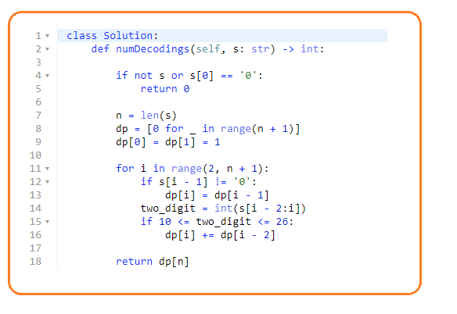

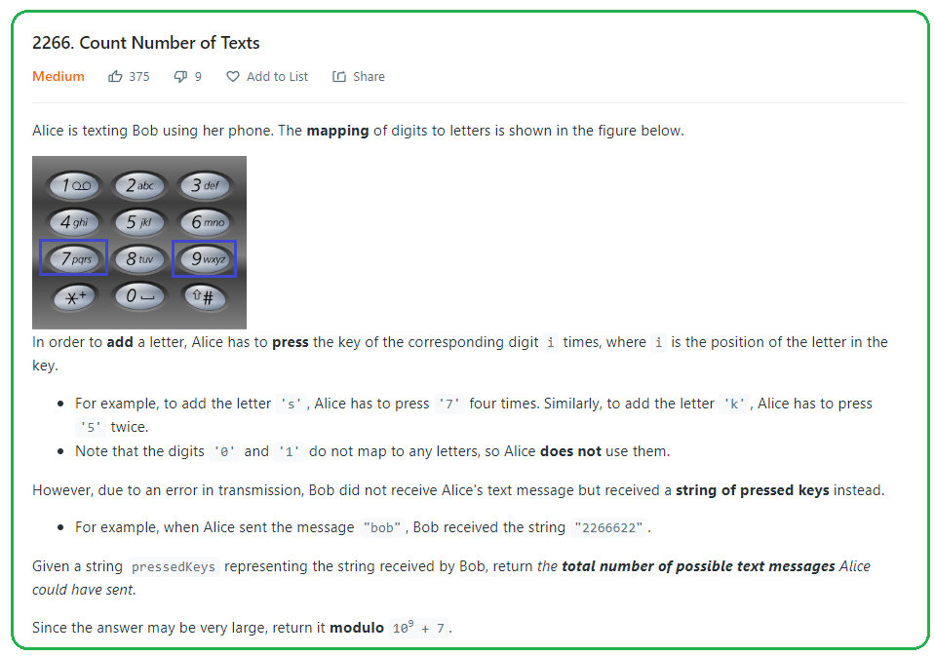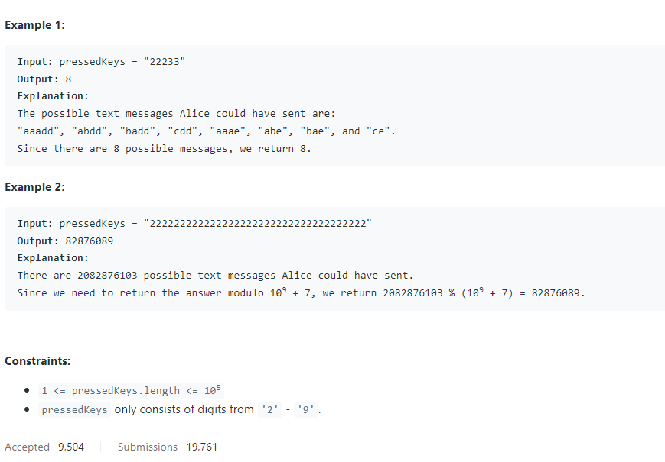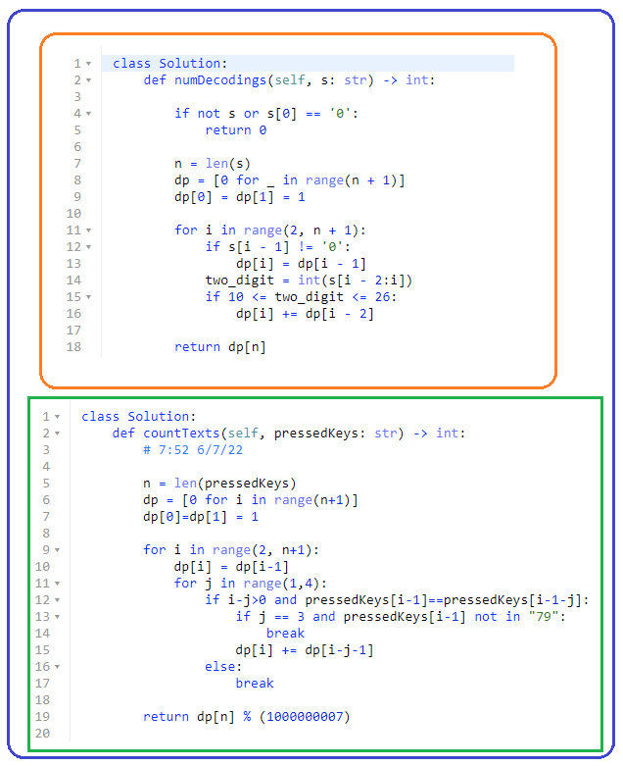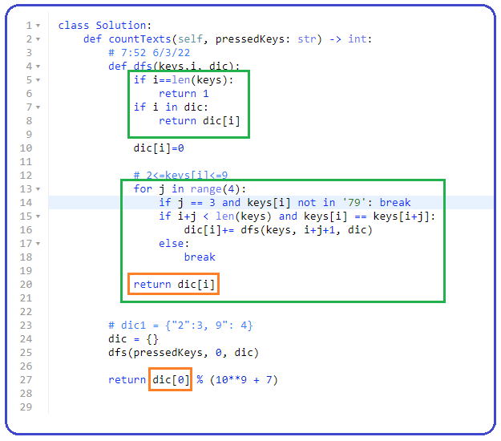

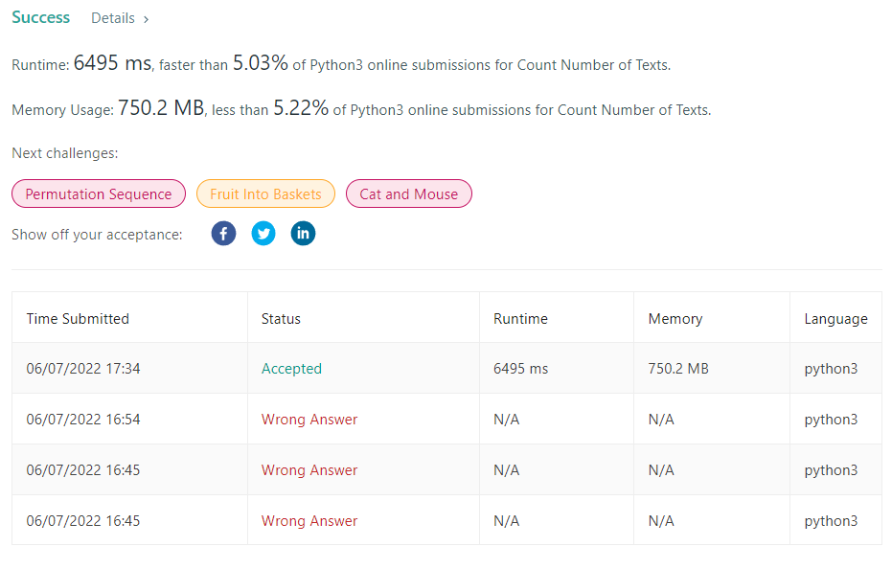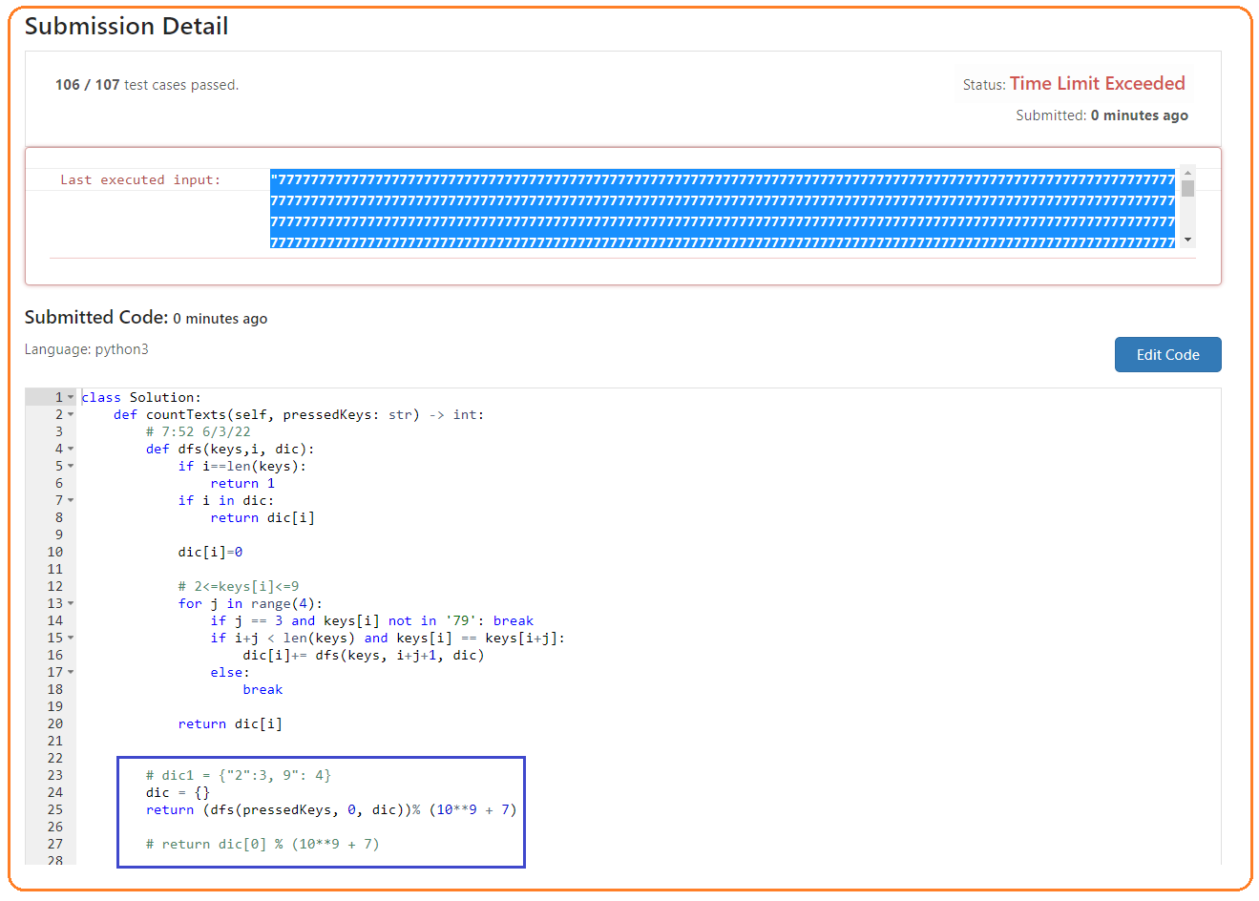

1. **79. Word Search, 4/8/22**

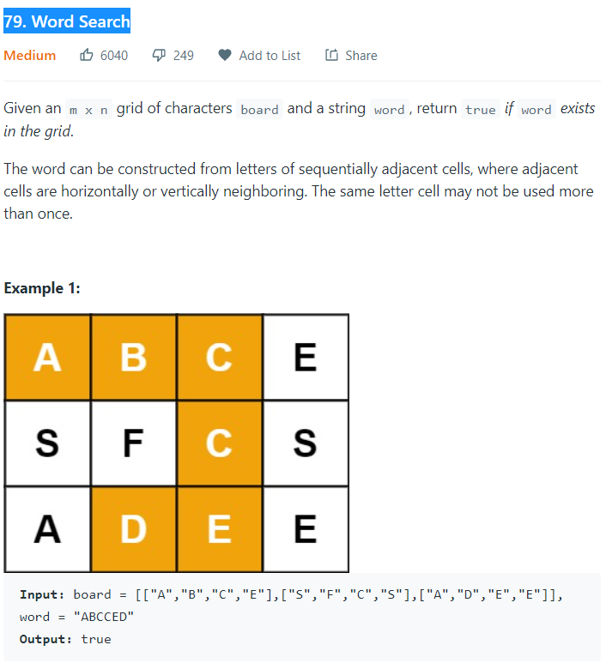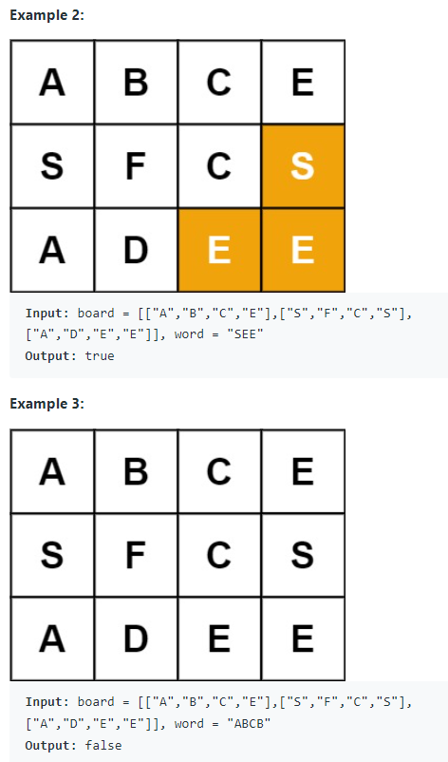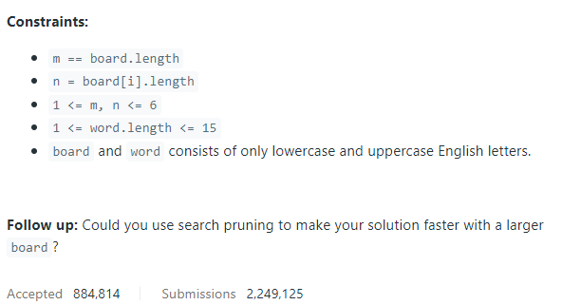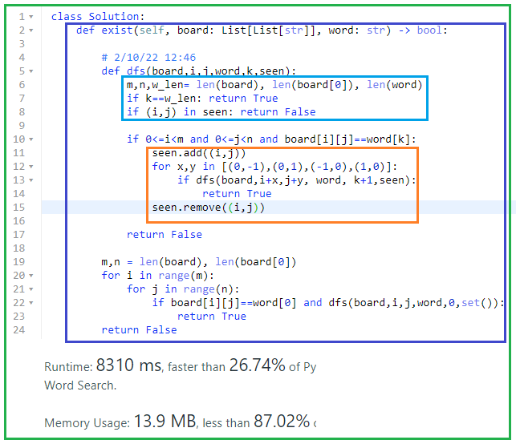

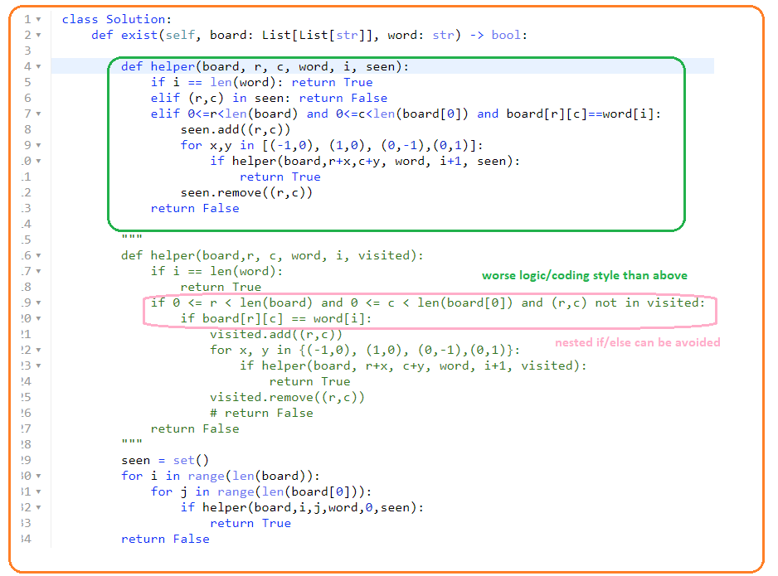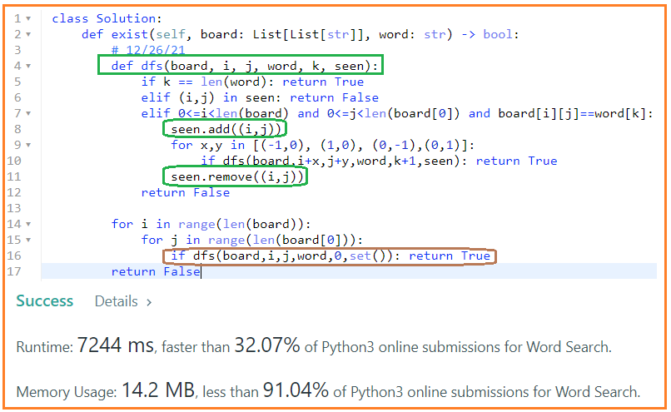

1. **473. Matchsticks to Square**

**12/26/21, 2/10/22,4/8/22,5/3,**

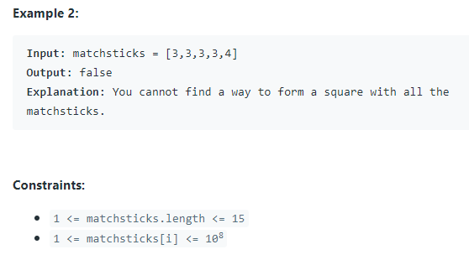

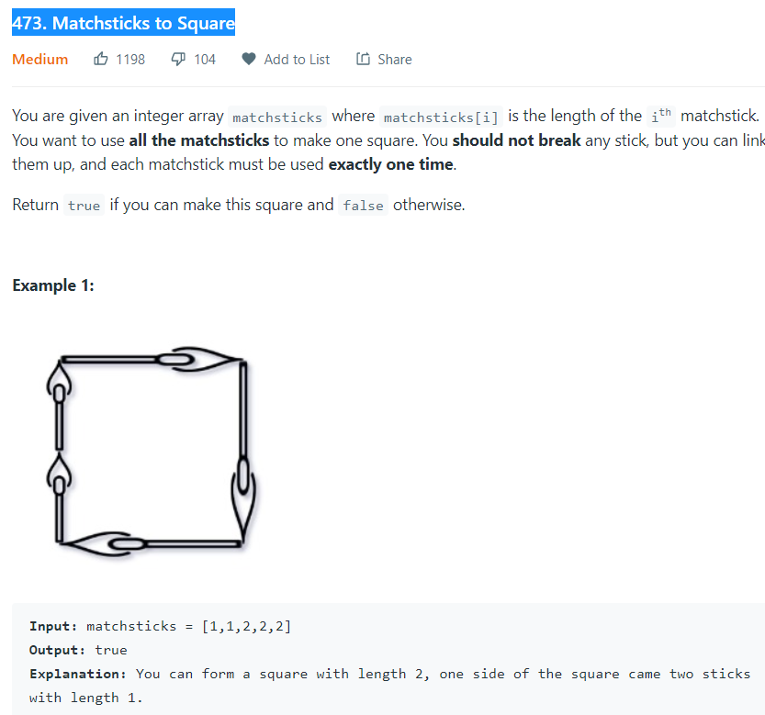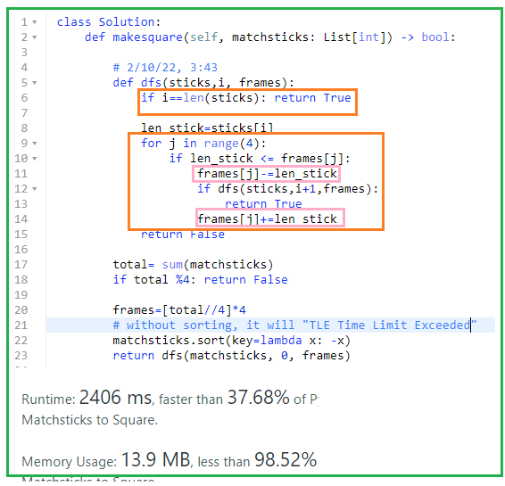

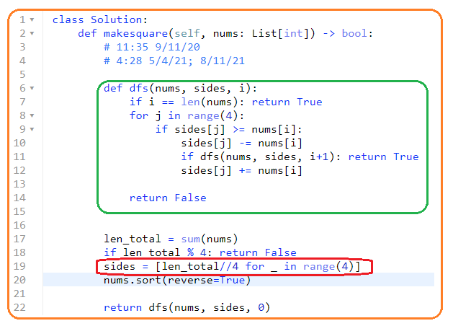

**9/27/21, 2/11/22,4/8,**

1. **Sum of subarrays == target value**

**Key: handle init_val == 0 case**

1. **1546. Maximum Number of Non-Overlapping Subarrays With Sum Equals Target**

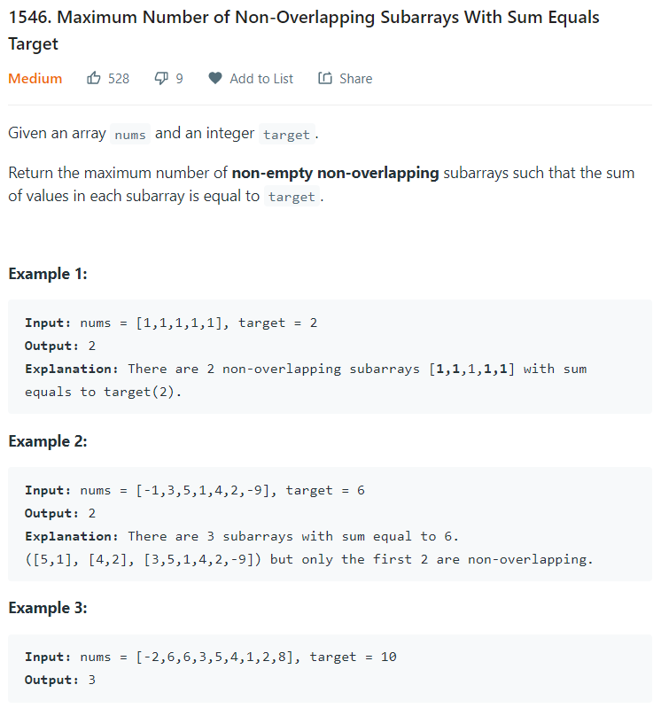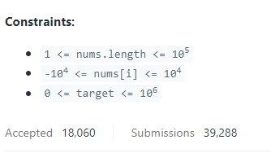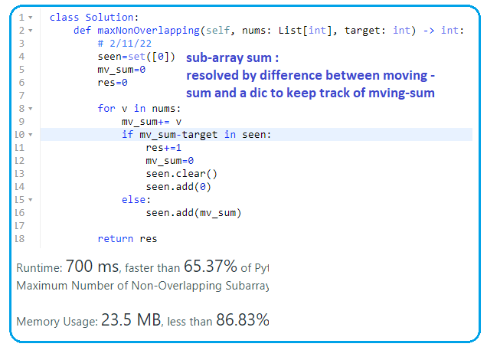

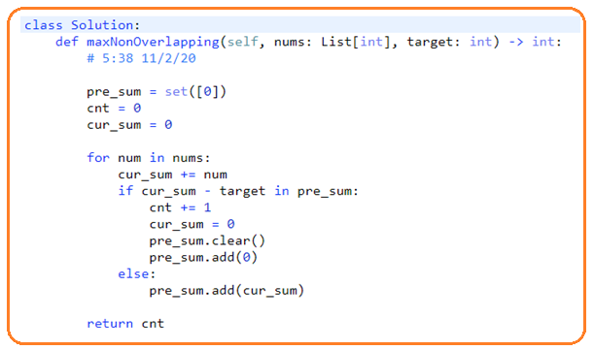

**Calculate cumulative sum**

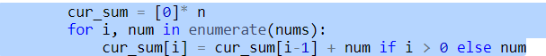

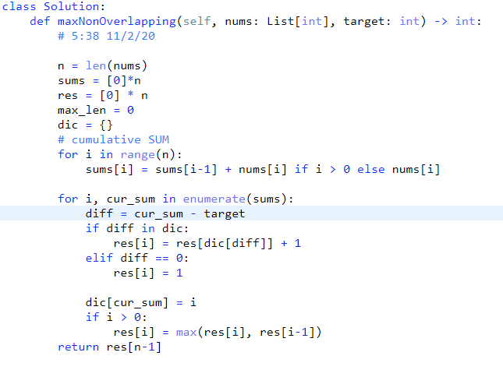

**Be careful, the array cumulative sum is NOT strictly increasing since the array element can be 0, or negative.**

1. **523. Continuous Subarray Sum**

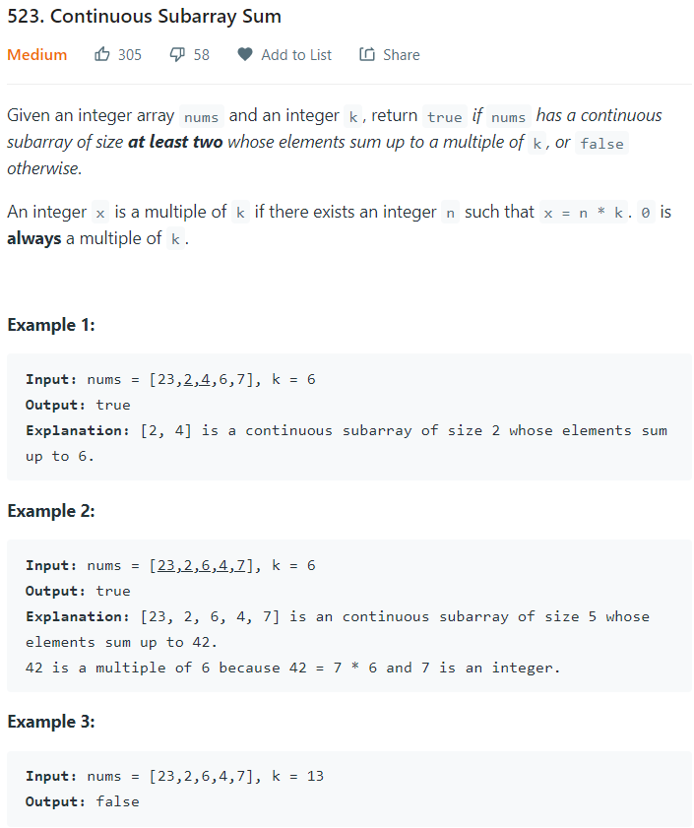

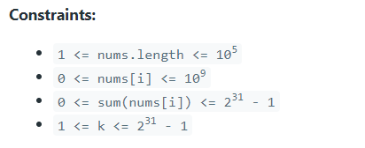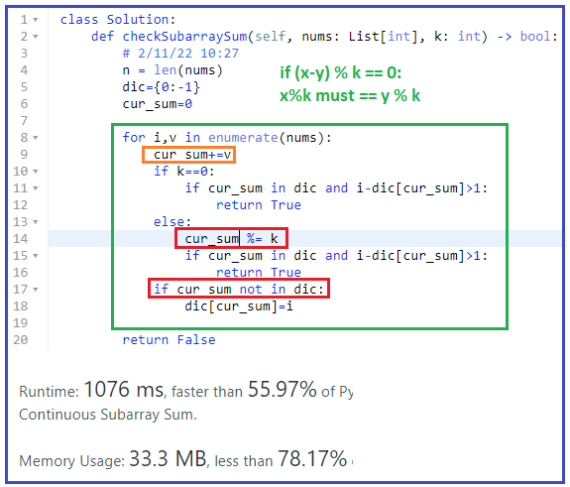

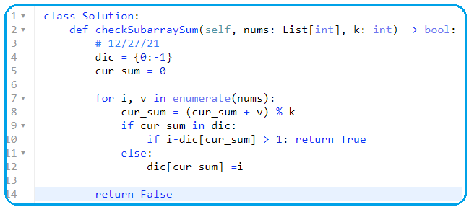

1. **53. Maximum Subarray**

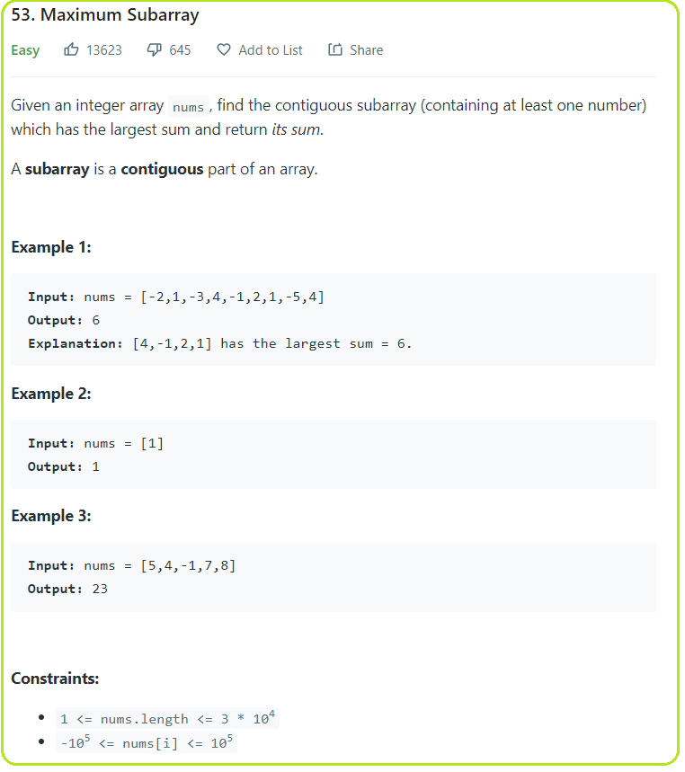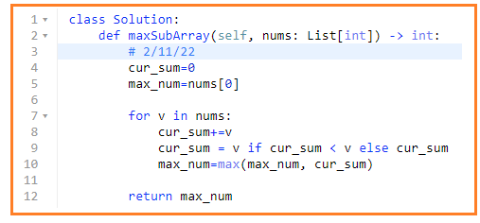

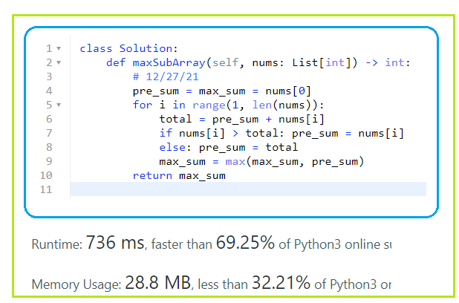

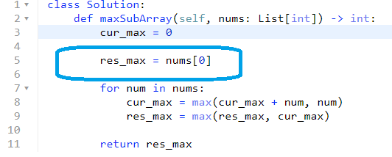

1. **918. Maximum Sum Circular Subarray**

**4/13/22, 5/4**

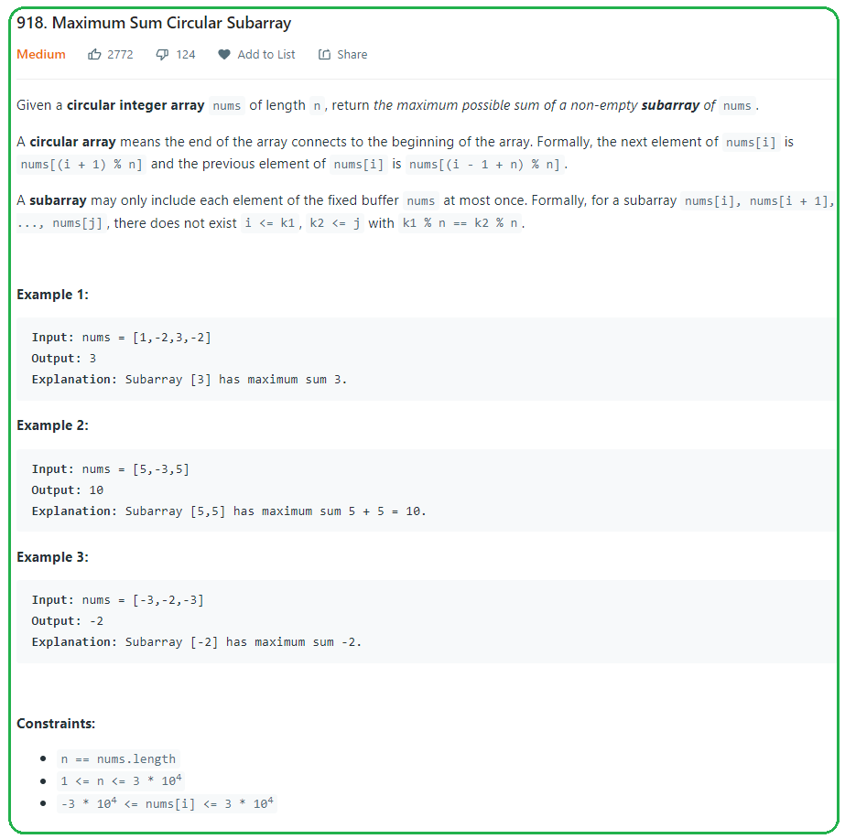

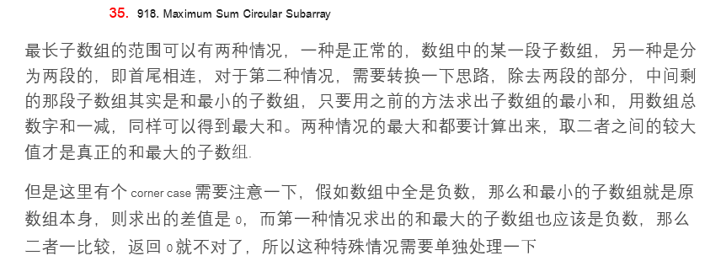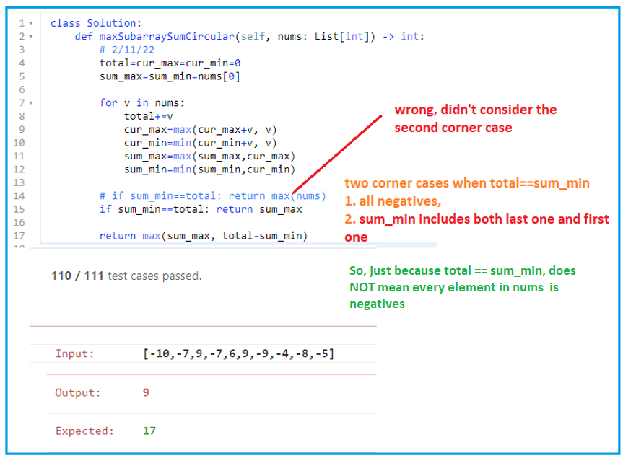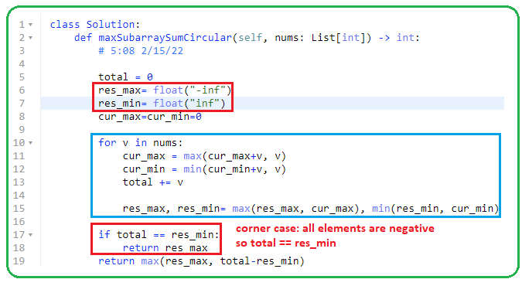

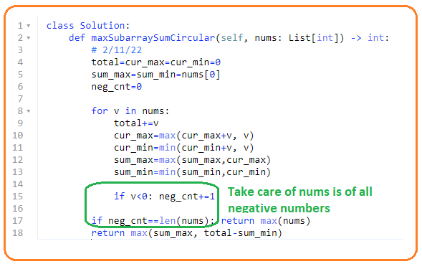

1. **1477. Find Two Non-overlapping Sub-arrays Each With Target Sum**

**12/28/21, 2/12/22, 4/13/22, 5/4**

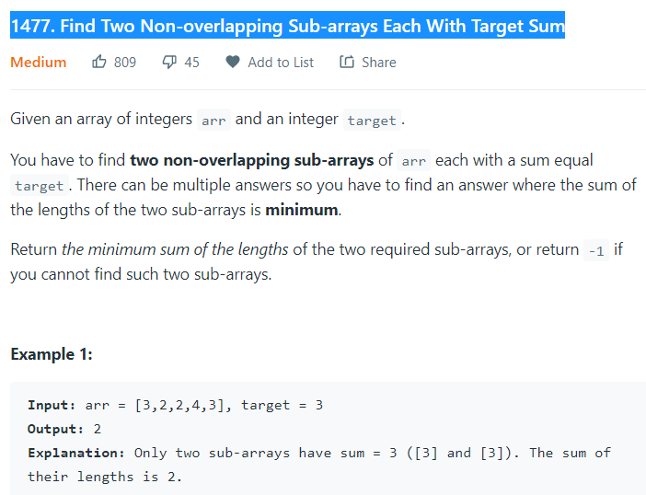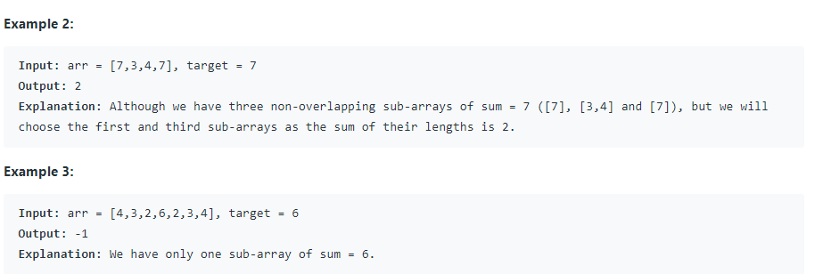

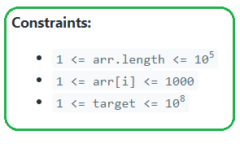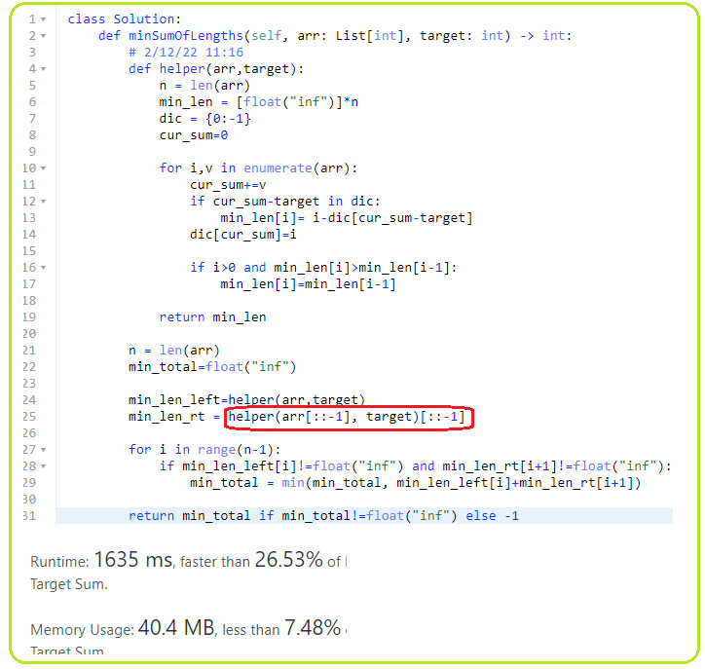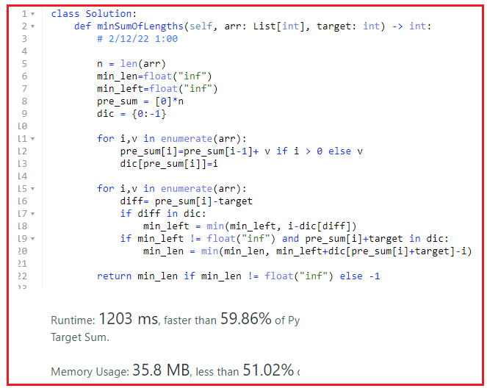

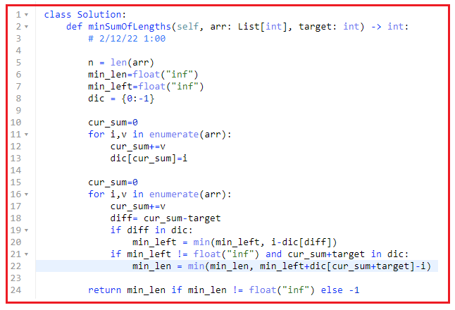

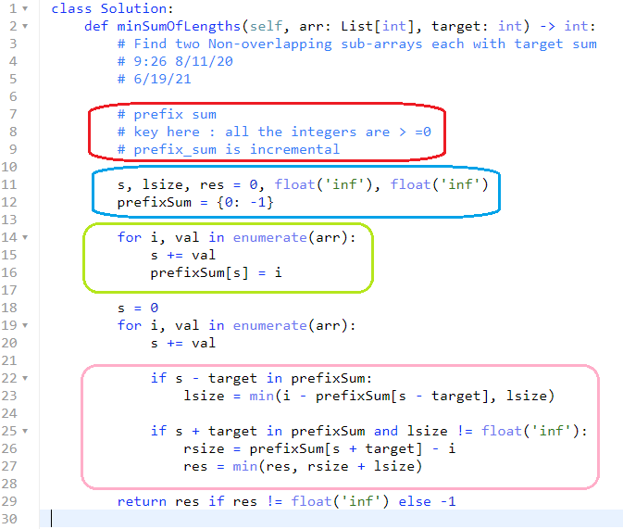

1. **Sum of subsequence of array**
2. **3sum with 3 pointers**

**12/28/21, 2/12/22,4/14/22**

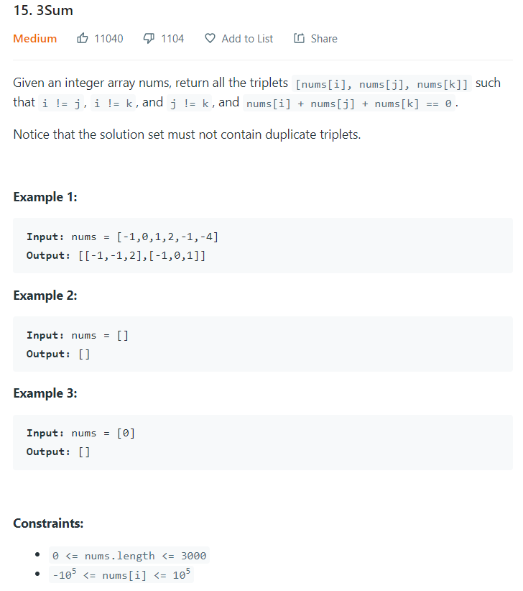

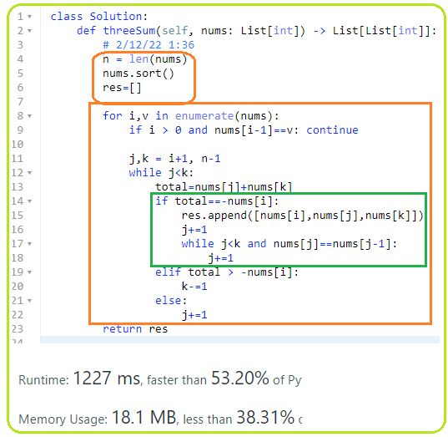

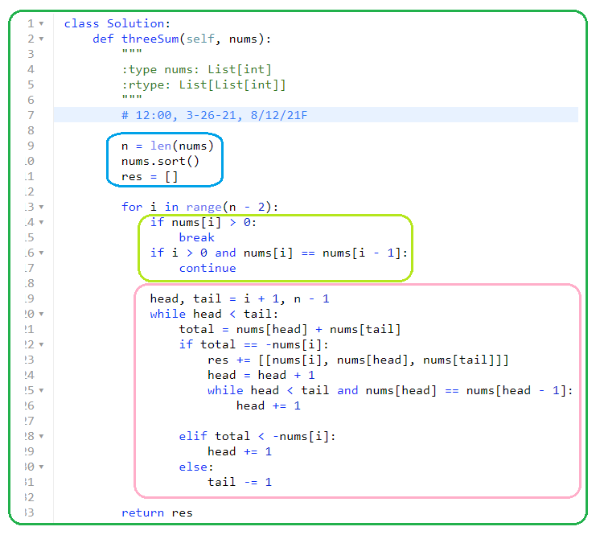

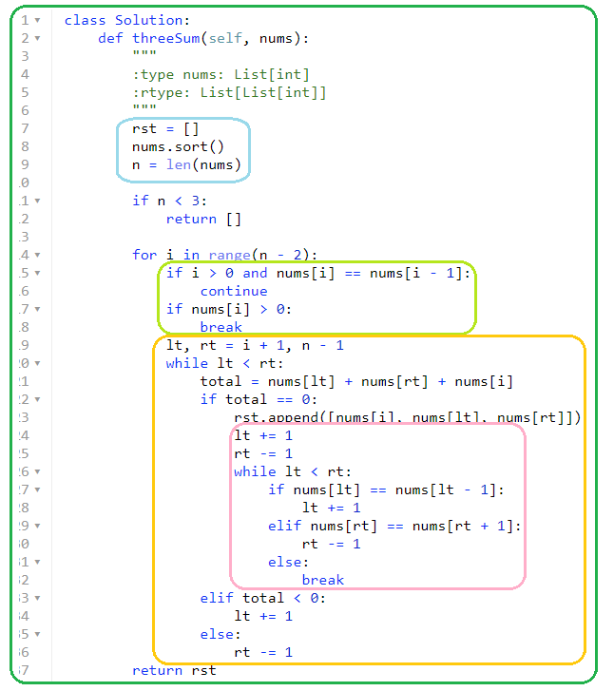

1. **Find max sum of sub-array**

**12/29/21, 2/12/22,**

1. **1191. K-Concatenation Maximum Sum**

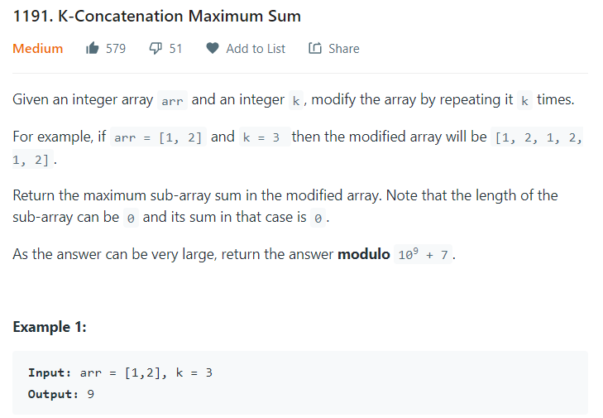

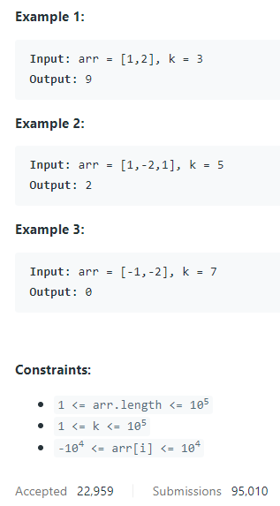

**Array can have negative values.**

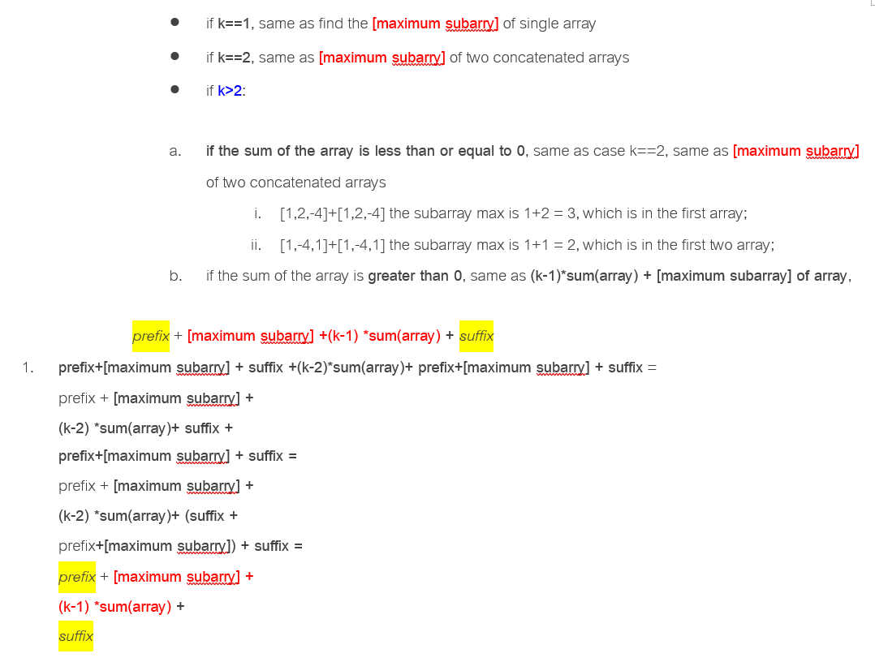

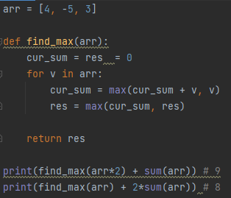

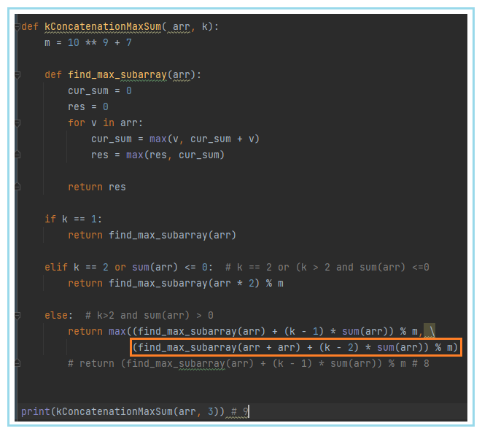

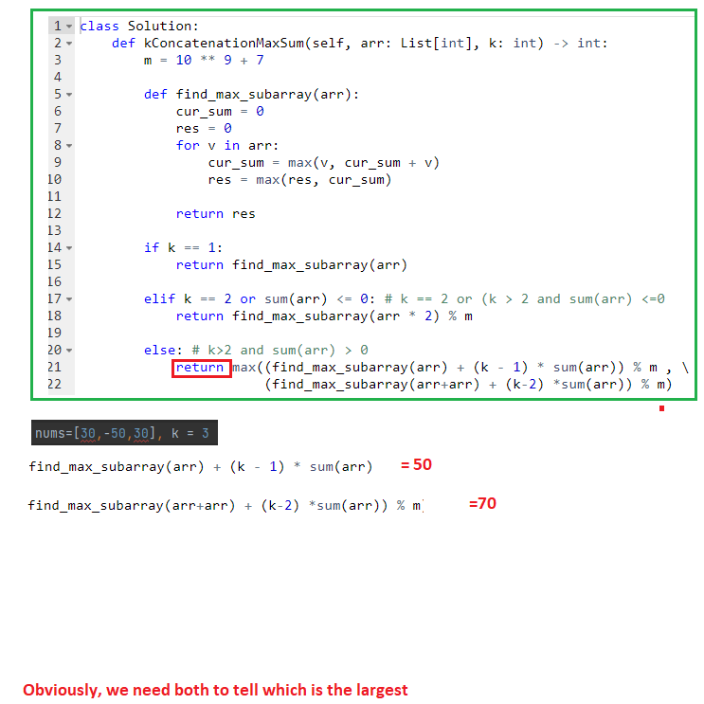

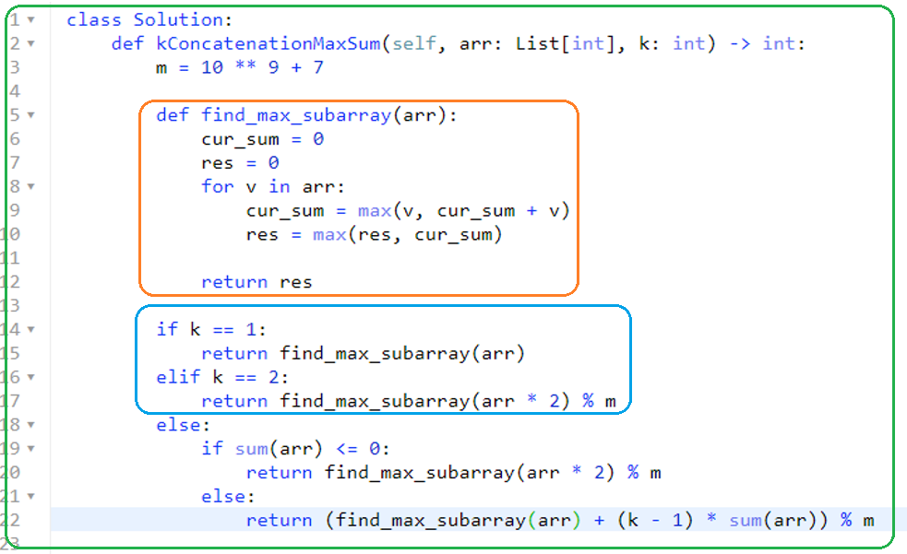

1. **198. House Robber**

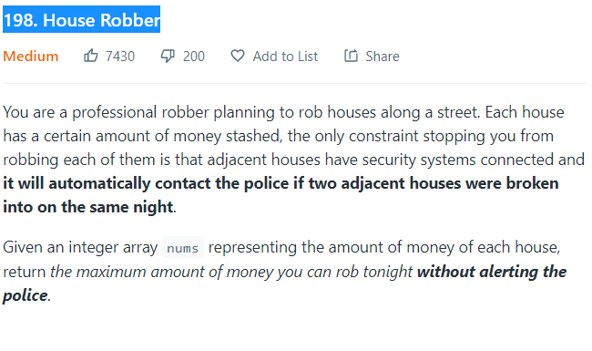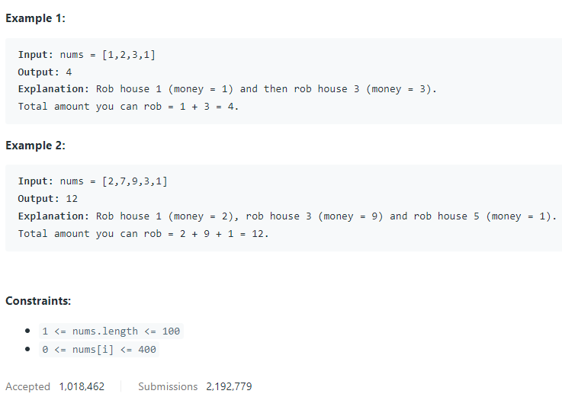

* **Simplified DP; each house is considered the last house and should return the largest amount of money SO FAR**
* 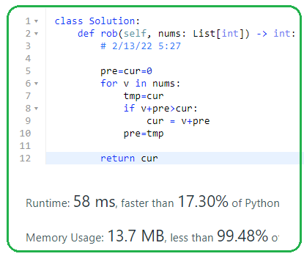
* 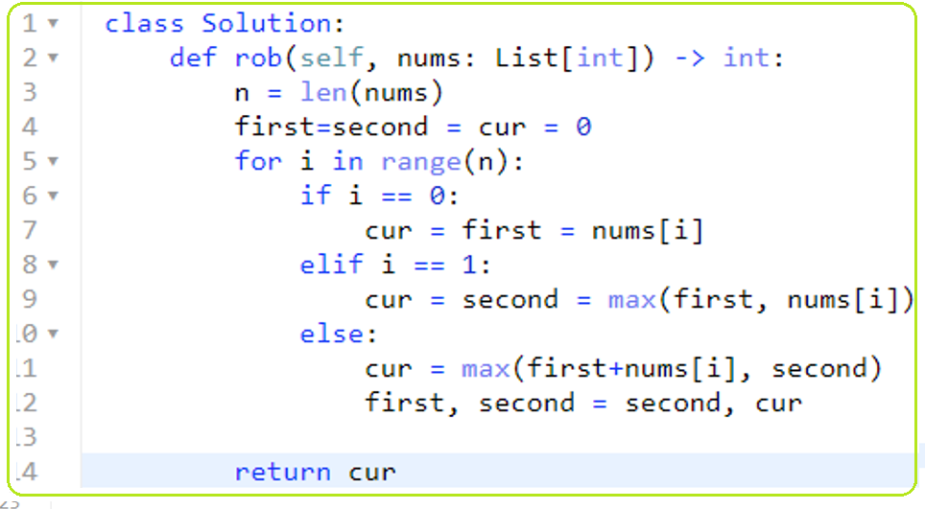
* 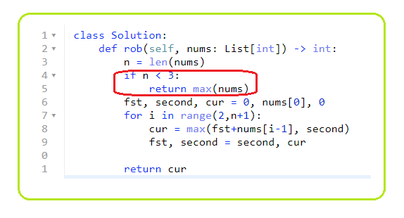

**Simplified even more**

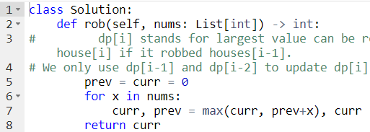

* **Regular dp**

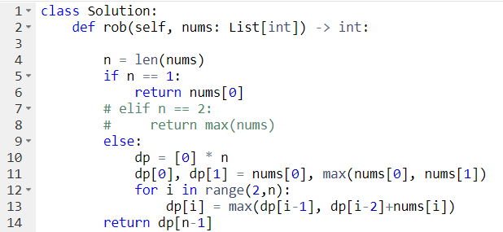

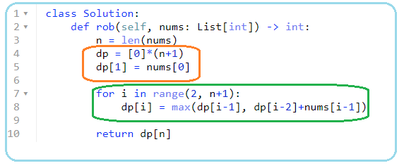

1. **213. House Robber II**

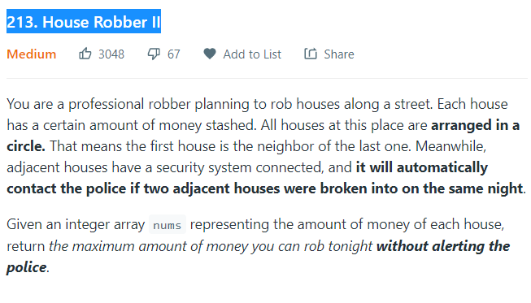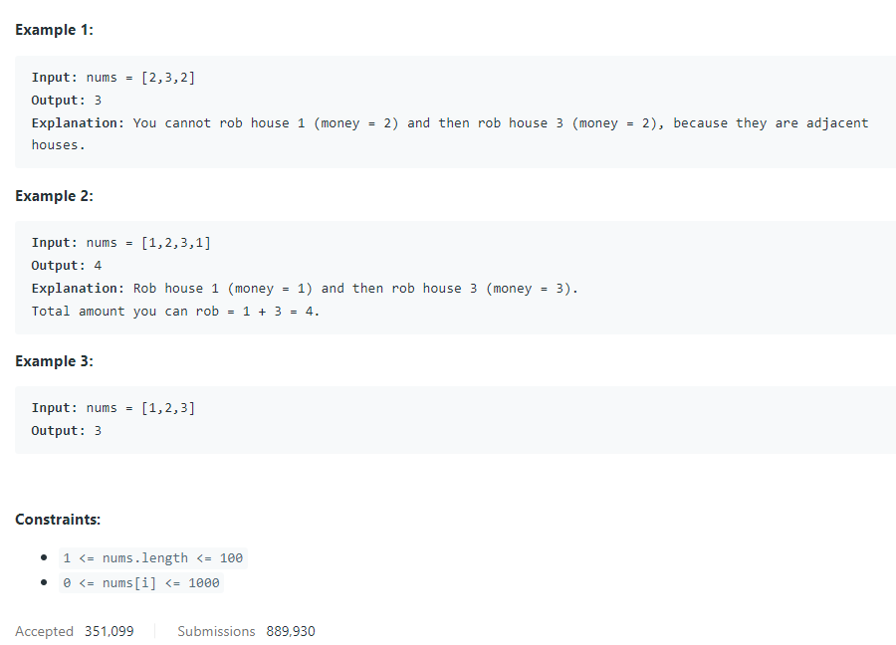

* **Dp**

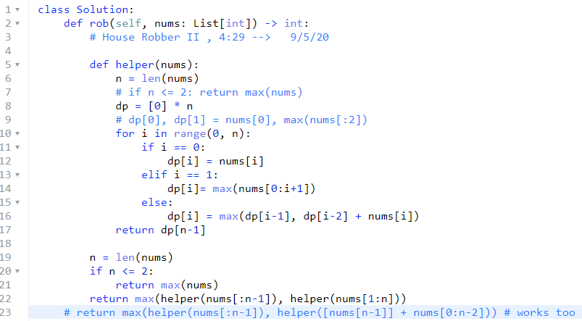

* **Simplified DP**

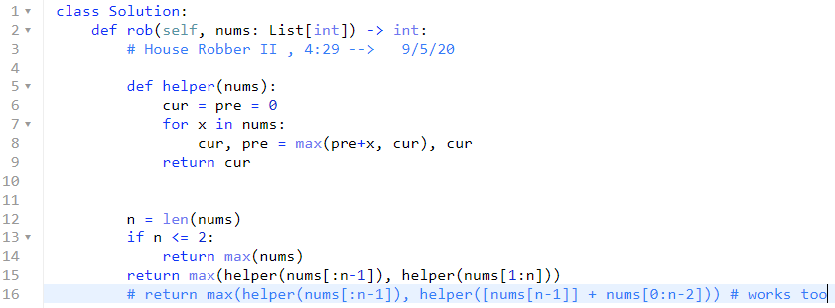

1. **Circular Array \*\*\*\*\***
2. **Dectect Cycle with set(),**

**12/29/21, 2/14/22,**

**457. Circular Array Loop**

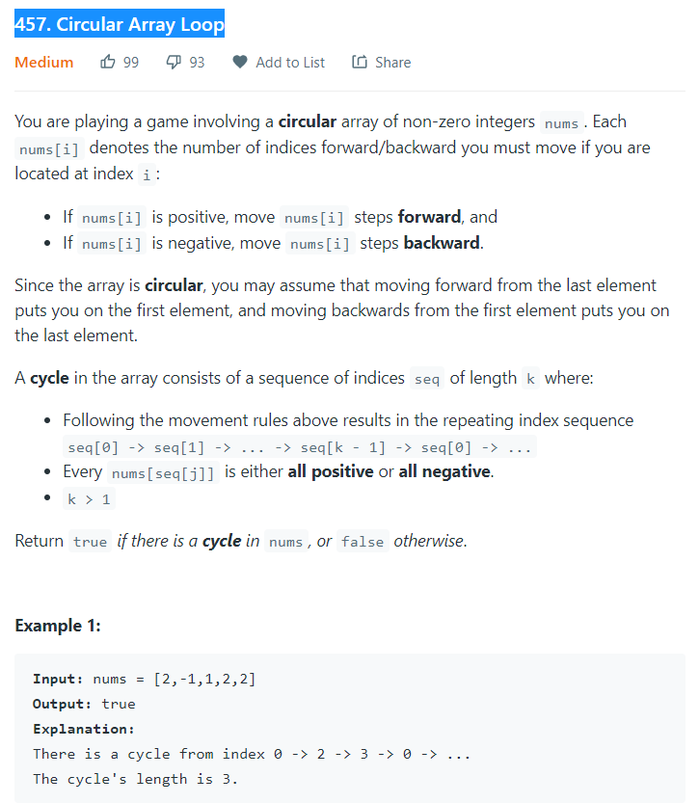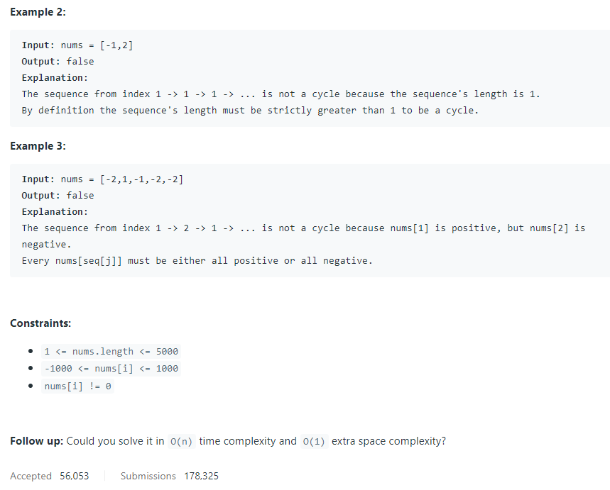

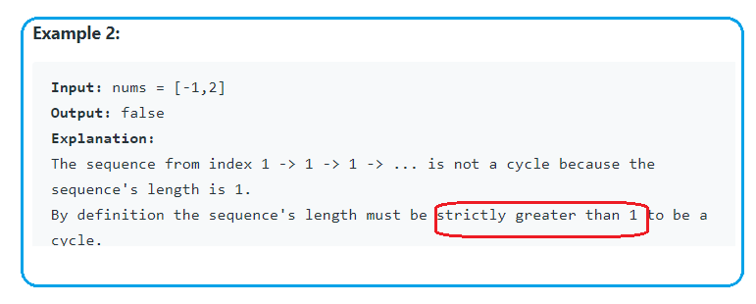

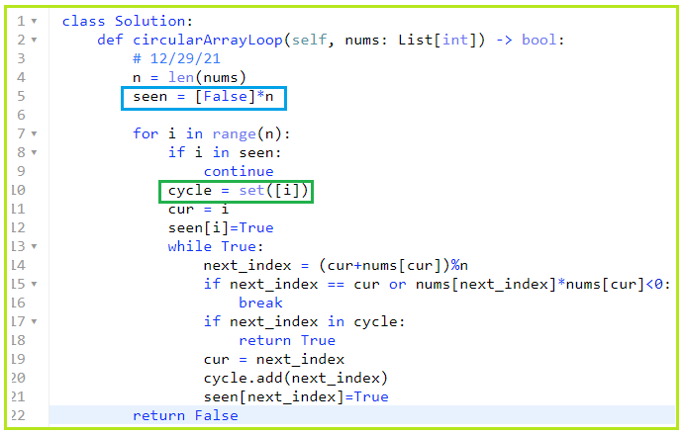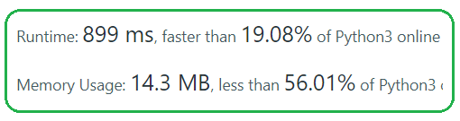

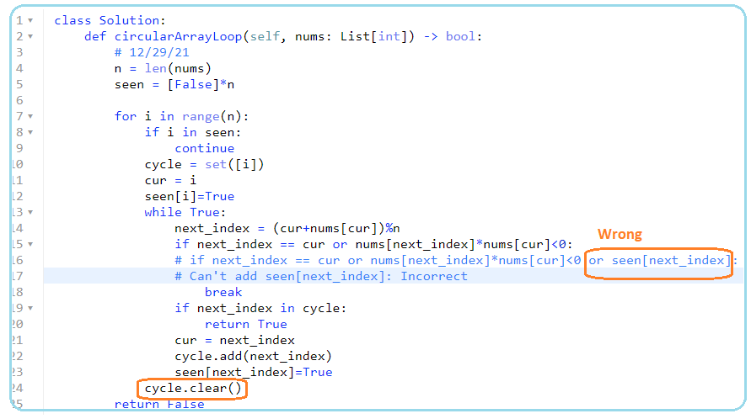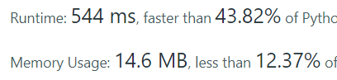

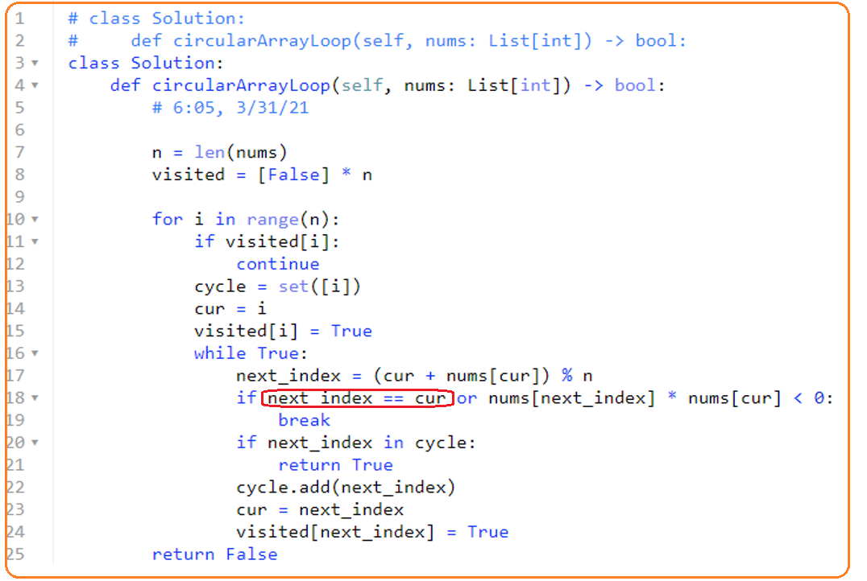

1. **Detect cycle with slow/fast pointers**

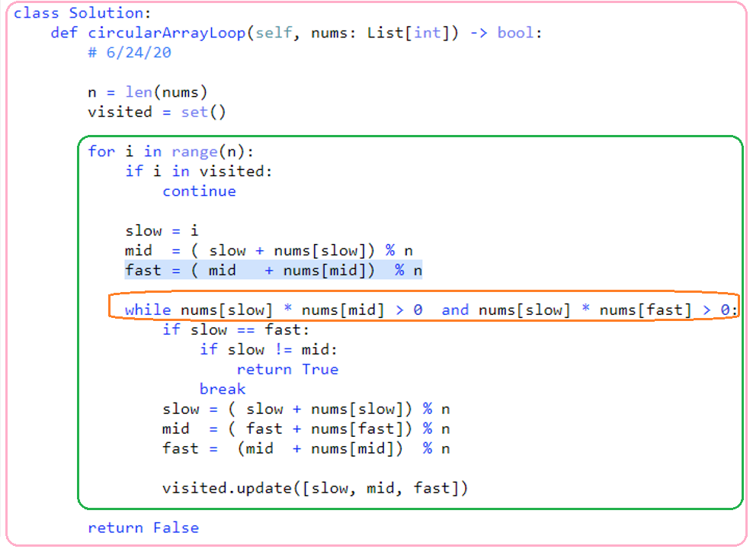

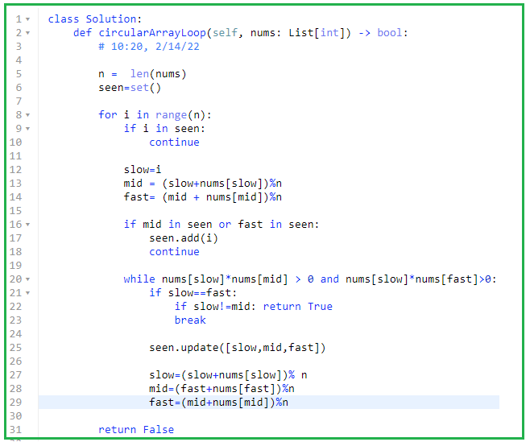

1. **61. Rotate List**

**2/15/22,**

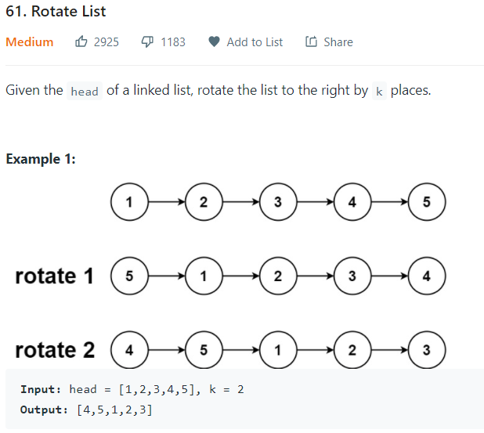

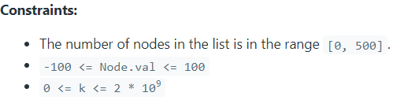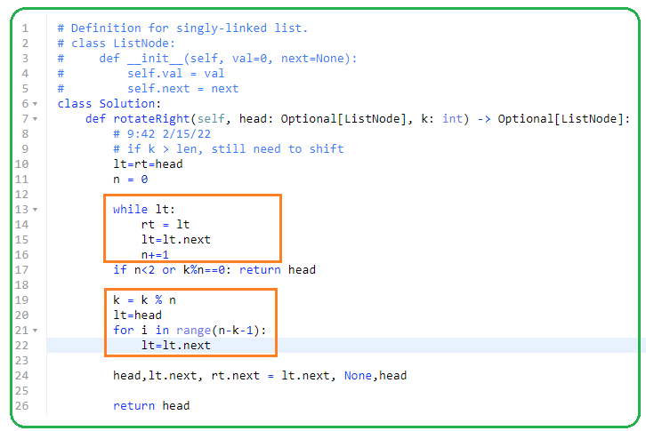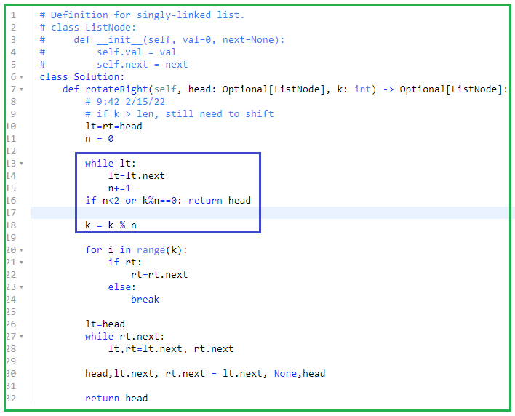

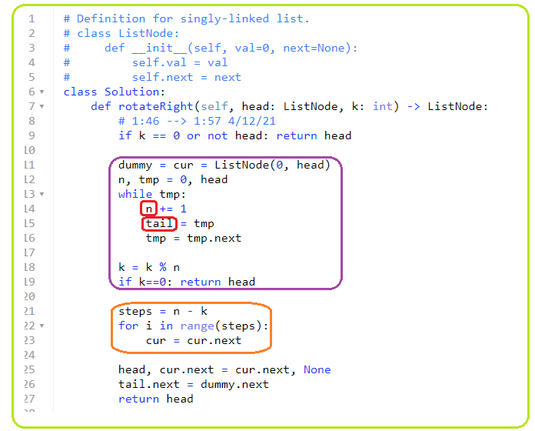

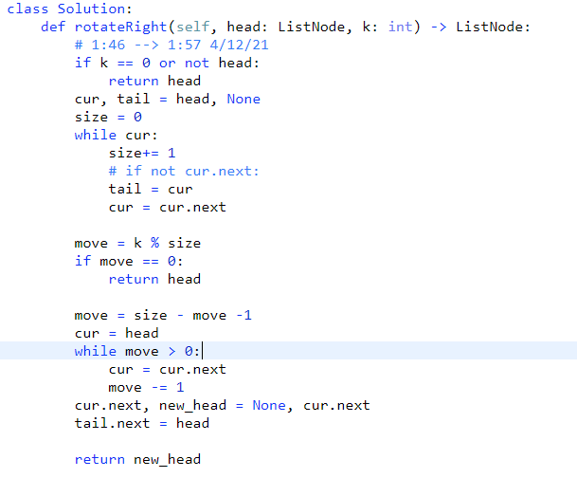

**9/29/21, 12/29/21**

1. **Corner case + detect cycle in circular Linked list**

**708. Insert into a Sorted Circular Linked List**

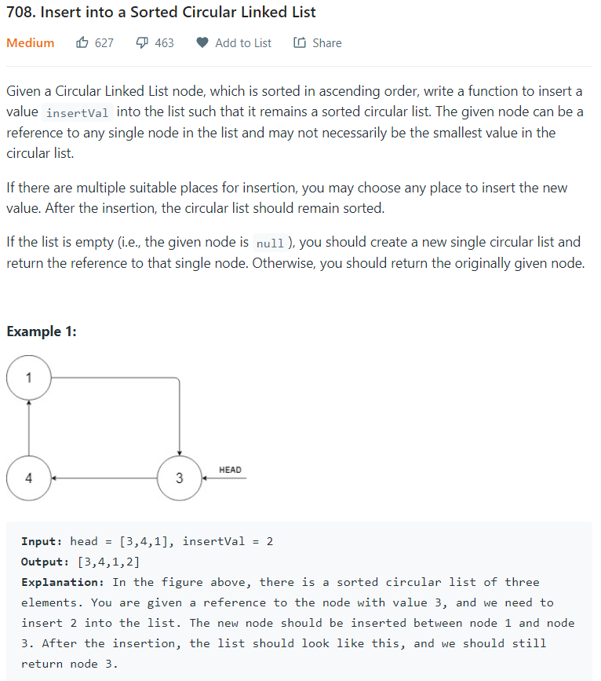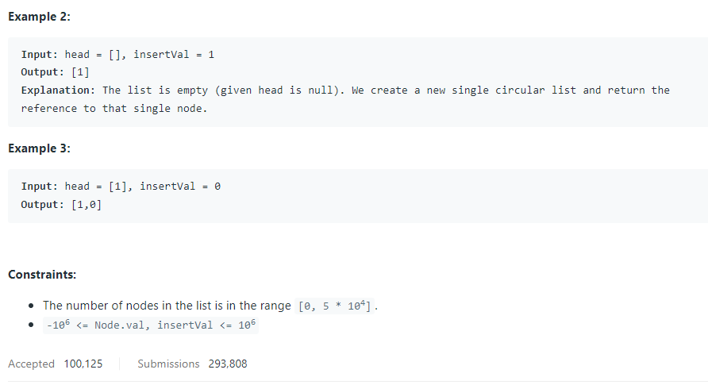

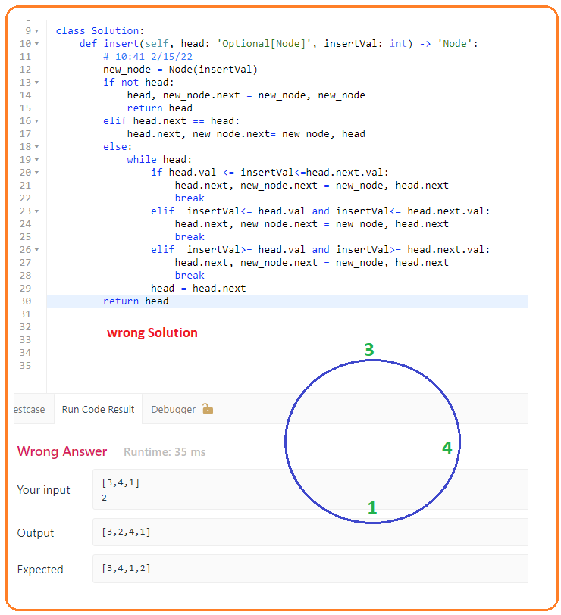

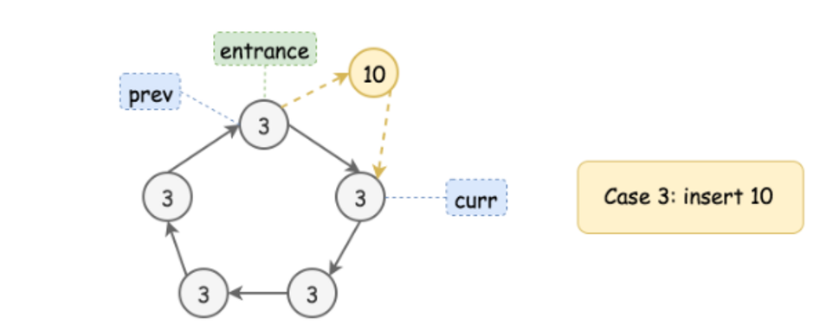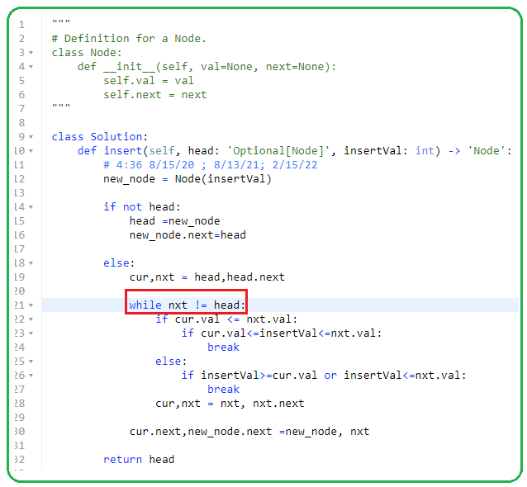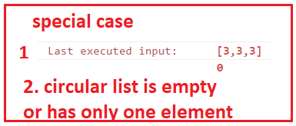

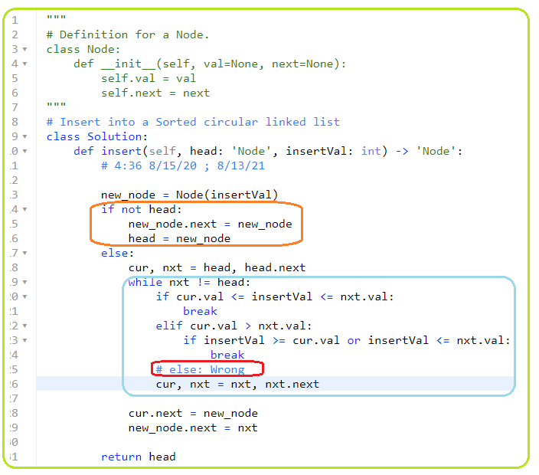

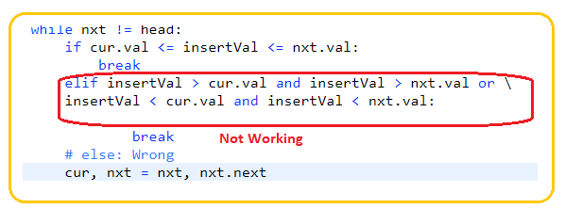

1. **918. Maximum Sum Circular Subarray**

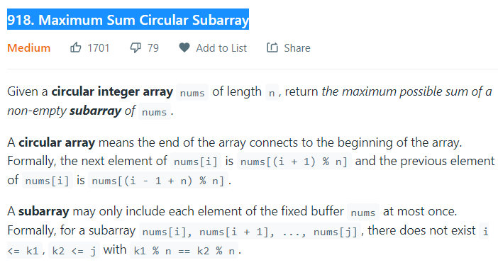



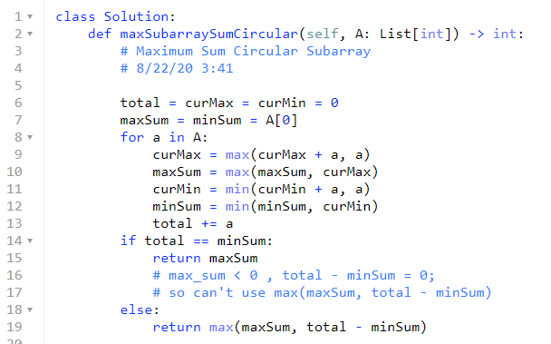

1. **Scheduling\*\*\*\*\***
2. **Sort based on start_day first, push end_day with same start day to heap**

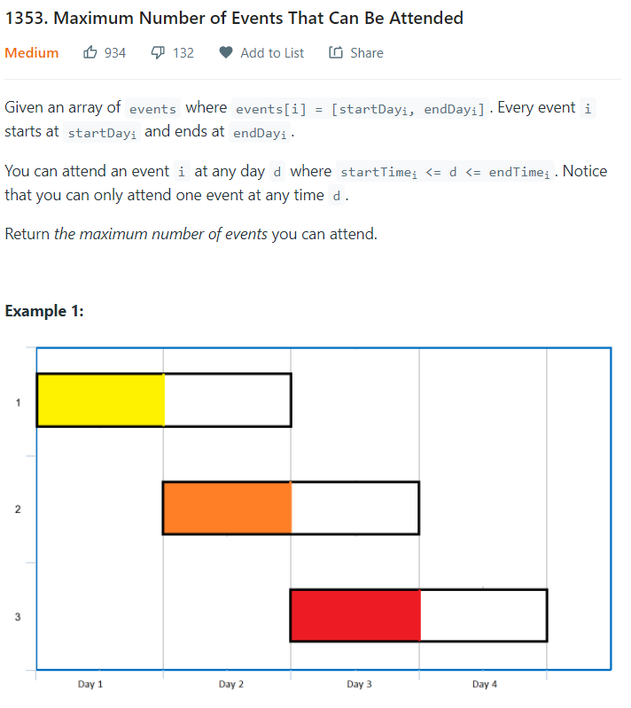

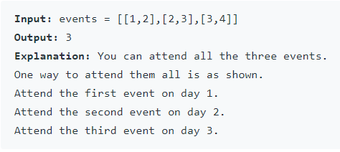

* **Sort the events based on the start-time:**
* **For the same start-time, add all the end time to a min-heap**
* **Remove the event with the smallest end time first, incrementing current day by 1.**

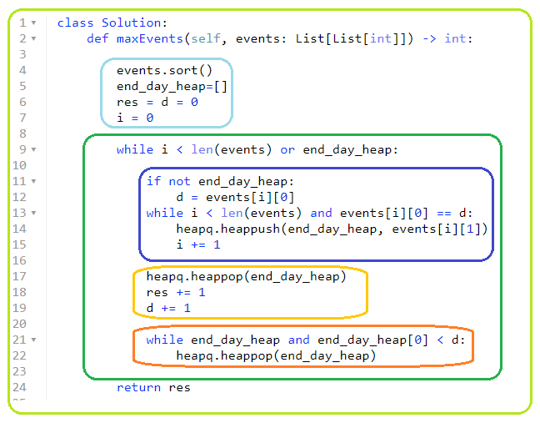

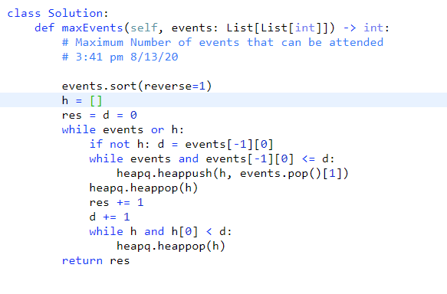

1. **56. Merge Intervals**

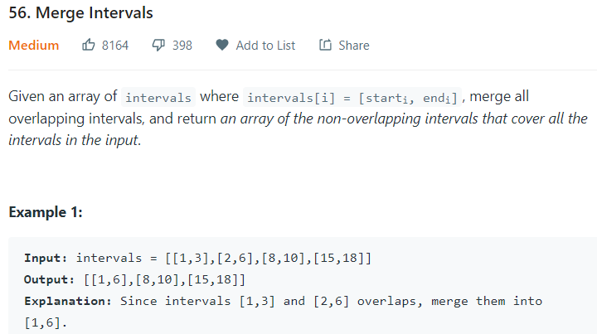

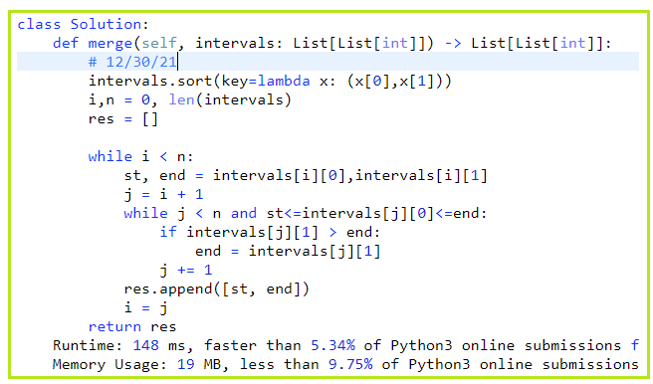

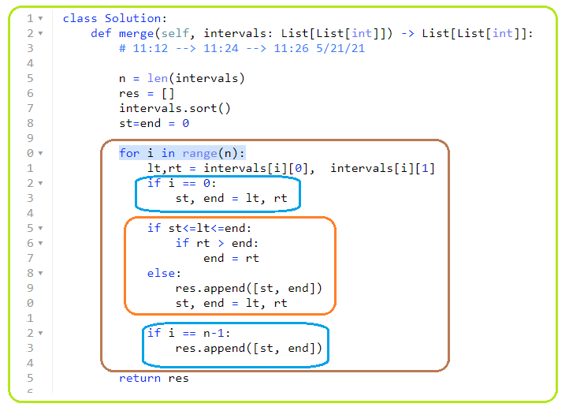

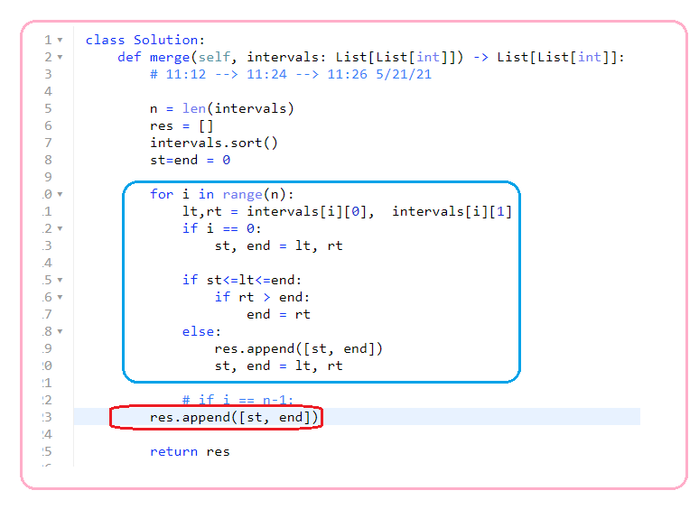

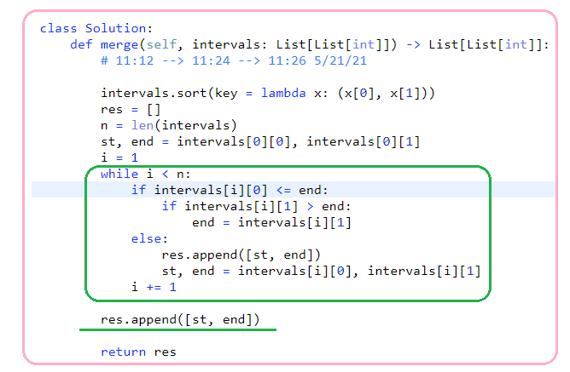

1. **Sorting\*\*\*\*\***
2. **179 Largest Number**

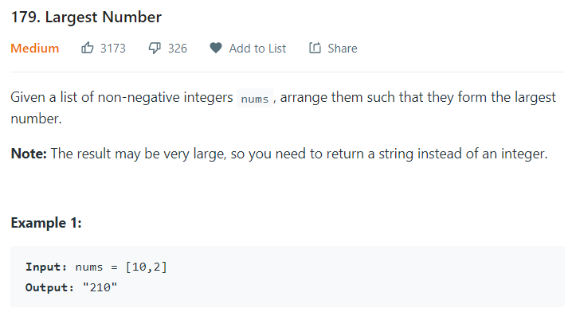

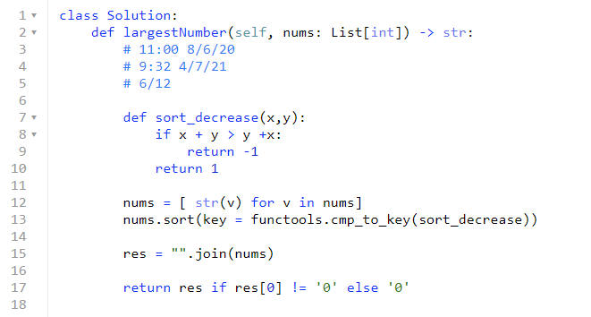

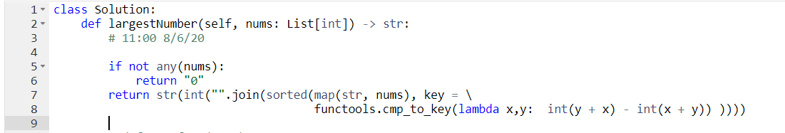

1. **373. Find K Pairs with Smallest Sums**

**12/30/21**

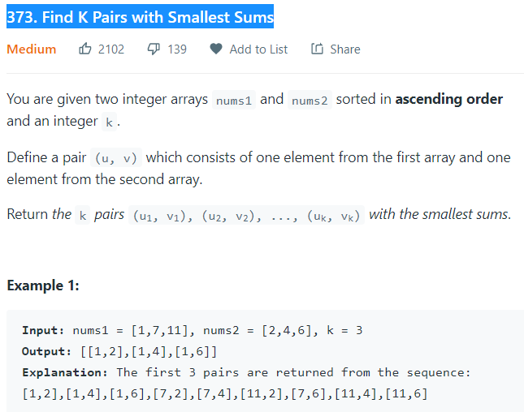

* **#1**

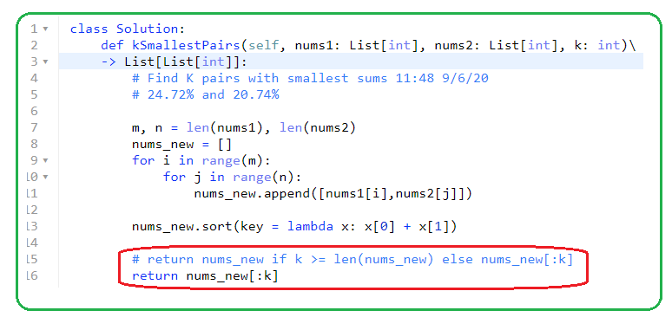

**#2 heapq**

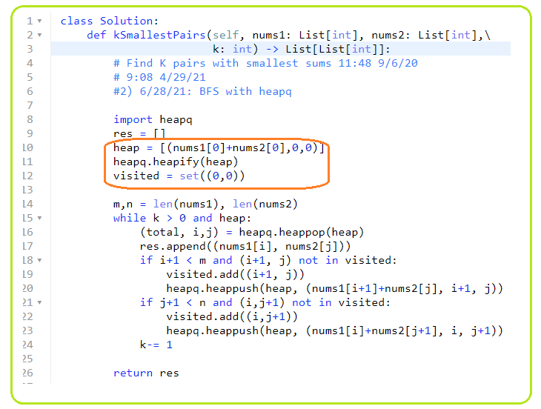

1. **826. Most Profit Assigning Work**

**12/30/21,**

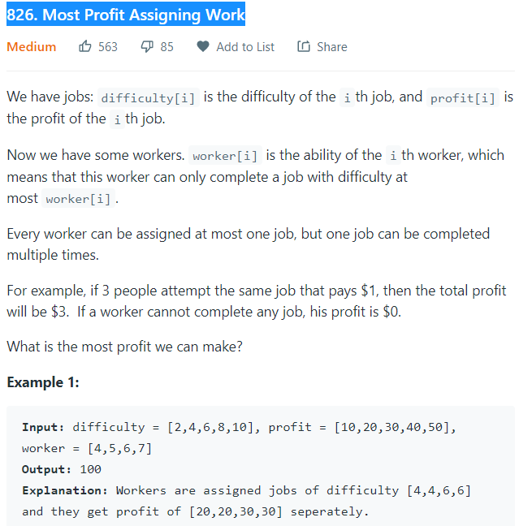

* **# sort1**

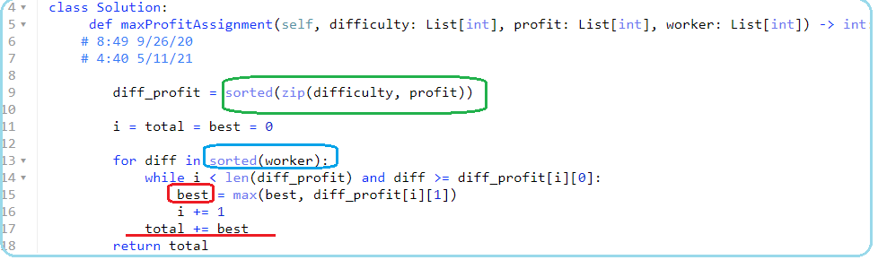

**#**

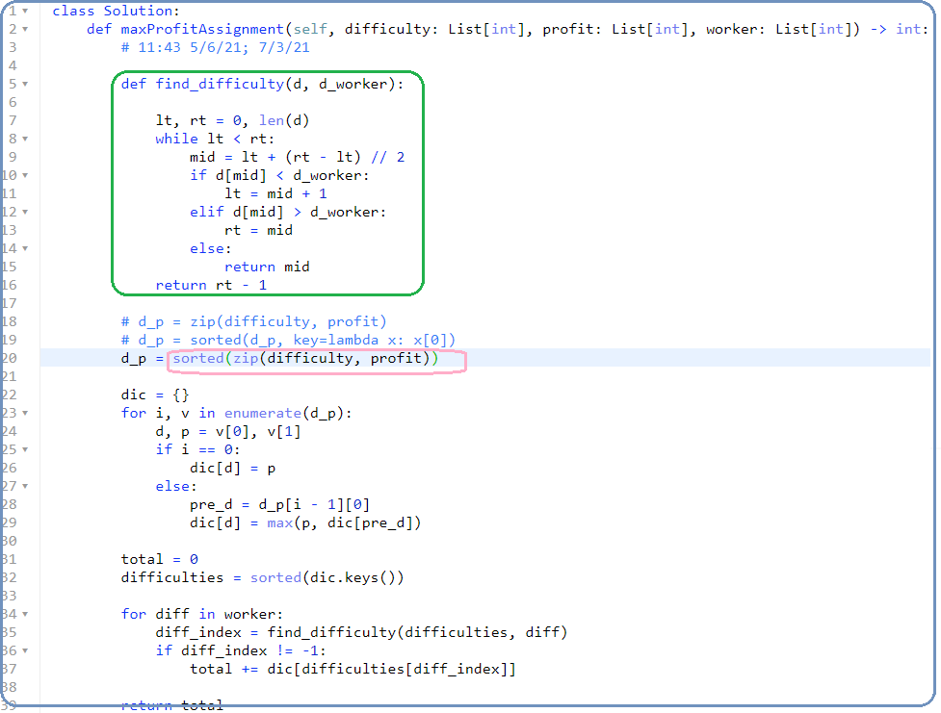

* **#**

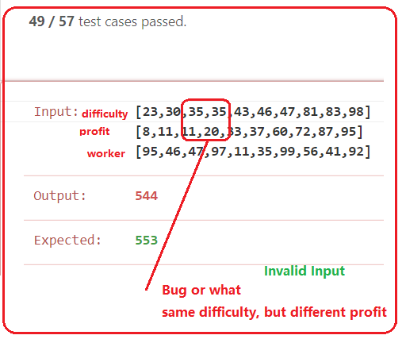

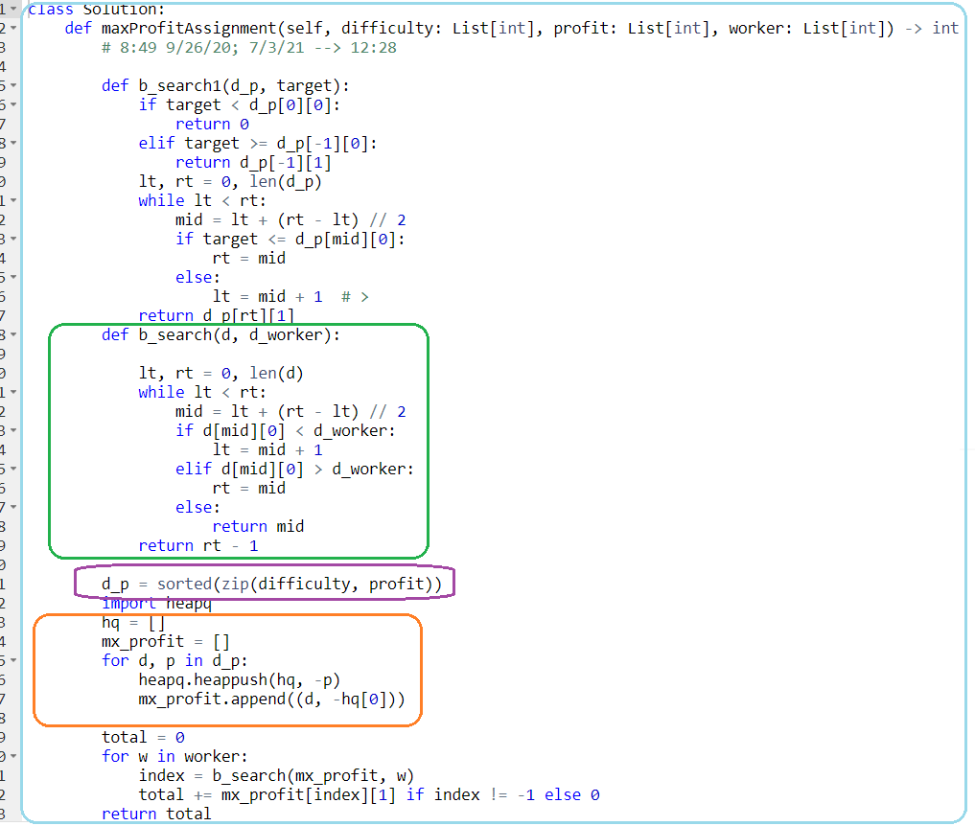

1. **Matrix-Opertation\*\*\*\*\***
2. **840. Magic Squares In Grid**

**12/31/21,1/28/22**

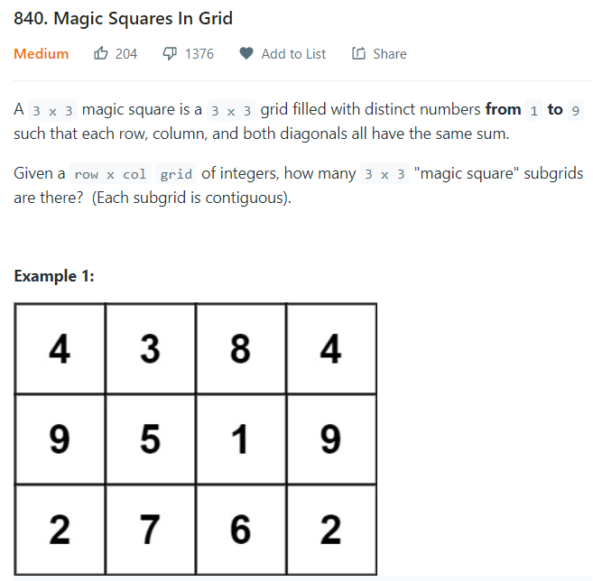

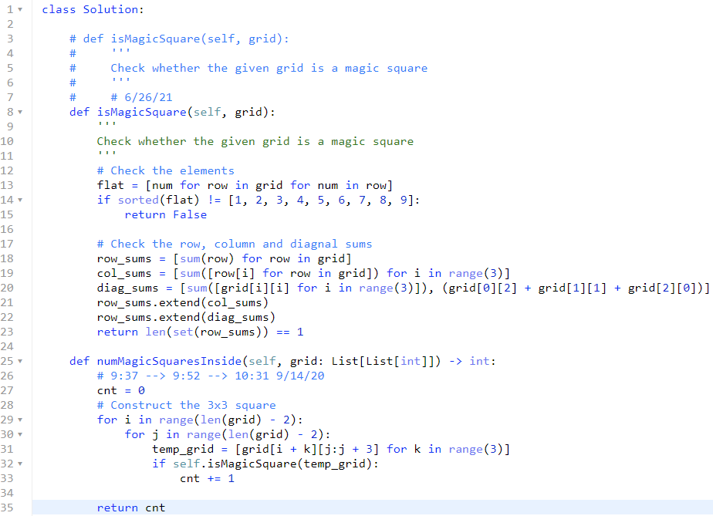

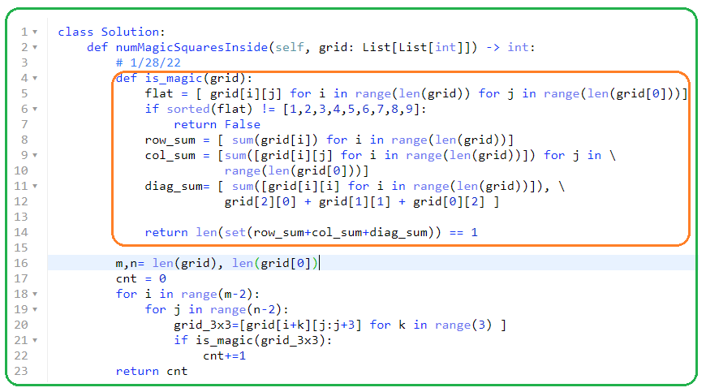

1. **#909. Snakes and Ladders**

 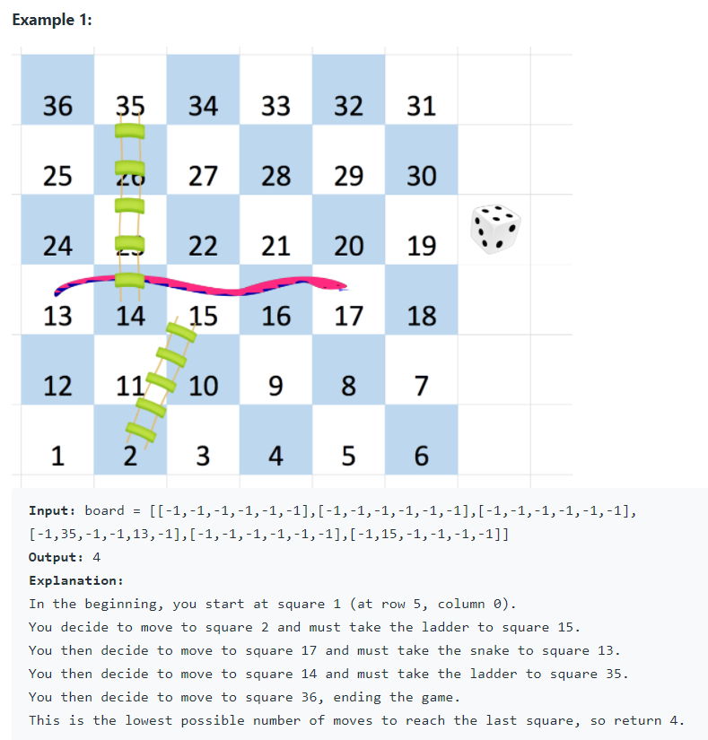



1. **Range Check**
2. **220 Contains Duplicate III**

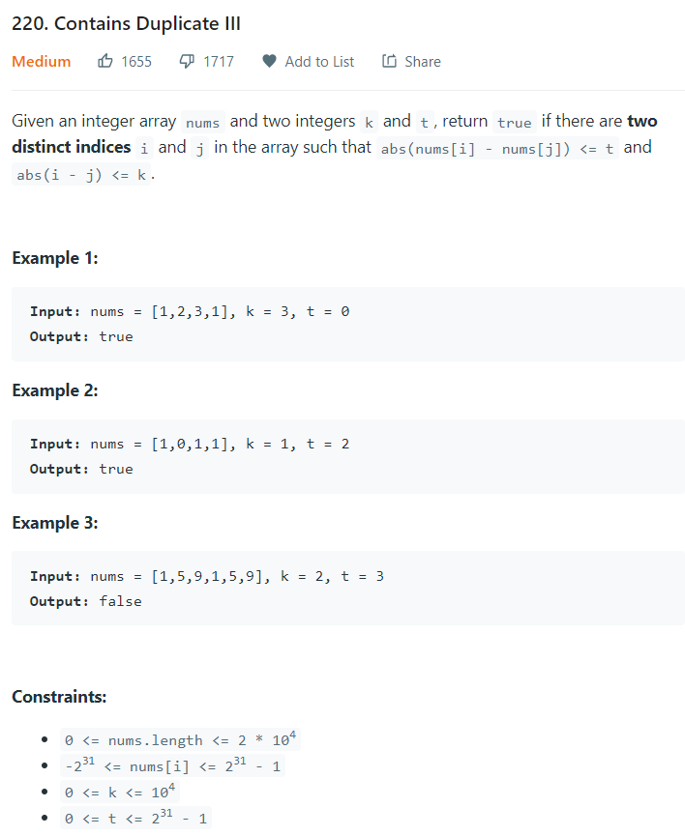

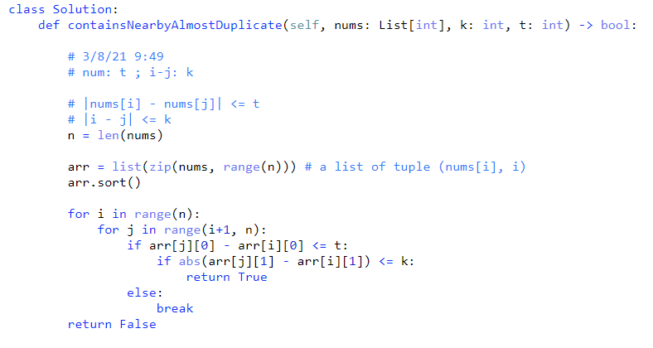

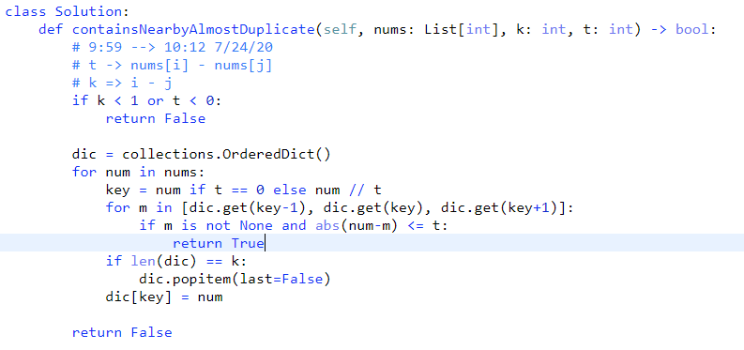

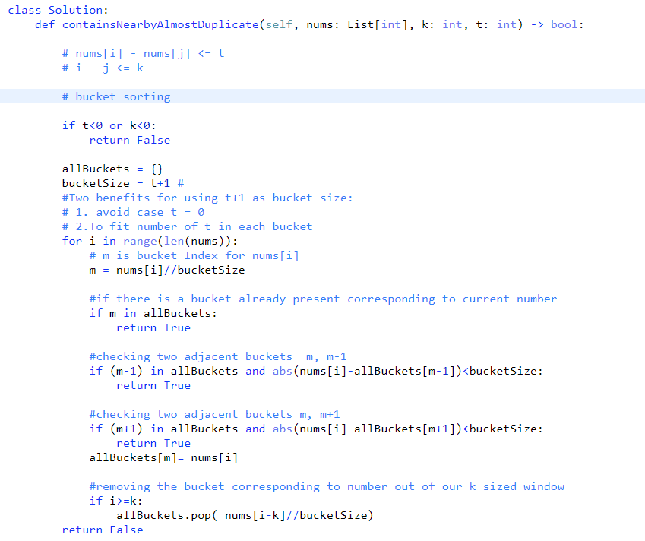

1. **307. Range Sum Query – Mutable**

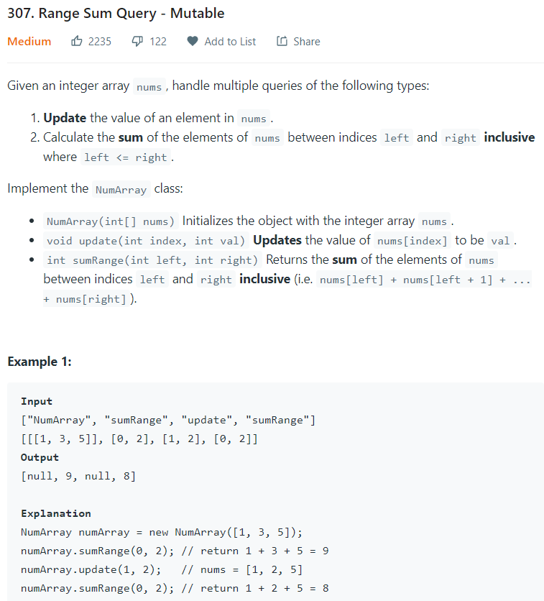

**Not cumulative sum**分块累加，各不干预。就是将原数组分为若干块，怎么分呢，这里就让每个 block 有 sqrt(n) 个数字就可以了，这个基本是让 block 的个数跟每个 blcok 中数字的个数尽可能相同的分割方法。然后我们就需要一个大小跟 block 个数相同的数组，来保存每个 block 的数字之和。在需要更新的时候，我们就先确定要更新的位置在哪个 block 里，然后只更新该 block 的和。而对于求区域和操作，我们还是要分别确定i和j分别属于哪个 block，若属于同一个 block，那么直接遍历累加即可，若属于不同的，则先从i累加到该 blcok 的末尾，然后中间横跨的那些 block 可以直接将和累加，对于j所在的 blcok，则从该 block 的开头遍历累加到j即可

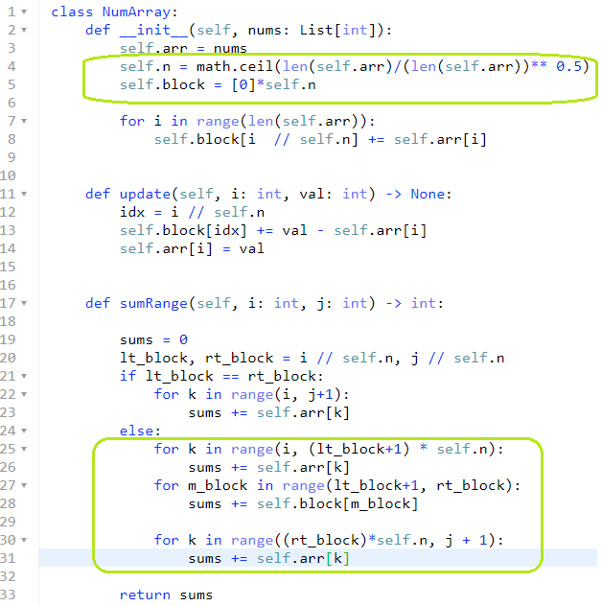

1. **Tricky problems**

**def gcd(x,y): # Greatest Common Denominator**

**return x if y == 0 else gcd(y, x % y)**

1. **1616**

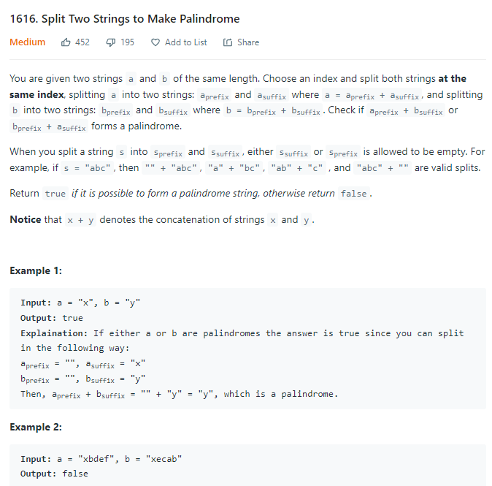 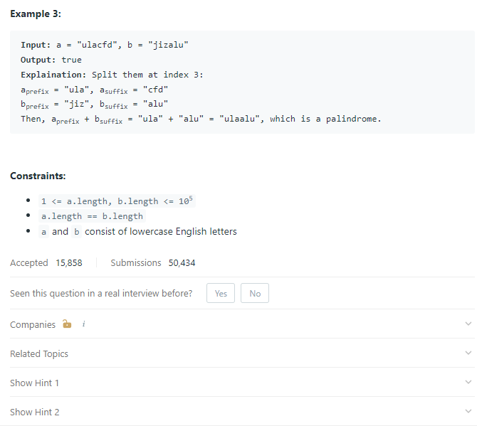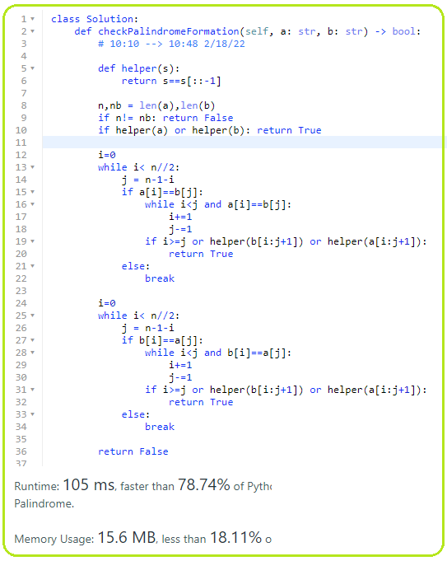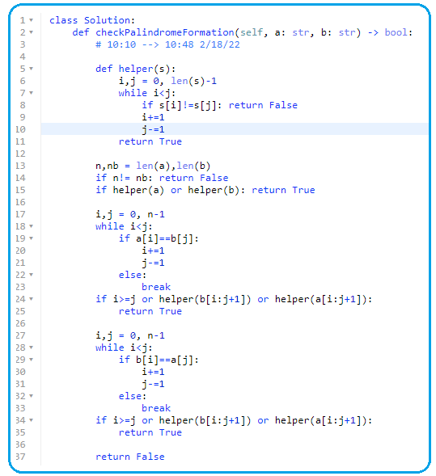

1. **29. Divide Two Integers**

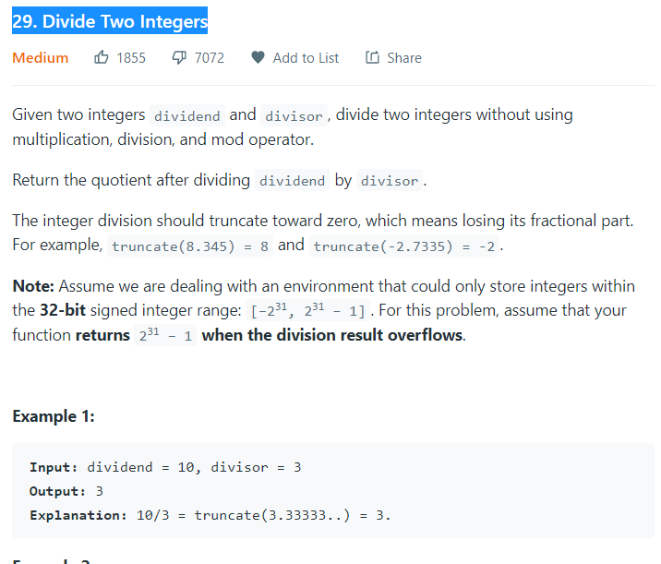

* **Repeated Subtractions**

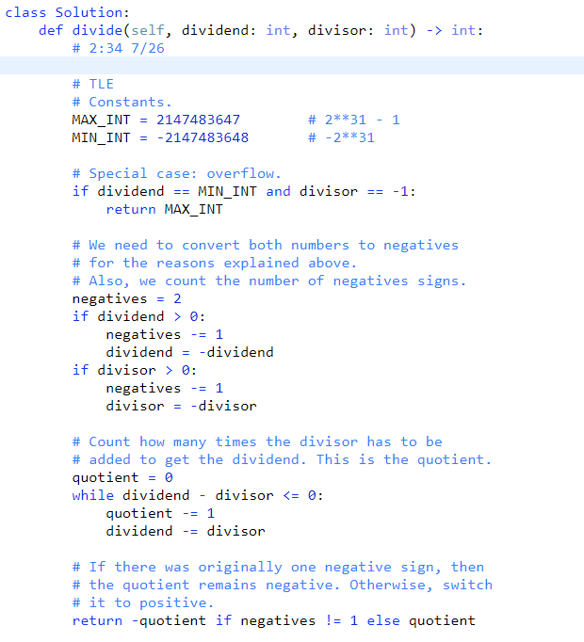

#### Repeated Exponential Searches

#### 

#### 468. Validate IP Address

#### 

#### 

#### 

#### if val > 255 or (chrs[0] == '0' and val !=0):

#### return False (wrong)

#### if val > 255 or (chrs[0] == '0' and len(chrs) > 1): # correct

#### 50. Pow(x, n)

#### 

#### 

#### 

#### 556. Next Greater Element III

#### 

#### 

#### 152. Maximum Product Subarray

#### 

#### 

#### 31. Next Permutation

#### 

#### 

#### 522. Longest Uncommon Subsequence II

#### 

#### 

#### 

#### 1146. Snapshot Array

#### 

#### 

#### 

#### 393. UTF-8 Validation

#### 

#### #

#### 

#### 

#### 

#### # bit manipulation

#### 

#### 334. Increasing Triplet Subsequence

#### 

#### 

#### Collections.defaultdict(set)

#### 288. Unique Word Abbreviation

#### 

#### 

#### 

1. **146. LRU Cache**

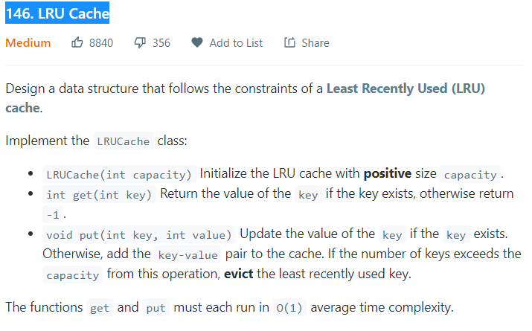

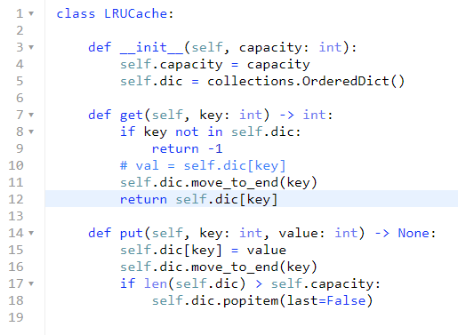

1. **Topological Sort**
2. **444. Sequence Reconstruction**
3. **Binary number**
4. **1073. Adding Two Negabinary Numbers**

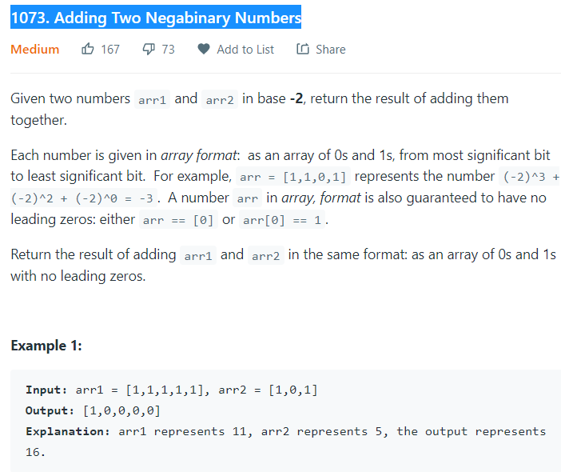

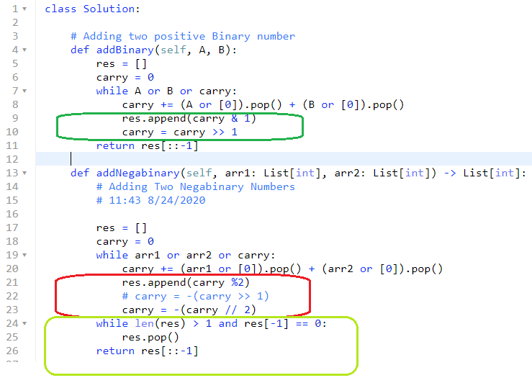

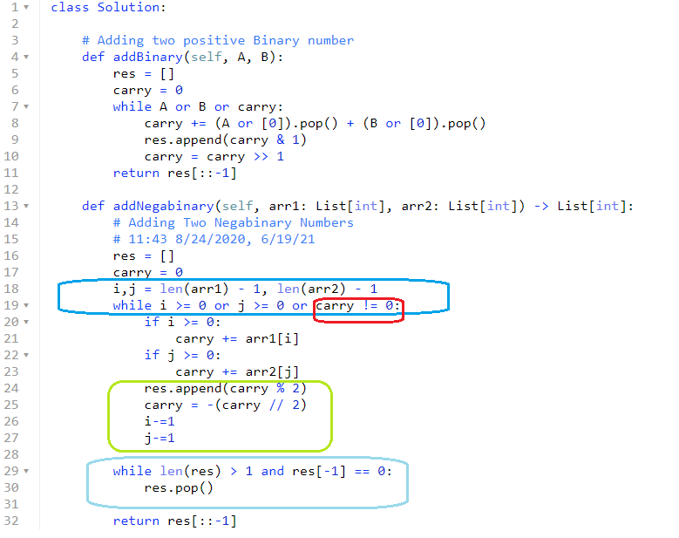

1. **Bit Mask**

[**https://www.geeksforgeeks.org/bitmasking-and-dynamic-programming-set-1-count-ways-to-assign-unique-cap-to-every-person/**](https://www.geeksforgeeks.org/bitmasking-and-dynamic-programming-set-1-count-ways-to-assign-unique-cap-to-every-person/)

**2002. Maximum Product of the Length of Two Palindromic Subsequences**

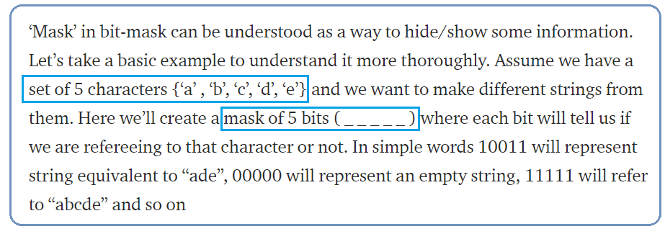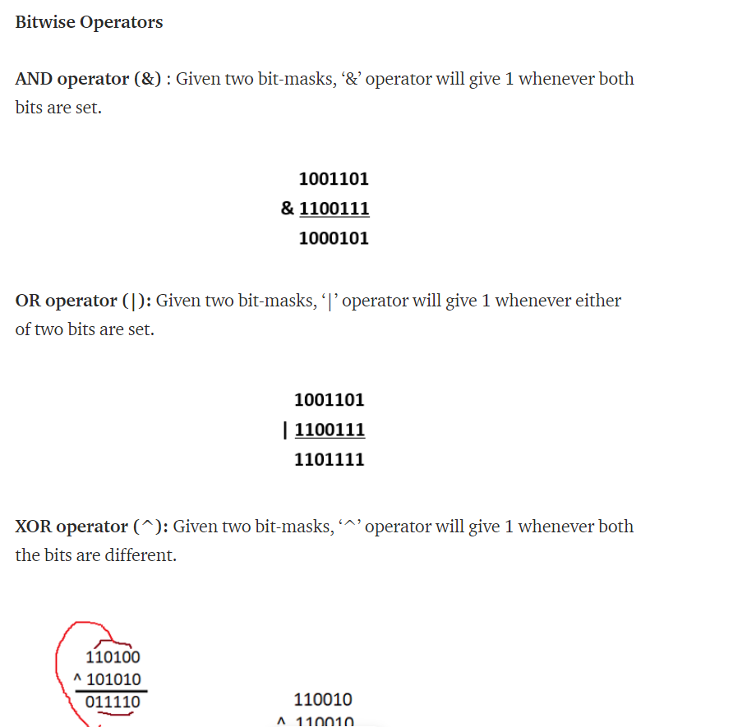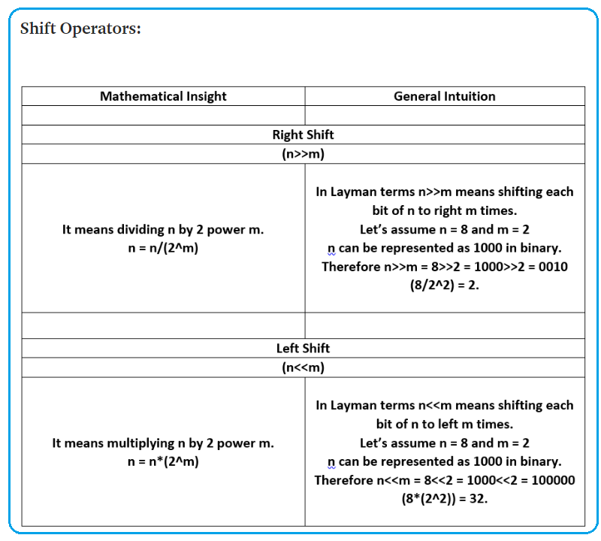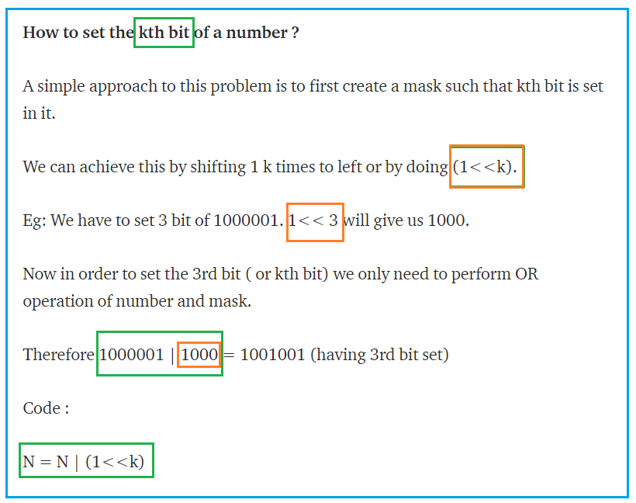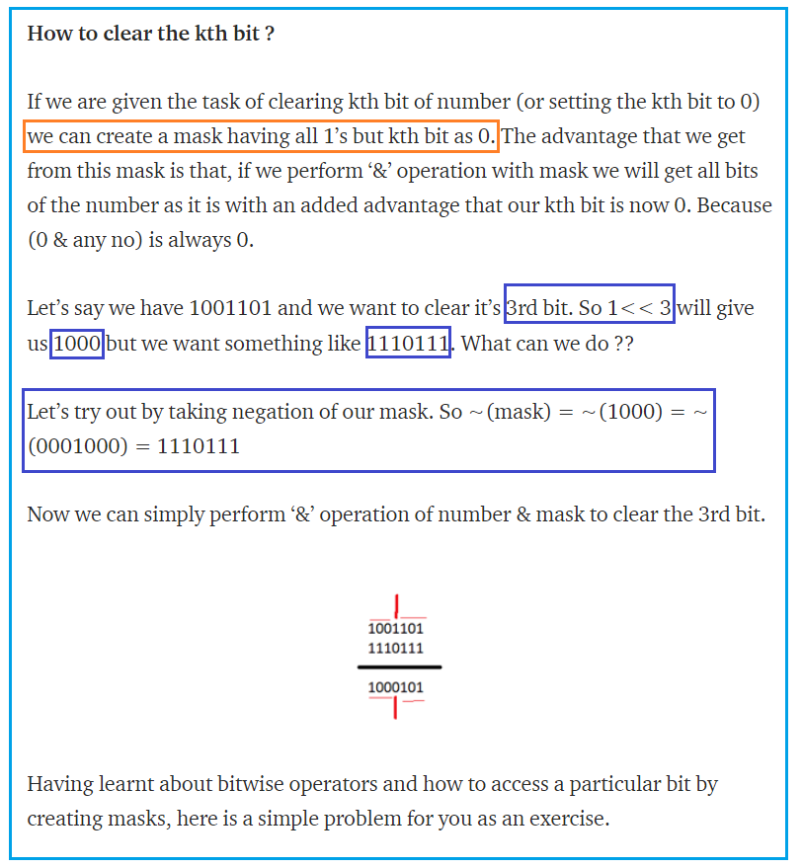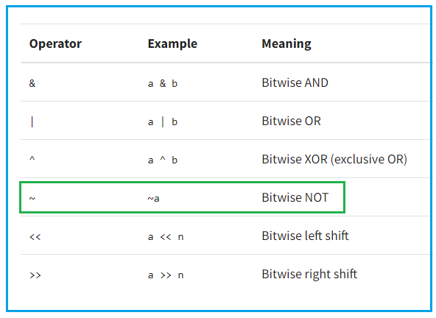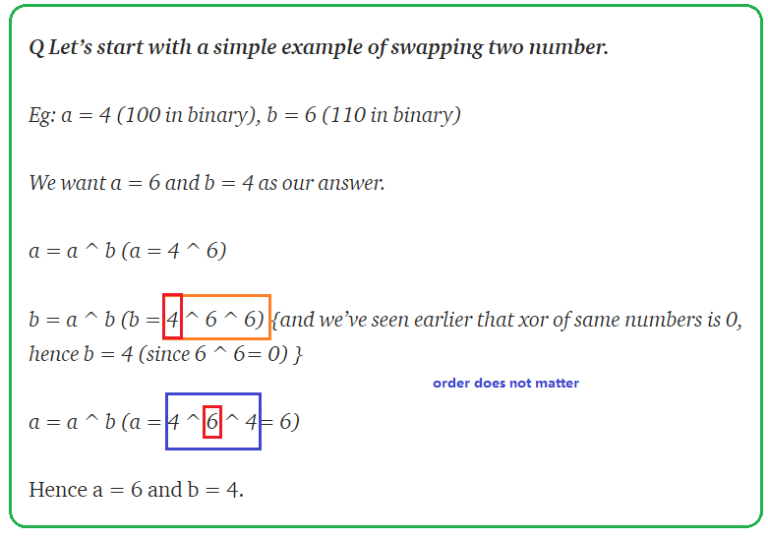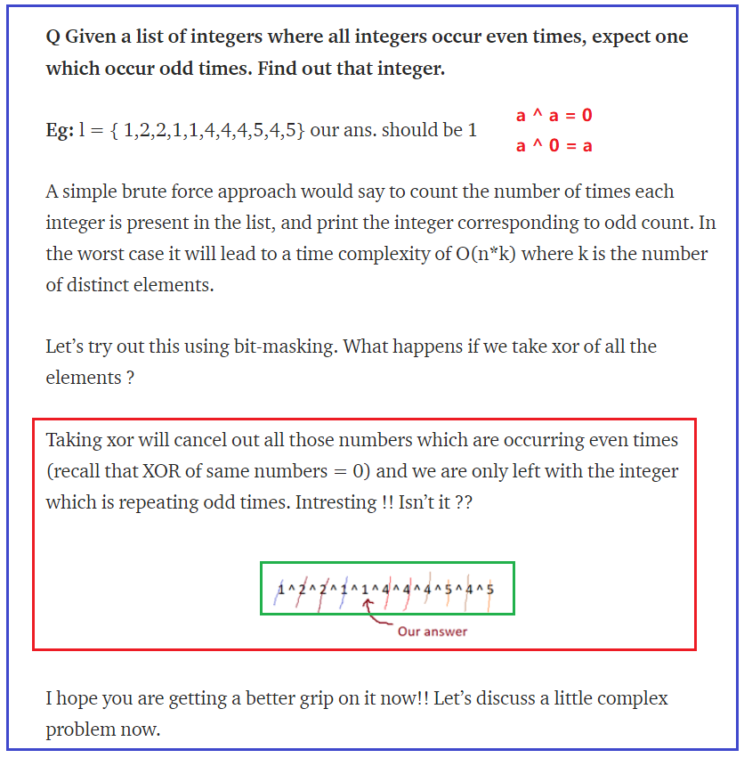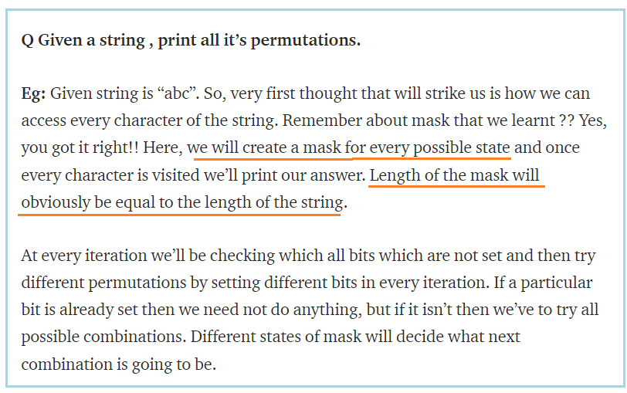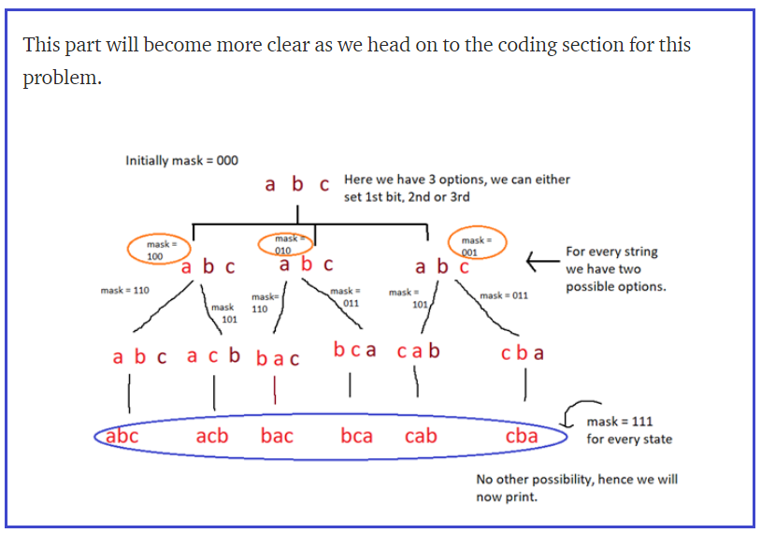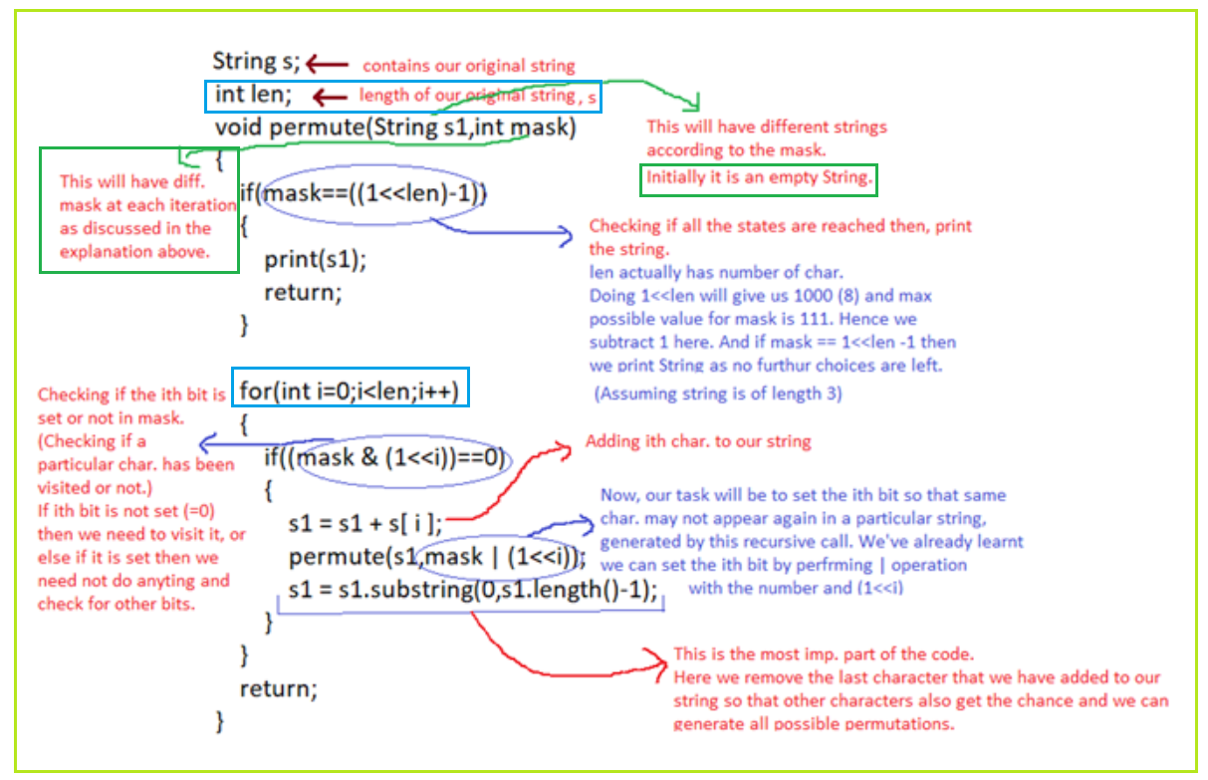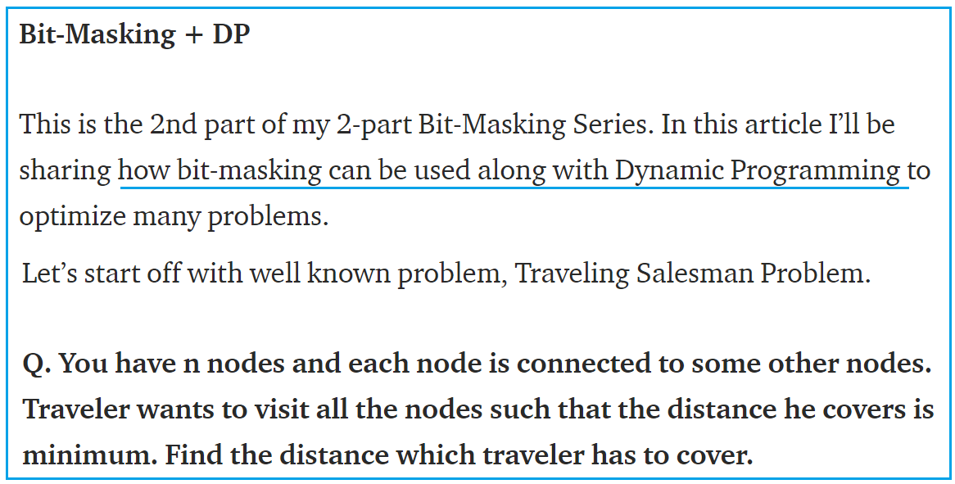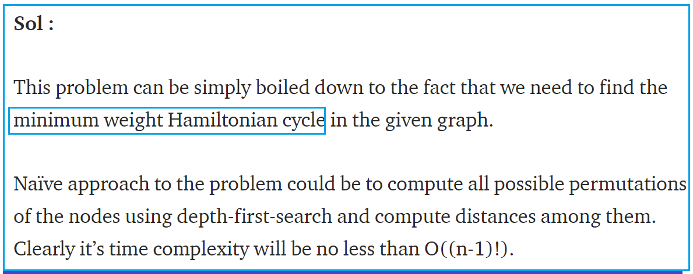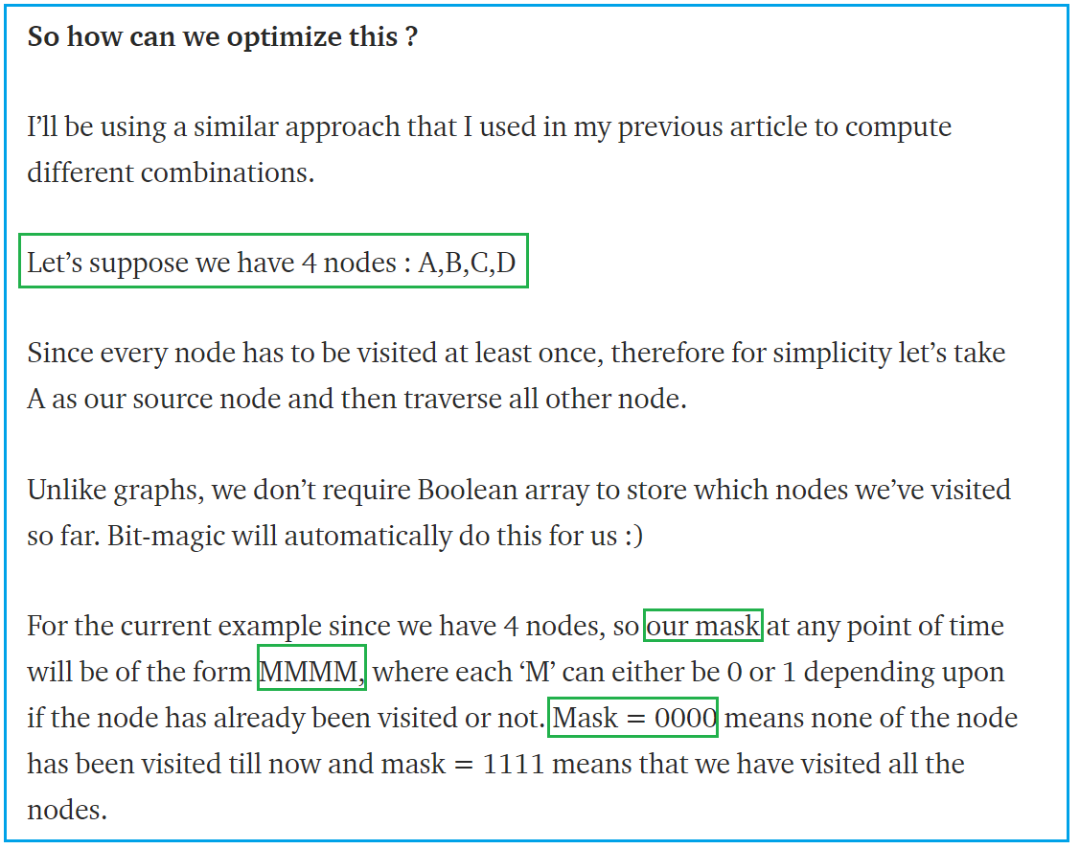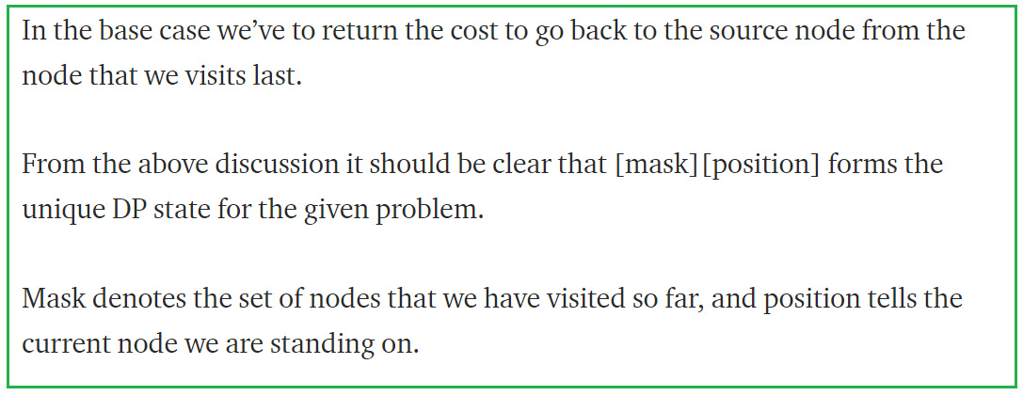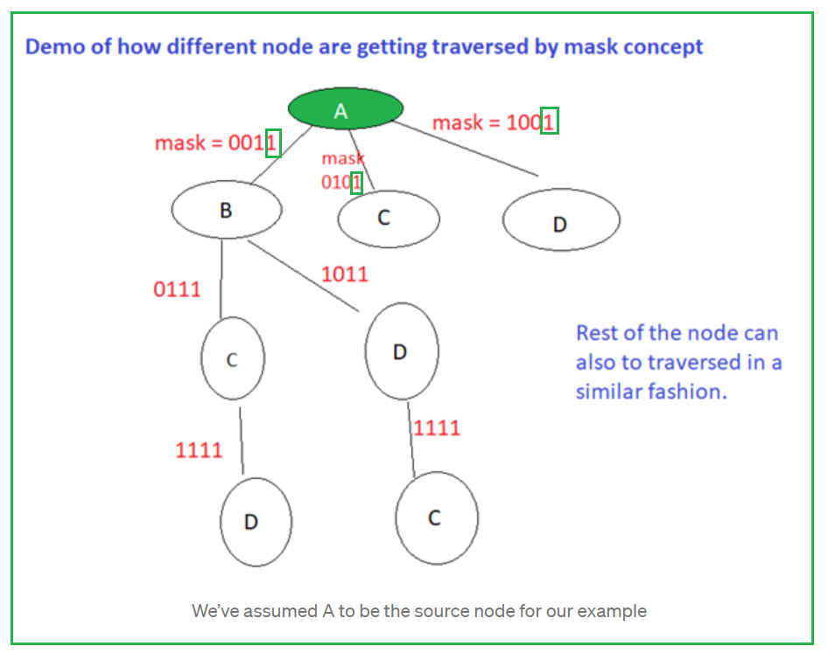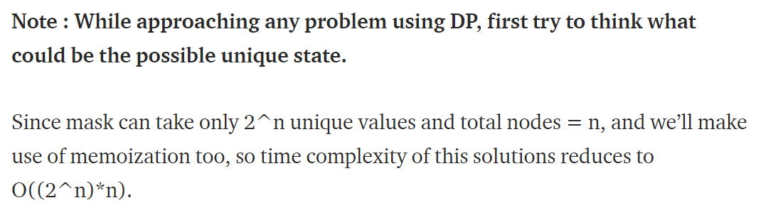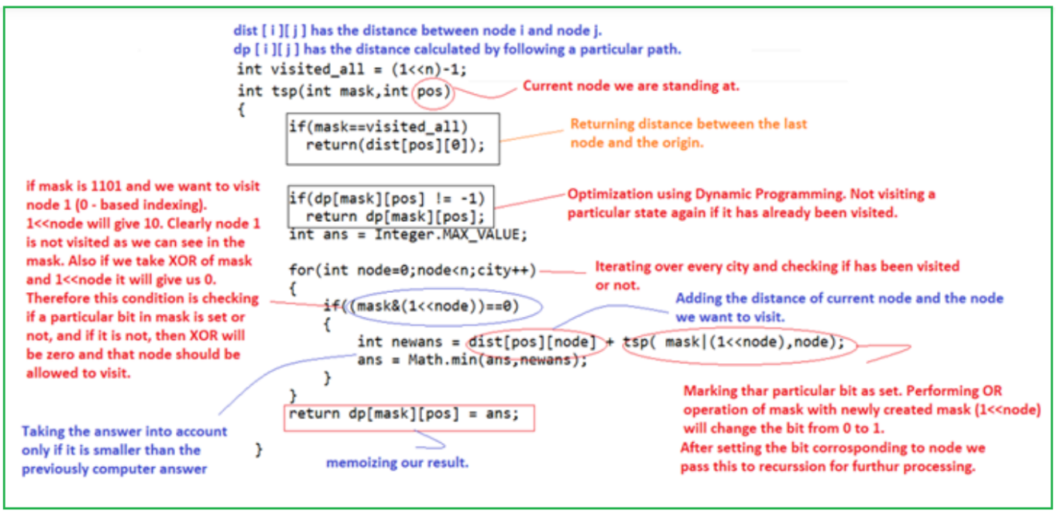

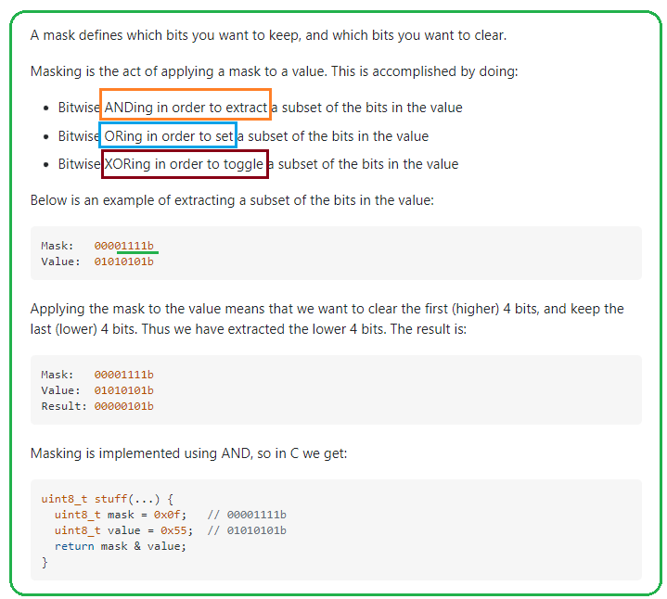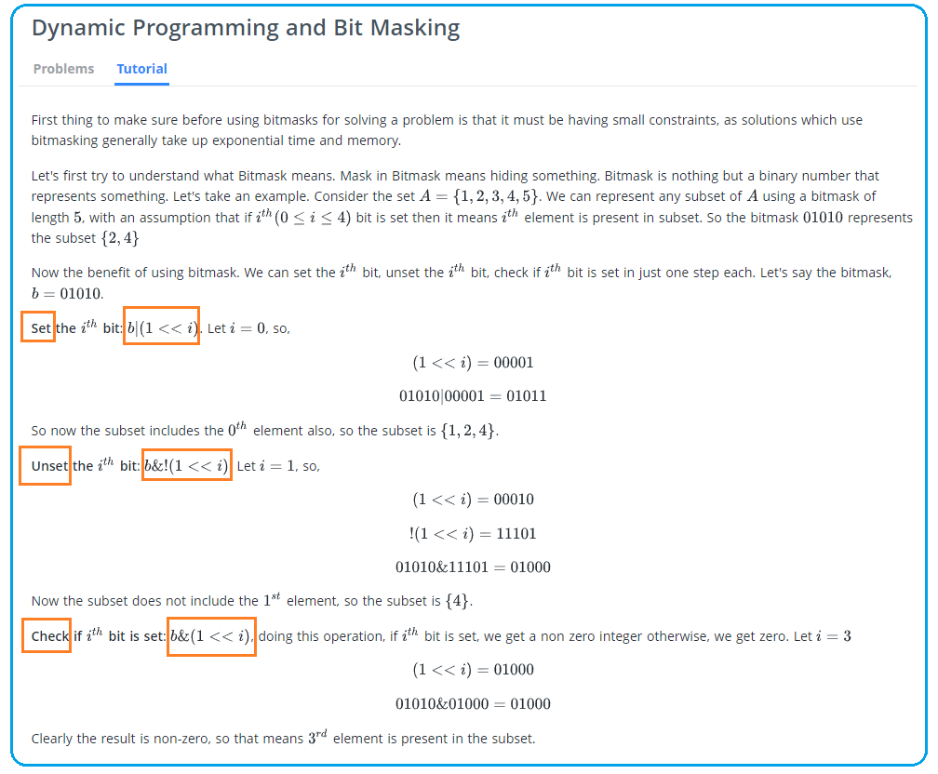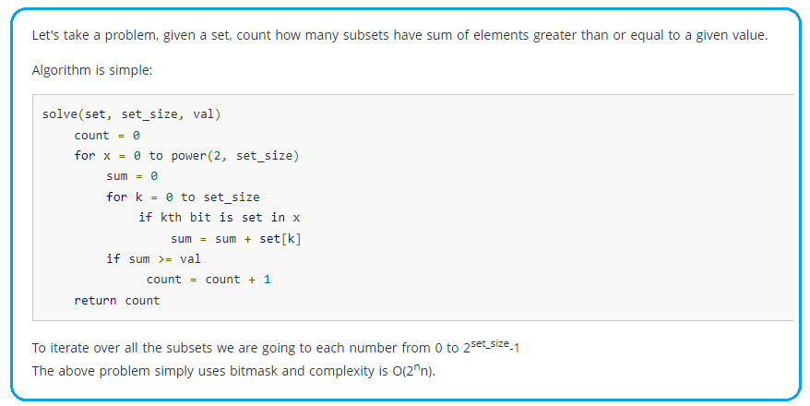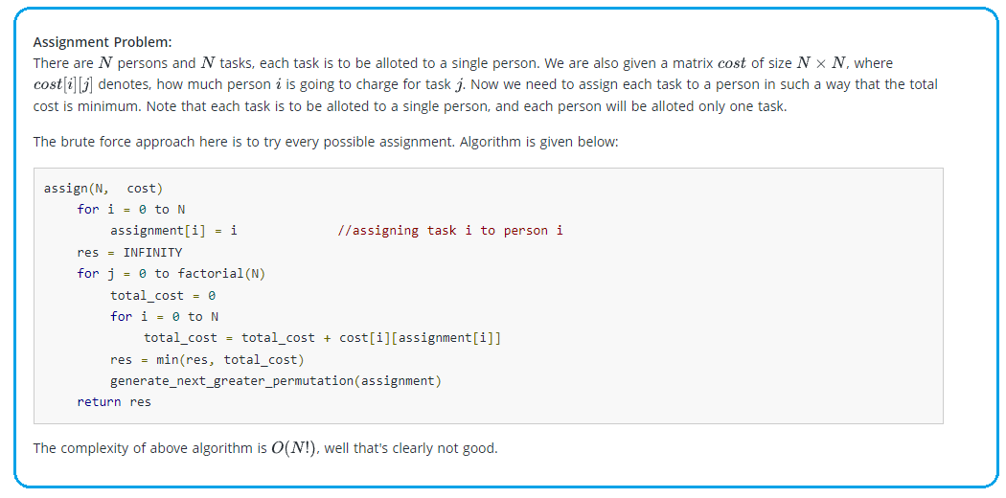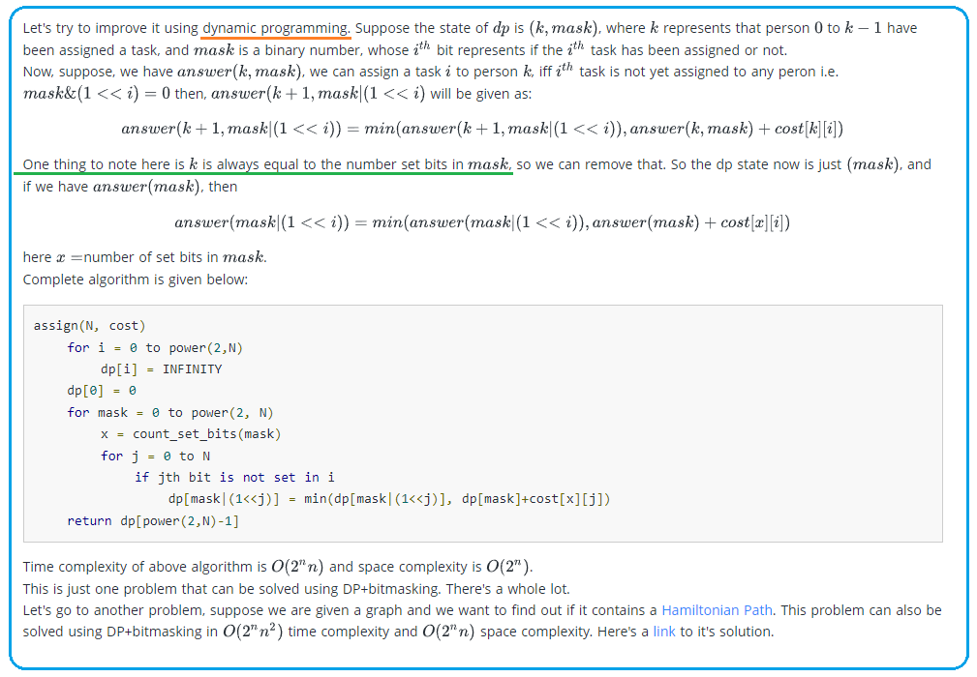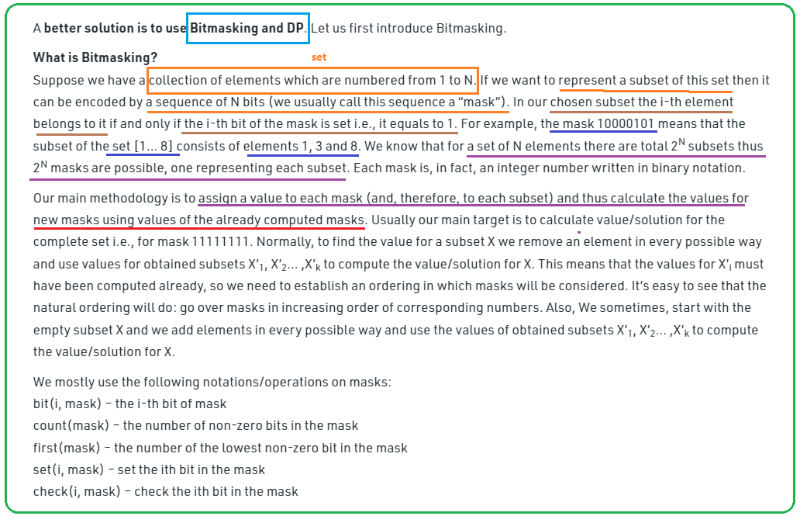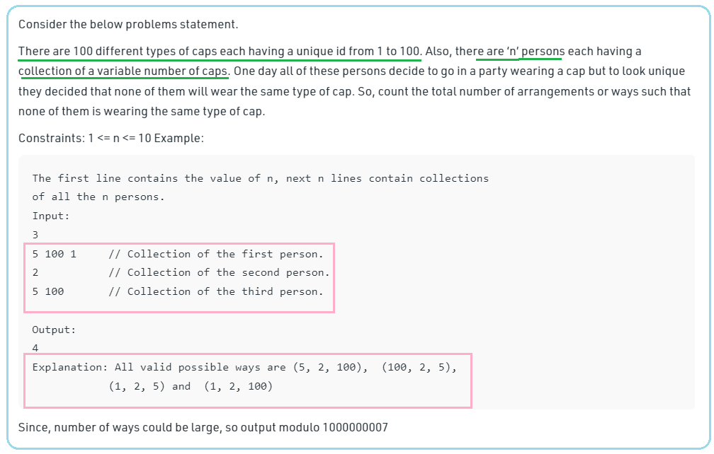

1. **TBD**

**79. Word Search**

Approach 1: Backtracking

**Intuition**

This problem is yet another 2D grid traversal problem, which is similar with another problem called [489. Robot Room Cleaner](https://leetcode.com/articles/robot-room-cleaner/).

Many people in the [discussion forum](https://leetcode.com/problems/word-search/discuss/) claimed that the solution is of ***DFS*** (Depth-First Search). Although it is true that we would explore the 2D grid with the DFS strategy for this problem, it does not capture the entire nature of the solution.

We argue that a more accurate term to summarize the solution would be ***backtracking***, which is a methodology where we mark the current path of exploration, if the path does not lead to a solution, we then revert the change (*i.e.* backtracking) and try another path.

As the general idea for the solution, we would walk around the 2D grid, at each step we *mark* our choice before jumping into the next step. And at the end of each step, we would also revert our marking, so that we could have a *clean slate* to try another *direction*. In addition, the exploration is done via the *DFS* strategy, where we go as further as possible before we try the next direction.

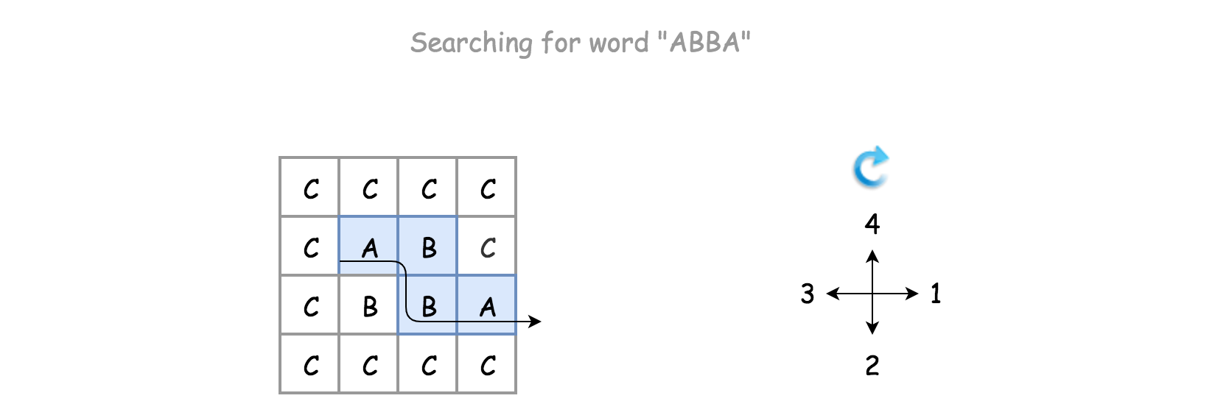

**Algorithm**

There is a certain code pattern for all the algorithms of backtracking. For example, one can find one template in our [Explore card of Recursion II](https://leetcode.com/explore/learn/card/recursion-ii/472/backtracking/2793/).

The skeleton of the algorithm is a loop that iterates through each cell in the grid. For each cell, we invoke the *backtracking* function (*i.e.* backtrack()) to check if we would obtain a solution, starting from this very cell.

For the backtracking function backtrack(row, col, suffix), as a DFS algorithm, it is often implemented as a *recursive* function. The function can be broke down into the following four steps:

* Step 1). At the beginning, first we check if we reach the bottom case of the recursion, where the word to be matched is empty, *i.e.* we have already found the match for each prefix of the word.
* Step 2). We then check if the current state is invalid, either the position of the cell is out of the boundary of the board or the letter in the current cell does not match with the first letter of the word.
* Step 3). If the current step is valid, we then start the exploration of backtracking with the strategy of DFS. First, we mark the current cell as *visited*, *e.g.* any non-alphabetic letter will do. Then we iterate through the four possible directions, namely *up*, *right*, *down* and *left*. The order of the directions can be altered, to one's preference.
* Step 4). At the end of the exploration, we revert the cell back to its original state. Finally we return the result of the exploration.

We demonstrate how it works with an example in the following animation.

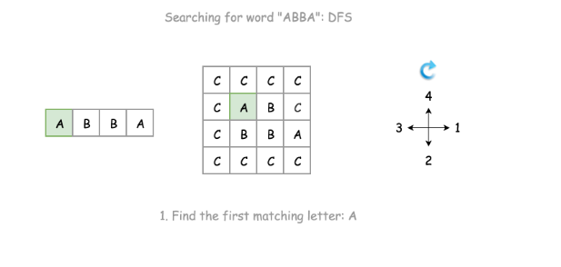

1 / 6

**Notes**

There are a few choices that we made for our backtracking algorithm, here we elaborate some thoughts that are behind those choices.

Instead of returning directly once we find a match, we simply *break* out of the loop and do the cleanup before returning.

Here is what the alternative solution might look like.

As once notices, we simply return True if the result of recursive call to backtrack() is positive. Though this minor modification would have no impact on the time or space complexity, it would however leave with some "side-effect", *i.e.* the matched letters in the original board would be altered to #.

Instead of doing the boundary checks before the recursive call on the backtrack() function, we do it within the function.

This is an important choice though. Doing the boundary check within the function would allow us to reach the bottom case, for the test case where the board contains only a single cell, since either of neighbor indices would not be valid.

**Complexity**

* Time Complexity: \mathcal{O}(N \cdot 4 ^ L)O(*N*⋅4*L*) where N*N* is the number of cells in the board and L*L* is the length of the word to be matched.  
  + For the backtracking function, its execution trace would be visualized as a 4-ary tree, each of the branches represent a potential exploration in the corresponding direction. Therefore, in the worst case, the total number of invocation would be the number of nodes in a full 4-nary tree, which is about 4^L4*L*.
  + We iterate through the board for backtracking, *i.e.* there could be N*N* times invocation for the backtracking function in the worst case.
  + As a result, overall the time complexity of the algorithm would be \mathcal{O}(N \cdot 4 ^ L)O(*N*⋅4*L*).
* Space Complexity: \mathcal{O}(L)O(*L*) where L*L* is the length of the word to be matched.  
  + The main consumption of the memory lies in the recursion call of the backtracking function. The maximum length of the call stack would be the length of the word. Therefore, the space complexity of the algorithm is \mathcal{O}(L)O(*L*).

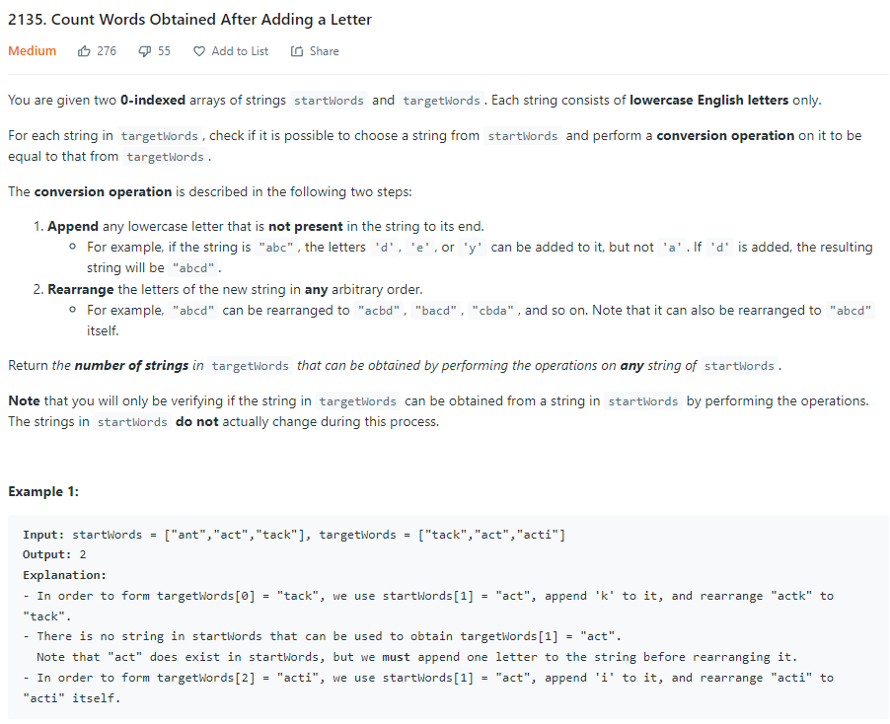

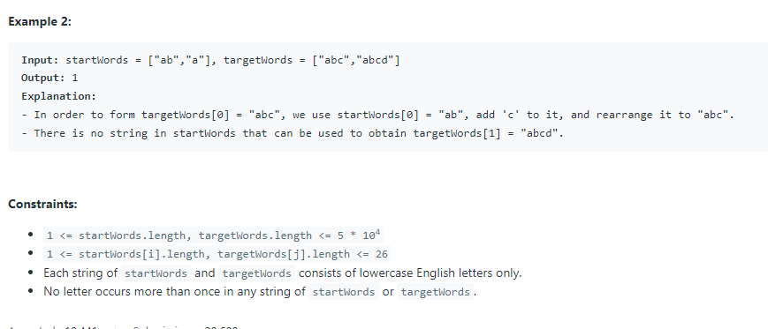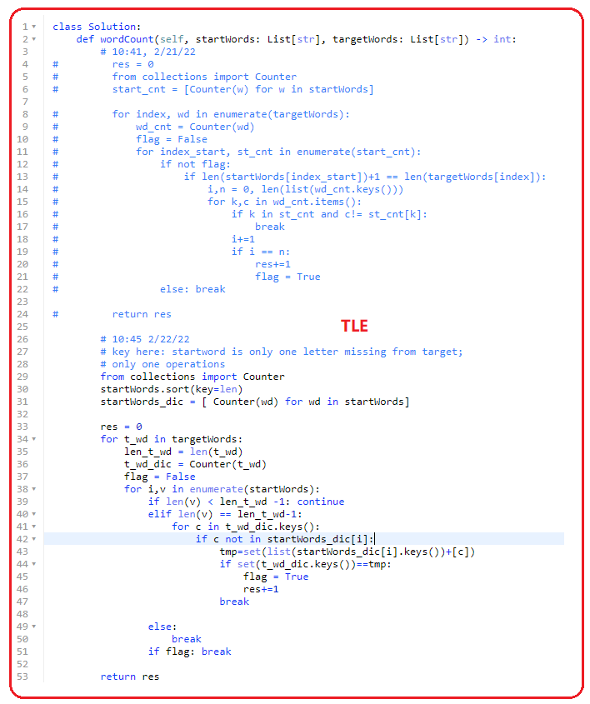

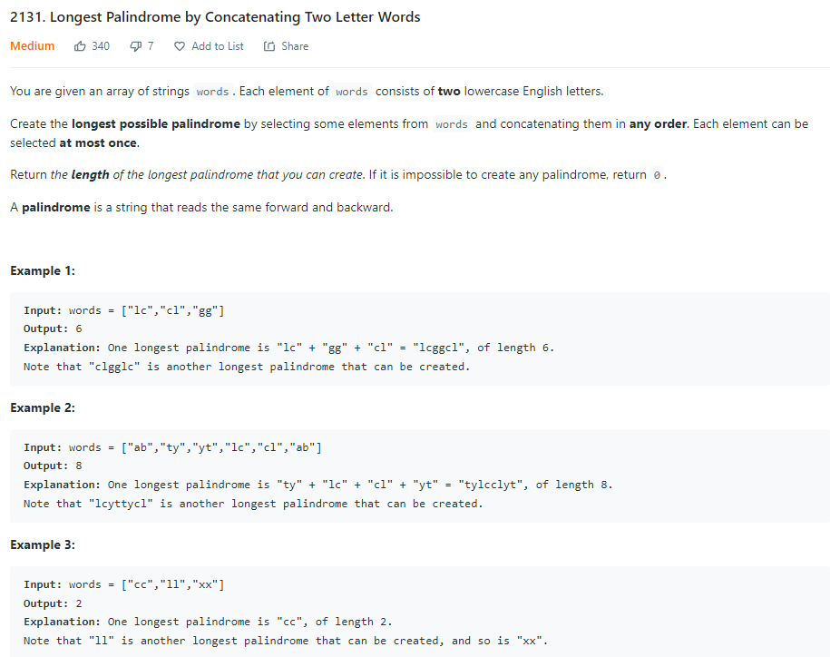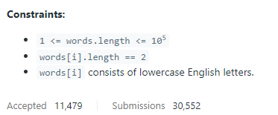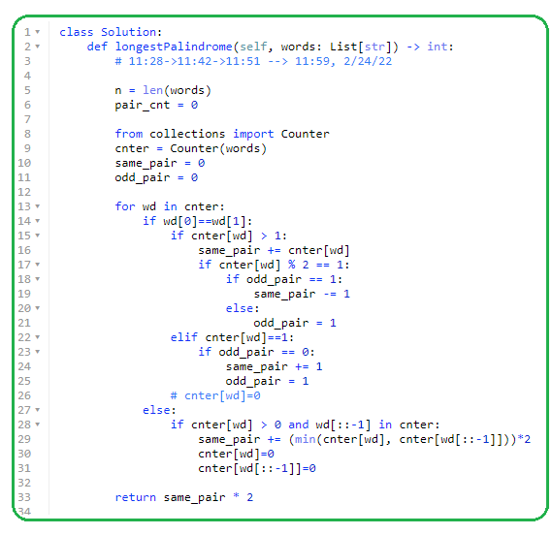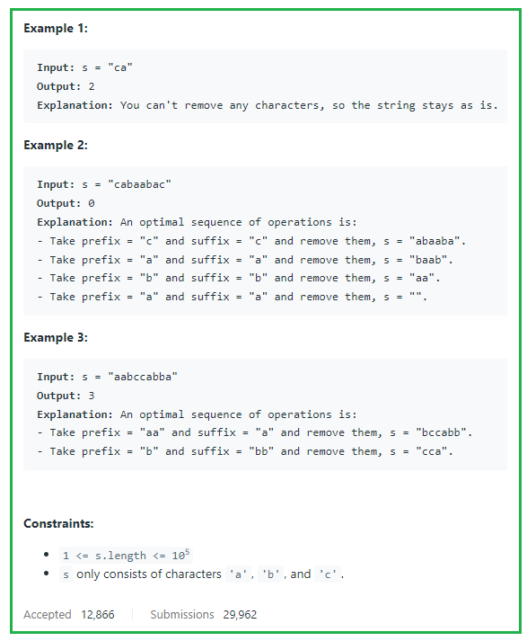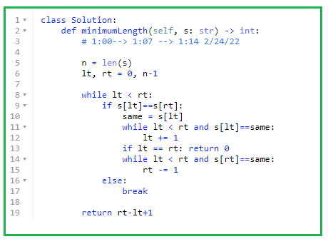

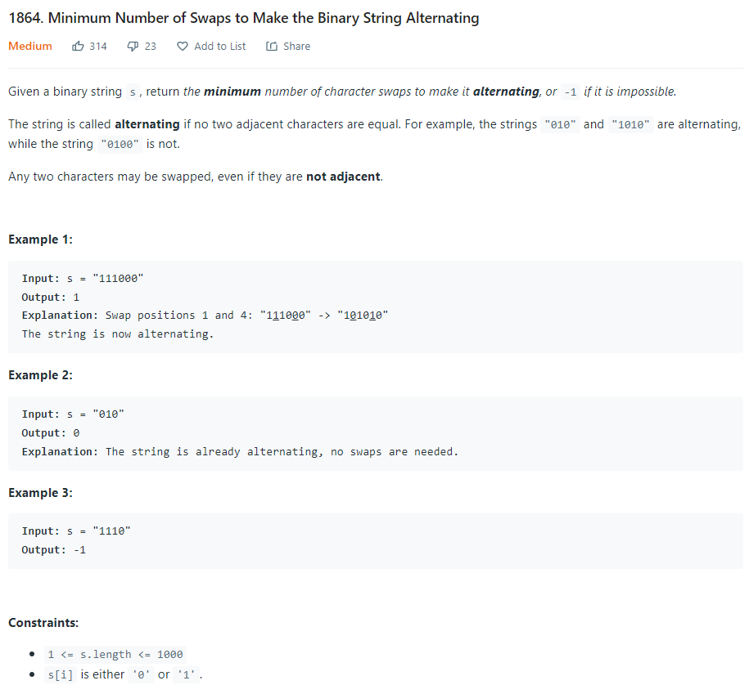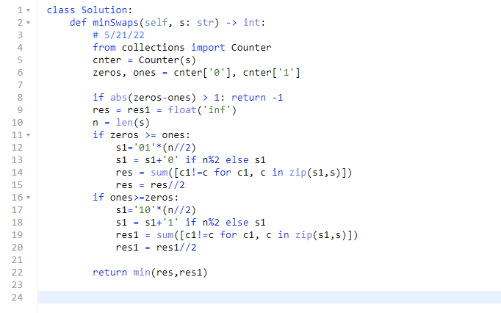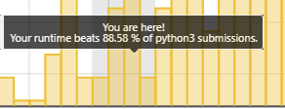

**2/26/22**

**1915. Number of Wonderful Substrings**

**1754. Largest Merge Of Two Strings**

**3/1/22**

**1717. Maximum Score From Removing Substrings**

**1058. Minimize Rounding Error to Meet Target**

**1985. Find the Kth Largest Integer in the Array**

**567. Permutation in String**

**3/2/22**

**1759. Count Number of Homogenous Substrings**

**291. Word Pattern II**

**3/3/22**

**1156. Swap For Longest Repeated Character Substring**

**2055. Plates Between Candles**

**1604. Alert Using Same Key-Card Three or More Times in a One Hour Period**

**5/10/22**

**2207. Maximize Number of Subsequences in a String**

**2211. Count Collisions on a Road**

**5/18/22**

**1888**

**1915**

**1754**

**5/26/22**

**2086. Minimum Number of Buckets Required to Collect Rainwater from Houses**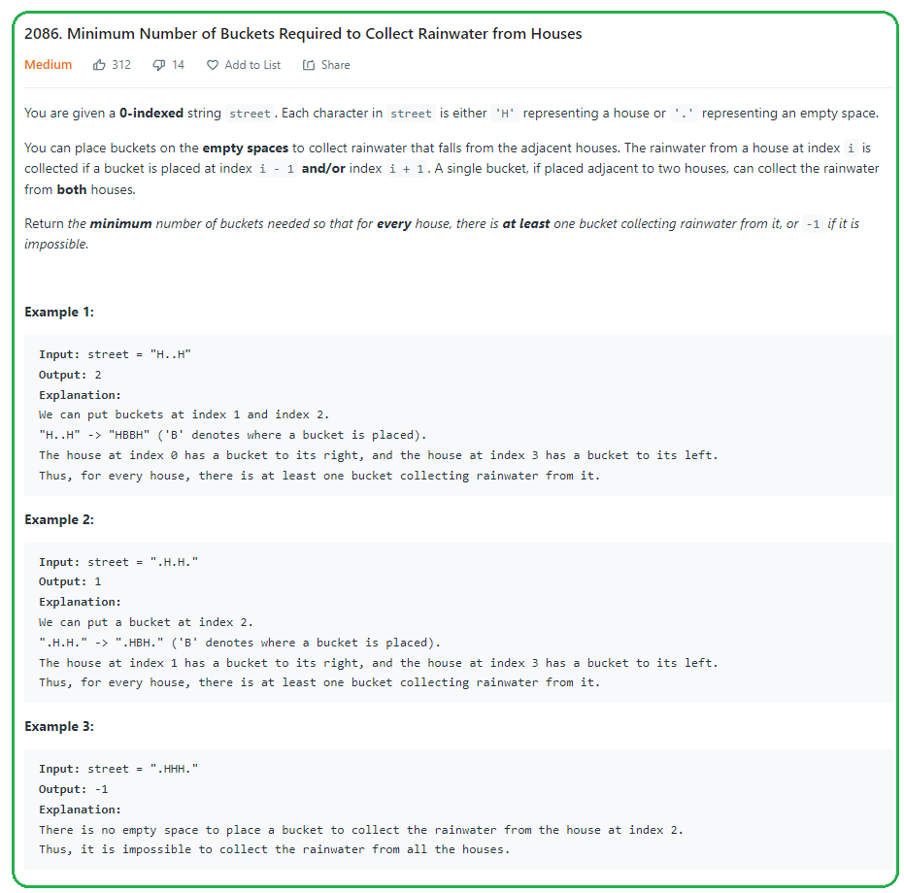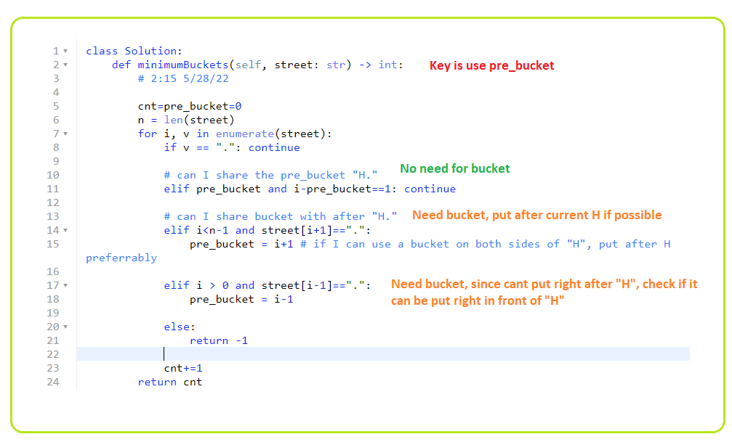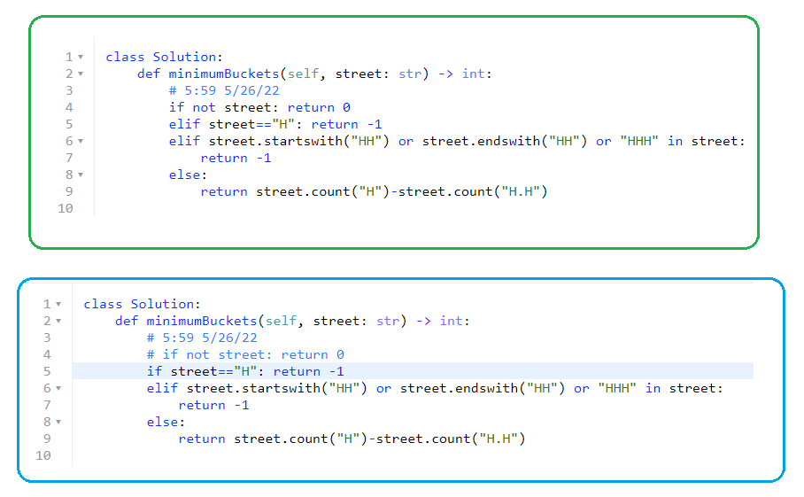

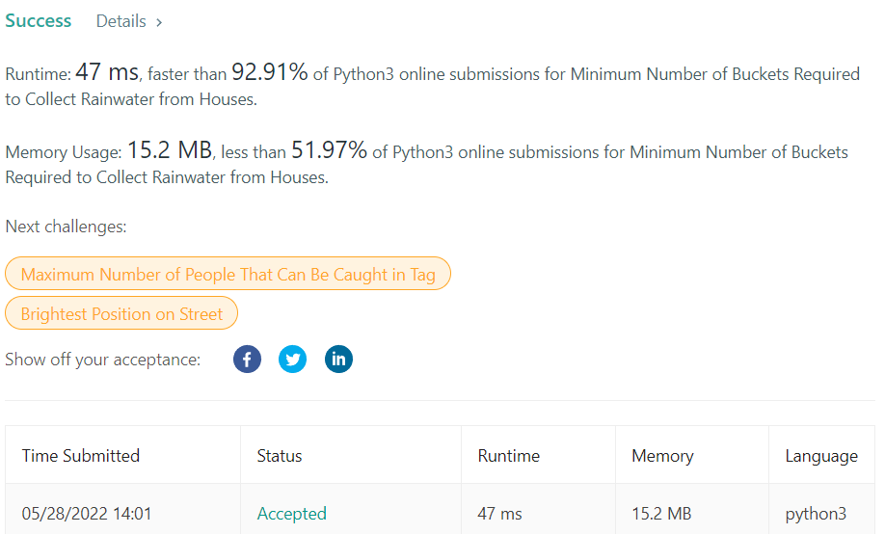

**2055. Plates Between Candles**

**2222. Number of Ways to Select Buildings**

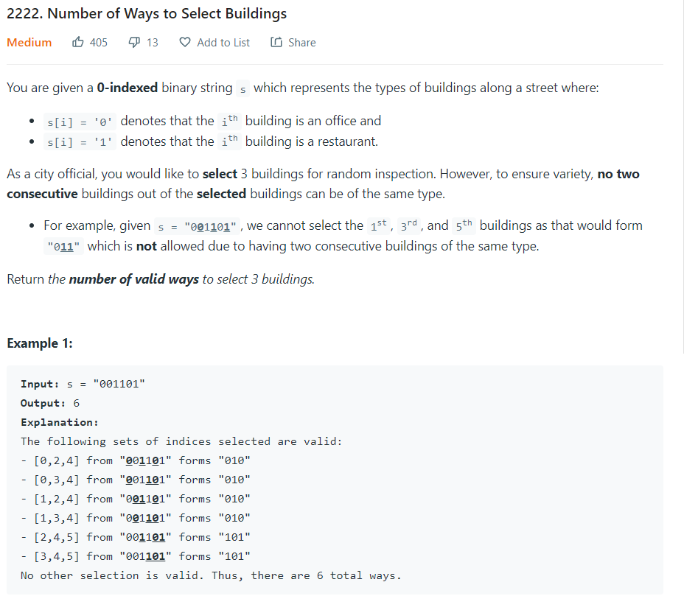 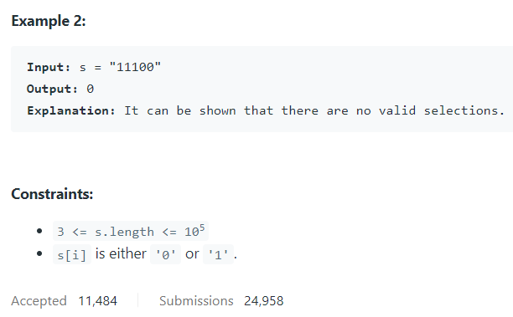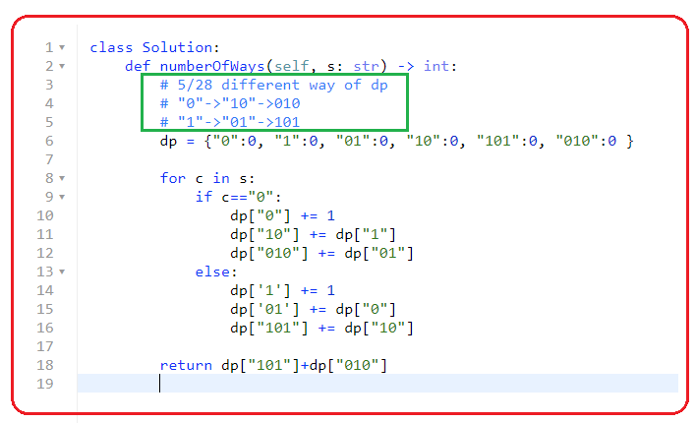 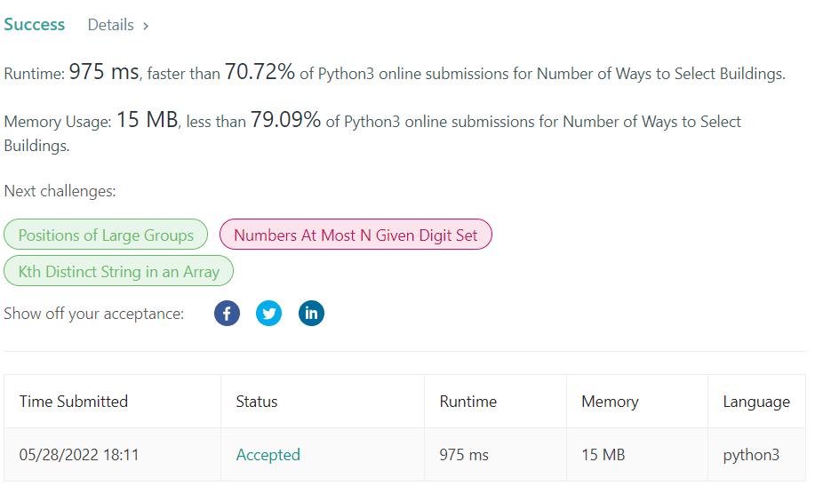

**5/31/22**

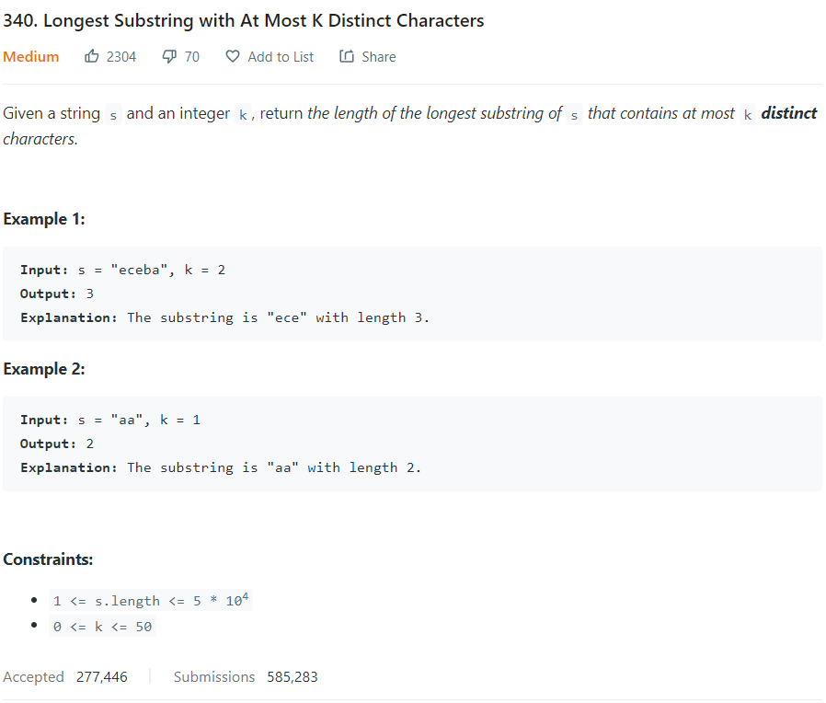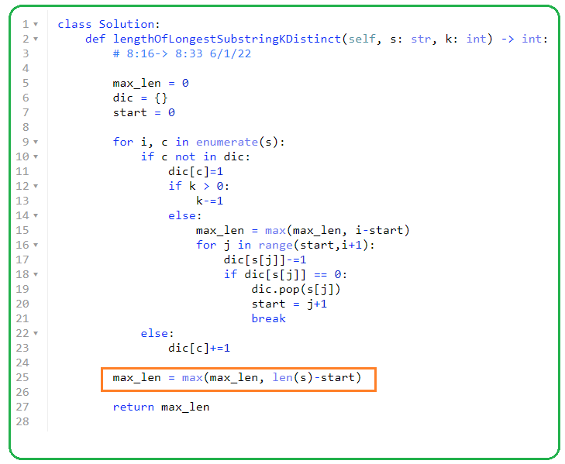

**1754. Largest Merge Of Two Strings**

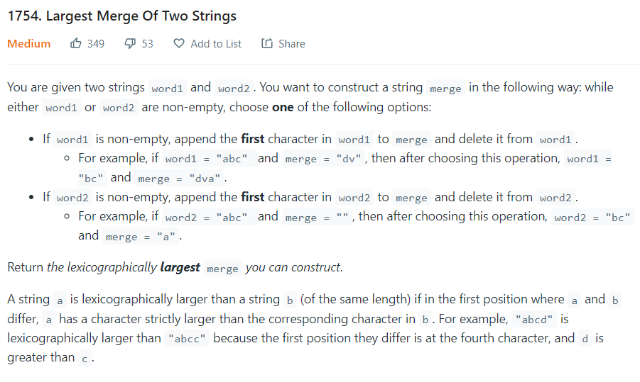 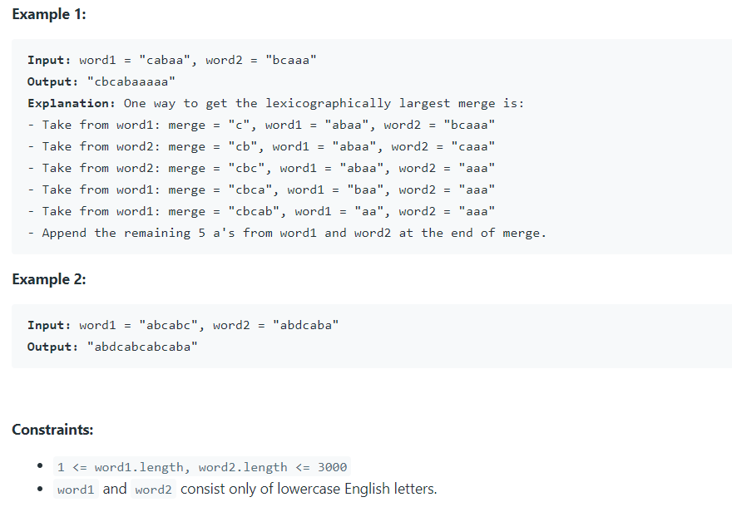 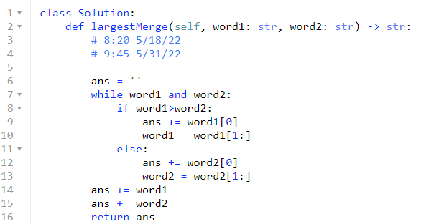

**1058. Minimize Rounding Error to Meet Target**

**1156. Swap For Longest Repeated Character Substring**

**291. Word Pattern II**

**6/1/22**

**1904. The Number of Full Rounds You Have Played**

**6/3/22**

**6/8/22**

**2096. Step-By-Step Directions From a Binary Tree Node to Another**

**6/21/2022**

**481. Magical String**

**6/22/22**

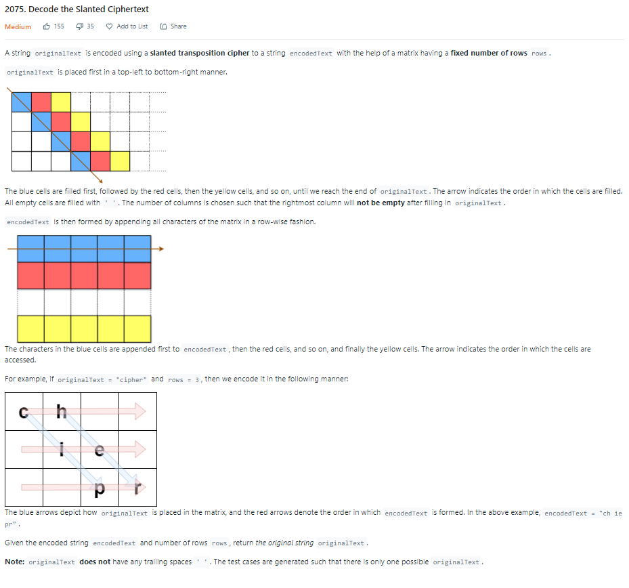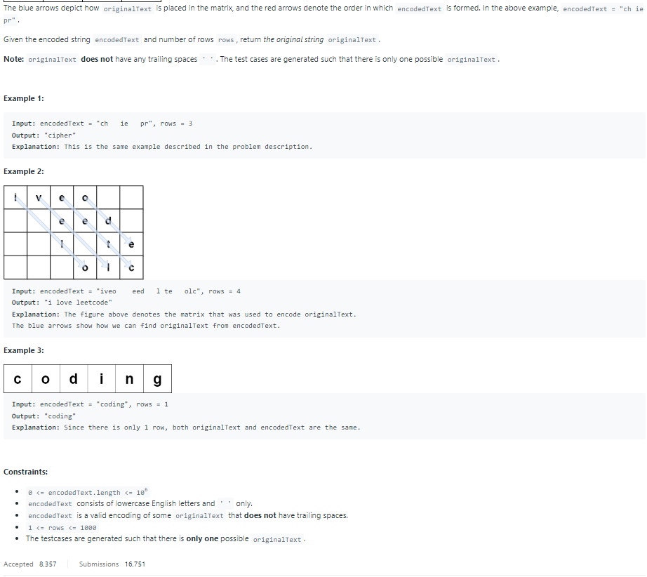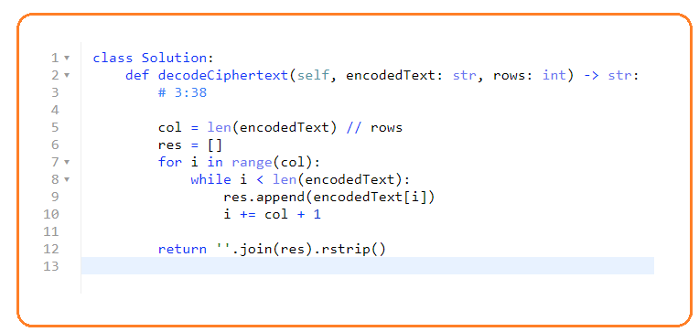 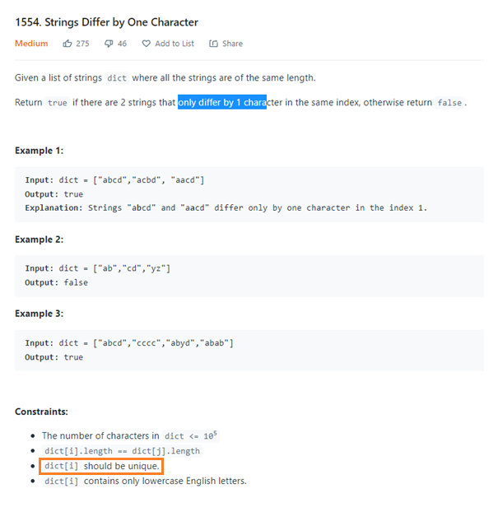

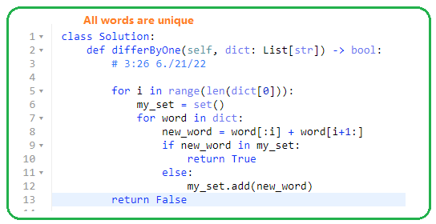

**988. Smallest String Starting From Leaf**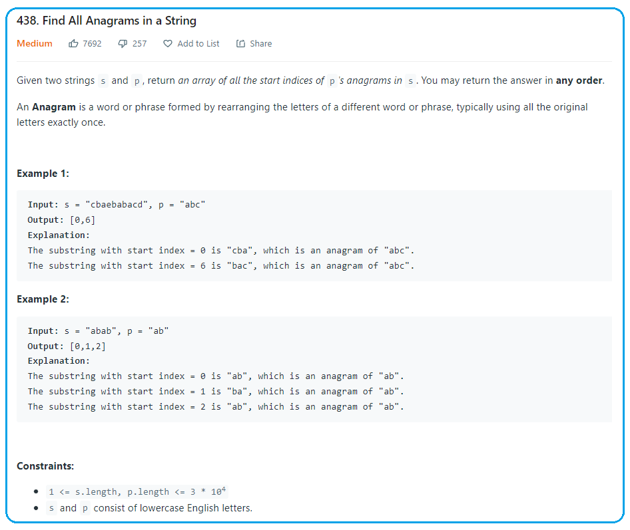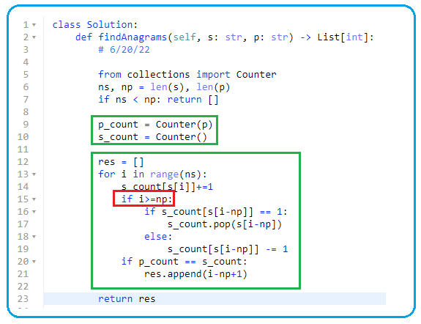

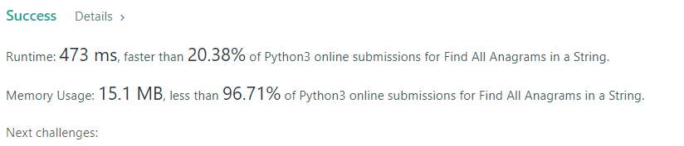

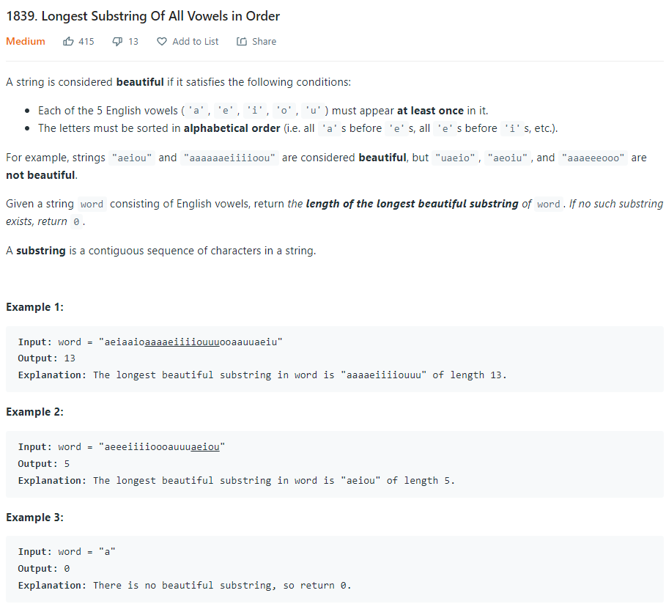

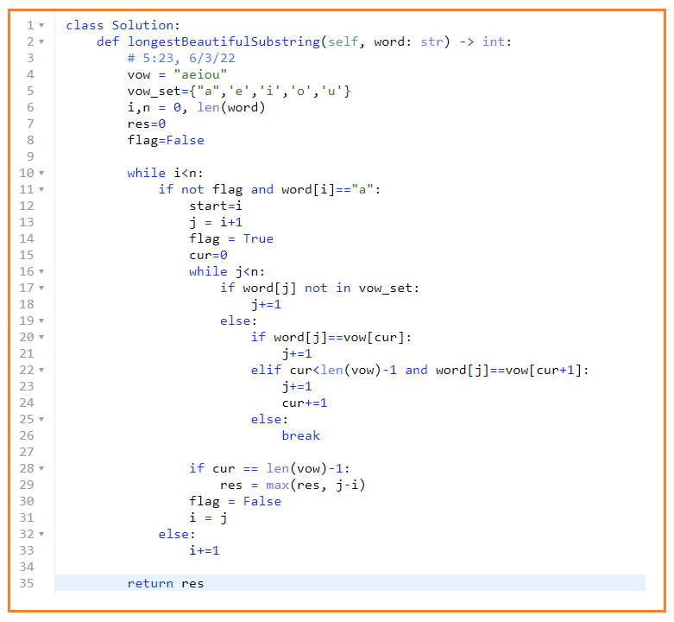

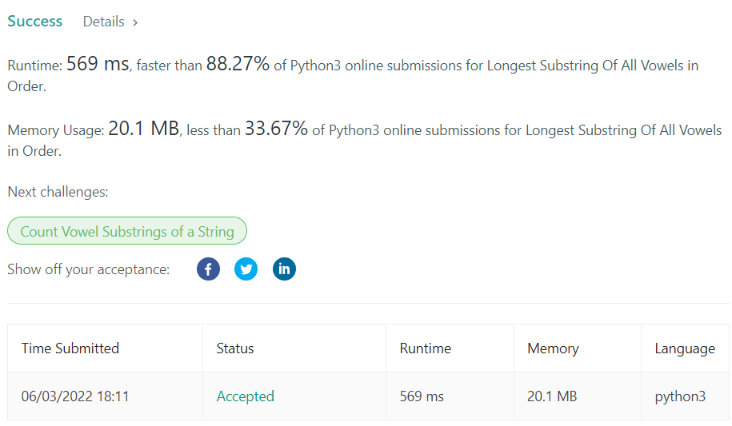

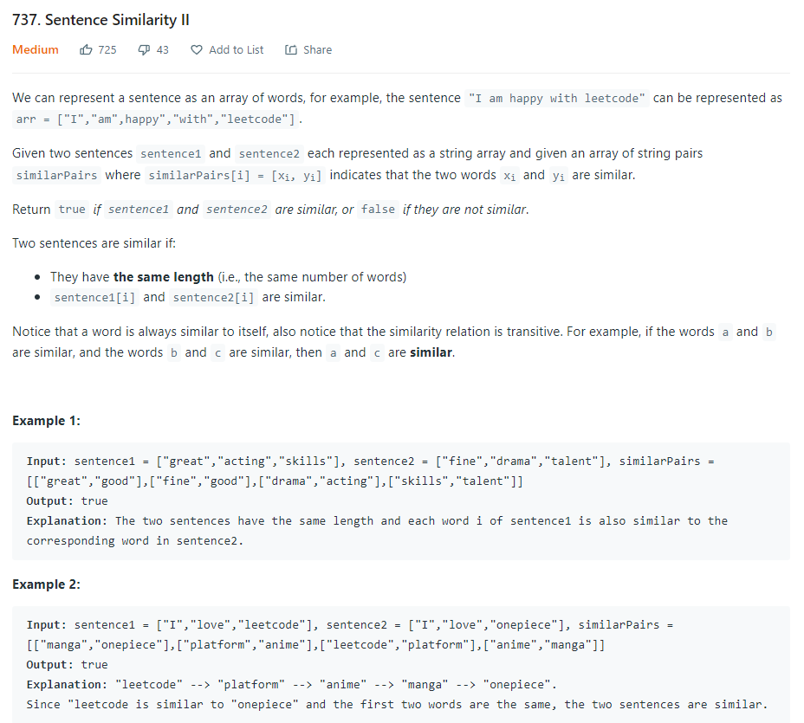

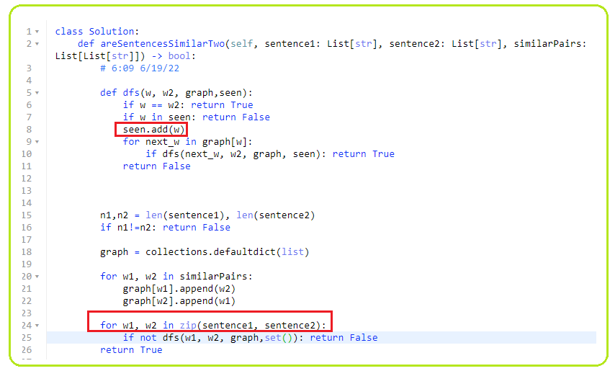

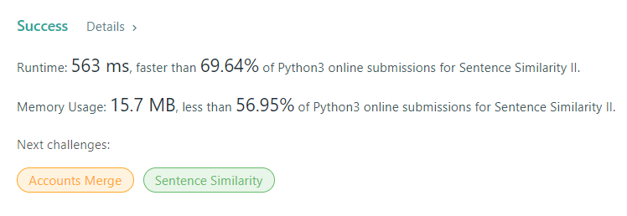

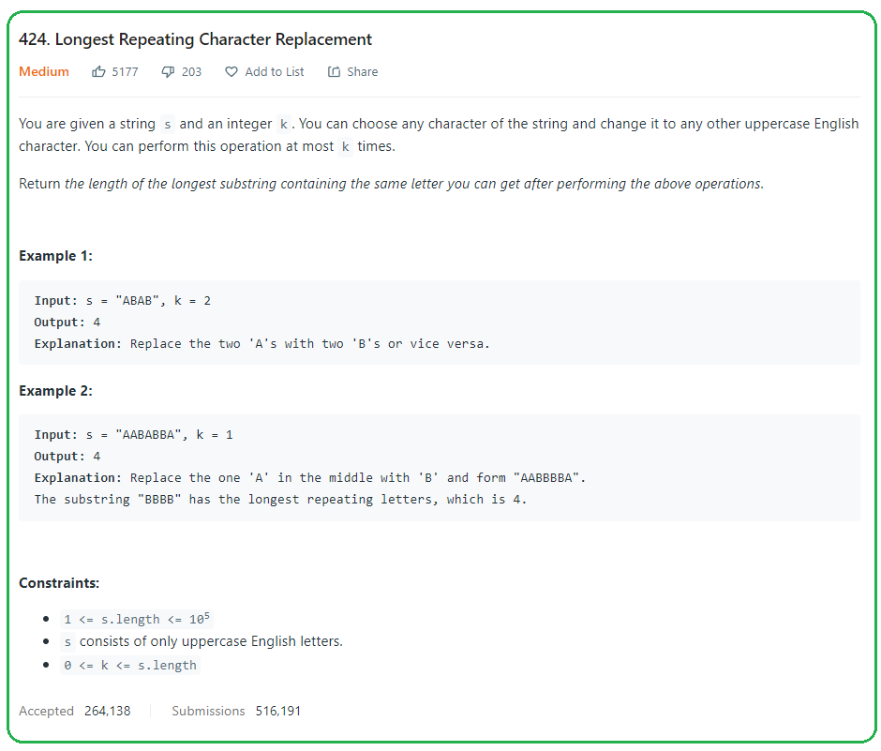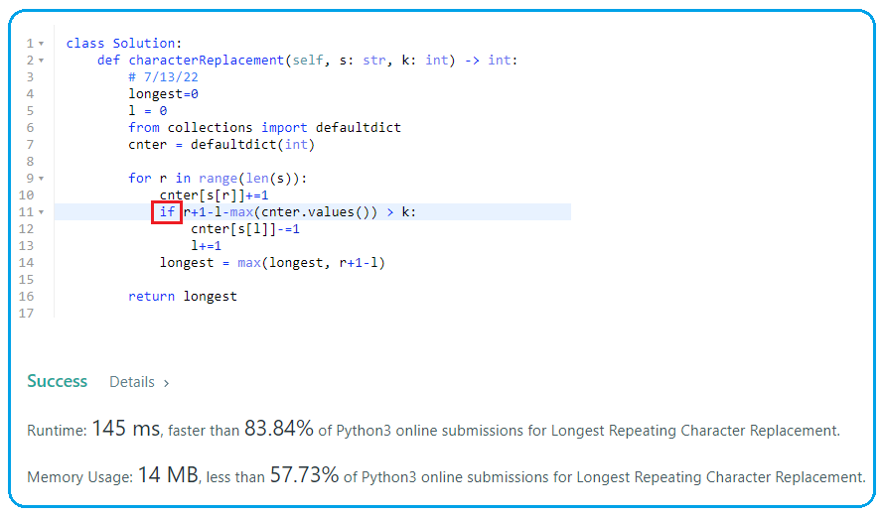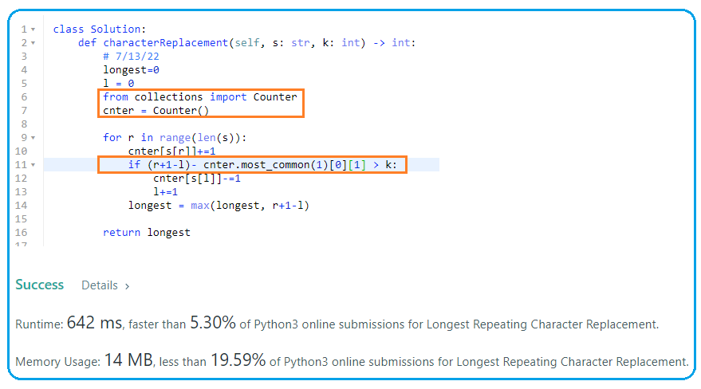

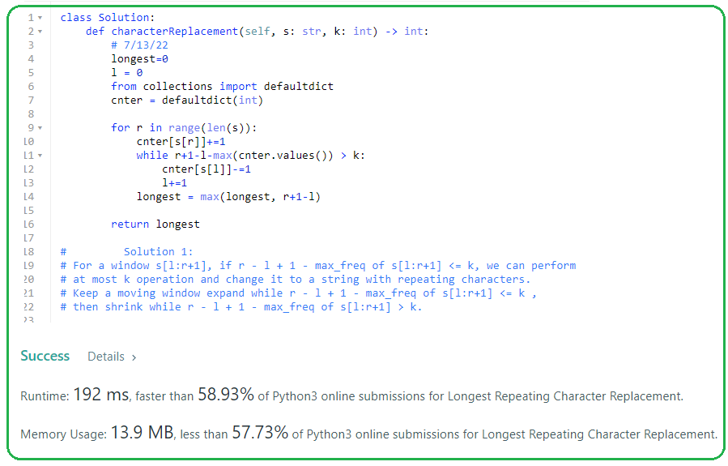

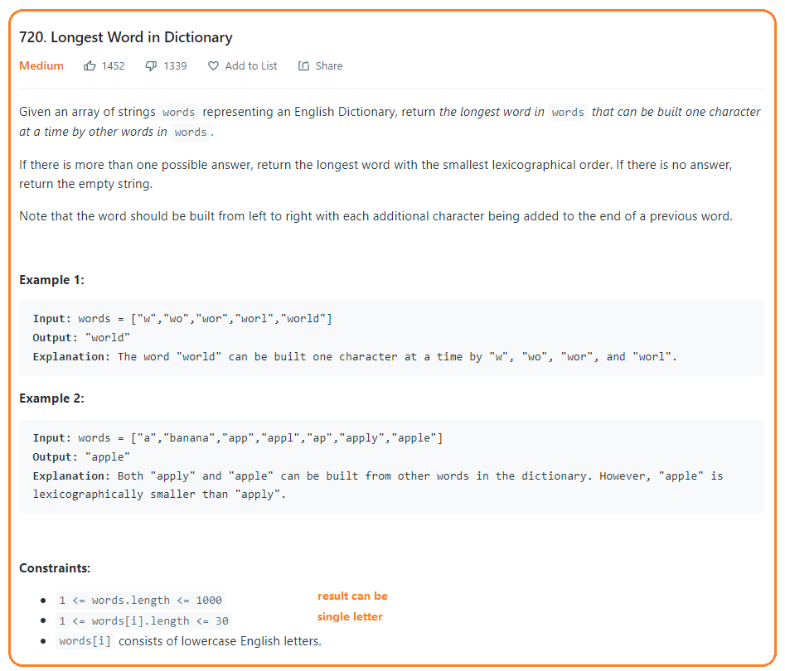

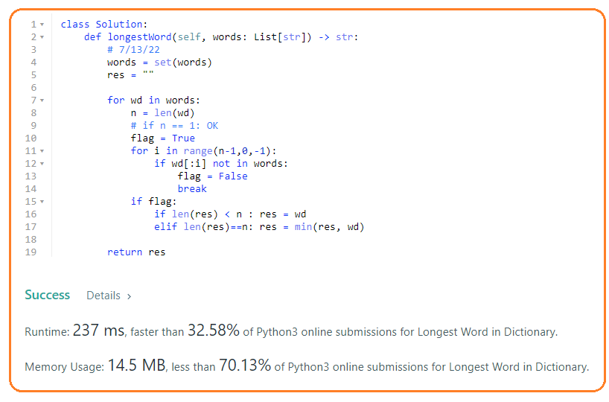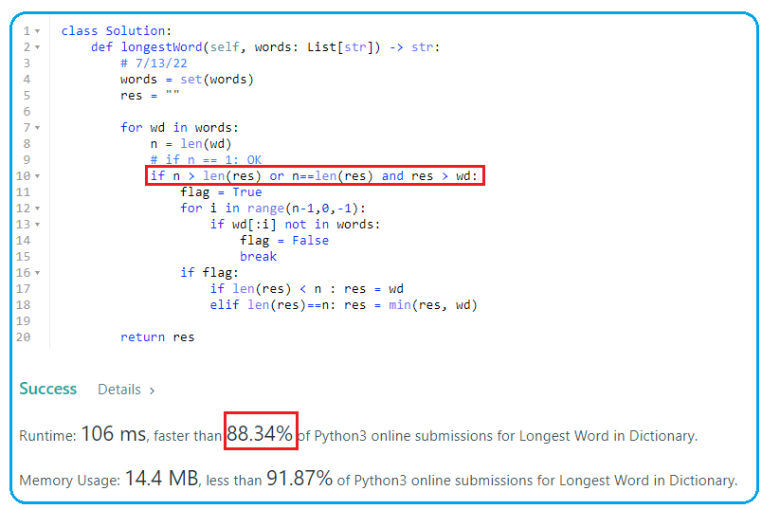

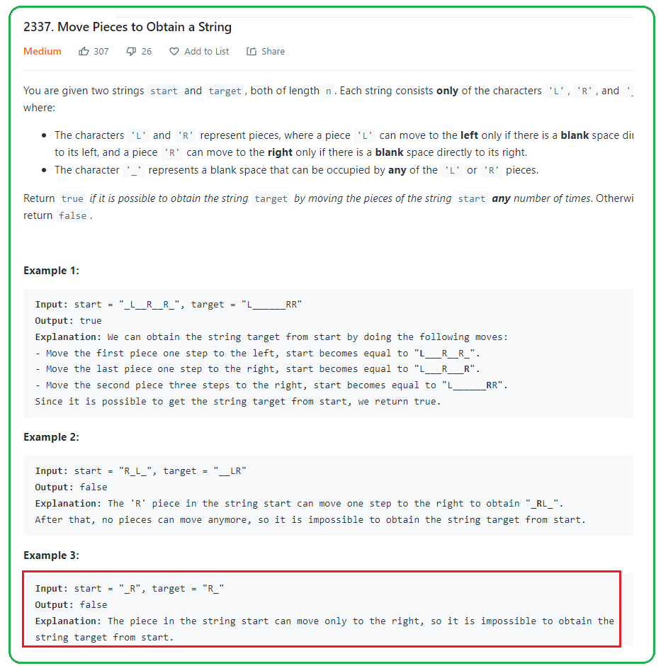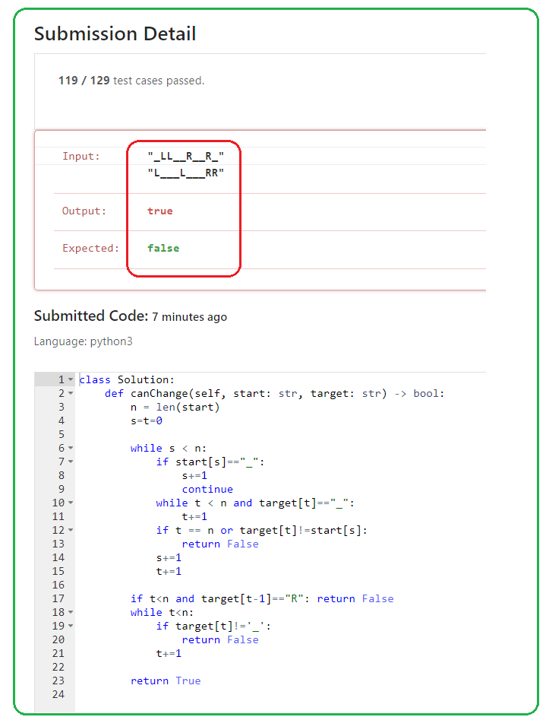

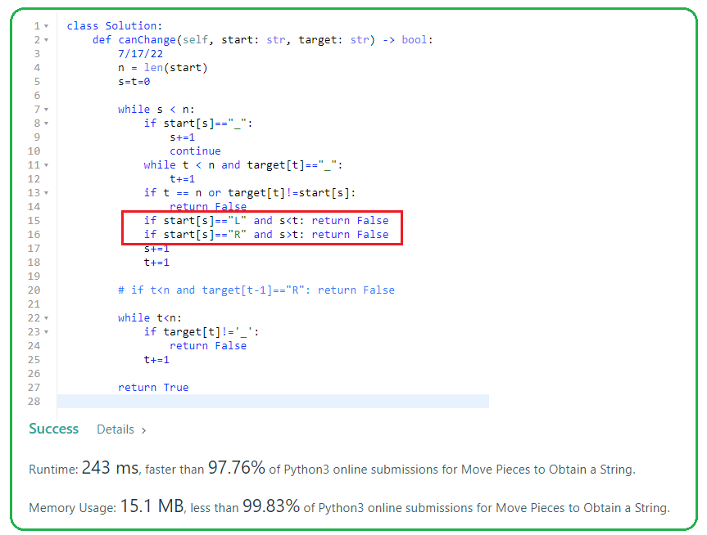

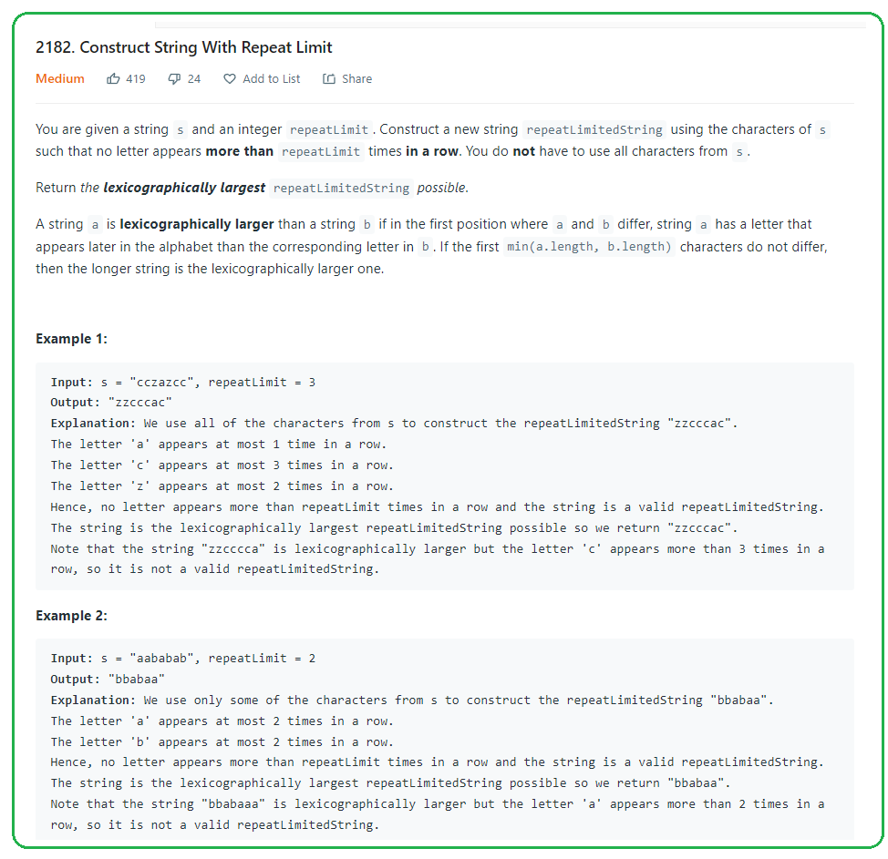

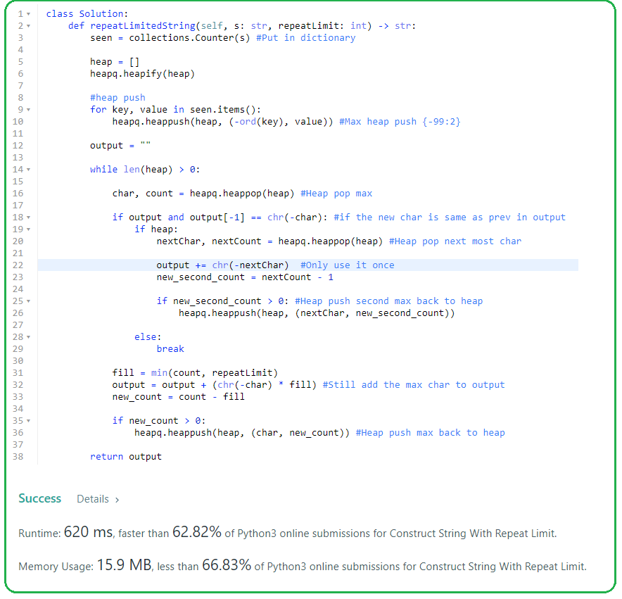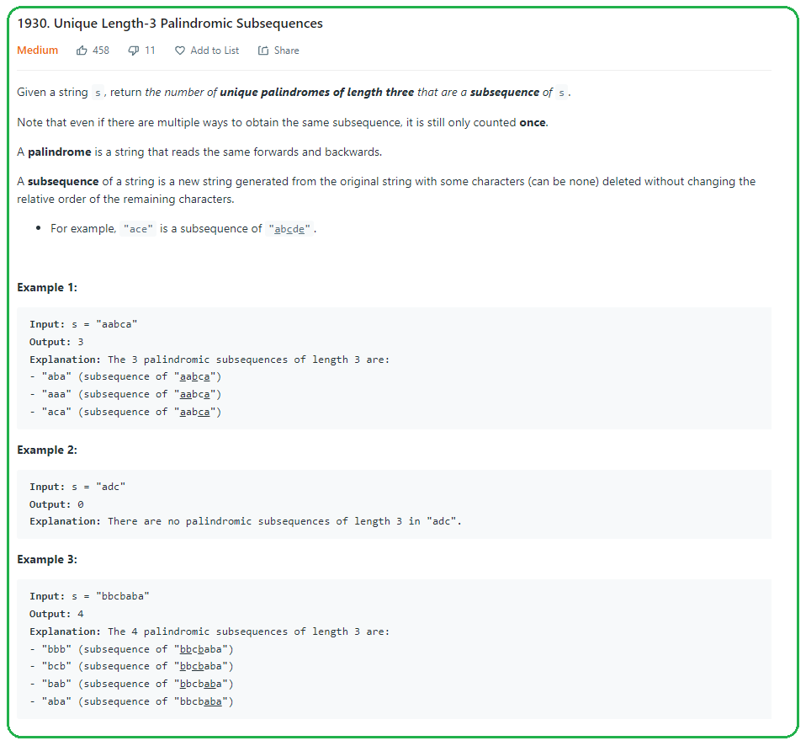

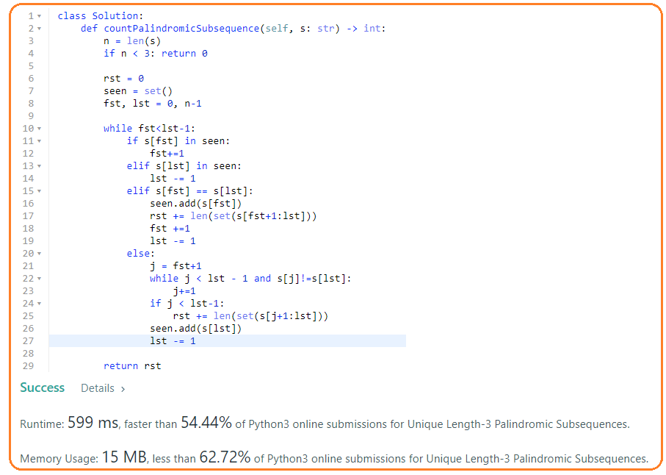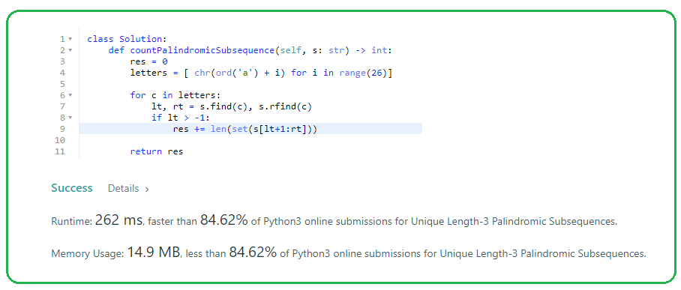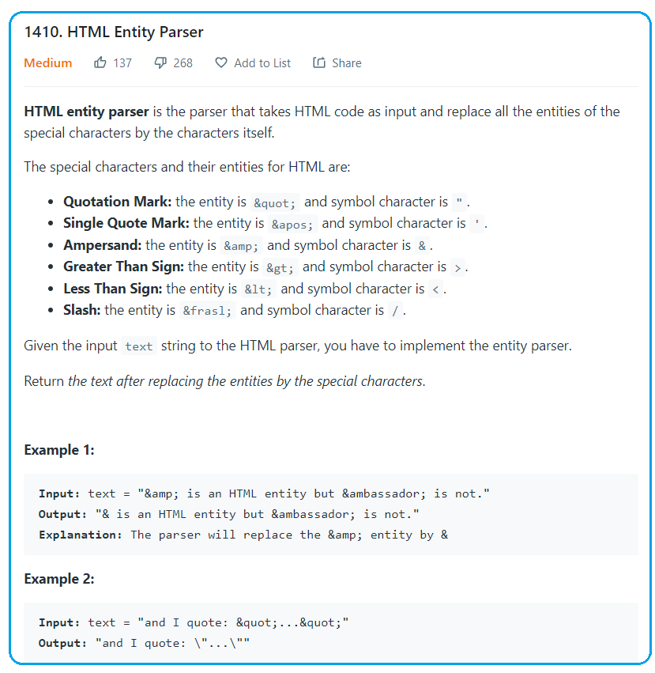

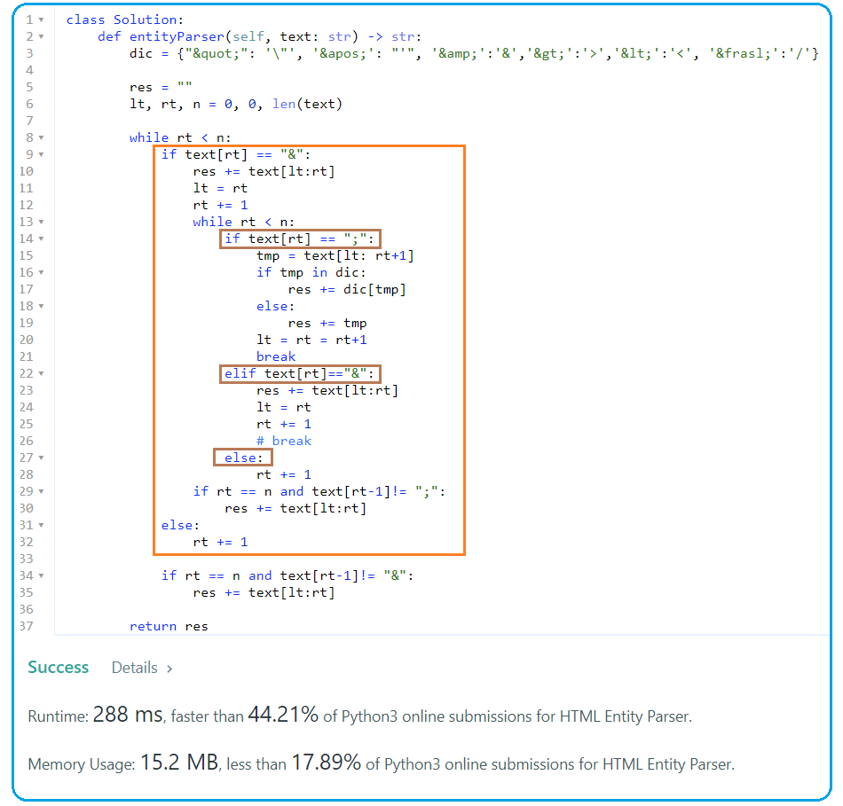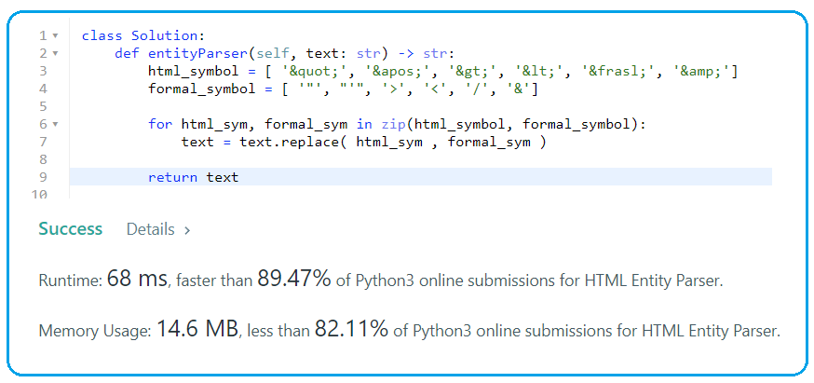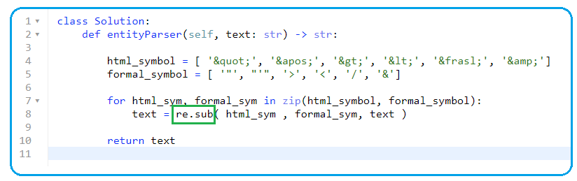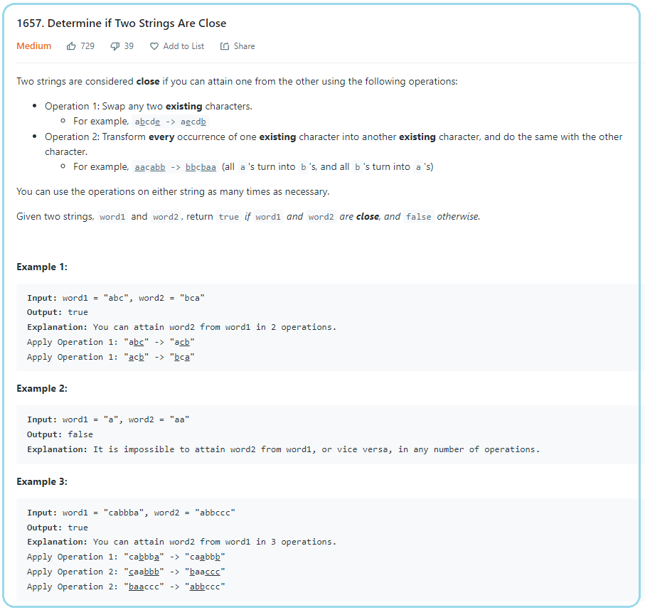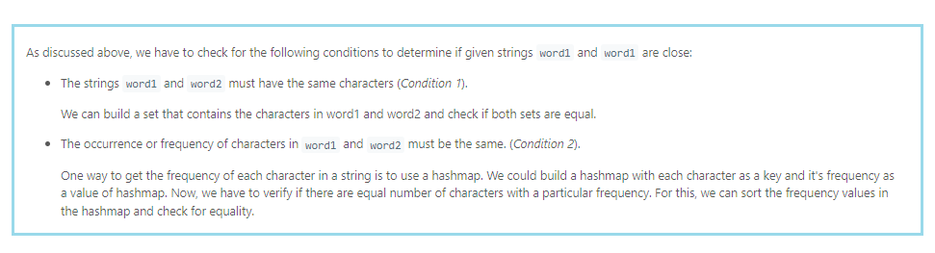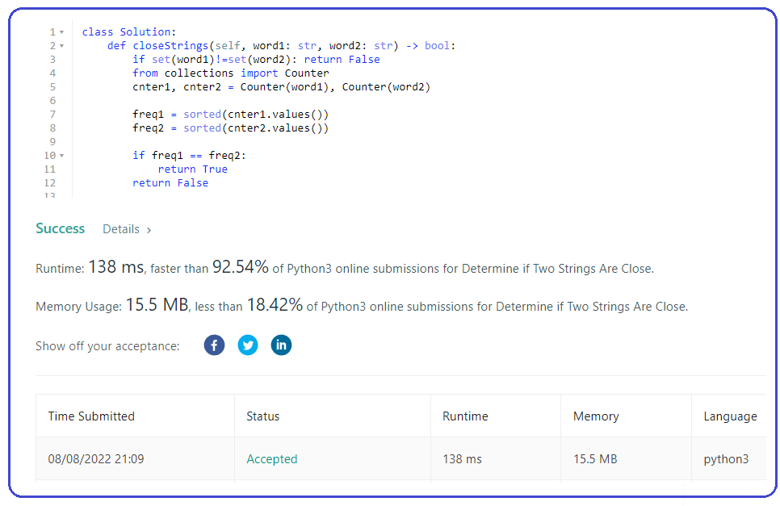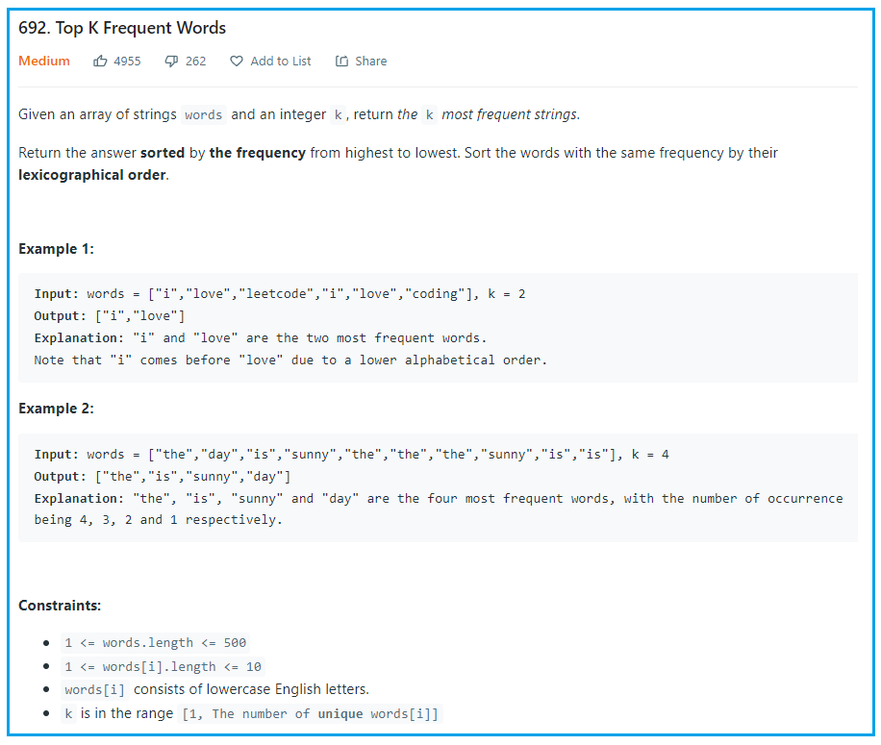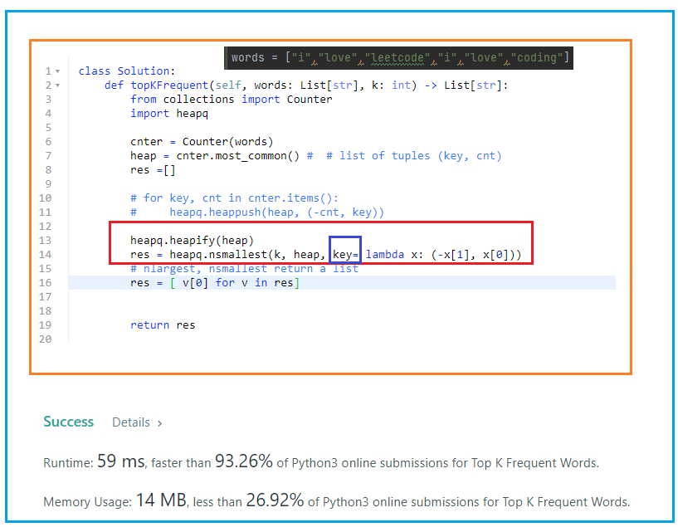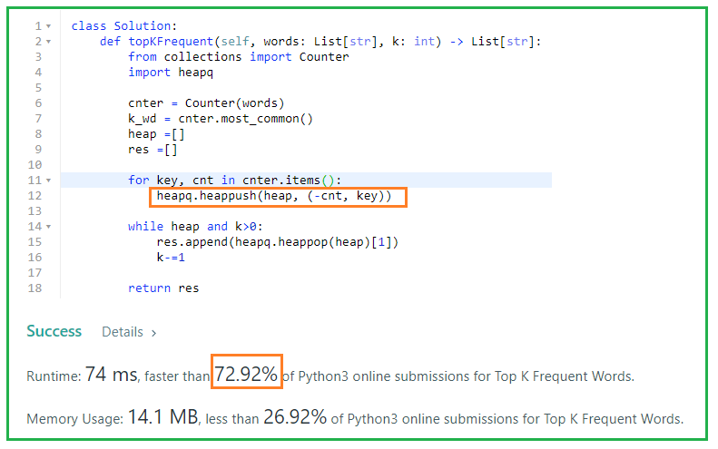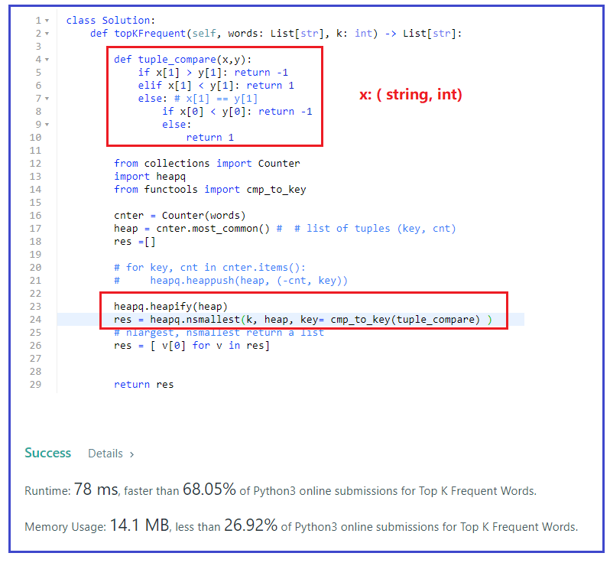

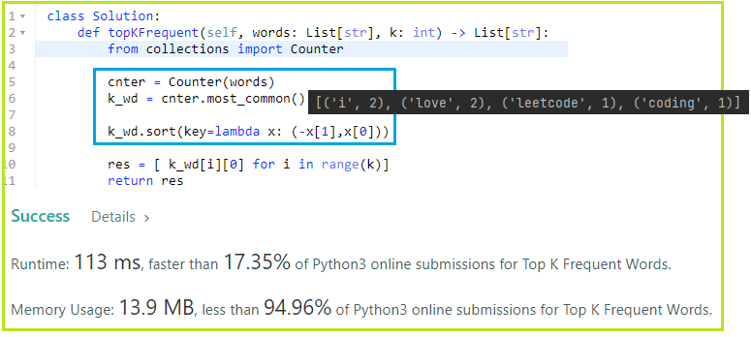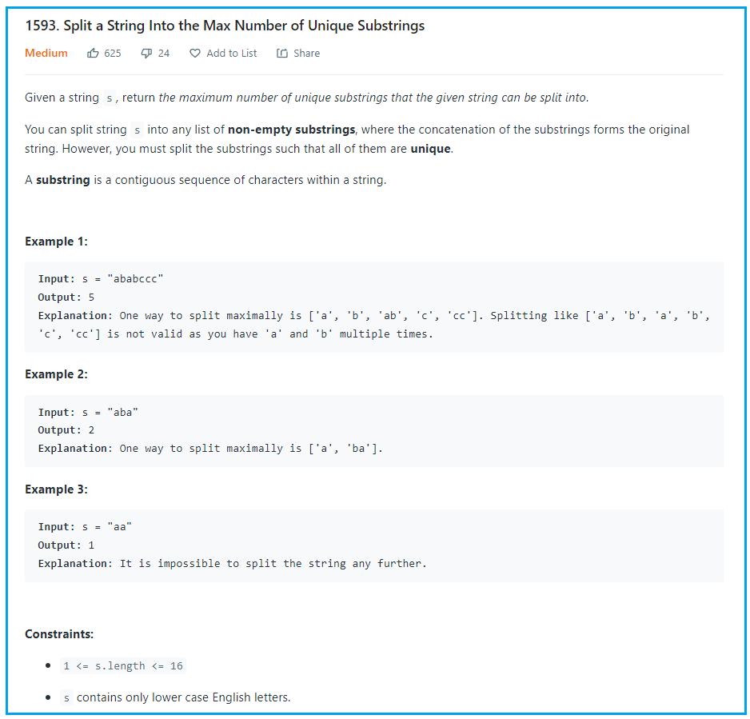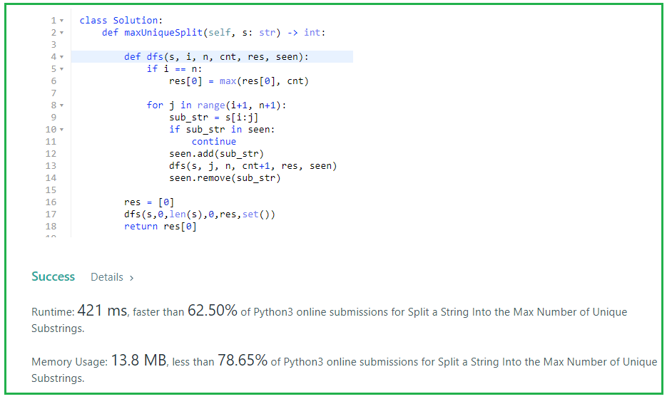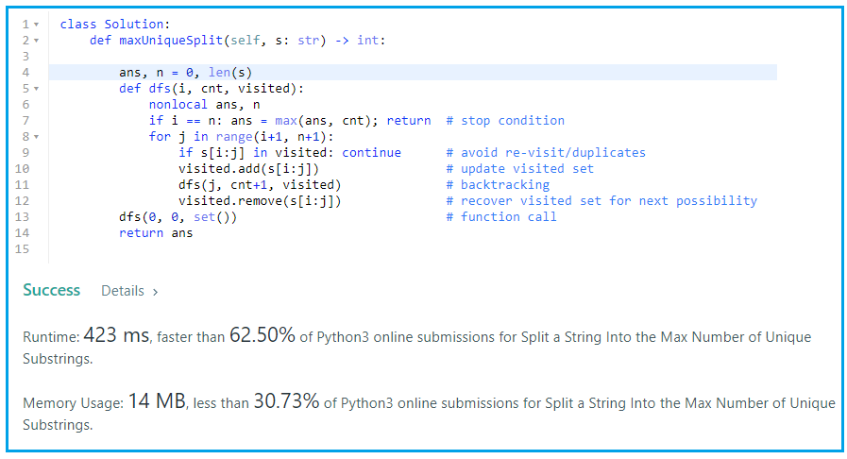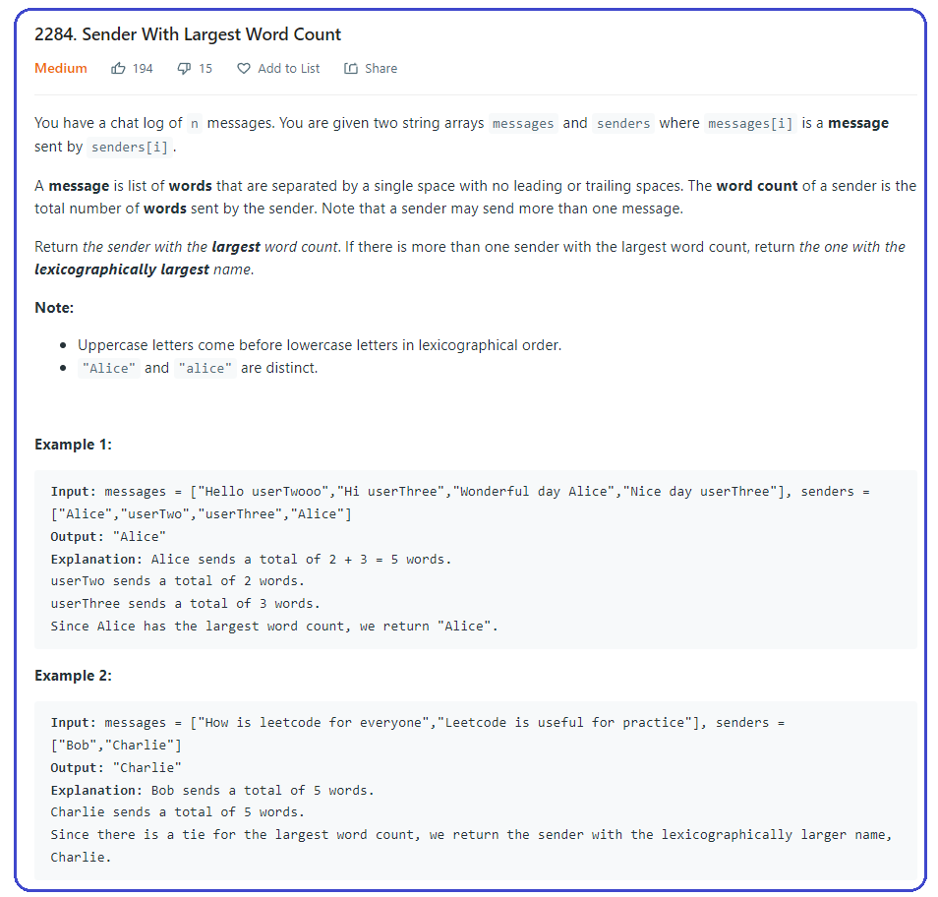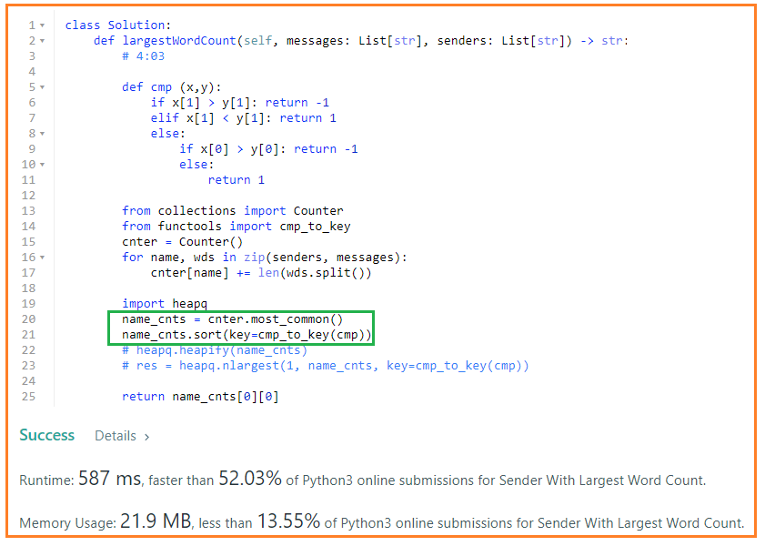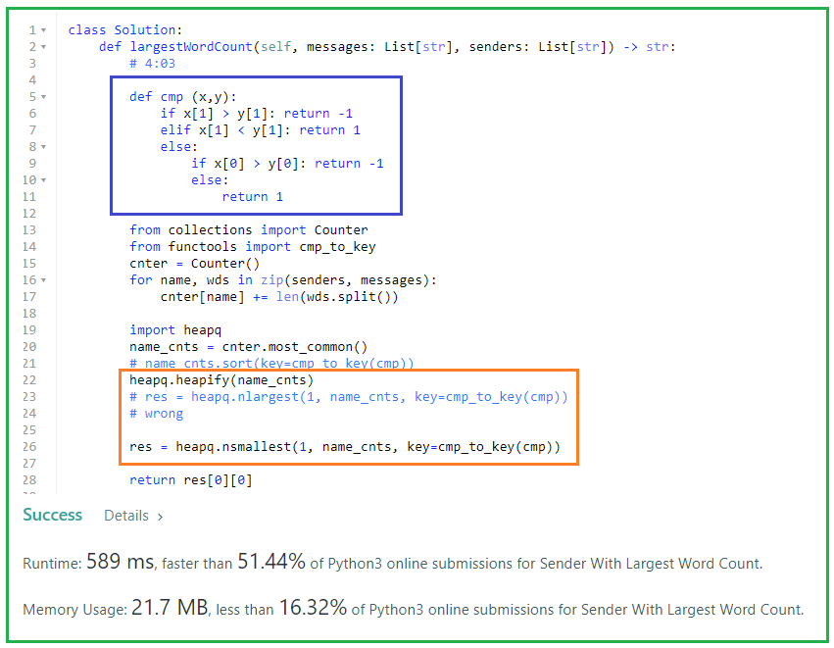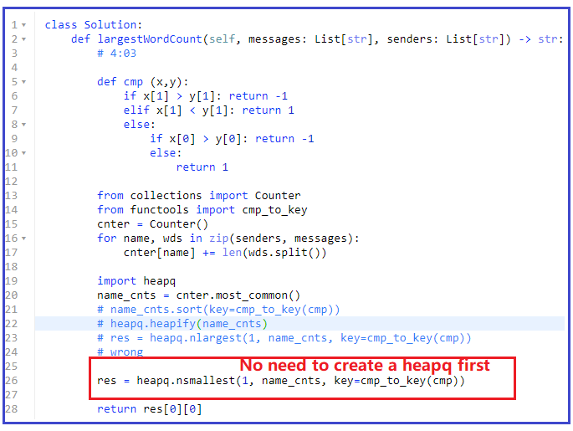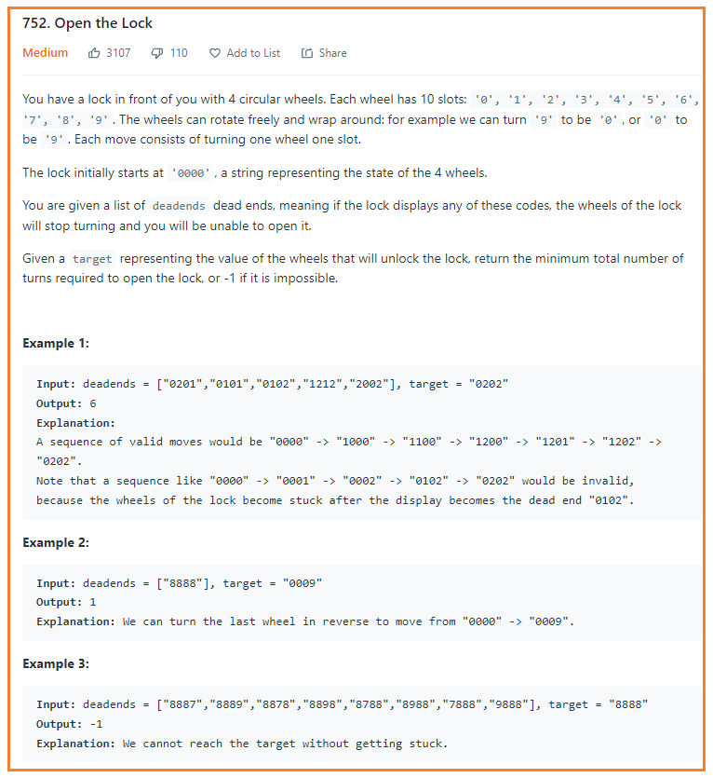

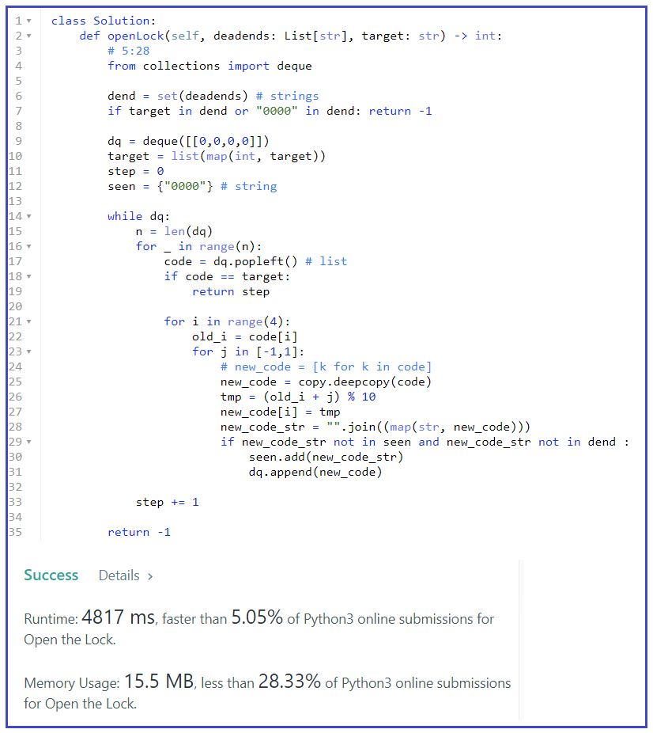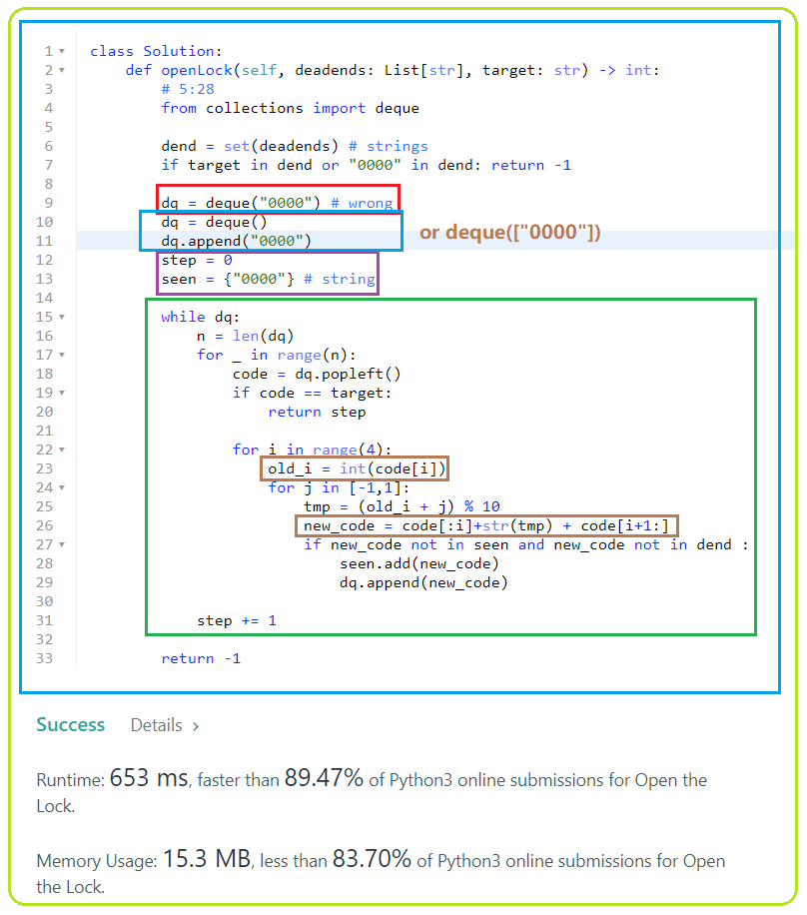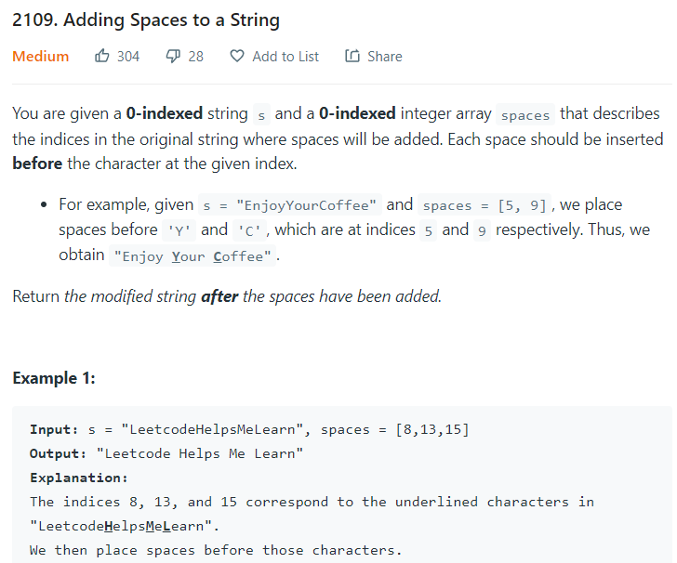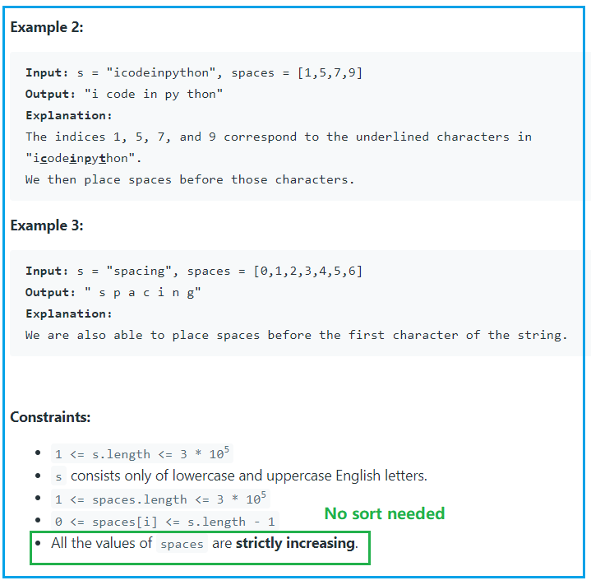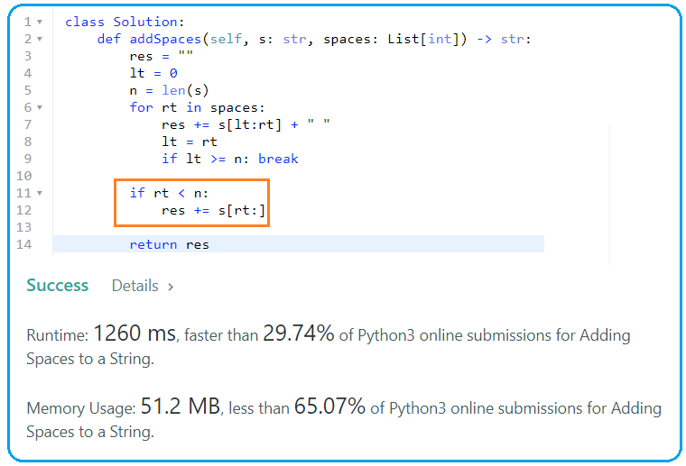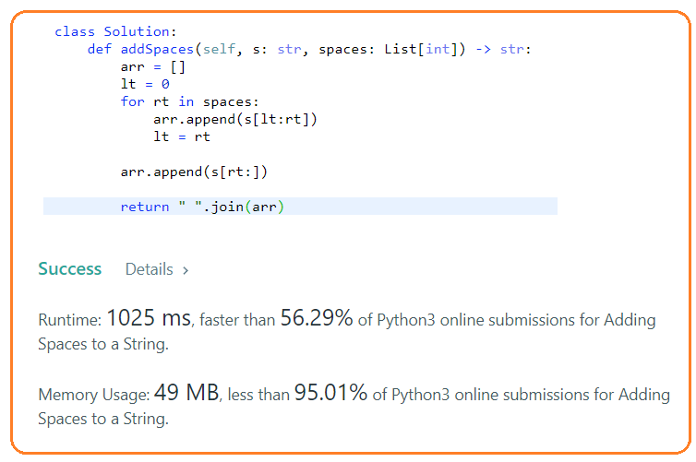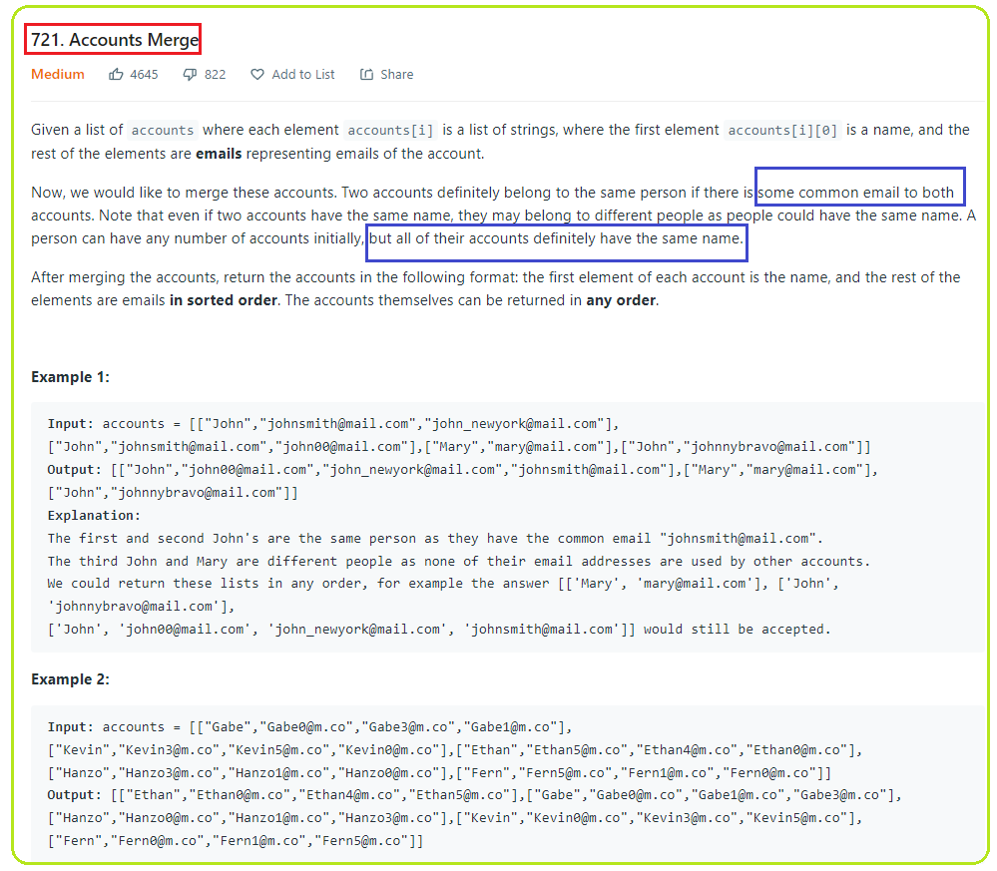

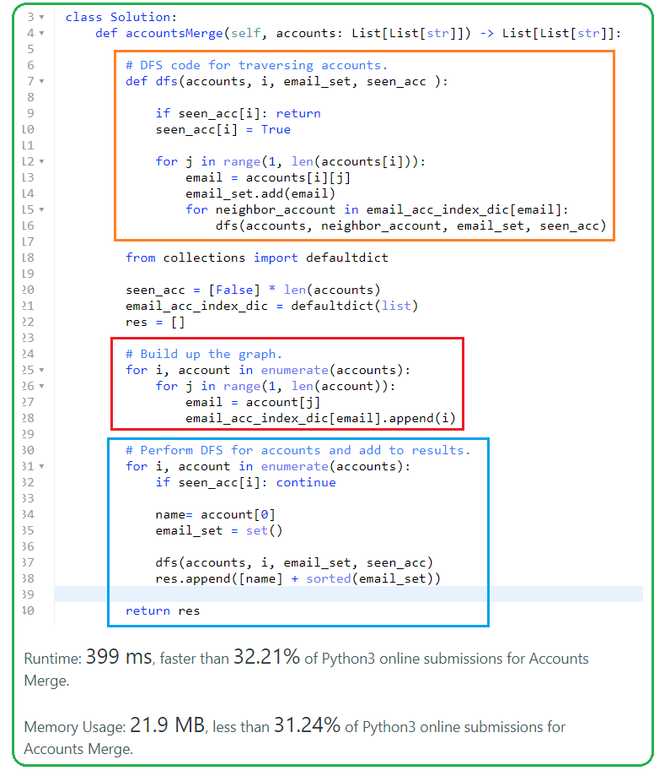

**6/24/22**

**990. Satisfiability of Equality Equations**

**758. Bold Words in String**

**6/27/2022**

**1239. Maximum Length of a Concatenated String with Unique Characters**

**1682. Longest Palindromic Subsequence II**

**2067. Number of Equal Count Substrings**

**7/1/22**

**424. Longest Repeating Character Replacement**

**247. Strobogrammatic Number II**

**720. Longest Word in Dictionary**

**7/17/22**

**2182. Construct String With Repeat Limit**

**7/23/22**

**1930. Unique Length-3 Palindromic Subsequences**

**7/25/22**

**592. Fraction Addition and Subtraction**

**1138. Alphabet Board Path**

**8/1**

**981. Time Based Key-Value Store**

**1156. Swap For Longest Repeated Character Substring**

**8/8**

**247. Strobogrammatic Number II**

**2063. Vowels of All Substrings**

**8/11/2022**

**1915. Number of Wonderful Substrings： bitmask**

**692 Top K Frequent Words**

**1593. Split a String Into the Max Number of Unique Substrings**

**8/13/2022**

**2284. Sender With Largest Word Count**

**752. Open the Lock**

**8/15/22**

**721. Accounts Merge**